Forum: United Nations Entity for Gender Equality and the Empowerment of Women (UNW)
Issue #2: Measure to address digital gender-based violence against women, with an emphasis on deepfakes and online abuse
Student Officers: Zara Zablah
Position: Chair of the United Nations Entity for Gender Equality and the Empowerment of Women

Introduction
The fast growth of digital technology and social media has significantly impacted communication, access to information, and global connection. However, due to these advancements, new forms of gender based violence have been created, specifically targeting women in online spaces. Digital gender-based violence (DGBV) contains a wide range of harmful behaviors, including cyber harassment, non-consensual sharing of intimate images, online stalking, and increasingly, the creation and dissemination of deepfake content. Deepfakes (Synthetic media generated using artificial intelligence) are a significant threat, as they can make highly realistic images or videos that are often used to exploit, defame, or silence women.

This issue is especially concerning due to the speed and scale at which online abuse can happen. Victims of digital gender-based violence frequently experience severe psychological distress, damage to their reputation, and isolation. Additionally, the cross-border nature of online spaces causes challenges for legal accountability, since the criminal can work from different locations with different laws. Other countries have enacted laws to address online harassment and non-consensual graphic content; there are still big gaps in global governance, technological regulations, and policies protecting the victim.

This problem is still very controversial because of the need to balance human rights, like freedom of expression and privacy, with the immediate need to keep individuals safe, especially women, from danger. In addition, tech companies have a significant impact on filtering content, but debates continue to be had regarding the amount of accountability and responsibility they have. The absence of standard international regulations makes the issue worse, leaving many victims with inadequate recourse.

Spreading awareness of digital gender-based violence, focusing on online abuse and deepfakes, is extremely important in making sure we create safe and inclusive online spaces. As the online world continues to expand, it’s crucial that the international community create clear, collaborative, and fair solutions that keep individuals safe while encouraging freedom of expression and innovation online. This problem is not only an issue of cybersecurity or digital regulation, but also a human rights issue that has a direct and significant impact on gender equality and women's empowerment globally.

Definition of Key Terms
Digital gender based violence: Any type of form of violence committed through digital spaces that targets individuals based on their gender, including harassment, threats, and abuse directed at women online. (United Nations Population Fund)

Deepfake: A form of artificial intelligence technology that is used to create realistic but fake images, audio, or videos, often used to manipulate or falsely represent people without their consent. (United Nations Entity for Gender Equality and Empowerment of Women )

Non-consensual content: The sharing or distribution of images, videos, or personal information without the consent of the individual involved, often causing damage or exploitation. (United Nations Entity for Gender Equality and the Empowerment of Women )

Online harassment: Repeated or severe use of digital communication to threaten, intimidate, or harm an individual, often targeting women in public or private online spaces.(United Nations Entity for Gender Equality and the Empowerment of Women).

Cyberstalking: The use of the internet or digital technologies to repeatedly monitor, harass, or threaten an individual, creating fear for their safety (United Nations Population Fund).

Algorithmic bias: The tendency of automated systems and artificial intelligence to reflect and reinforce existing inequalities, including gender discrimination. (United Nations Educational, Scientific and Cultural Organization).

General Overview
The main idea
Digital gender-based violence against women has become a growing Global concern due to the rapid growth of technology and online platforms (UN Women). Although these platforms have increased access to communication, education, and economic opportunities, they have also created new spaces where abuse can happen (United Nations Population Fund). Forms of digital violence such as harassment, cyberstalking, deepfakes, and the spread of non-consensual content have made it really difficult to ensure safety in online environments (United Nations Educational, Scientific and Cultural Organization). As these forms of abuse spread quickly and across borders, addressing them requires both National and international efforts(United Nations).

Regulatory challenges
The main challenge in addressing this issue is the lack of consistent regulations across countries (United Nations). Although some states have implemented strict laws to control online content and hold technology companies accountable, others have prioritized freedom of expression and limited government intervention (United Nations Educational, Scientific and Cultural Organization). This has created a significant gap in enforcement, allowing predators to take advantage of weak legal systems (United Nations Entity for Gender Equality and the Empowerment of Women). Additionally, growing technologies such as artificial intelligence continue to expand faster than legal frameworks, making it difficult for governments to effectively respond to new forms of abuse (United Nations Educational, Scientific and Cultural Organization).

Role of technology companies
Technology companies play a big part in addressing digital gender based violence, as they control platforms where most of these abuses occur (United Nations Entity for Gender Equality and the Empowerment of Women). Social media companies and digital service providers are often responsible for Content moderation, reporting systems, and the removal of harmful content (United Nations). However, there's a continuing conflict regarding the extent of their responsibility. Some argue that these companies should be held fully accountable for preventing and removing abusive content,t but others debate that excessive regulations could limit freedom of expression and innovation (United Nations Educational, Scientific and Cultural Organization). In addition, inconsistencies in how platforms enforce their policies have created concerns about transparency and effectiveness (United Nations Entity for Gender Equality and the Empowerment of Women). As a result of all this,s the role of technology companies remains a key point of discussion in developing solutions to this issue

Impact on women
Digital gender based violence has serious consequences for women's safety, well-being, and participation in society (United Nations Population Fund). Many victims often experience psychological harm, reputational damage, and in some cases, real-world threats (United Nations Entity for Gender Equality and the Empowerment of Women). This can encourage women from participating in online communities, limiting their access to education, employment, and public engagement (United Nations). Due to digital violence, not only is it affecting individuals, butit also reinforces broader gender inequalities and restricts women's ability to fully engage in modern society (United Nations).

Major Parties Involved and Their Views
United States
The United States has faced significant challenges related to digital gender based violence due to its large online population and technological advancements. Issues such as deepfakes and non-consensual content have brought a lot of concern about privacy and users' safety. The United States supports strong platform accountability and legal protection, but they also see the importance of maintaining freedom of expression.

China
China has strict control over digital platforms, allowing for strong regulations of online content. Although this reduces the visibility of certain forms of abuse, it also brings concern due to censorship and limited freedom of expression. China usually supports National regulations and sovereignty rather than international oversight.

Germany
Germany has set some of the strongest laws addressing online hate speech and digital abuse. It supports strict regulations of digital platforms and targets the importance of holding companies accountable. Germany also advocates for international cooperation to ensure a safer online space.

India
India has one of the largest digital populations in the world. Due to this, they face growing cases of online harassment targeting women. Although the government has introduced legal measures, enforcement remains inconsistent. India supports stronger protection but faces many conflicts due to its size and digital infrastructure.

Saudi Arabia
Saudi Arabia enforces strict regulations over digital content in line with its legal and cultural foundation. This allows for control over certain forms of online abuse. The country prioritizes National sovereignty and internal policies over International Help.

Brazil
Brazil has high levels of online activity, leading to increased exposure to online abuse. Brazil has taken steps to address online violence but continues to face enforcement challenges. They support stronger protections and awareness efforts at both National and international levels.

Timeline of Events, Relevant Resolutions, Treaties, and Events

1948 | The Universal Declaration of Human Rights recognizes the right to life, security, and equality for all individuals.
1979 | Adoption of the Convention on the Elimination of All Forms of Discrimination against Women (CEDAW), a very important International treaty protecting women's rights.
1993 | The Declaration on the elimination of violence against women formally recognizes violence against women as a human rights violation.
2010 | The United Nations entity for gender equality and the empowerment of women (UN Women) to promote gender equality globally.
2015 | Adoption of the Sustainable Development Goals (SDGs), including Goal 5, which aims to achieve gender equality and eliminate violence against women.
2018 | Growing global awareness of online harassment, with movements such as # MeToo highlighting digital abuse and gender-based violence.
2020 | Increased use of fake technology raises concerns about non-consensual content and online exploitation of women.
2022 | Several countries began introducing stricter laws addressing online abuse and digital gender-based violence
present | Ongoing international discussions on regulating location intelligence and protecting individuals from digital harm.

United Nations Involvement
The United Nations played a significant role in addressing violence against women, including emerging forms such as digital gender-based violence. Through various resolutions, treaties, and organizations, the United Nations has established a global framework aimed at promoting gender equality and protecting women's rights.
One of the most important international agreements is the Convention on the Elimination of All Forms of Discrimination against Women (CEDAW), which requires member states to take appropriate measures to eliminate discrimination and violence against women. Additionally, the Declaration on the Elimination of Violence against Women (1993) condemned violence against womanizer violation of Human Rights and called for global action to prevent it.

The creation of the United Nations entity for gender equality and empowerment of women (UN Women) in 2010 further strengthened efforts to address gender-based violence. UN Women works with governments and organizations to develop policy, raise awareness, and support victims of violence, including those affected by digital abuse. Furthermore, the Sustainable Development Goals, especially Goal 5: gender equality, emphasize the elimination of all forms of violence against women and girls. While these Frameworks provide important guidance, the United Nations continues to face challenges in addressing digital gender-based violence due to the rapid evolution of technology and the lack of consistent International regulation.

Overall, the United Nations remains a central actor in promoting cooperation among member states and encouraging the development of effective strategies to combat both traditional and digital forms of violence against women.

Evaluation of Previous Attempts to Resolve the Issue
Efforts to address digital gender based violence against women have increased in recent years. However, their effectiveness has been very limited by gaps in enforcement and rapid technological development. International frameworks such as the Convention on the Elimination of All Forms of Discrimination against Women (CEDAW) and the Declaration on the Elimination of Violence against Women have established important standards for protecting women's rights (United Nations). Although these frameworks provide strong legal and moral guidance, they were created before the rise of digital technologies and therefore do not fully address modern forms of online abuse.

In addition, organizations such as the United Nations Entity for Gender Equality and Empowerment of Women (UN Women) have worked to raise awareness and promote policies aimed at reducing digital violence (United Nations Entity for Gender Equality and the Empowerment of Women). Many countries have also introduced national laws aimed at online harassment, cyberstalking, and non-consensual content. However, enforcement remains inconsistent, especially in developing countries where resources and technology capacity are limited (United Nations Population Fund).

Another big limitation of previous attempts to solve this issue is the lack of global coordination. Since digital platforms work across borders, differences in national laws create gaps that allow perpetrators to avoid accountability. Technology Companies have implemented content moderation systems, but these attempts are often criticized for being inconsistent, slow, or lacking transparency ( United Nations Educational, Scientific and Cultural Organization).

Overall, previous attempts have increased awareness and established important legal Frameworks; they have not fully succeeded in preventing digital gender-based violence. The rapid growth of Technology combined with inconsistent enforcement and lack of international cooperation continues to limit the effectiveness of these measures.

Possible Solutions
One possible solution is the creation of an international legal framework specifically targeting digital gender-based violence, including deepfake and non-consensual content. This framework could establish clear Global definitions of digital abuse, set a minimal legal standard, promote cooperation between countries, and investigate and prosecute offenders. Since digital platforms work across borders, aligning National laws would help reduce the legal gaps that currently allow creditors to avoid accountability. However, this approach still might face challenges, as some countries neighbors International regulations due to concerns over sovereignty and different views on freedom of expression (United Nations)

Another solution is to strengthen platform accountability through mandatory transparency and a rapid response system. Governments can require technology companies to improve reporting mechanisms to ensure faster removal of harmful content and publish data on how cases of abuse are handled. Additionally, platforms could invest in more advanced detection technologies such as artificial intelligence systems that identify harmful content before it spreads. All the solutions would make platforms more responsible for users' safety; it also raises concerns about over-censorship and the potential impact on freedom of expression. Therefore, balancing regulations with user rights would be essential (United Nations Educational, Scientific and Cultural Organization)

Sustainable Development Goal (SDG)
This issue is most directly connected to Sustainable Development Goal 5: gender equality, which aims to eliminate all forms of violence against women and girls in both public and private environments (United Nations). Digital gender-based violence represents a modern form of this issue, as online spaces have become an important part of everyday life. Addressing this form of violence is essential to ensuring that women can safely participate in digital environments.

This issue also relates to Sustainable Development Goal 16: Peace, Justice, and Strong Institutions, which focuses on promoting the rule of law, ensuring access to justice, and building effective and accountable institutions ( United Nations). The lack of consistent enforcement and legal protections in digital spaces highlights the need for strong institutions and international cooperation.

Additionally, this issue also connects with Sustainable Development Goal 9: Industry, Innovation, and Infrastructure, which is relevant due to its focus on technological development and innovation (United Nations). As technology continues to grow, it is essential to ensure that digital advancements are used responsibly and do not contribute to harm or inequality.

Overall, achieving the Sustainable Development Goals requires addressing digital gender-based violence through stronger policies, improved enforcement, and international collaboration to ensure a safe and inclusive digital space for all.

Appendix
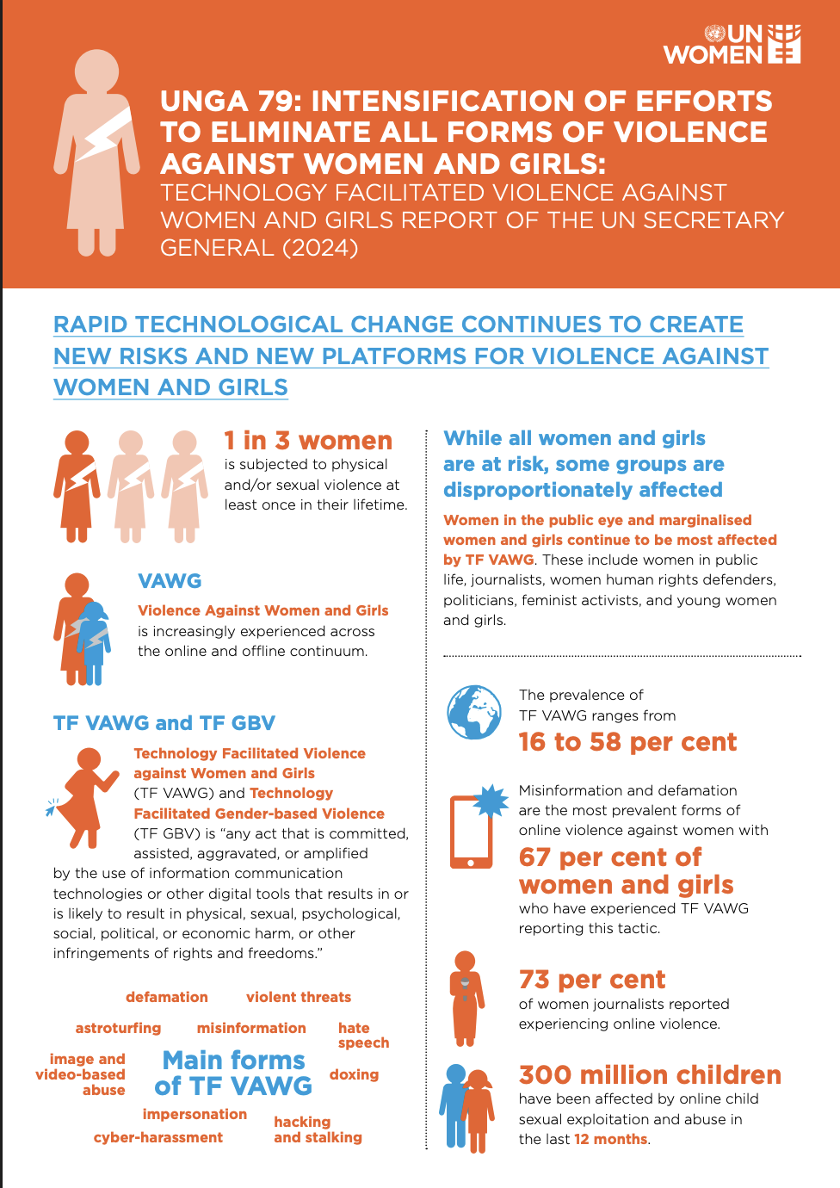
Source A: The image above includes an infographic presenting statistics on technology-facilitated violence against women globally. It highlights how a significant percentage of women, particularly those in public roles such as journalists and activists, experience online harassment and abuse. Around 73% of women journalists report experiencing online violence. This is important because it demonstrates the widespread nature of digital gender-based violence and how it has increased with the expansion of digital platforms. This emphasizes the urgent need for stronger protection policies.

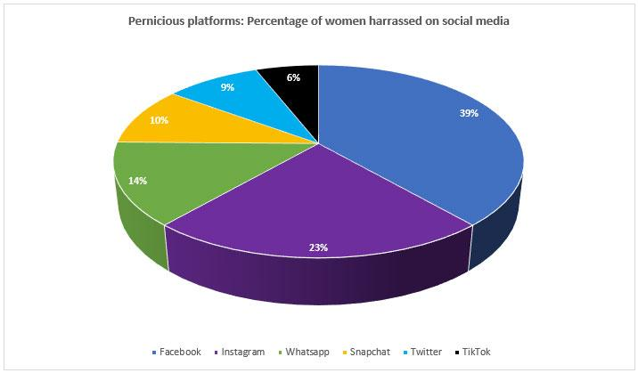
Source B: This image above is a pie chart presenting the percentage of women harassed across different social media platforms. It shows that platforms such as Facebook and Instagram account for the highest proportions of reported harassment followed by other platforms like what's up, snapchat, twitter, and tiktok. this is significant because it highlights how digital gender-based violence is with spread across major online platforms demonstration of the issue is not limited to a single space but is a global concern within the digital environment

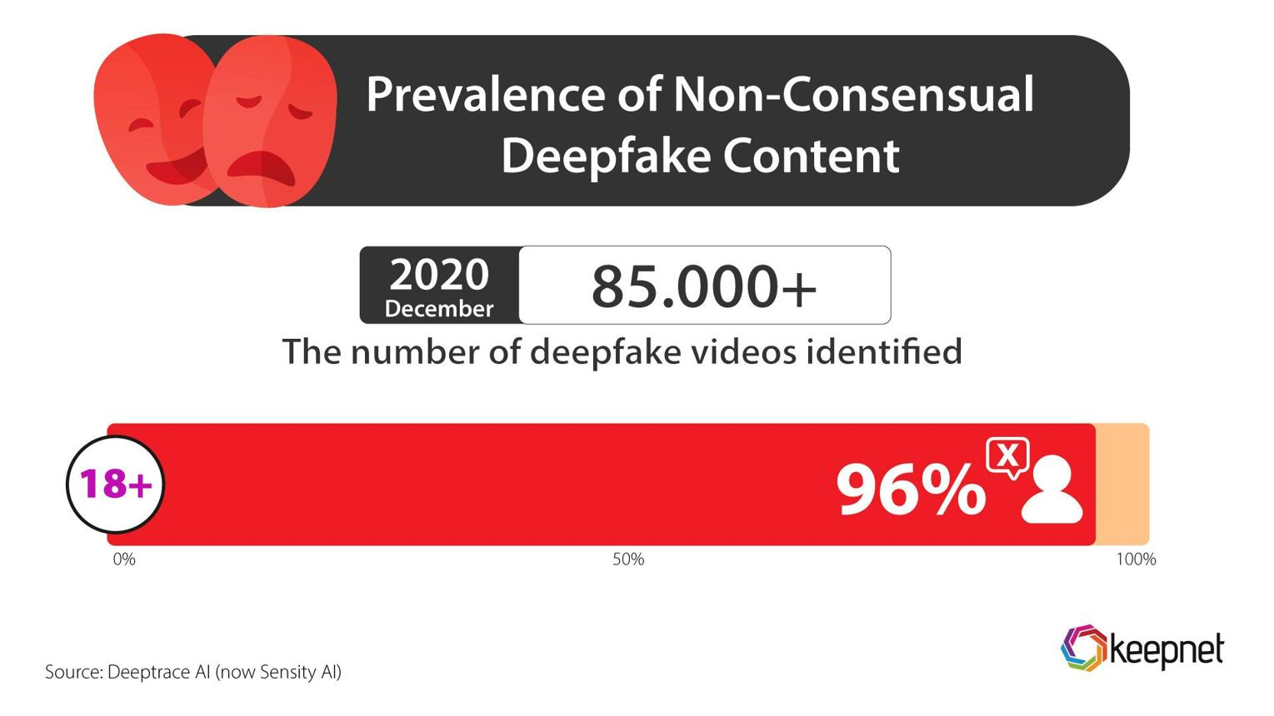
Source C: This image of both is an infographic data on the prevalence of non-consensual detailed content online. It shows that over 85,000 fake videos have been identified by 2020, with approximately 96% of the content being non-consensual and primarily targeting women. This is significant because it highlights how emerging technologies, such as artificial intelligence, or being widely misused to exploit and harm women.

Bibliography

United Nations. “Convention on the Elimination of All Forms of Discrimination against Women.” United Nations Human Rights Office of the High Commissioner, 18 Dec. 1979, Convention on the Elimintion of All Forms of Discrmination against Women. Accessed 24 Mar.2026.

United Nations. “Declaration on the Elimination of Violence against Women.” United Nations Human Rights Office of the High Commissioner, 20 Dec. 1993, Declaration on the Elimination of Violence against Women. Accesed 24 Mar.2026.

United Nations. “Goal 5: Achieve Gender Equality and Empower All Women and Girls.” United Nations Sustainable Development Goals, Sustainable Development Goal 5. Accessed 25 Mar.2026.

United Nations. “Goal 9: Build Resilient Infrastructure, Promote Inclusive and Sustainable Industrialization and Foster Innovation.” United Nations Sustainable Development Goals, Sustainable Development Goal 9.Accessed 25 Mar.2026

United Nations. “Goal 16: Promote Just, Peaceful and Inclusive Societies.” United Nations Sustainable Development Goals, Sustainable Development Goal 16. Accessed 25 Mar.2026.

United Nations Entity for Gender Equality and the Empowerment of Women. “AI-Powered Online Abuse: How AI Is Amplifying Violence against Women and What Can Stop It.” UN Women, 18 Nov. 2025, AI-Powered Online Abuse. Accessed 13 Apr.2026.

United Nations Entity for Gender Equality and the Empowerment of Women. “Digital Abuse, Trolling, Stalking, and Other Forms of Technology-Facilitated Violence against Women.” UN Women, 13 Nov. 2025, Digital Abuse,Trolling,Stalking, and Techonolgy Facilitated Violence. Accsessed 13 Apr.2026.

United Nations Entity for Gender Equality and the Empowerment of Women. “Digital Violence Is Intensifying, Yet Nearly Half of the World’s Women and Girls Lack Legal Protection from Digital Abuse.” UN Women, 18 Nov. 2025, Digital Violence is Intensifying.Accessed 14 Apr.2026

