Tab 2
Forum: Organization of American States (OAS)
Issue #2: Measures to preserve indigenous cultures and rights under the pressure of globalization and development.
Student Officers: Bai Yi Wang
Position: Chair of the Organization of American States

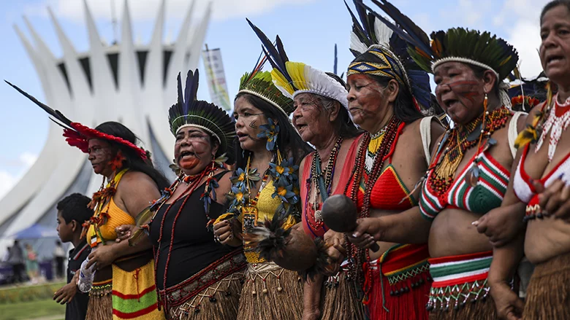
World Bank. “Indigenous Latin America in the Twenty-First Century.” World Bank, 2018, www.worldbank.org/en/region/lac/brief/indigenous-latin-america-in-the-twenty-first-century-brief-report-page.

Introduction
The preservation of human rights is a major goal the United Nations intends to meet, and it is agreed upon by world leaders. However, indigenous rights are often offended and put to trial on the boundary of governance and order. This is because governmental institutions often prioritize development over respecting indigenous groups. Indigenous communities in the OAS continue to face challenges like land wars, discrimination, limited political voice, lack of rights, lack of access to humanitarian needs, threats to their culture, and threats to their home. Their land is also often taken away due to mining, farming, and urban sprawl, like the Amazon rainforests being invaded by local governments for resource extraction. This existing difference in interests is making the relationship between indigenous and local government-controlled parties tense.

Globalization poses a major threat to indigenous cultures and rights because it erodes traditions, languages, and invades indigenous-owned properties for development, often without their permission. The movement across the world causes assimilation to occur as a natural effect and impact, unifying the world while creating plain singularity. Language unification through globalization is one of the specific threats posed; it causes marginalization of minority languages, and as the United Nations human Rights Office of the High Commissioner mentioned, it has caused thousands of minority languages to be threatened because it isn’t spoken and learned by as many locals anymore. The reason for that is that globalization prompted locals to find major languages more useful to learn, and those languages were taken as a learning priority. Delegates should be debating ways to protect indigenous rights, preserve cultural traditions, maintain a balance between different parties, and promote the indigenous voice.

Definition of Key Terms
Assimilation: when indigenous groups adopt the traits of a dominant society, and as a result, they lose their original cultural specialties.

Marginalization: When communities, often minority groups, are pushed to the edge of society, making them powerless and excluded from the mainstream community.

Globalization: When different communities become connected and influenced by each other. It’s usually considered beneficial as it fosters collaboration and trade; however, it’s also commonly linked with environmental disruptions and cultural errosions (United Nations).

Indigenous communities: Communities socially and culturally distinct from the dominant population. Usually coming from a country’s original inhabitants prior to colonization.

Urban Sprawl: Slow and uncontrolled expansion of urban areas characterized by increasing land use area and low land use density. It negatively impacts indigenous communities because it offends indigenous land rights (UN Habitat).

Humanitarian Needs: These are the basic requirements to maintain human life, such as shelter, food, water, healthcare, etc.

Minority Languages: Languages spoken often by indigenous or minority communities, different from the mainstream or official language in the country. Due to globalization, many minority languages are on the verge of extinction.

Major Parties Involved
Ecuador:
Ecuador is highly relevant in this issue because it has a large, legally recognized group of indigenous people in the highlands and in the Amazon rainforests, with their rights protected through laws. Nevertheless, they still experience conflict between the government and indigenous people due to oil (and other resources) extractions in the Amazon rainforests, where a lot of the indigenous lives.

Brazil:
Brazil is highly relevant in this issue due to its large Indigenous population in the Amazon rainforests. Deforestation, agriculture, and mining continue to threaten the country's indigenous lands and lead to both environmental damage and conflicts.

Mexico:
Mexico is relevant in this issue because of its large Indigenous population and the ongoing inequality they face. Many Mexican indigenous communities still face real issues of poverty, discrimination, and exclusion (marginalization), and development projects like mining and infrastructure building (urban sprawl) are often displacing people, and they're not taken care of, putting indigenous lands and cultures at risk.

Guatemala:
Guatemala is relevant in this issue because of its large indigenous population (approximately 43-50% of the total population) and its long history of discrimination against them. There are issues because of ongoing land disputes and limited political representation of the indigenous party, showing how development can deepen existing inequalities and conflicts.

Peru:
Peru is highly relevant in this issue because it has a large indigenous population living in their Andes mountains and Amazon rainforests, shared with other countries with indigenous populations like Ecuador. The government and indigenous communities had conflicts over mining and oil extractions, which often offended their rights.

United States:
The United States is highly relevant to this issue because it's a developed country where indigenous rights are at risk. Although there are multiple institutions for indigenous rights protection, like the Indian Law Resource Center, the country's move back to using "Beautiful Clean Coal" highlights the threat of offending land and indigenous rights for the country's development. This trend was seen in history, too, where 12,000 Navajo people were displaced due to the mining on Black Mesa.

General Overview
Globalization and indigenous cultures
Globalization fosters the trade of ideas and therefore shortens physical distances between nations. Nevertheless, as globalization fosters the exchange of rare merchandise, innovative inventions, trained professionals, beverages, and economy, the exchange of culture and language is also occurring. Many indigenous communities move around the world through interactions, and although it brings major conveniences to their lives, it’s also threatening the identity of their mother community. Human nature directs the indigenous migrants to learn local traditions, languages, and cultures to blend in with the new society. They must adapt in order to live in the area, work with the locals, learn in schools, and interact with others. In some cases, forced assimilation occurred, where indigenous communities were forced to adapt to the dominant society through socioeconomic pressures; one example is the case that occurred in Canada, where a local residential school intended to erase indigenous identities from the young students in order to make them settle in the society. The Chief Justice of the Canadian Supreme Court even ruled this as a form of genocide (UNESCO). It is important to note that, given the above, the United Nations did further promote the United Nations Declaration on the Rights of Indigenous Peoples to prevent such situations from recurring (United Nations, “United Nations Declaration on the Rights of Indigenous Peoples”). Within the declaration, Article 8 specifically mentions that “Indigenous peoples and individuals have the right not to be subjected to forced assimilation or destruction of their culture”. Regardless, intentional assimilation still occurs in the indigenous communities, and it is seen as voluntary integration (International Human Rights Association of American Minorities). These people intentionally adapt to the dominant society’s culture, not only the country one migrates to, but also to the dominant communities in their country of origin, to facilitate their daily lives. An unintended result, coerced or not, is often the loss of indigenous cultures. Sometimes, minority rights are also undermined as a result of favoring local governments intentionally.

Development and Indigenous Rights
Development is also an unavoidable step in human society: it is a natural occurrence that has happened since humans began existing on the planet. Although human development has brought many facilities to dominant communities, it is usually at a cost of risking indigenous rights. To address it, the UN proposed many principles and regulations, such as the most famous Free, Prior, and Informed Consent (FPIC), which states that no developmental or any other projects may be occurring without the agreement of the impacted community, often the indigenous minorities (United Nations, “Free Prior and Informed Consent – an Indigenous Peoples’ Right and a Good Practice for Local Communities – FAOUnited Nations for Indigenous Peoples | United Nations for Indigenous Peoples”). This agreement applies to institutional, private, governmental, and all other associations. Although it was agreed upon or supported by many nations, such as Bolivia, Brazil, Canada, Mexico, Peru, and the United States, etc., it lacks consistency and implementation. When development contradicts indigenous groups, marginalization occurs because some government associations choose to ignore indigenous rights in order to maintain their power and their stance in the global economy. Current development projects, mainly energy-related, consistently affect indigenous rights, especially land rights. As the United Nations Permanent Forum on Indigenous Issues clarified, “Development paradigms of modernization and industrialization have often resulted in the destruction of indigenous peoples’ political, economic, social, cultural, education, health, spiritual and knowledge systems as well as extraction of their natural resources”.

Timeline of Events, Relevant Resolutions, Treaties, and Events
Date | Description of Event
1948 | The Organization of American States (OAS) was formed as an international organization to address issues and foster collaboration among American states.
1948 | The United Nations published and adopted the Universal Declaration of Human Rights, establishing limits and protecting people from across national boundaries (United Nations, “Universal Declaration of Human Rights”).
1957 | The first international agreement addressing indigenous and tribal people was adopted by the International Labor Organization (ILO) as Convention No. 107 (International Labour Organization).
1980’s | The ILO’s Convention No. 169 replaced its Convention No. 107 because it was seen as disrespectful to indigenous communities, as it stated that they should be integrated and assimilated into the dominant society (International Labour Organization).
1989 | The OAS officially requested that the Inter-American Commission on Human Rights (IACHR) draft a legal instrument to protect indigenous rights (United Nations Dag Hammarskjöld Library).
1997 | The OAS produced its first draft of a declaration on indigenous rights.
2000 | The UN’s ECOSOC established the United Nations Permanent Forum on Indigenous Issues (UNPFII) to provide funds to solve issues and improve different aspects regarding indigenous communities (United Nations Economic and Social Council).
2001 | A historical conflict, Awas Tingni v. Nicaragua, happened and was considered a foundational model for promoting indigenous land rights globally (United Nations Human Rights Office of the High Commissioner).
2007 | The UN adopted its UN Declaration on the Rights of Indigenous Peoples (UNDRIP), which established the principle of Free, Prior, and Informed Consent (FPIC) for all actions taken affecting indigenous rights, especially for the purpose of development (United Nations, “United Nations Declaration on the Rights of Indigenous Peoples”).
2016 | The OAS finally adopts the American Declaration on the Rights of Indigenous Peoples after two decades of proposing it and working on it (Organization of American States).
2018 | The UN adopted the regional Escazú Agreement in Costa Rica, allowing communities to mandate access to information, participation and justice in environmental matters. This gives indigenous communities the legal measures to fight back, maintaining a power balance with the government (United Nations Treaty Collection).
2026 | United Nations Permanent Forum on Indigenous Issues (UNPFII)'s 25th session discussing the theme: "Ensuring Indigenous Peoples’ health, including in the context of conflict" (United Nations Dag Hammarskjöld Library)

United Nations Involvement
UN Declaration on the Rights of Indigenous Peoples, 2007:
The United Nations’ Declaration on the Rights of Indigenous Peoples (UNDRIP) established the minimum living standards for indigenous peoples. It is a UN General Assembly solution, indicating that it’s non-binding; however, it has profound impacts on the formation of international law. This declaration is the safeguard against globalization, clarifying that all indigenous peoples can determine, maintain, and spread their individual characteristics, cultures, beliefs, and pursuits. It also included the Free, Prior, and Informed Consent (FPIC) law, preventing states from extracting excessive resources from the community without approval.

International Labor Organization Convention No. 169, 1980:
The International Labor Organization (ILO) Convention No. 169 was written on top of the Convention No. 107 because it was found offensive to indigenous communities, stating that indigenous peoples should be integrated and assimilated into the dominant society, fostering globalization (International Labour Organization). The UN acknowledged the threats that Convention No. 107 posed; therefore, it was replaced with Convention No. 169. This convention strictly rejects forced assimilation, mandating that all nations respect indigenous communities. Additionally, it also enforces protection on globalization. It mandates that even if the nation is extracting an underground resource of its ownership, it must consult indigenous communities prior to the extraction. This convention also guarantees that the communities shall share all economic benefits from the extraction and the environmental damages caused, impacting the communities, shall also be compensated for. This is a vital and fundamental convention relating indigenous rights to globalization and development.

American Declaration on the Rights of Indigenous Peoples, 2016:
The American Declaration on the Rights of Indigenous People states was adopted by the Organization of American States (OAS). It was prepared by the Inter-American Court of Human Rights “in regard to the human rights of indigenous peoples”. This declaration’s beliefs are highly similar to the UNDRIP, but the range of implementation and the cultural specifications for indigenous communities in the Americas mark. Nevertheless, this declaration was still adopted as its focus is to close differences among local and regional government laws and international human rights laws.

Evaluation of Previous Attempts to Resolve the Issue
International Legal Frameworks
Previously, many United Nations committees intended to support indigenous rights and preserve their culture, and it was mainly done through imposing legal frameworks and constrains to local governments, such as the United Nations Declaration on the Rights of Indigenous Peoples (UNDRIP) and the International Labour Organization (ILO)’s Conventions. These addressed culture loss and events where indigenous rights were offended, and land rights were often the case. These frameworks provided a moderately complete measure to preserve indigenous cultures and rights under the pressure of globalization and development. The international legal frameworks provided indigenous communities with the tools to defend themselves, giving them the power to fight for their culture and rights. However, these weren’t as efficient in certain regions due to many of their non-binding characteristics, and the government's preference for development (United Nations Human Rights Office of the High Commissioner, “INDIGENOUS LANDS SEVERELY DAMAGED by DEVELOPMENT, MINING, TOURISM, PERMANENT FORUM TOLD, as DEBATE BEGINS on ENVIRONMENT”).

Economic Funding
The United Nations currently intends to protect indigenous groups from development, overexploitation, and globalization using Economic support, one of which is the World Heritage Fund. The World Heritage Fund was created with its primary task to educate and protect endangered Heritage sites. As of 2026-2027, there are 7.3 million dollars directed for the cause. It protects endangered heritage sites best from natural causes or small-scale threats; nevertheless, it doesn’t protect indigenous communities as properly as the issue suggests because this system can’t bypass local government systems that prioritize the nation’s development. The Tenure Facility is another example of Economic Funding created to address the issue. Compared to the World Heritage Fund, it more closely addresses indigenous land rights under the pressures of development and globalization. Interestingly, the website highlighted that the indigenous communities manage more than half of the world’s land but own only around 10% of their ancestral lands. Maybe due to that specific reason, the Tenure Facility works to reduce land conflicts, advises on human rights, promote sustainable development through working with indigenous peoples and local communities. Their funds are also given directly to the indigenous peoples, which better advocates for them.

Possible Solutions
Reinforcing Existing Measures
Many of the United Nations’ different committees have addressed similar issues previously and set regulations to prevent them from recurring. Overall, indigenous cultures and rights under the pressure of globalization and development are moderately well addressed. However, there are other factors in play, such as the lack of enforcement of the policies. Government involvement levels vary among different nations. This causes the enforcement, protection, and preservation statuses to vary across countries, which is a concern, as not all stakeholders are considered and addressed. Solutions to this issue could involve fostering collaboration among different committees, governmental associations, and indigenous leaders, and ensuring absolute transparency in all actions taken, as required by existing measures.

Supporting the Spread of Indigenous Cultures
Apart from ensuring the implementation of existing measures, the committee could also form new measures to support the spread of indigenous cultures, allowing indigenous cultures to be taught and learned by outside communities. The United Nations could also seek support from nongovernmental institutions, too, as they are often highly involved in issues of interest. This ensures that minority cultures thrive instead of disappearing. It would be beneficial to the process to offer support systems in indigenous languages, building facilities for indigenous communities, etcetera. Such measures address cultural extinction threats, indigenous rights, development, and globalization while giving indigenous communities the ability to negotiate with local government organizations to benefit their communities, too. This, in comparison to previous attempts, addresses both the preservation of indigenous cultures and the promotion of indigenous rights. To promote the distribution of minority cultures, certain benefits could be given by the government.

Sustainable Development Goals (SDGs)
SDG 10, Reduced Inequalities
Implementing measures to preserve indigenous cultures and rights under the pressure of globalization and development is related to Sustainable Development Goal (SDG) #10 of “Reduced Inequalities” because it is about fighting the influence of the dominant society on indigenous cultures to also thrive (United Nations, “Department of Economic and Social Affairs. Sustainable Development”). The issue discusses human rights in general and, through the process, inevitably highlights how past resolutions intended to maintain a power balance between different cultural groups and other existing associations, which ensures that all voices are heard; the issue also discusses whether indigenous communities have the opportunity to maintain their own traditions; therefore, preserving indigenous cultures and rights falls under SDG 10, aiming to reduce inequalities (United Nations, “Department of Economic and Social Affairs. Sustainable Development”).

SDG 17, Partnerships for the Goals
Addressing any related topic to indigenous cultures and rights automatically fosters a connection to Sustainable Development Goal (SDG) #17 of “Partnerships for the Goals” (United Nations, “Department of Economic and Social Affairs. Sustainable Development”). This is because supporting indigenous communities involves collaboration among different government agencies, international communities, and indigenous communities themselves to understand the necessary guidelines implemented and to promote the standards among their social groups. To reach a common goal successfully and effectively, and to ensure that local organizations follow the agreed guidelines, SDG 17 is relevant, because it’s the SDG involving communication and cooperation (United Nations, “Department of Economic and Social Affairs. Sustainable Development”).

Appendix
This section of the issue bulletin is dedicated to providing delegates with valuable sources to utilize during their research.
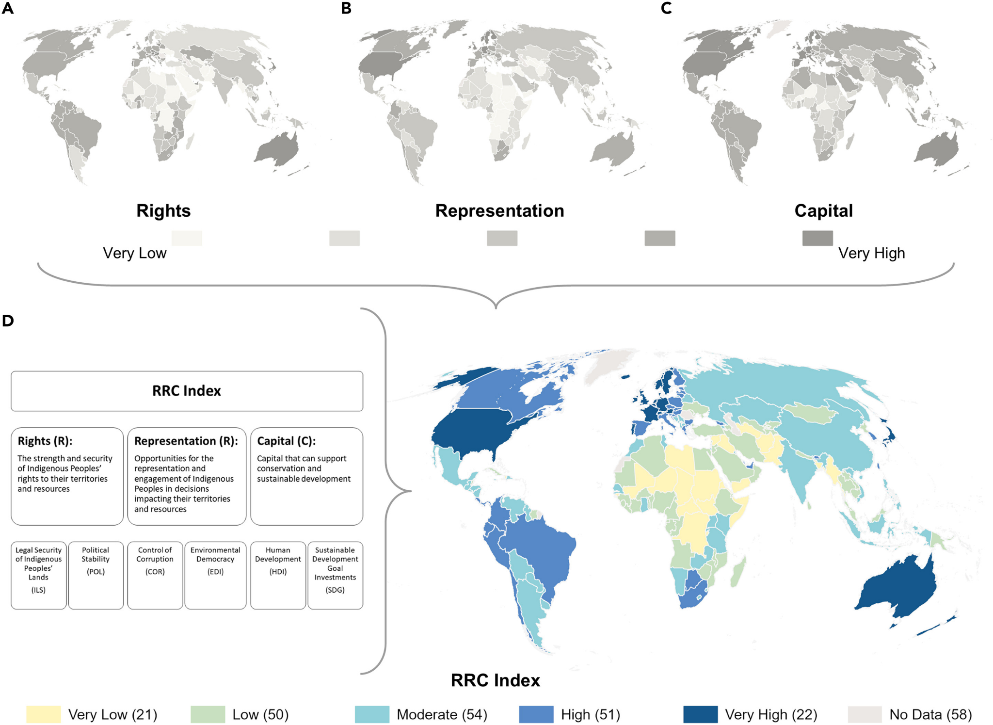
Source A: The image above shows the RRC Index rates among different countries in the world, including the Americas’ nations. The RRC index indicates three different categories of assessments combined: rights, the level of human rights present in the indigenous community; representation, the voice and autonomy indigenous peoples have; and capital, the funding indigenous peoples. In the map, a lower RRC indicates a more vulnerable indigenous community (Kennedy et al.).

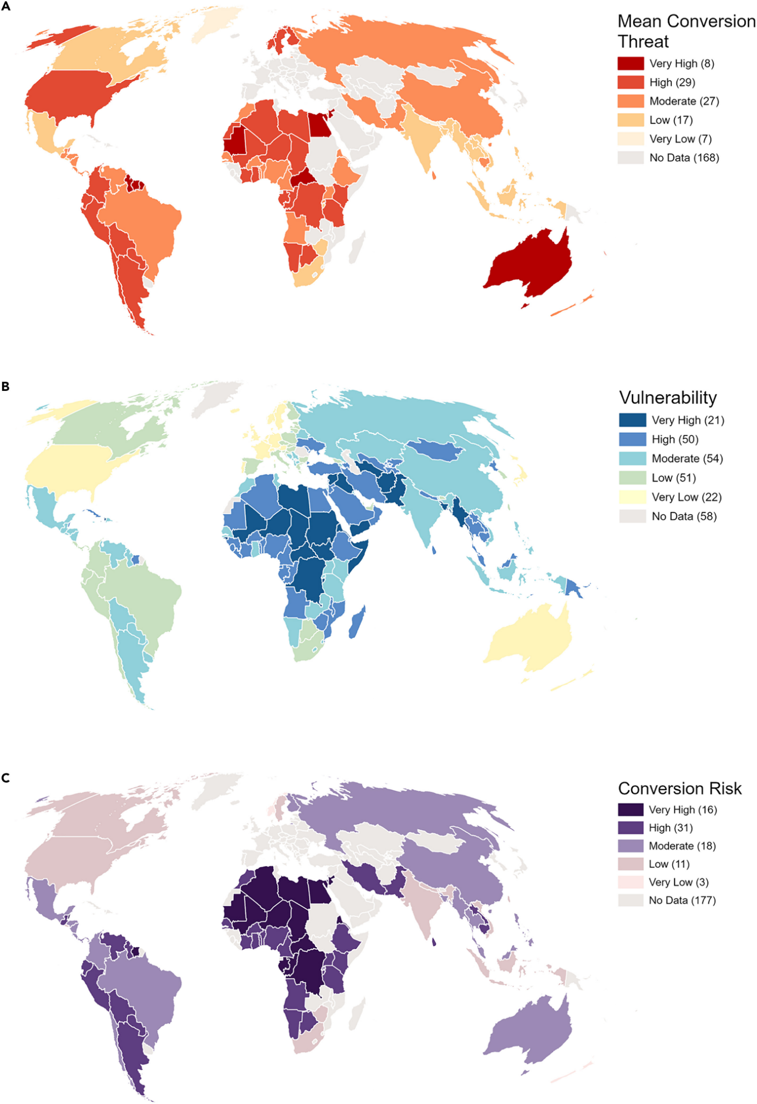
Source B: These three images display the mean conversion threat, vulnerability, and conversion risk of indigenous communities. These three indices indicate different meanings. Mean conversion threat indicates the physical risk indigenous lands and peoples face under globalization and development; the vulnerability index is supplementary to the RRC Index in Source A—a higher vulnerability index means that the community is more vulnerable; conversion risk indicates a combination of the previous two indices. The indigenous community is at risk if there is a high level of resource exploitation (Map A) and high vulnerability (Map B) because they are victims and they don’t have the power to defend themselves, which indicates high conversion risk (Map 3)(Kennedy et al.).

Bibliography
International Human Right Association of American Minorities. “WORLD CONFERENCE against RACISM, RACIAL DISCRIMINATION, XENOPHOBIA and RELATED INTOLERANCE.” United Nations Digital Library System, 17 Feb. 2001, digitallibrary.un.org/record/440732/files/A_CONF.189_PC.2_NGO_5-EN. Accessed 10 May 2026.
International Labour Organization. “Convention 169 and International Day of the World’s Indigenous People | International Labour Organization.” Www.ilo.org, 7 May 2012, www.ilo.org/resource/convention-169-and-international-day-worlds-indigenous-people.
Kennedy, Christina M., et al. “Indigenous Peoples’ Lands Are Threatened by Industrial Development; Conversion Risk Assessment Reveals Need to Support Indigenous Stewardship.” One Earth, vol. 6, no. 8, Elsevier BV, Aug. 2023, https://doi.org/10.1016/j.oneear.2023.07.006.
Organization of American States. “:: Indigenous Peoples > Department of International Law > OAS :”: Oas.org, 2021, www.oas.org/dil/indigenous_peoples_preparing_draft_american_declaration.htm. Accessed 18 May 2026.
Tenure Facility. “Tenure Facility Fund.” Tenure Facility, thetenurefacility.org/tenure-facility-fund/. Accessed 24 May 2026.
UN Habitat. “Urban Lingo: A UN-Habitat Dictionary | UN-Habitat.” Unhabitat.org, unhabitat.org/urban-lingo-a-un-habitat-dictionary.
UNESCO. “The Children Speak: Forced Assimilation of Indigenous Children through Canadian Residential Schools.” Unesco.org, 2023, www.unesco.org/en/memory-world/children-speak-forced-assimilation-indigenous-children-through-canadian-residential-schools.
UNESCO World Heritage Convention. “World Heritage Fund.” UNESCO World Heritage Centre, whc.unesco.org/en/world-heritage-fund/.
United Nations. “Department of Economic and Social Affairs. Sustainable Development.” Sdgs.un.org, 2020, sdgs.un.org/#goal_section.
---. “Free Prior and Informed Consent – an Indigenous Peoples’ Right and a Good Practice for Local Communities – FAOUnited Nations for Indigenous Peoples | United Nations for Indigenous Peoples.” Department of Economic and Social Affairs Indigenous Peoples Www.un.org, 14 Oct. 2016, www.un.org/development/desa/indigenouspeoples/publications/2016/10/free-prior-and-informed-consent-an-indigenous-peoples-right-and-a-good-practice-for-local-communities-fao/.
---. “Globalization WPAY | United Nations for Youth.” United Nations Youth, 8 June 2015, www.un.org/development/desa/youth/globalization-wpay.html.
---. “United Nations Declaration on the Rights of Indigenous Peoples.” United Nations Declaration on the Rights of Indigenous Peoples, United Nations, Sept. 2007, https://doi.org/10.1353/hrq.2011.0040.
---. “Universal Declaration of Human Rights.” United Nations, 10 Dec. 1948, www.un.org/sites/un2.un.org/files/2021/03/udhr.pdf.
United Nations Dag Hammarskjöld Library. “Research Guides: Indigenous Issues: Quick Guide.” Un.org, 2025, research.un.org/en/indigenous.
United Nations Economic and Social Council. Economic and Social Council Establishment of a Permanent Forum on Indigenous Issues Economic and Social Council Resolution 2000/22. 2000, www.un.org/esa/socdev/unpfii/documents/about-us/E-RES-2000-22.pdf. Accessed 18 May 2026.
United Nations Human Rights Office of the High Commissioner. “INDIGENOUS LANDS SEVERELY DAMAGED by DEVELOPMENT, MINING, TOURISM, PERMANENT FORUM TOLD, as DEBATE BEGINS on ENVIRONMENT.” OHCHR, 15 May 2003, www.ohchr.org/en/press-releases/2009/10/indigenous-lands-severely-damaged-development-mining-tourism-permanent-forum.
---. “UN Expert Praises Nicaragua for Formally Confirming Land Ownership for Indigenous Group.” OHCHR, 2026, www.ohchr.org/en/press-releases/2009/10/un-expert-praises-nicaragua-formally-confirming-land-ownership-indigenous. Accessed 18 May 2026.
United Nations Permanent Forum on Indigenous Issues. Indigenous Peoples: Development with Culture and Identity Articles 3 and 32 of the UN Declaration on the Rights of Indigenous Peoples. www.un.org/esa/socdev/unpfii/documents/Development%20with%20Culture%20and%20Identity.pdf.
United Nations Treaty Collection. “18. REGIONAL AGREEMENT on ACCESS to INFORMATION, PUBLIC PARTICIPATION and JUSTICE in ENVIRONMENTAL MATTERS in LATIN AMERICA and the CARIBBEAN.” Treaties.un.org, 18 May 2026, treaties.un.org/Pages/ViewDetails.aspx?src=TREATY&mtdsg_no=XXVII-18&chapter=27&clang=_en. Accessed 18 May 2026.

Issue Bulletin Checklist
Issue Bulletin Formatting Checklist PANAMUN XXXIV
Make a copy of this document and scratch out the points as you go. Once you’re done, check with a DSG. Make sure you complete all the checklists BEFORE showing the Issue Bulletin to a DSG and submitting it in the Google Drive Folder titled “Final Issue Bulletins.”

All of this should be completed by the end of the meeting.

General settings:

- Insert a line after the header
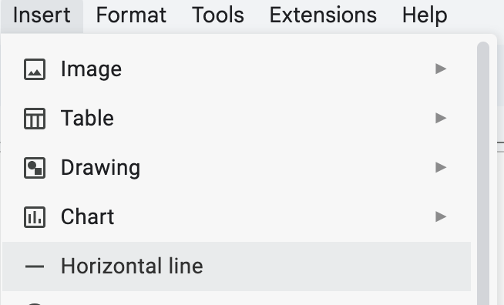
- Font size: 11
- Font: Century Gothic
- Paragraphs: no indentations
- Align & Indent: “justified” setting in Google Docs
- The header (right top corner of the document) should say 2026 and XXXIV Annual Session. The year is the only thing in blue.
- 2 spaces between sections, one between paragraphs
- SPACING 1.5
- Custom 0 to 0

Example: https://docs.google.com/document/d/1cG4pJwtqyRCb_0y9_TiB1ns8zwjeftAZmcSAS9PTixA/edit?tab=t.0#heading=h.gjdgxs

Content in the Issue Bulletin

- Headers of the IB

- These headers should be the only ones in blue → make sure they are written exactly as they are here

High & Middle School Committees (Including Historical Security Council)

Introduction
Definition of Key Terms
General Overview
Major Parties Involved and Their Views
Timeline of Events, Relevant Resolutions, Treaties, and Events
United Nations Involvement
Evaluation of Previous Attempts to Resolve the Issue
Possible Solutions
Sustainable Development Goal (SDG)
Appendix
Bibliography

International Court of Justice
Introduction
Case In Context
Authority of the Court
Questions a judgement should ask
Side A (Prosecution)
Side B (Defense)
Bibliography

Fédération Internationale de Football Association (FIFA)
Introduction
Definition of Key Terms
General Overview
Major Parties Involved
Timeline of Events
Evaluation of Previous Attempts to Resolve the Issue
Possible Solutions
Sustainable Development Goals (SDGs)
Appendix
Bibliography

- Sub-headings

- All subheadings go in black and capitalized

Example:
The Main Idea
Regulatory Challenges and Diversion of Drugs
Role of Healthcare Professionals

Initial Headers
- Forum = committee
- Use the correct issue #
- Student Officers → in alphabetical order by last name
(If you are a foreign Chair pairing, your name goes in the IB you wrote)
- Position: “Chair”, NOT “Chairs”

Should look like this:

Forum: The World Health Organization (WHO)
Issue #1: Addressing the consequences of access to controlled drugs for medical purposes
Student Officers: Isabella Ostojich and Valentina Zaobornyj
Position: Chair of the World Health Organization
CHAIR 1 CHAIR 2
- Introduction
- Brief history
- What is the problem/issue about?
- Why is this issue controversial?
- Importance of solving issue

- General Overview
- Balance of general and detailed
- Summary of issue
- Important information delegates need to know

- Key Terms

- Key Term is bolded
- The term and definition are separated by a colon:
- Both the key term and the definition are capitalized

Should look like this:
Addiction: The condition of being dependent on a particular substance. Drug addiction is a relapsing disorder distinguished by irresistible drug seeking and use, regardless of the consequences it may lead to (National Institute on Drug Abuse).

- Major Parties
- Should include all major parties involved
- Includes how the parties has been affected or have contributed
- Should be around 3-6 major parties

- Timeline of Events

- Should be in the format of a table
- To make the lining disappear: select the outline and change the color of the outline to white
- Include only year for date, and include month in the description

- United Nations Involvement

- All treaties need their own heading (black and bolded) and then their explanation

Example:
Single Convention on Narcotic Drugs, 1961
The Single Convention on Narcotic Drugs was the first international treaty…………

Convention on Psychotropic Substances, 1971
10 years later, the Convention on Psychotropic Substances of 1971 was held………….

- Evaluation of Previous Attempts to Resolve the Issue

- All “evaluations of previous attempts to resolve the issue” need their heading (black and bolded) and then their explanation

Example:
Single Convention on Narcotic Drugs
The Single Convention on Narcotic Drugs, adopted by the UN in 1961, proclaimed that “narcotic drugs… are indispensable for the relief………..

World Health Organization’s Multiple Attempts
The World Health Organization (WHO) has made many attempts to resolve the issue, particularly with the intent of increasing patients’ access to……..

- Possible Solutions

- All ‘possible solutions’ need their heading (black and bolded) and then their explanation

Example:
Aligning Regulations Among Countries
Continuously, each country has stipulated diverse rules with respect to access to controlled drugs for medical purposes…….

- Sustainable Development Goal (SDG)
- All ‘Sustainable Development Goal’ need their heading (black and bolded) and then their explanation

If you truly feel like you can add a second SDG, then do so. But ONLY if you can meaningfully connect the SDG with the committee and issues.

SDG 3, Good Health and Well-Being
Sustainable Development Goal #3, Good Health and Well-Being, aims to promote quality, attainable healthcare for people of all……….

- Appendix

- Add Short intro/description to appendix, how delegates may use it. 3-5 sentences.
- Insert link or image of the source
- Label ‘Source A:’
- Write a short description of the source

Example:

Appendix
Short intro/description to the appendix, on how delegates may use it. 3-5 sentences.

Insert link or image of Source A
Source A: Short description of source

Insert link or image of the Source B
Source B: Short description of source

- Bibliography

Call a DSG to check the format
- DSG Approved

