Forum: Disarmament International Security Council (DISEC)
Issue #1: Addressing the legality and ethical implications of fully autonomous weapons in modern warfare.
Student Officers: Sofia Magana and Eva Valencia
Position: Chair of the Disarmament International Security Council

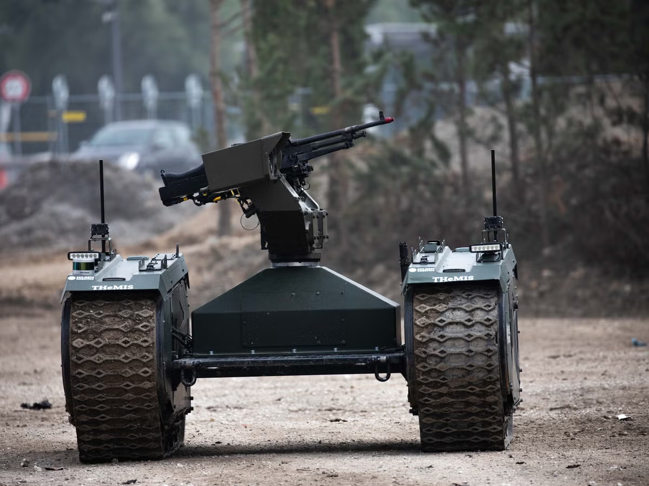
Hambling, David. “Why the U.S. Is Backing Killer Robots.” Popular Mechanics, Popular Mechanics, 14 Sept. 2018, www.popularmechanics.com/military/research/a23133118/us-ai-robots-warfare/.

Introduction
Fully autonomous weapons, systems that can select and engage with targets without human intervention, sit at the crossroads of international law, ethics, and emerging technologies. Most states and human rights bodies have not banned them outright. yet. However, there is an intense debate over whether they can ever comply with the laws of war and about the moral costs they entail.

Legally, the key challenge is accountability: if an autonomous system violates the laws of war, it is unclear who should be held responsible, developers, commanders, or operators, because the machine’s behavior may be opaque or unpredictable. This “accountability gap” has led human rights organizations and legal scholars to warn that current legal frameworks are ill‑equipped to handle learning, adaptive systems on the battlefield. At the same time, over 120 countries have called for a binding treaty on autonomous weapons, and the UN Secretary‑General has urged a global ban on fully autonomous systems. Yet, no comprehensive treaty has entered into force. Ethically, the debate centers on whether delegating life‑and‑death decisions to machines undermines human dignity and moral responsibility. Autonomous systems lack consciousness, emotions, and context‑sensitive judgment, so they cannot truly understand mercy, proportionality, or the moral weight of killing. Critics argue that allowing machines to decide whom to target risks treating human life as a mere tactical variable, eroding the principle that killing in war must remain a grave human act. Others, however, insist that well‑designed autonomous or semi‑autonomous systems could reduce civilian casualties by enabling faster, more precise targeting and filtering out emotional or biased decisions.

The debate over fully autonomous weapons is not merely limited to a discussion about technology but also the future of governance, ethics, and accountability in armed conflict. As militaries around the world invest in AI‑driven systems, policymakers, legal experts, and civil society are grappling with a central question: how much autonomy is too much when the stakes are human lives, and what rules and institutions are needed to ensure that warfare remains both lawful and morally defensible?

Definition of Key Terms
Autonomy: The act of functioning without external control and having complete control over any action when it comes to systems, technologies, organizations, or entities. In the context of technology and weapon systems, it refers to a machine's ability to detect its surroundings and make decisions based on those observations.

Target Selection: The ability to select and engage with moving or stationary objectives, entities, or segments with the intention of maximizing damage with accuracy. In the context of autonomous weapons, this involves analyzing data from sensors and algorithms to identify potential targets and engage with them.

International Humanitarian Law: A set of rules founded to regulate the effects of armed conflicts while protecting civilians who are not actively participating in the war (civilians, medics, etc.) and those who were wounded in the conflict.

Accountability: An individual's moral obligation to own up to actions, inaction, and decisions in modern warfare to maintain adherence to ethical, operational, and legal standards.

War Crimes: Any violations of humanitarian international laws in warfare, more specifically the Geneva Convention laws, differing depending on whether the laws are regulated internationally or nationally. Crimes include intentionally targeting innocent civilians, inhumane containment of prisoners, and any form of torture. Rule breaching is considered a serious offense and can lead to prosecutions.

Ban/preemptive ban: The action to prevent the development of something before it has the chance to spread widely or materialize; it is a strategic intervention to intercept chaos before it has the opportunity to cause damage.

Arms Race: A competition between two or more countries to develop their military capacity to their maximum potential. The term is primarily used to describe the growth or spread of specific military entities. This cycle of mutual escalation can lead to increased global tension and instability.

Algorithms: In autonomous weapons specifically, algorithms are the coding behind any autonomous weapon's capability to engage and destroy targets. Algorithms are the “brain” of the systems that allow them to interact with objectives with no human intervention.
Deterrence: The action of pressuring a country to avoid certain events or actions by using fear or threats to discourage them and outline the consequences of said action. In a military context, this occurs when a country weighs out the negatives in decision-making and acts accordingly to what is best for the nation.

General Overview
The Main Idea
Lethal Autonomous Weapons (LAWS) are technologies that can select and strike targets without human operators. Technological advancements have increased the realism of these systems, making their presence in modern warfare a subject of concern. Some nations believe that fully autonomous weapons are justified, as they enhance efficiency and reduce danger to military soldiers. A multitude of countries believe that the use of these systems is immoral and dangerous, as they claim “machines” should not have the capability of deciding whether or not to take life.
There are many reasons as to why there is such an enormous divide between countries regarding LAWS, particularly due to varying priorities between nations. Countries on the higher end of the development scale appear to prioritize their use and progress of autonomous weapons to conserve their overall security and strategic interests. Nevertheless, nations located at the lower end of this scale hold the greatest concern about the morality involved in providing the decision-making capacity to machines regarding the potential use of LAWS to target and dispatch civilians. Moreover, the nations that are concerned about the moral aspect of developing autonomous weapons happen to be preoccupied with reference to other countries' capacity to moderate the emerging technologies faster than the government can establish guidelines and regulations.

Legal challenges and international humanitarian law (IHL)
A primary concern for LAWS is what is known as International Humanitarian Law (IHL) compliance. IHL differentiates between combatants and non-combatants and regulates the acceptable use of force in warfare (IHL databases 2018). Autonomous systems will use AI technology to exercise judgment and decision-making. IHL compliance is predicated on having the ability to make reasoned, contextually derived judgments; however, the IHL and LAWS are unlikely to integrate, as AI doesn't have real reasoning capabilities. Therefore, the number of unlawful attacks and the number of civilian casualties will continue to rise.

Law's accountability has been known to be obscure; consequently, if autonomous weapons are eventually lethal, who is to blame for the failure of the system? Is it the person who programmed it, the military officer who dispatched the device, or the state for authorizing it? International law has no clear delineation or distribution of liability in this instance. The UN has had some discussions on LAWS, but to date, there are no international laws addressing the issue.

Technological capabilities and limitations
In addition to legal and technical aspects, LAWS present significant ethical concerns. One of the main challenges is whether it is justifiable for machines to make decisions involving human life. Critics argue that the use of lethal autonomous weapons separates responsibility from direct human decision-making and contributes to the dehumanization of conflict (FSI Stanford, 2025). As a result, the concept of “meaningful human control” has become central to this debate, referring to the need for human involvement in critical, life-threatening decisions. However, there is still no clear international consensus on what level of human involvement is sufficient.

Some countries argue that LAWS have the potential to make modern warfare more efficient and could significantly reduce the rate of mortality in innocent, nonparticipating civilians. On the contrary, other countries believe that delegating life and death decisions to nonliving subjects crosses an ethical border that should remain uncrossed, therefore causing controversy and the inability to set clear boundaries as to how far the development of LAWS should go.

Ethical concerns and human responsibility
The development of lethal autonomous weapon systems (LAWS) has led to heated controversy (IHL). Regarding their potential to comply with International Humanitarian Law (IHL), there is a particular concern addressing operational systems and their potential to entail unlawful harm and the issues of distinction and proportionality, given the probable lack of contextual judgment needed in identifying with precision the status of individuals and their role in a given situation, whether it's a civilian or a combatant. According to The Forge (reference 2021), the limits imposed by current technologies may not be permanent. There may be reasonable grounds to argue that greater technological sophistication may lead to the development of autonomous weapons that can perform given tasks more reliably than human soldiers, who could likely be affected by fear, fatigue, and bias.

The question of responsibility and accountability regarding LAWS is highly contentious. According to (tandfonline, 2025), delegating life and death machines is likely to diminish human accountability and could consequently create a greater threat to human dignity. On the contrary, critics have argued that the threat to human dignity is unfounded, as the potential for responsibility is given as a result of maintaining a degree of human involvement in the conceptualization, design, and operationalization of these systems. The degree of accountability and responsibility LAWS may impose generates a reasonable challenge to the extent to which LAWS may or may not be legalized.

Global risk and arms race
Concerns exist around the development of LAWS regarding the potential drift towards competitive global arms races among nations. As more countries begin to invest in developing and manufacturing lethal autonomous weapons, there is rising pressure within other countries to remain at the same level in terms of competitiveness and national security. Consequently, this issue could lead to the rapid spread of lethal, unregulated military devices.

A rising concern within this subject is the decrease in the conflict threshold. Considering these systems reduce the need for human soldiers, countries may be encouraged to lower barriers to introduce armed conflict, knowing less citizens are at risk of fatality; hence, the frequency of global instability and conflict rises significantly. Moreover, there is also concern that these technologies eventually enter into the possession of non-state actors, such as terrorist groups, inconveniencing them and making them harder to control

Major Parties Involved and Their Views
United States
The U.S. is one of the most advanced developers of AI‑driven and semi‑autonomous weapon systems (such as drone‑like platforms and loitering munitions) and has publicly opposed a global ban on fully autonomous weapons. Instead, it promotes a regulatory approach anchored in its own policy: it requires that any lethal autonomous weapon system allow meaningful human control over the use of force, arguing that existing IHL can be applied to new technologies without a treaty‑style prohibition.

Russia
Russia is investing heavily in autonomous and robotic weapons, and is also among the small group of states that reject a new legally binding treaty on autonomous weapons. Its position emphasizes technological competition and military advantage, framing regulation as a constraint on national security and sovereignty.

China
China is a leading military-technology power and actively develops increasingly autonomous lethal systems, including AI-enabled platforms and drones. It has supported discussions at the UN on lethal autonomous weapons systems (LAWS) and has repeatedly called for human‑centered regulation and the preservation of human control, but it has not joined the camp demanding an outright ban, instead favoring a more cautious, non‑binding framework.

United Kingdom
The UK is a key member of NATO with advanced drone and AI defense programs and is one of the states that opposes a new treaty banning fully autonomous weapons. British officials argue that autonomous systems can be lawful and much more precise than human operators, provided they comply with international humanitarian law and have appropriate human oversight. They emphasize that existing military doctrine and law are sufficient in providing regulation.

Israel
Israel, in its current activity with Gaza and Lebanon, has developed advanced drone and AI‑enabled weapon systems, including loitering munitions and autonomous‑like targeting tools. One of their main points is that autonomous weapons can enhance international humanitarian law rather than pose a threat to it. They claim that autonomous platforms can be more compliant with regulations than human soldiers.

Timeline of Events, Relevant Resolutions, Treaties, and Events
Date Description of Event

2012 | "Losing Humanity" is the first major report from Human Rights Watch,, warning that fully autonomous weapons could breach international humanitarian law and calling for a ban before they are used.
2013 | Christof Heyns, a special rapporteur for the United Nations Human Rights Council, urges nations to cease the production of deadly autonomous weapons because they raise questions about accountability and whether it is ethical for machines to make decisions about killing.
2014 | The Convention on Certain Conventional Weapons begins formal discussions on autonomous weapons, marking the first multilateral legal process addressing their regulation.
2015 | More than 1,000 AI researchers and public figures have signed an open letter calling for a ban on autonomous weapons. They stress the risks to civilian safety and global security norms. (Future of Life Institute)
2016 | The CCW establishes a Group of Governmental Experts (GGE) to study LAWS, focusing on whether existing international humanitarian law (IHL) is sufficient.
2020 | A UN report on the Libya conflict suggests a Turkish-made autonomous drone may have attacked targets without direct human control, raising real-world accountability concerns.
2022 | Experts say that the increased use of AI in conflicts like Ukraine makes matters urgent since autonomous targeting systems are developing faster than legislation. (Reuters)
2023 | UN Secretary-General António Guterres calls for a legally binding instrument regulating or banning autonomous weapons by 2026, framing them as a threat to human rights.
2025 | The Russo-Ukrainian War and the Israel–Hamas War are two examples of conflicts that employ AI-assisted targeting systems on an increasing scale. This raises international attention on how emerging autonomous capabilities fit within existing laws of war (SIPRI).
2026 | In ongoing Middle East operations, militaries continue integrating AI into rapid targeting and strike systems, while negotiations under the United Nations highlight a divide between states pushing for regulation of autonomous weapons and those favoring continued development (Reuters)

United Nations Involvement
Convention on Certain Conventional Weapons (CCW), 1980
The Convention on Certain Conventional Weapons (CCW), established in 1980, can be seen as the key international instrument that the UN employs to discuss innovations and weaponry. The CCW is meant to regulate weapons regarded as unnecessary suffering or indiscriminate weapons (Disarmament, unda). Given that artificial intelligence innovations have sparked debate about the future of warfare, there has been growing discussion of LAWS under the umbrella of the CCW.

The CCW has enabled negotiations among the high contracting parties concerning LAWS to evaluate their legality, ethics, and practicality. The discussion aims at determining whether current humanitarian international laws are sufficient to govern LAWS or whether special regulations are necessary to control them. In this regard, the CCW is considered an effective tool for the exchange of viewpoints and opinions regarding LAWS from different angles. Even so, it should be noted that although there were numerous discussions and negotiations in the context of CCW, no international agreement concerning LAWS was established within that framework (Treaties, UN)

Group of Governmental Experts (GGE) on LAWS
The Group OF Governmental Experts (GGE) on lethal autonomous weapon systems was created within the CCW to enable more specialized and technical discussions on the topic. It brings together representatives from different member states to explore the challenges associated with LAWS in greater depth, particularly in international law, ethical concerns, and technological developments.

The GGE has been instrumental in highlighting major issues such as accountability, adherence to the International Humanitarian Law, and the idea of meaningful human control. Through its ongoing meetings and reports, the group has clarified key concepts and suggested possible ways to regulate LAWS (meetings, UNODA). These efforts have contributed to a more comprehensive global understanding of the issue.

Even so, the GGE has struggled to produce concrete results. Member states continue to disagree on how LAWS should be managed, with some favoring regulation and others resisting limitations. Consequently, while the GGE has advanced discussions, it has not yet achieved binding agreements or coordinated international action.

United Nations General Assembly (UNGA) Discussions
The United Nations General Assembly (UNGA) has become increasingly involved in discussions about lethal autonomous weapon systems, acknowledging their potential effects on global security and international law. Through debates and resolutions, the UNGA has created a space for a broader range of member states to share their perspectives on the development and deployment of LAWS. Resolutions such as 79/62 (United Nations General Assembly, 2024) have drawn attention to ethical concerns, humanitarian risks, and security challenges linked to these systems. The General Assembly has stressed the need for ongoing dialogue and international cooperation, encouraging countries to explore possible regulatory measures.

Despite this growing focus, there is still no shared global stance on LAWS within the UNGA. The wide range of views among member states makes it difficult to reach an agreement, reflecting the challenge of balancing technological progress with ethical and legal responsibilities.

Role of International Organizations and Advocacy Groups
Beyond official United Nations bodies, a range of international organizations and advocacy groups have significantly influenced discussions on lethal autonomous weapon systems. Organizations like the United Nations Institute for Disarmament Research (UNIDIR) support these efforts by conducting research and offering policy guidance to inform government decisions (UNIDIR, 2024)

Non-governmental organizations, including the Campaign to Stop Killer Robots, have also played a key role in raising awareness about the risks associated with LAWS. They push for stronger regulations and, in some cases, a complete ban, highlighting the concerns about ethics, accountability, and the protection of civilians (StopKillerRobots, 2018). While these groups do not have formal decision-making authority, their work has increased global awareness and shaped public debate. By influencing opinions and encouraging international dialogue, they continue to impact how discussions on LAWS evolve.

Evaluation of Previous Attempts to Resolve the Issue
So far, efforts to determine the ethics and legality of fully autonomous weapons (FAWs) have been fragmented, mainly reactive, and limited by different state interests and technological development. They have raised awareness and set norms, but they have not created a clear, binding, or operationally useful framework.

Geneva Convention Article 36
Current international regulatory initiatives, predominantly built around International Humanitarian Law (IHL), have focused on the interpretation of existing frameworks, such as Article 36 of the Geneva Conventions, to cover emerging autonomous technologies. Critics, on the other hand, say that simply adhering to regulations is insufficient because AWS challenges fundamental ideas such as "mens rea" (guilty mind) and the position of human accountability in lethal decision-making.

Proposed New Treaty
Human rights organizations and the International Committee of the Red Cross (ICRC) are calling for a new, legally binding treaty to address autonomous weapon systems (AWS). They argue that existing International Humanitarian Law (IHL) is inadequate, given that it was created for human decision-making as opposed to for machine-learning algorithms. The proposed framework would ban systems that are inherently unpredictable or designed to target humans, require all other autonomous weapons to operate under meaningful human control so that lethal decisions stay human-led, and set a clear, future-proof definition of AWS based on systems that use sensor data instead of direct human input to choose and engage targets.

United Nations General Assembly Resolutions
The United Nations General Assembly's resolutions have helped set global standards for lethal autonomous weapons by navigating past the gridlock in forums like the Convention on Certain Conventional Weapons. For example, a December 2024 resolution with 166 votes in favor reveals significant international support for regulating the technology. This has put more political pressure on states to negotiate a legally binding instrument, which the secretary-general has called for by 2026. At the same Time has expanded the debate beyond technical military issues to focus on basic human rights like the right to life and dignity.

Possible Solutions
Establishing International Guidelines and Frameworks
A potential solution that could help address some of the issues associated with LAWS could be creating an internationally recognized set of guidelines related to their use. At present, there is no comprehensive set of global regulations governing the use of LAWS. Alternatively, each state uses its own guidelines and frameworks based on its interests. Therefore, developing a common set of principles, such as adherence to the rules of international humanitarian law, human oversight in decision-making, etc., may be a step in the right direction. It could be done via an international means, such as the CCW. At the same time, it is crucial to establish flexible guidelines that adapt to technological changes over time. Moreover, the pace of innovation in AI is considerably high nowadays; thus, any fixed regulations will inevitably become outdated in the near future. To avoid such problems, periodic reviews can be conducted during subsequent updates to the relevant international agreements governing LAWS.

Defining and Implementing Meaningful Human Control
Another solution would involve working out an understanding of what the term “meaningful human control” entails. The notion of human involvement is critical in discussions of LAWS’ use. However, no internationally recognized criteria exist that define to what degree and at which points in the decision-making process humans should intervene. Creating an exact definition would allow states to establish acceptable limitations on autonomy within weapons systems without hampering technological progress. Additionally, defining the principal implementation of meaningful human control in LAWS is predominant when discussing the issue, as there can be certain differences from theoretical assumptions. For example, it may be necessary to develop clear protocols that would be followed when designing such systems, deploying them, and conducting the course of operation.

Promoting Transparency and Information Sharing
The issue of increased transparency could be another solution to some of the problems associated with LAWS development. In recent years, many nations have engaged in the rapid development and acquisition of new technologies, which has led to increasing concerns in the international community. By sharing information, including policies regarding LAWS and safeguards in place, states could enhance transparency in the field. Furthermore, this approach can be expanded to include the analysis of the processes of developing LAWS and their use on the international level. This initiative will be helpful in terms of preventing potential issues associated with the lack of information about the capabilities of different nations in this matter, which will reduce the risks of misinterpretation.

Sustainable Development Goal (SDG)
SDG 16, Peace, Justice and Strong Institutions
Sustainable Development Goal (SDG) 16, Peace, Justice, and Strong Institutions, promotes "promote peaceful and inclusive societies for sustainable development, provide access to justice for all, and build effective, accountable, and inclusive institutions at all levels” (UN DESA). Fully autonomous weapons challenge this goal because they raise fundamental questions about accountability for unlawful killings, the ability to comply with international humanitarian law, and the risk of uncontrolled or opaque decision‑making in warfare. Ensuring that machines are not allowed to make life‑and‑death decisions without meaningful human control supports SDG 16’s emphasis on preventing violence, protecting human rights, and upholding transparent, responsible governance in security and military affairs.

Appendix
This section of the issue bulletin is dedicated to providing delegates with valuable sources to utilize during their research.

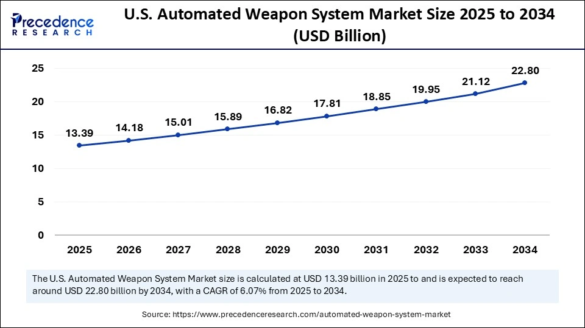
Source A:
The growing market for automated weapon systems points to increasing worldwide investment in technologies to automate warfare and the associated dangers posed by the rapid growth of LAWS. As seen in the graph (Precedence, 2025), the market will demonstrate considerable growth throughout the coming years. Hence, the growing demand for automated weapon systems is expected, as many nations tend to invest more and more in automation for military purposes due to its efficiency and low risk to people. Nonetheless, one must understand that such developments are associated with a wide range of challenges arising from the possible imbalance between the pace of technological development and the pace of the development of appropriate regulations. Such growth in the market for automated weapon systems calls for effective regulation since its further growth may be connected with the proliferation of such technologies if not regulated properly.

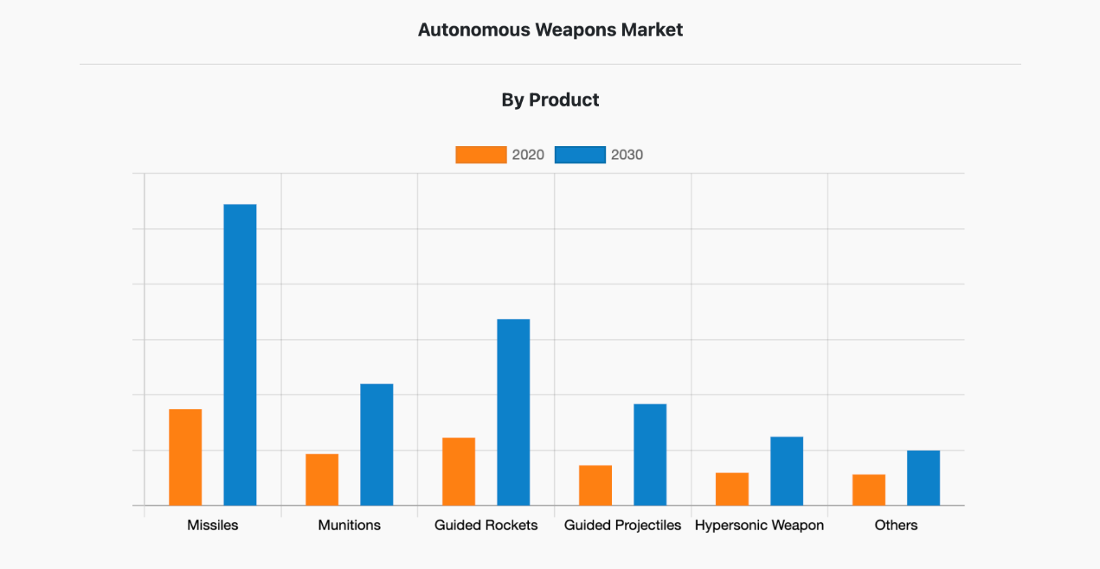

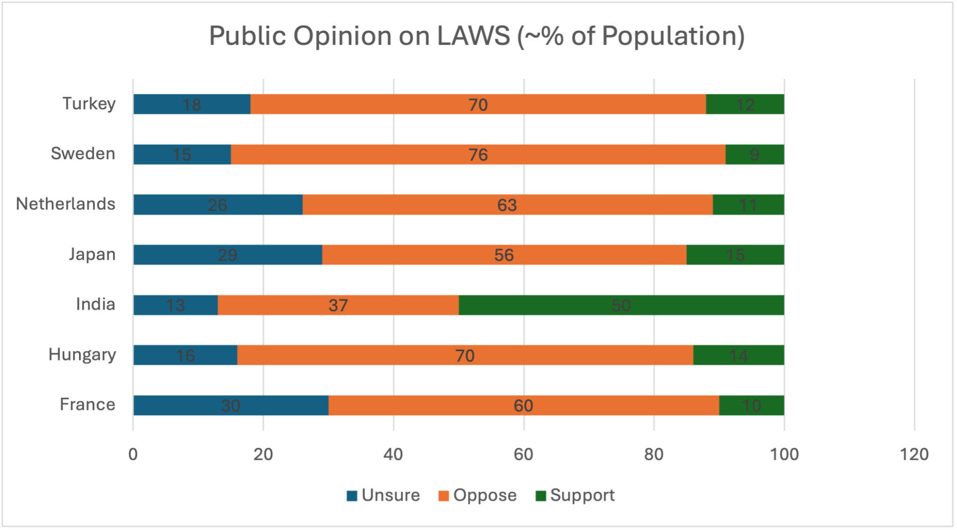
Source C: Based on the graph illustrating public attitudes toward artificial intelligence, it is evident that while many people are open to its use in certain defense roles, there is strong resistance to fully autonomous systems. Most respondents are comfortable with AI when it serves as a supportive tool that enhances human decision-making rather than replacing it entirely. In other words, the use of artificial intelligence in defense is generally accepted as long as meaningful human involvement is preserved. Furthermore, the data indicate that people are more willing to trust AI systems that act as assistants to soldiers, but remain hesitant to grant them full control over critical decisions, particularly those involving the use of force (Trends Research, n.d.).

Bibliography

Works Cited

“Autonomous Weapons Market Share, Growth, Analysis by 2030.” Allied Market Research, Aug. 2021, www.alliedmarketresearch.com/autonomous-weapons-market-A13132.
Cambridge Dictionary. “DETERRENCE | Meaning in the Cambridge English Dictionary.” Cambridge.org, 13 Nov. 2019, dictionary.cambridge.org/dictionary/english/deterrence.
“Convention on Certain Conventional Weapons -Group of Governmental Experts on Lethal Autonomous Weapons Systems (2025) | United Nations.” Unoda.org, 2025, meetings.unoda.org/ccw/convention-on-certain-conventional-weapons-group-of-governmental-experts-on-lethal-autonomous-weapons-systems-2025.
Davison, Neil. A Legal Perspective: Autonomous Weapon Systems under International Humanitarian Law. 2018.
“Definition of War Crimes.” Icrc.org, 2023, ihl-databases.icrc.org/en/customary-ihl/v1/rule156.
Docherty, Bonnie. “A Hazard to Human Rights.” Human Rights Watch, 28 Apr. 2025, www.hrw.org/report/2025/04/28/a-hazard-to-human-rights/autonomous-weapons-systems-and-digital-decision-making.
“Document Viewer.” Un.org, 2025, docs.un.org/en/a/res/79/62?utm_source=chatgpt.com.
Guo, Jie. “The Ethical Legitimacy of Autonomous Weapons Systems: Reconfiguring War Accountability in the Age of Artificial Intelligence.” Ethics & Global Politics, 25 July 2025, pp. 1–13, https://doi.org/10.1080/16544951.2025.2540131.
Hambling, David. “Why the U.S. Is Backing Killer Robots.” Popular Mechanics, Popular Mechanics, 14 Sept. 2018, www.popularmechanics.com/military/research/a23133118/us-ai-robots-warfare/.
Hwag, Euysun. “Lethal Autonomous Weapons: The Next Frontier in International Security.” Stanford.edu, 2025, fsi.stanford.edu/sipr/content/lethal-autonomous-weapons-next-frontier-international-security-and-arms-control.
“Lethal Autonomous Weapon Systems | United Nations Office for Disarmament Affairs. ”Unoda.org, 2025, disarmament.unoda.org/en/our-work/emerging-challenges/lethal-autonomous-weapon-systems.
Perlo-Freeman, Sam. “Arms Race.” Encyclopædia Britannica, 19 Apr. 2024, www.britannica.com/topic/arms-race.
Precedence Research. “Automated Weapon System Market Size to Hit USD 73.56 Billion by 2034.” Precedenceresearch.com, Precedence Research, 2025, www.precedenceresearch.com/automated-weapon-system-market.
Sayler, Kelley. “Defense Primer: U.S. Policy on Lethal Autonomous Weapon Systems.” Congress.gov, 2025, www.congress.gov/crs-product/IF11150.
Stanhope, Jack. “Opposing Inherent Immorality in Autonomous Weapons Systems | Future Forge.” Defence.gov.au, 2021, theforge.defence.gov.au/article/opposing-inherent-immorality-autonomous-weapons-systems.
Stop Killer Robots. “Stop Killer Robots.” Stopkillerrobots.org, 2018, www.stopkillerrobots.org/.
“The Application of International Humanitarian Law in Relation to Lethal Autonomous Weapons Systems → UNIDIR.” UNIDIR → Building a More Secure World, 5 Mar. 2025, unidir.org/event/the-application-of-international-humanitarian-law-in-relation-to-lethal-autonomous-weapon-systems/. Accessed 21 Apr. 2026.
“The Backlash against Military AI: Public Sentiment, Ethical Tensions, and the Future of Autonomous Warfare.” Trendsresearch.org, 2025, trendsresearch.org/insight/the-backlash-against-military-ai-public-sentiment-ethical-tensions-and-the-future-of-autonomous-warfare/.
“United Nations Treaty Collection.” Treaties.un.org, treaties.un.org/pages/ViewDetails.aspx?chapter=26&clang=_en&mtdsg_no=XXVI-2&src=TREATY.
“What Is Preemption?” Local Solutions Support Center, www.supportdemocracy.org/what-is-state-preemption.

