UNICEF_DRAFT_2

Forum: United Nations International Children’s Emergency Fund (UNICEF)
Issue #1: Addressing the treatment and detention of migrant and refugee children by governments
Student Officers: Sofia Rios and Saksham Seth
Position: Chair of the International Children’s Emergency Fund

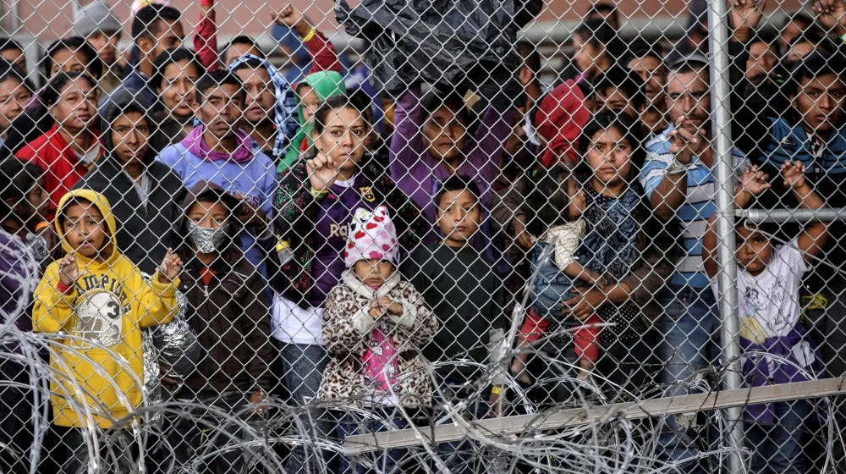
https://www.aljazeera.com/news/2020/6/25/us-supreme-court-ruling-boosts-trumps-power-to-deport-immigrants. Accessed 18 May 2026
Introduction
The treatment and detention of migrant and refugee children by governments is one of the most urgent humanitarian and human rights issues globally. Around the world, millions of children are forced to leave their countries due to armed conflict, persecution, violence, poverty, and natural disasters. According to the United Nations Commissioner for Refugees (UNHCR), children make up nearly 40 percent of the world's displaced population, regardless of representing a much smaller portion of the global population. Many of these children travel alone or become separated from their families, leaving them very vulnerable to abuse, exploitation, and trafficking.

In response to increasing migration issues, many governments detain migrant and refugee children while having asylum claims or enforcing immigration laws. However, organizations such as UNICEF and OHCHR state that detention is never in the best interest of the children, as it can cause psychological harm and limit access to education and healthcare.

This issue remains highly controversial because governments must balance border security and be obligated to protect children's rights. As a result, countries and the community continue to debate on how to ensure migrant and refugee children are treated with dignity and respect.

Definition of Key Terms
Migrant Child: A child under the age of 18, as defined in Article 1 of the Convention on the Rights of the Child, who is moving or has moved across an international border, irrespective of their legal status, whether the movement is voluntary or involuntary, and what the causes of the movement are. There is no formal legal definition of an "international migrant" in international law, but the term broadly applies to those who move for reasons not specifically covered by the legal definition of a "refugee," such as work, study, or family reunification (Mantoo).
Refugee: Under article 1 of the 1951 Convention Related to the Status of Refugees, a refugee is a person who, owing to a well-founded fear of being persecuted for reasons of race, religion, nationality, membership of a particular social group, or political opinion, is outside the country of their nationality and is unable or unwilling to avail themselves of the protection of that country (UNHCR). Refugees are entitled to international protection and cannot legally be returned to a country where their life or freedom would be threatened.
Internally Displaced Person (IDP): "Internally displaced people" is a term referring to those who have been forced or obliged to flee their homes during conflict, violence, persecution, or disasters; however, they remain within the borders of their own country (UNHCR, “Internally Displaced People”). The key difference between an IDP and a refugee is that a refugee is someone who is outside their country’s international border, whereas an IDP is someone who has not crossed an international border and remains inside the country (UNHCR, “Internally Displaced People”).
Asylum seeker: A person who has fled their country and is seeking international protection but whose claim for refugee status has not yet been legally determined. Seeking asylum is a human right, and every person has the right to apply for asylum if they are fleeing conflict or persecution. They must not be returned to situations where their lives are in danger. (UNHCR, “Asylum-Seekers”). Every asylum seeker has the right to have their claim heard fairly and efficiently, and not every asylum seeker is ultimately recognized as a refugee, but every refugee was once an asylum seeker. There is a difference between an asylum seeker and a refugee; a refugee is someone who has been compelled to leave their country and cannot return due to a serious threat to life. It gives certain rights and protections. Whereas an asylum seeker is someone who has or intends to apply to be recognized as a refugee, but their application is yet to be processed (UNHCR, “Asylum-Seekers”).
Non-Refoulement: A core principle of international law, codified in Article 33 of the 1951 Refugee Convention, which prohibits states from expelling or returning a refugee “in any manner whatsoever to the frontlines of territories where his life or freedom would be threatened” on account of race, religion, nationality, membership of a particular social group, or political opinion” (UNHCR, “UNHCR Note on the Principle of Non-Refoulement”). It is considered a norm of customary international law and binds even states that have not signed the convention.
Best Interests of the Child: A foundational principle established under Article 3 of the Convention on the Rights of the Child, which requires that “in all actions concerning children, whether undertaken by public or private social welfare institutions, courts of law, administrative authorities, or legislative bodies, the best interests of the child shall be a primary consideration” (UNHCR, “UNHCR Note on the Principle of Non-Refoulement”). The UN Committee on the Rights of the Child has clarified that this principle prohibits the immigration detention of children under any circumstances.
Immigration Detention: The deprivation of liberty of a non-citizen by a state, typically in administrative custody, on account of their immigration status. The UN Committee on the Rights of the Child has stated that “the detention of a child because of their or their parent’s migration status constitutes a child rights violation and always contravenes the principle of the best interests of the child.” (End Child Detention). Though immigration detention, under human rights law, is meant to be a last resort, it is illegal for children.
Stateless Person: Defined under Article 1 of the 1954 Convention Relating to the Status of Stateless Persons as “a person who is not considered a national by any state under the operation of its law” (UNHCR, “Stateless People”). Stateless children face heightened risks of detention and denial of basic rights such as education, healthcare, and freedom of movement, often because they cannot prove their identity or legal status.

General Overview
Context
Migrant and refugee children represent some of the most vulnerable populations in the global migration system, yet they are also some of the most frequently detained, separated from family, and denied access to basic rights such as education, healthcare, and legal counsel. By the end of 2024, approximately 48.8 million children worldwide had been displaced by conflict and violence, including 19.1 million refugee children and asylum seekers (UNICEF). Despite international legal frameworks such as the 1989 Convention on the Rights of the Child, which guarantees that the best interests of the child shall be a primary consideration in all actions affecting them, governments increasingly treat migrant children as immigration enforcement subjects first and as children second. The UN network on Migration estimates that at least 330,000 children are deprived of their liberty every year on the basis of their or their parents’ migration status, a figure widely considered to be a significant underestimate (OHCHR). The contradiction between universally ratified child rights commitments and the reality of detention, family separation, pushbacks, and inadequate protection defines the issue. The most controversial aspect lies in the tension between national sovereignty over borders and the binding obligations states have assumed under international law to protect every child within their jurisdiction, regardless of their legal status.
Conditions in Detention Facilities
Conditions in immigration detention facilities holding migrant and refugee children have been documented by UN agencies, courts, and human rights organizations as systematically inadequate and, in many cases, as constituting cruel, inhuman, or degrading treatment. The UN Committee on the Rights of the Child has stated unambiguously that “the detention of a child because of their or their parents’ migration status constitutes a child rights violation and always contravenes the principle of the best interests of the child” (End Child Detention). In Libya, where the European Union has funded migration containment partnerships since 2017, Human Rights Watch researchers documented “severe overcrowding, unsanitary conditions, malnutrition, and lack of adequate health care” across four official detention centers in 2018, witnessing “large numbers of children, including newborns, detained in grossly unsuitable conditions" and also discovering beatings and whips used by guards (Human Rights Watch). At the Al Mabani detention center, Libya’s largest, more than 5,000 people, including 100 children and 300 women, have been held in a facility with an official capacity of approximately 1,250 (UNICEF, “The Safety and Wellbeing of Children at High Risk in Detention Centres in Libya”). Doctors Without Borders, which ended its medical activities in Tripoli in August 2023 due to deteriorating conditions, documented detainees being “crammed into cells so overcrowded that they are forced to sleep in a sitting position, with sewage from overflowing septic tanks and clogged toilets spilling inside” (Doctors Without Borders).
In the United States, former UN High Commissioner for Human Rights Michelle Bachelet declared in July 2019 that conditions in which migrants and refugees were being held were “appalling,” stating, “As a pediatrician, but also as a mother and former head of state, I am deeply shocked that children are forced to sleep on the floor in overcrowded facilities, without access to adequate healthcare or food, and with poor sanitation conditions” (UN News). Bachelet stated that according to several UN human rights bodies, detaining migrant children may constitute cruel, inhumane, or degrading treatment that is prohibited under international law and emphasized that immigration detention is “never in the best interests of a child” because “even for short periods under good conditions” it “can have a serious impact on their health and development” (UN News).
Family Separation Policies
Family separation as a deliberate immigration enforcement strategy has produced some of the most documented violations of child rights in recent years. The United States government’s “Zero Tolerance” policy, formally announced in April 2018, directed federal prosecutors to criminally charge all adults crossing the southern border without authorization; because children cannot be held in adult criminal detention, they were reclassified as unaccompanied and transferred to the custody of the Office of Refugee Resettlement (American Bar Association). According to the Women’s Refugee Commission, “at least 5,569 children were separated from their parents or guardians under the Trump administration, a figure that includes separations during and after the formal zero-tolerance policy” (Women’s Refugee Commission). Family separations began in the summer of 2017, before the public announcement of zero tolerance in April 2018, and the practice continued for at least eighteen months after the policy’s official end in June 2018, with at least 1,134 families separated between June 2018 and the end of 2019 (Camilo Montoya-Galvez). The American Immigration Council documented that "although the administration was aware that family separation would cause harm, it nonetheless implemented the policy” as a deliberate deterrent (American Immigration Council). As of November 30, 2023, more than 1,000 children remained separated from their parents (Women's Refugee Commission).
Unaccompanied Minors and Legal Representation
Unaccompanied migrant children face the immigration system without the procedural protections that domestic legal systems grant child defendants in juvenile court. In the United States, although the Fifth Amendment guarantees of due process extend to non-citizens in removal proceedings, there is no statutory right to government-appointed counsel, even for children (American Bar Association CILA and American Bar Association Commission on Immigration). Between fiscal years 2005 and 2017, only 64% of unaccompanied children in immigration proceedings obtained any legal counsel during their cases, and by 2024, that figure had declined to 57% (Fátima Khayar Cámara). The Vera Institute of Justice found that unaccompanied children with legal representation were “more than 7X more likely than unrepresented unaccompanied children to receive an outcome that allows them to remain in the United States” (Vera). On March 21, 2025, the United States government terminated the federal contract that provided legal representation under the Unaccompanied Children Program, affecting approximately 26,000 unaccompanied children nationwide, including children as young as two years old (RMIAN). A federal court issued an emergency Temporary Restraining Order on April 1, 2025, partially halting the termination (immdef). The lack of representation is not unique to the United States. The number of unaccompanied minors among asylum applicants in the European Union rose from 13,550 in 2020 to 40,415 in 2023, but more than 18,000 unaccompanied child migrants vanished within Europe between January 2018 and December 2020, with no consistent system for tracking, guardianship, or legal representation across member states (Migration Data Portal; Cheatham and Roy). In Bangladesh, where nearly 1 million Rohingya refugees reside in the Cox’s Bazar district, the government has banned Rohingya refugee children from accessing formal, accredited education (Human Rights Watch and Esveld). The denial of birth registration compounds the issue: the UN reports that at least 60 Rohingya babies are born every day in Bangladesh, but birth registration is not taking place for Rohingya newborns, leaving them without official proof of legal identity and statelessness from the moment of birth (Open Society Justice Initiative). Human Rights Watch documented in June 2025 that foreign aid cuts have worsened the existing education crisis for 437,000 school-age children in Rohingya refugee camps in Bangladesh, which led to UNICEF suspending thousands of “learning centers” due to lack of funding, further isolating a generation from formal schooling and legal recognition (Human Rights Watch, “Bangladesh: Foreign Aid Cuts Affect Rohingya Children’s Education”).

Major Parties Involved and Their Views
United States
The United States has used immigration detention a lot, including families and unaccompanied minors arriving at the southern border. While the government argues that detention is necessary to enforce immigration laws and maintain security within the border, it has faced criticism over crowding, family separation, and poor conditions in the detention facilities. In past years, the United States has expanded alternatives to detention and increased efforts to place children whose cases are processed (U.S. Customs and Border Protection).

Mexico
Mexico is both a country of origin and a major transit country for migrant children traveling towards the US. The government has detained migrant children, but legal reforms now prioritize different approaches to detention and greater protection measures. Despite these changes, implementation remains inconsistent, and many children still face insufficient shelter conditions and limited access to services (UNICEF Mexico Child Migration).

Germany
Germany generally adopts a rights-based approach to asylum and provides education, healthcare, and social services to refugee children. However, worries still remain over long asylum procedures and integration challenges. Germany supports stronger European Union cooperation to improve protection for migrant and refugee children (UNHCR Germany)

Turkey
Turkey hosts the largest refugee population in the world, including millions of Syrian children. The government has expanded access to education and healthcare, but because there's a large number of refugees, it places considerable pressure on public services and resources. Turkey advocates for increased international burden sharing and financial assistance (UNHCR Türkey).

United Nations High Commissioner for Refugees (UNHCR)
The United Nations High Commissioner for Refugees is the primary UN agency responsible for protecting refugees, asylum seekers, and stateless persons. UNHCR opposes the detention of children for immigration purposes and promotes community-based alternatives, family reunification, and access to legal protection (UNHCR Detention Guidelines).

United Nations Children's Fund (UNICEF)
The United Nations Children's Fund works to protect migrant refugee children by providing education, healthcare, psychosocial support, and advocacy. UNICEF makes sure that every child is treated first and foremost as a child, regardless of their migration status (UNICEF Child migration).

Office of the United Nations High Commissioner for Human Rights (OHCHR)
The Office of the United Nations High Commissioner for Human Rights has repeatedly stated that detention based only on immigration status violates children's rights. The organization advocates for ending child immigration detention and ensuring states comply with international human rights obligations (OHCHR Migration and Human Rights).

Timeline of Events, Relevant Resolutions, Treaties, and Events
Date | Description of event
1951 | The Refugee Convention was adopted, defining who qualifies as a refugee and the principle of non-refoulement, which prohibits countries from returning individuals to places where they face prosecution (UNCHR).
1967 | The 1967 Protocol Relating to the Status of Refugees removed the geographic and temporal limitations of the 1951 Convention, extending refugee protections to all regions of the world (UNHCR).
1989 | The Convention on the Rights of the Child (CRC) was adopted, recognizing that all children, no matter their migration status, are entitled to protection, education, healthcare, and treatment in their best interest (ONCHR).
1989 | The Convention on the Rights of the Child (CRC) was adopted, recognizing that all children, no matter their migration status, are entitled to protection, education, healthcare, and treatment in their best interest (ONCHR).
1990 | The International Convention on the Protection of the Rights of All Migrant Workers and Members of Their Families strengthens protections for migrant families and affirms the rights of children to education, health care, and family unity (OHCHR).
2005: | The UN Committee on the Rights of the Child stated that unaccompanied and separated children should not be detained based on their migration status and must receive special protection and assistance (OHCHR).
2016 | The New York Declaration for Refugees and Migrants committed member states to education and legal services (UNHCR).
2018 | The Global Compact for Safe, Orderly, and Regular Migration encouraged governments to develop alternatives to immigration detention and adopt child detention and adopt child sensitive migration policies (UNICEF).
2023 | UNICEF released an advocacy brief reaffirming that immigration detention is never in the best interests of the child and calling on governments to invest in community-based alternatives and family supports (UNICEF).
2024 | UNICEF reported that nearly 48.8 million children were displaced by conflict and violence by the end of 2024, highlighting the growing number of migrant and refugee children in need of protection and different detention approaches (UNICEF Data on Child Displacement).
2025 | The United Nations and humanitarian agencies continue to urge governments to end the detention of children and expand community-based alternatives, emphasizing that detention is not in the best interest of the child (UN Report on Children and Armed Conflict Displacement Trends).
United Nations Involvement
The United Nations has established a clear and consistent legal framework regarding the treatment of migrant and refugee children is built primarily on three foundational instruments. The most central of these is the Convention on the Rights of the Child (CRC), adopted on November 20th, 1989, by the UN General Assembly. Article 37 (b) of the CRC establishes that no child shall be deprived of liberty unlawfully or arbitrarily and that any detention of a child must be used only as a measure of last resort and for the shortest appropriate period of time (United Nations Human Rights Office of the High Commissioner). The CRC Committee and the Committee on the Protection of the Rights of All Migrant Workers (CMW) have since jointly clarified, through their Joint General Comment No. 4/No. 23 (2017), that the “last resort” standard does not apply in migration contexts at all, meaning immigration detention of children constitutes a child rights violation under any circumstances, regardless of whether the child is accompanied by a parent. (United Nations, “Joint General Comment No. 4 (CMW) and No. 23 (CRC) on State Obligations Regarding the Human Rights of Children in the Context of International Migration”).
The second key instrument is the New York Declaration for Refugees and Migrants (A/RES/71/1), adopted unanimously by all 193 UN Member States on 19 September 2016. Among its explicit commitments, member states pledged to work toward ending the practice of detaining children for the purposes of determining their migration status and to ensure that all refugee children receive education within a few months of arrival. (United Nations Human Rights Office of the High Commissioner, “The New York Declaration for Refugees and Migrants”). UNICEF welcomed the Declaration for its emphasis on compliance with the CRC and its recognition of the acute risks faced by migrant children, particularly unaccompanied minors (UNICEF, “UNICEF Statement on the New York Declaration on Refugees and Migrants”).
The Global Compact for Safe, Orderly, and Regular Migration (A/RES/73/195), adopted at the intergovernmental conference in Marrakesh, Morocco, on December 10, 2018, by 164 UN Member States. Under Objective 13 of the Compact, States Committed to using immigration detention only as a measure of last resort and to working toward ending the practice of child detention in the context of international migration (United Nations, GLOBAL COMPACT for SAFE, ORDERLY, and REGULAR MIGRATION INTERGOVERNMENTALLY NEGOTIATED and AGREED OUTCOME). The Compact is the first international agreement to address all dimensions of international migration comprehensively, and it explicitly upholds the principle of the best interests of the child at all times in all situations concerning children (United Nations Human Rights Office of the High Commissioner, “Global Compact for Safe, Orderly and Regular Migration (GCM)”). At the time of the Compact’s adoption, UNICEF noted that more than 100 countries still had policies of migration detention for children and called on states to reduce that figure to zero through the implementation of the Compact’s provisions (UNICEF, “Statement on the Adoption of the Global Compact for Safe, Orderly and Regular Migration”).

Evaluation of Previous Attempts to Resolve the Issue
The international community has made significant efforts to improve the treatment of migrant and refugee children through legal frameworks and policy agreements. Such as the Convention on the Rights of the Child (1989), the 1951 Refugee Convention, and the Global Compact for Safe, Orderly and Regular Migration (2018) have established important standards for protecting children and finding alternatives to detention. These agreements have helped raise awareness and have led some countries to adopt more child-centered migration policies.

Organizations such as UNICEF, UNHCR, and OHCHR have also provided humanitarian assistance, legal support, and policy recommendations. They have contributed to improvements in access to education, healthcare, and family reunification services for many children. In some countries, alternatives to detention, such as community-based housing and case management programs, have shown that they are more effective and less harmful.

Despite these advances, implementation remains inconsistent. Many governments continue to detain children due to limited resources, political pressures, and concerns over border security. In addition, many international agreements are not legally binding, which limits enforcement and accountability. As a result, while previous efforts have established strong legal and moral frameworks, significant gaps remain between international commitments and the realities faced by migrant and refugee children

Possible Solutions
Standardizing Legal Protections and Due Process for Migrant Children
Despite the existence of international frameworks such as the Convention on the Rights of the Child and the Global Compact for Safe, Orderly and Regular Migration, the legal protections afforded to migrant and refugee children vary significantly from country to country. Many states have yet to fully align their national legislation with the standards established by these instruments, resulting in inconsistent treatment of children at borders and in detention settings. A possible direction for delegates to consider is the development of mechanisms that encourage or require states to incorporate CRC obligations directly into their national immigration laws, ensuring that principles such as the best interests of the child and non-discrimination apply regardless of a child’s migratory status. Delegates may also explore how existing UN treaty body monitoring systems could be strengthened to hold states accountable when their domestic policies fall short of international standards.

Strengthening Access to Basic Services in Reception and Detention Settings
Even in cases where migrant and refugee children are held in government facilities, access to essential services such as education, healthcare, and psychosocial support remains inconsistent and often inadequate. The deprivation of these services compounds the harm already experienced by children who have fled conflict, poverty, or instability. Delegates should consider what binding or incentive-based frameworks could be established to guarantee that any facility housing migrant children meets a minimum standard of care, independent of the host country’s economic capacity. Additionally, the role of UN agencies such as UNICEF and UNHCR in monitoring and supporting service delivery within these settings may be worth exploring as part of a broader solution.

Sustainable Development Goal (SDG)
This issue is most connected to SDG 10: Reduced Inequalities, which aims to reduce inequalities within and among countries. Migrant and refugee children often face discrimination, limited access to education and healthcare, and unequal treatment due to their legal status. By promoting choices to detention and ensuring equal access to important services, governments can help reduce the social and economic inequalities experienced by these vulnerable children (United Nations Sustainable Development Goals).

Additionally, this issue relates to SDG 16: Peace, Justice and Strong Institutions, which seeks to promote justice, protect human rights, and ensure access to effective institutions for all. Protecting migrant and refugee children from harmful detentions and guaranteeing their rights aligns with building more inclusive and accountable institutions (United Nations Sustainable Development Goals).

Finally, the issue also connects to SDG 4: Quality Education, as detention and displacement often disrupt children's access to schooling. Ensuring that migrant and refugee children receive continuous education can improve their future opportunities and support their integration into society (United Nations Sustainable Development Goals).

Appendix
This section of the issue bulletin is dedicated to providing delegates with valuable sources to utilize during their research.
https://data.unicef.org/topic/child-migration-and-displacement/migration
Source A: UNICEF’s data hub on child migration and displacement, providing global statistics on the number of migrant and refugee children, displacement trends, and country-specific data.
https://www.unhcr.org/refugee-children
Source B: UNHCR’s dedicated page on refugee children, outlining the specific vulnerabilities they face and the international protections owed to them under refugee law.
https://www.unhcr.org/us/what-we-do/publications/refugee-children-and-adolescents
Source C: The full collection of General Comments issued by the UN Committee on the Rights of the Child, providing authoritative legal interpretation of children’s rights under the CRC.

https://www.migrationdataportal.org/themes/child-and-young-migrants
Source D: The IOM Migration Data Portal’s dedicated section on child and young migrants, offering disaggregated data and trend analysis on unaccompanied minors globally.

Bibliography

American Bar Assocation CILA and American Bar Association Commission on Immigration. Unaccompanied Minors in Immigration Court: The Critical Role of Legal Representation Prepared by ABA CILA and ABA Commission on Immigration How Do Immigration Court Proceedings Function in Unaccompanied Children’s Cases? 2025, cilacademy.org/wp-content/uploads/2025/04/2025-04-10-uc-immigration-court-explainer.pdf.
American Bar Association. “Family Separation and Detention.” Americanbar.org, 2018, www.americanbar.org/advocacy/governmental_legislative_work/priorities_policy/immigration/familyseparation/. Accessed 10 May 2026.
American Immigration Council. “Government Documents on Family Separation - American Immigration Council.” American Immigration Council, 6 Jan. 2025, www.americanimmigrationcouncil.org/foia-request/government-documents-family-separation-tracking-policys-evolution-implementation-and-harm/. Accessed 10 May 2026.
Bipartisan Policy Center. “Why Are Families Being Separated at the Border?” Bipartisan Policy Center, 13 June 2018, bipartisanpolicy.org/article/why-are-families-being-separated-at-the-border-an-explainer/.
Brief, Advocacy. END IMMIGRATION DETENTION of CHILDREN. 2024, www.unicef.org/media/151371/file/Advocacy%20Brief:%20End%20Child%20Immigration%20Detention%20.pdf?utm_source=chatgpt.com. Accessed 9 June 2026.
Camilo Montoya-Galvez. “Family Separation: 1,134 Migrant Families Separated since End of Trump ‘Zero Tolerance’ Policy, ACLU Says.” Cbsnews.com, 16 Dec. 2019, www.cbsnews.com/news/family-separation-1134-migrant-families-separated-since-end-of-trump-zero-tolerance-policy-aclu/. Accessed 10 May 2026.
CBP. “U.S. Customs and Border Protection.” U.S. Customs and Border Protection, 2026, www.cbp.gov/?utm_source. Accessed 9 June 2026.
Cheatham, Amelia, and Diana Roy. “U.S. Detention of Child Migrants.” Cfr.org, Council on Foreign Relations, 28 Aug. 2014, www.cfr.org/backgrounders/us-detention-child-migrants. Accessed 24 May 2026.
Doctors Without Borders . “‘You’re Going to Die Here’: Abuse in Libyan Detention Centers.” Doctors without Borders - USA, 2023, www.doctorswithoutborders.org/latest/youre-going-die-here-abuse-libyan-detention-centers. Accessed 10 May 2026.
End Child Detention. “International Law - End Child Detention.” End Child Detention, 29 June 2018, endchilddetention.org/toolbox/issue-child-immigration-detention/international-law/. Accessed 10 May 2026.
European Parliament. “Vulnerability of Unaccompained and Separate Child Migrants .” Europarl.europa.eu, June 2024, www.europarl.europa.eu/RegData/etudes/BRIE/2024/762339/EPRS_BRI(2024)762339_EN.pdf.
Fátima Khayar Cámara. “A Matter of Time: The Crisis of Legal Representation for Immigrant Children.” Acacia Center for Justice, 18 Nov. 2024, acaciajustice.org/blog-matter-of-time-legal-representation-unaccompanied-children/. Accessed 24 May 2026.
Human Rights Watch. “Bangladesh: Foreign Aid Cuts Affect Rohingya Children’s Education.” Human Rights Watch, 25 June 2025, www.hrw.org/news/2025/06/25/bangladesh-foreign-aid-cuts-affect-rohingya-childrens-education. Accessed 24 May 2026.
---. “Libya: Nightmarish Detention for Migrants, Asylum Seekers.” Human Rights Watch, 21 Jan. 2019, www.hrw.org/news/2019/01/21/libya-nightmarish-detention-migrants-asylum-seekers. Accessed 10 May 2026.
Human Rights Watch, and Bill Van Esveld. “‘Are We Not Human?’” Human Rights Watch, 3 Dec. 2019, www.hrw.org/report/2019/12/03/are-we-not-human/denial-education-rohingya-refugee-children-bangladesh. Accessed 24 May 2026.
immdef. “Unaccompanied Children in Immigration Court: Legal Action Needed Now.” IMMDEF, 25 Apr. 2025, www.immdef.org/blog/ucphearing3. Accessed 24 May 2026.
Jazeera, Al. “US Supreme Court Ruling Boosts Trump’s Power to Deport Immigrants.” Al Jazeera, 25 June 2020, www.aljazeera.com/news/2020/6/25/us-supreme-court-ruling-boosts-trumps-power-to-deport-immigrants. Accessed 18 May 2026.
Mantoo, Shabia. “‘Refugees’ or ‘Migrants’? How Word Choices Affect Rights and Lives.” UNHCR US, 19 Dec. 2023, www.unhcr.org/us/news/stories/refugees-or-migrants-how-word-choices-affect-rights-and-lives.
Migration Data Portal. “Child and Young Migrants.” Migration Data Portal, 12 Sept. 2024, www.migrationdataportal.org/themes/child-and-young-migrants. Accessed 24 May 2026.
OHCHR. “UN Experts Advocate for an End to Migrant Children Detention.” OHCHR, 2024, www.ohchr.org/en/stories/2024/02/un-experts-advocate-end-migrant-children-detention. Accessed 10 May 2026.
Open Society Justice Initiative. “How Newborn Rohingya Are Made Legally Invisible.” Justiceinitiative.org, 2018, www.justiceinitiative.org/voices/saving-newborn-rohingya-legal-abyss. Accessed 24 May 2026.
RMIAN. “RMIAN.” RMIAN, 21 Mar. 2025, www.rmian.org/happenings-news/rmian-decries-termination-of-funding-for-legal-representation-for-unaccompanied-children. Accessed 24 May 2026.
UN News. “UN Rights Chief ‘Appalled’ by US Border Detention Conditions, Says Holding Migrant Children May Violate International Law.” UN News, 8 July 2019, news.un.org/en/story/2019/07/1041991. Accessed 10 May 2026.
UNHCR. “Asylum-Seekers.” UNHCR, 2024, www.unhcr.org/about-unhcr/who-we-protect/asylum-seekers.
---. “Internally Displaced People.” UNHCR, 2024, www.unhcr.org/about-unhcr/who-we-protect/internally-displaced-people.
---. “Stateless People.” UNHCR, 2024, www.unhcr.org/about-unhcr/who-we-protect/stateless-people.
---. “The 1951 Refugee Convention.” UNHCR, 2026, www.unhcr.org/about-unhcr/overview/1951-refugee-convention.
---. “The 1951 Refugee Convention and 1967 Protocol Relating to the Status of Refugees | UNHCR.” UNHCR, 2026, www.unhcr.org/media/1951-refugee-convention-and-1967-protocol-relating-status-refugees. Accessed 9 June 2026.
---. “UNHCR Note on the Principle of Non-Refoulement.” Refworld, Nov. 1997, www.refworld.org/policy/legalguidance/unhcr/1997/en/36258.
---. “UNHCR, the UN Refugee Agency | UNHCR Turkey.” UNHCR Turkey, 2025, www.unhcr.org/tr/en. Accessed 9 June 2026.
UNICEF. “Child Alert: Child Migration in Latin America and the Caribbean.” Unicef.org, 7 Sept. 2023, www.unicef.org/child-alert/migration-latin-america-caribbean. Accessed 9 June 2026.
---. “Child Displacement and Refugees - UNICEF DATA.” UNICEF DATA, 3 July 2025, data.unicef.org/topic/child-migration-and-displacement/displacement/. Accessed 10 May 2026.
---. “Child Displacement and Refugees - UNICEF DATA.” UNICEF DATA, 3 July 2025, data.unicef.org/topic/child-migration-and-displacement/displacement/. Accessed 9 June 2026.
---. “Inclusion of Children in the Context of Migration into National Child Protection Systems.” Unicef.org, 2022, www.unicef.org/documents/inclusion-children-context-migration-national-child-protection-systems-0. Accessed 9 June 2026.
---. “Migration Systems and Policies Must Uphold the Rights of Children – UNICEF.” Unicef.org, 2026, www.unicef.org/press-releases/migration-systems-and-policies-must-uphold-rights-children-unicef. Accessed 9 June 2026.
---. “Protecting Migrant and Displaced Children.” Unicef.org, 2026, www.unicef.org/stories/protecting-migrant-children. Accessed 9 June 2026.
---. “Statement on the Adoption of the Global Compact for Safe, Orderly and Regular Migration.” Unicef.org, 2018, www.unicef.org/eca/press-releases/statement-adoption-global-compact-safe-orderly-and-regular-migration. Accessed 17 May 2026.
---. “The Safety and Wellbeing of Children at High Risk in Detention Centres in Libya.” Unicef.org, 2021, www.unicef.org/press-releases/safety-and-wellbeing-children-high-risk-detention-centres-libya. Accessed 10 May 2026.
---. “UNICEF Statement on the New York Declaration on Refugees and Migrants.” Unicef.org, 2016, www.unicef.org/press-releases/unicef-statement-new-york-declaration-refugees-and-migrants. Accessed 17 May 2026.
United Nations. “Convention on the Rights of the Child.” OHCHR, 2026, www.ohchr.org/en/instruments-mechanisms/instruments/convention-rights-child. Accessed 10 May 2026.
---. GLOBAL COMPACT for SAFE, ORDERLY and REGULAR MIGRATION INTERGOVERNMENTALLY NEGOTIATED and AGREED OUTCOME. 2018, refugeesmigrants.un.org/sites/default/files/180713_agreed_outcome_global_compact_for_migration.pdf.
---. “Goal 4 | Department of Economic and Social Affairs.” Un.org, 2025, sdgs.un.org/goals/goal4. Accessed 9 June 2026.
---. “Goal 10 | Department of Economic and Social Affairs.” Un.org, 2025, sdgs.un.org/goals/goal10. Accessed 9 June 2026.
---. “Joint General Comment No. 4 (CMW) and No. 23 (CRC) on State Obligations Regarding the Human Rights of Children in the Context of International Migration.” OHCHR, edited by Committee on the Rights of the Child, United Nations, 16 Nov. 2017, documents.un.org/doc/undoc/gen/g17/343/65/pdf/g1734365.pdf. Accessed May 2026.
United Nations Human Rights Office of the High Commissioner. “Convention on the Rights of the Child.” OHCHR, 2026, www.ohchr.org/en/instruments-mechanisms/instruments/convention-rights-child. Accessed 17 May 2026.
---. “Global Compact for Safe, Orderly and Regular Migration (GCM).” OHCHR, 2018, www.ohchr.org/en/migration/global-compact-safe-orderly-and-regular-migration-gcm. Accessed 17 May 2026.
---. “The New York Declaration for Refugees and Migrants.” OHCHR, 2016, www.ohchr.org/en/migration/new-york-declaration-refugees-and-migrants. Accessed 17 May 2026.
United Nations Migration Network. “The GCM in a Nutshell.” United Nations Network on Migration, 7 July 2021, migrationnetwork.un.org/global-compact-for-migration. Accessed 9 June 2026.
Vera. “Representation Matters.” Vera Institute of Justice, 7 July 2018, www.vera.org/publications/representation-matters. Accessed 24 May 2026.
Women's Refugee Commission. “Family Separation: Their Own Worlds.” Women’s Refugee Commission, Women’s Refugee Commission, Jan. 2024, www.womensrefugeecommission.org/wp-content/uploads/2024/01/Family-Separation-Their-Own-Words.pdf. Accessed 10 May 2026..
This report documents the experiences of families affected by separation policies and immigration enforcement, highlighting the emotional, psychological, and legal impacts on parents and children through firsthand accounts and advocacy research.

Example
Forum: United Nations International Children’s Emergency Fund (UNICEF)
Issue #1: Combating the recruitment and exploitation of children by armed groups and criminal organizations
Student Officers: Saksham Seth & Sofia Rios
Position: Chair of the International Children’s Emergency Fund


"Medications." Freepik, 2020, https://www.freepik.com/free-photo/medications_5095604.htm. Accessed 19 May 2025.

Introduction
The issue of regulating access to controlled drugs for medical purposes is multifaceted and complex. The consequences of access to drugs for medical purposes include increased accessibility to dangerous substances, risk of misuse and addiction, negative side effects, and diversion. While medically controlled drugs such as fentanyl, hydromorphone, meperidine, methadone, or morphine can be necessary for managing pain and other symptoms, they also carry a high risk of substance use disorder and addiction. Furthermore, the prolonged use of controlled drugs can lead to physical and psychological dependence, making it challenging for patients to cease their use (“Controlled Substances Agreement - Students”). Therefore, as many countries prioritize criminal justice and drug control measures, they are restricting the use of controlled substances for medical purposes (as well as any possession of drugs) as an attempt to diminish the use of non-medical drugs. However, this process undermines the needs of those individuals with chronic illnesses or who have undergone surgery and have benefited from the use of these prescriptions during their treatment (Burke-Shyne et al.). According to World Health Organization (WHO) statistics, only 6 million out of the 40 million people in need of palliative care each year receive it due to unnecessarily restrictive regulatory barriers (WHO). The World Health Organization’s (WHO) Model List of Essential Medicines includes 12 internationally controlled substances such as morphine, diazepam, and methadone (“WHO Model Lists of Essential Medicines”).

These medicines are essential to many patients’ treatment, however, many have denied them and continue to live in pain. Furthermore, the criminalization of drugs for medical purposes has created an opportunity for a black market of illegal drugs to develop, leading to patients finding alternative, and often dangerous, ways to receive treatment. Patients turning to illegal methods to purchase these drugs have resulted in drug addiction, overdose, and numerous health risks (Manfredi). In summary, the consequences of access to controlled drugs for medical purposes are dangerous and could perpetuate the misuse of drugs, while on the other hand, criminalizing controlled drugs could also be detrimental to patients’ rights to access healthcare and the advances of modern science.

Definition of Key Terms
Addiction: The condition of being dependent on a particular substance. Drug addiction is a relapsing disorder distinguished by irresistible drug seeking and use, regardless of the consequences it may lead to (National Institute on Drug Abuse).

Overdose: Taking more than the prescribed/recommended amount of a substance, usually a medicine or drug. This ingestion overwhelms the body and could result in life-threatening consequences, depending on the amount taken.

Dependence: Heavily relying on something to continue before being exposed to that specific thing. For example, drug dependence refers to a person depending on the consumption of drugs to an extreme level and on a regular basis in order to function normally. Developing a dependence on drugs will have many negative impacts on the individual's life in various aspects.

Off-label Use: The use of prescribed drugs for a purpose other than what they were indicated for, such as a different dosage.

Prescription Drugs: A medicine that is only available to clients with the written instruction of an authorized healthcare professional (Therapeutic Goods Administration).

Diversion: The illegal distribution or use of prescription drugs for other purposes than those intended by the prescriber. Prescription drug diversion could occur at any time as prescription drugs are transported from the manufacturer to wholesale distributors, to pharmacies, or to the client (Department of Health and Human Services).

War on Drugs: The initiative of the United States Government to battle illegal drug use. Under the control of former US president Richard Nixon, the consequences for using illicit drugs were aggravated, as he stated that drug abuse was “public enemy number one”(Britannica).

Psychoactive Drugs: Substances that have an impact on the mental process, triggering changes in behavior, mood, feeling, thoughts, etc. Some examples of psychoactive drugs are caffeine, nicotine, heroin, and marijuana/cannabis. Psychoactive drugs are also known as psychotropic drugs.

Decriminalization: Changing the laws with the aim of turning something that used to be illegal into a legal act.

Cannabis: Also known as marijuana, cannabis is produced from the flowers or dried leaves of the Cannabis Sativa or Cannabis Indica plant. Cannabis contains chemicals such as cannabinoids that cause drug-like effects throughout the central nervous system and immune system. Through medical use, cannabis is commonly used to treat cancer symptoms or side effects such as pain, vomiting, and cachexia (loss of muscle mass and body weight) (NCI Dictionary of Cancer Terms).

Opioid: A type of drug that is derived from poppy seeds and whose main function is to block severe pain (National Institute on Drug Abuse). Even though opioids are mostly legal around the globe and doctors usually prescribe them for patients undergoing intense pain, they have significantly contributed to the number of deaths due to overdose. “In 2021, 45 people died each day from a prescription opioid overdose, totaling nearly 17,000 deaths” (Centers for Disease Control and Prevention).

Controlled Drug: A drug whose possession or use is controlled by a professional in the medical field (through a prescription) or the government (through laws and regulations) to prevent people from developing an addiction to it.

Palliative Care: A specialized form of treatment for patients living with a serious illness, such as heart failure or cancer. Palliative care focuses on optimizing the quality of life of these patients and minimizing pain. However, palliative care can also be provided along with treatment to attempt to cure a patient’s illness (National Institute on Aging). Medical Cannabis (MC) is commonly used among palliative patients to address multiple symptoms such as reducing pain, fatigue, anxiety, and depression (Annals of Palliative Medicine).

Hospice Care: Targeted towards patients likely reaching the end of life once during a serious illness might not be possible. A patient receiving hospice care understands their illness is not responding to medical care. Therefore, in hospice care attempts to cure the illness are stopped, focusing on comprehensive comfort care and support for the family (National Institute on Aging). Many hospice patients are provided opioids such as oxycodone for pain relief (Government Accountability Office).

General Overview
The Main Idea
The most controversial aspect is the different perspectives that exist in regard to the issue; while certain nations may allow a vast number of drugs in the medical field, other countries may allow none. This decision can be influenced by multiple factors, such as low-income countries not having access to the drug, countries that have high rates of drug-related deaths, the potential of drug misuse, and the number of patients requiring a controlled substance for medical purposes, among others. If a citizen who is ill requires intensive treatment utilizing controlled drugs, the country in which they are will directly impact their accessibility to the drug. On one hand, many believe that the use of controlled drugs should be limited in order to avoid the diversion and misuse of drugs. However, this leaves the patient's life at risk, considering it’s very likely that they won’t have access to the required substance in order to cure the particular disease. Consequently, it is crucial to establish well-thought-out regulations to control drugs in the medical field, which are applied at a global level.

Regulatory Challenges and Diversion of Drugs
“An estimated 60 million people engaged in non-medical opioid use in 2021, 31.5 million of whom used opiates (mainly heroin).” (UNODC) This unsettling number highlights the urgent need to reinforce the way drugs are controlled, to avoid as many misuses as possible. The drugs that are most commonly diverted worldwide belong to different categories, which include opioids like fentanyl, anesthetics like ketamine and propofol, and antipsychotics like olanzapine. (National Library of Medicine) The aforementioned classes of drugs are all used in the medical field for multiple purposes. Opioids and anesthetics are mainly used for treating severe pain, while antipsychotics are used for treating psychotic symptoms. Drugs that are diverted are usually obtained from a family member or friend (who is receiving the prescribed drug legally). Drug diversion poses a major risk due to the fact that the source diverting the drug isn’t authorized to do so, and drug prescription may only be carried out by a qualified health professional, due to the consequences it can lead to. To ensure the decrease of the diversion of drugs and enforcement of regulations, many actions have been taken in the past, such as three conventions, however, the issue still persists.

Role of Healthcare Professionals
The role of healthcare professionals is crucial regarding the issue of the control of access to drugs and their consequences. While professionals in diverse medical fields can have different prescriptive authorities (usually varying depending on the country), ultimately, each professional is responsible for the job of prescribing drugs, which encompasses a range of duties, such as, ensuring that they are complying with every safety measure and legal regulation to optimize the patients’ well being and guarantee an effective treatment. (National Library of Medicine) General safety measures include; identifying risk factors within their patients (for example patients with drug dependency issues, mental health issues, and additional care requirements, among others), communicating with the patient to ensure transparency, accurately identifying the type of drug and dose that the patient requires and safekeeping of the drugs in order to avoid theft which could potentially result in drug diversion or misuse. Prescribers should commit to their role obligations in order to perform their jobs adequately, especially considering the possible consequences of imprecise prescription, given that the prescription of controlled substances is far more serious and sensitive in comparison to the prescription of regular medicines. (Medical Council Joint Guidance)

Health Consequences
The function of controlled drugs in the medical field is to treat patients with severe illnesses, prevent disease, help decrease the amount of pain, and destroy cells in chemotherapy, among others. Nevertheless, these functions can be completely reversed if the patient develops a dependence on a drug, instead of helping the drug complete its function and therefore improving the patient’s treatment, worsening it by making it little to no effective and causing negative side effects. This addiction can lead to severe health consequences since the patient’s body isn’t able to handle such a large dose (in the case of overdose) or such frequent intakes (in the case of developing a dependency). The health consequences vary and are characterized depending on the specific drug being misused. “Worldwide, about 600,000 deaths were attributable to drug use in 2019. Close to 80% of these deaths are related to opioids, with about 25% of those deaths caused by opioid overdose.” (World Health Organization) Considering that opioids are one of the most commonly abused prescription drugs, potential symptoms of opioid overdose are losing consciousness, being unable/having difficulties to breathe, and being unresponsive. (American Addiction Centers) These symptoms can develop into grave health consequences, for instance, seizures, hypoventilation, and central nervous system depression, which could result in death. (National Library of Medicine)

Major Parties Involved and Their Views
United States
In 2021, over 75% of the drug overdose deaths (nearly 107,000 in total) in the US involved an opioid (National Institute on Drug Abuse). After an over-prescription of opioid medications in the 1990s, many patients grew reliant on the substance. Authorities attempted to resolve this issue through a “Just Say No” policy, where doctors drastically diminished the prescription of the substance. As a result, patients turned to illicit methods to acquire substances such as fentanyl once their prescription was cut off or became too expensive, which further developed the opioid crisis (The Lancet Regional Health- Americas). Furthermore, as of 2023, the United States (US) was the country with the most banned prescription drugs, reaching 562. Common prescription drugs such as Diazepam, Codeine, and Tramadol are on that list (Nath). Overall, the U.S. holds a strong stance on banning addictive substances and diminishing their prescription, especially since the “War on Drugs'' initiated by President Richard Nixon in the 1960s (which many believe to be ongoing to this day).

Canada
Canada is one of the countries with the best access to pain relief drugs, particularly opioid analgesics such as morphine, with a significant 3090% of the available distribution of opioids for a patient in palliative care (Afsan Bhadelia et al.). The use of opioids in Canada is legal if prescribed by a licensed practitioner and used by the person for whom they are prescribed. About one in eight patients were prescribed opioids in Canada as of 2018. Prescription opioids are available in many forms in Canada, such as tablets, capsules, syrups, solutions, liquid forms for injection, transmucosal preparations, skin patches, nasal sprays, and suppositories. However, this legalization of controlled substances has begun to affect Canada negatively. In 2016–2017, opioid poisonings resulted in an average of 17 hospitalizations each day, higher than the averages in 2014–2015 (13 per day) and 2007–2008 (10 per day) (Canadian Centre on Drug Abuse and Addiction). Overall, Canada’s open stance on opioid prescription is often criticized for its varying positive and negative effects on public health.

Portugal
Portugal’s decriminalization of drugs has been internationally recognized and praised for its non-discriminatory treatment system. In the year 2000, Portugal decriminalized the possession, acquisition, and public use of all drugs. This approach shifted the focus to the public health crisis and away from public order. Since doing so, it has yielded positive results and Portugal has gone from having an estimated 1% of the population addicted to heroin to having one of the lowest drug addiction rates in the European Union (EU) (Naina Bajekal).

India
"For two days, I had agonizing pain in both the back and front of my body. I thought I was going to die. The doctor said that there was no need to medicate my pain, that it was just a hematoma, and that the pain would go away by itself. I was screaming all through the night," states an Indian man describing his stay in hospital immediately after a construction site accident in which he sustained spinal cord trauma (Human Rights Watch). In 1985, India altered its policy on narcotics in line with the 1961 UN Single Convention on Narcotic Drugs. From 1985 to 1997, the consumption of medical morphine in India dropped by a drastic 97%. Patients suffer daily from the lack of pain management medications, being prescribed lighter medicines such as paracetamol for terminal diseases like Cancer. This is nowhere near enough and is considered a severe healthcare crisis (VICE). This issue has caused many to advocate for a law reform on the decriminalization of certain drugs.

China
China has prohibited certain medical drugs, such as ketamine and CBD, labeling them as dangerous and addictive. Sleeping pills, ADHD medication, and strong painkillers are not allowed without a prescription (Mohammad Hossein Mehrolhasani et al.). Furthermore, some common cold and flu pills are banned due to concerns about their potential abuse. Instead of focusing on health care and rehabilitation, China’s strict medical drug policies emphasize prohibition and punishment, in some cases even resulting in the death penalty (UNODC Laboratory and Scientific Service Portals).

Philippines
The Philippines has been heavily criticized for its brutal war on drugs, which has resulted in thousands of deaths. The campaign launched by President Rodrigo Duterte in 2016 promised to kill all drug users and dealers in the country. Police and vigilantes have been tasked with the killing of suspects involved in drug operations (The Economist). Furthermore, Duterte has gone as far as to publicly state that he will never apologize for the deaths, and his campaign is widely supported in the Philippines (Reuters). The International Criminal Court (ICC) has even launched an investigation into the operation of the killings, as the operation could constitute a crime against humanity. When involving the criminalization of drugs for medical purposes, the Philippines has banned drugs such as the use of cannabis, which can be fundamental during treatments for PTSD, anxiety, and depression (International Trade Association).

United Nations Office on Drugs and Crime (UNODC)
The United Nations Office on Drugs and Crimes (UNODC) leads the global response to improve access to controlled drugs, specifically pain control medications, for medical purposes. The UNODC’s goal is to improve the accessibility of these drugs while controlling their non-medical use and diversion (“Access to Controlled Drugs for Medical Purposes (GLOK67)”).

International Narcotics Control Board (INCB)
The International Narcotics Control Board (INCB) is an independent monitoring body that was established during the 1961 UN Single Convention and Narcotics Convention (lamija.dzigal). It aims to monitor and promote the implementation of international drug treaties, serving as a direct contact between concerned authorities. Furthermore, the INCB maintains a permanent dialogue with governments to aid them in complying with treaties, recommending rectifying measures, and holding them accountable during a treaty violation (International Narcotics Control Board).

Timeline of Events, Relevant Resolutions, Treaties, and Events

Date Description of Event

1909 | The Opium Commission, the first international conference on drugs, meets in Shanghai (UNODC).
1912 | The International Opium Convention is the first international treaty on drugs, being passed in The Hague (UNODC).
1919/20 | The International Opium Convention became part of the World War I peace treaties, leading many countries to ratify it (UNODC).
1925 | With the League of Nations as the custodian of the Opium Convention, a new treaty is passed, extending its scope to cannabis (UNODC).
1931 | The Convention for Limiting the Manufacture and Regulating the Distribution of Narcotic Drugs seeks to limit the supply of narcotic drugs to the portion required for medical or scientific purposes (UNODC).
1946 | International drug control is transferred from the League of Nations to the newly formed United Nations (UN). The Commission on Narcotic Drugs (CND) is established by the UN Economic and Social Council, becoming the central policy-making body in the UN for matters concerning narcotic drugs (UNODC).
1953 | Opium production and trade for medical and scientific practices are limited following the signing of the Opium Protocol (UNODC).
1961 | The Single Convention on Narcotic Drugs was adopted. This convention lists all controlled substances and creates the International Narcotics Control Board (INCB). Today, the Single Convention on Narcotic Drugs is considered the cornerstone of today’s international drug control regime (UNODC).
1972 | The Single Convention is amended with a protocol for the implementation of proper prevention, treatment, and rehabilitation services (UNODC).
1988 | In order to cope with the security threat posed by illegal drug trafficking in several regions, the Convention Against Illicit Traffic in Narcotic Drugs and Psychotropic Substances is passed (UNODC).
2002 | The United Nations Office on Drugs and Crime (UNODC) adopts its current name (UNODC).
2014 | Following the First International Survey on the Availability of Opioids for Cancer Pain Management, the European Society for Medical Oncology (ESMO) and other endorsing partners issue a joint palliative care statement at the World Health Assembly supporting the successful adoption of the WHO resolution ‘Strengthening of palliative care as a component of integrated treatment throughout the life course’, calling for increased access to palliative care to relieve patients’ suffering worldwide (ESMO).
2019 | WHO announces a revision of the discontinued documents “Ensuring balance in national policies on controlled substances: Guidance for availability and accessibility of controlled medicines” (2011) and “WHO guidelines on the pharmacological treatment of persisting pain in children with medical illnesses” (2012). This revision aims to ensure patients with severe pain of all ages have access to effective pain control medication, including opioids when needed (WHO).

United Nations Involvement
The United Nations has held a significant role over the years concerning the issue of access to controlled drugs for medical purposes.

Single Convention on Narcotic Drugs, 1961
The Single Convention on Narcotic Drugs was the first international treaty created regarding drug control, which was signed in March 1961. This treaty aims to forbid the development and distribution of narcotic drugs. Furthermore, the treaty seeks to prevent drug abuse by creating four schedules in order to classify each drug based on its potential for abuse. They range from drugs that possess the most risk, as well as a higher chance of abuse and little to no medical use, to drugs that possess the least risk, as well as the lowest chance of abuse and great medical use. While this strategy of classification has been created, it hasn’t been adopted at a global level. Overall, the convention did not ban many psychotropics, due to their recent discovery, but was specifically centered on drugs that included cannabis, cocaine, or opium-like effects.

Convention on Psychotropic Substances, 1971
10 years later, the Convention on Psychotropic Substances of 1971 was held, in which the issue of psychotropic substances was addressed. The main objective of this convention was to limit psychotropic substances, including hallucinogens, and central nervous stimulants, among others. Parties who attended the convention must ensure that they limit the use of psychoactive substances, particularly for scientific and medical use, while ensuring their availability for the aforementioned purposes. In order to manage the use of psychoactive substances, governments must comply with sharing information regarding the manufacture, import, and export of psychotropic substances, as recommended by the Economic and Social Council (ECOSOC). While the convention has been successful in decreasing the amount of psychoactive drug abuse and diversion, the problem still persists. The treaty has been amended multiple times and continues to evolve.

Global Program on "Access to Controlled Drugs for Medical Purposes While Preventing Diversion and Abuse" (GLOK67)
The Global Program on "Access to Controlled Drugs for Medical Purposes While Preventing Diversion and Abuse" is a collaborative program in which many organizations have shown their contribution, such as the International Narcotics Control Board (INCB), United Nations Office on Drugs and Crimes (UNODC) and World Health Organization (WHO). The aim of this program is to globally ensure that there is availability of specific drugs needed to treat patients in severe conditions, ensuring that all patients receive adequate treatment. While, at the same time, preventing the diversion of drugs leads to drug abuse across the globe.

Evaluation of Previous Attempts to Resolve the Issue
Single Convention on Narcotic Drugs
The Single Convention on Narcotic Drugs, adopted by the UN in 1961, proclaimed that “narcotic drugs… are indispensable for the relief of pain and suffering.” The convention called for countries to provide adequate amounts of narcotics to ensure their availability for medical needs. However, nearly 60 years later, this promise remains unfulfilled, especially in middle and low-income countries (Lohman, “‘Please, Do Not Make Us Suffer Any More…’”). According to the World Health Association (WHO), in September 2008, approximately 80 percent of the world's population had either none or insufficient access to treatment for moderate to severe pain, and every year tens of millions of people around the world, including around four million cancer patients and 0.8 million HIV/AIDS patients suffer from such pain without treatment. WHO and the International Narcotics Control Board (INCB) have repeatedly reminded countries of their obligation. However, due to the lack of compliance and accountability mechanisms, progress on this issue has been stagnant worldwide.

World Health Organization’s Multiple Attempts
The World Health Organization (WHO) has made many attempts to resolve the issue, particularly with the intent of increasing patients’ access to controlled drugs when undergoing palliative care. For example, during the Executive Board of the World Health Organisation’s 134th session, a report composed by the secretariat on the importance of strengthening palliative care was introduced as a provisional agenda item. This report aims to address the crucial measures to address palliative care and its development with a public health approach. It highlighted that “Opioid analgesics are essential for treating moderate-to-severe pain in cancer patients and severe pain in patients with various advanced progressive non-cancerous conditions” (World Health Organization Executive Board). Additionally, in 2014, WHO successfully adopted the resolution ‘Strengthening of palliative care as a component of integrated treatment throughout the life course’ (ESMO). The resolution focused on the importance of implementing internationally controlled substances for medical and scientific purposes. Additionally, it called for an equitable implementation of controlled drugs for palliative care worldwide (Sixty-Seventh World Health Assembly). WHO has continued to make multiple attempts to resolve this issue, such as creating a WHO Model List of Essential Medicines. This list includes medicines such as morphine, a medication critical for pain management and emergency response in times of conflict. The WHO Model List of Essential Medicines highlighted the importance of the availability of these medicines as a core obligation for countries (Leyh and Gispen). However, despite the WHO’s notable attempts, the issue remains unresolved. According to the International Narcotics Control Board (INCB), in 2016, only 14% of available morphine, excluding preparations included in Schedule III of the 1961 Convention, was available in countries constituting 80% of the world population. In all, WHO’s attempts to increase access to controlled drugs for medicinal purposes are ongoing, and the UN is continuously working to address this issue.

Possible Solutions
Aligning Regulations Among Countries
Continuously, each country has stipulated diverse rules with respect to access to controlled drugs for medical purposes, leading to significant differences in the medical field and resulting in more cases of drug addiction and other risks. Therefore, each country implementing the WHO’s guidance would ensure adequate access to controlled drugs for medical purposes while simultaneously decreasing the chances of diversion and abuse. The Single Convention on Narcotic Drugs of 1961 led to the creation of a system of organization of drugs, separating them into diverse schedules depending on characteristics such as cthe hance of abuse, medical use, and risk factors. Expanding this classification method in the medical field at an international level would result in a standardized and reliable approach to controlled substances that has been carefully thought out.

Enhancing Patient Safety
Healthcare professionals hold a crucial role when it comes to the prescription of controlled substances in the medical field. Due to the fact that the prescription of drugs is extremely critical for the patient’s health, it is essential that the professionals in charge are well-trained and suited for this role. Many cases of diversion prescription drugs emerge from the person prescribing them. Therefore, to decrease the amount of diverted drugs, medical training should be reinforced for professionals who hold this significant responsibility. They should be well aware of medications and knowledgeable about safe prescribing, in order to avoid overdose and take into consideration the prescription patterns. Healthcare professionals’ aim should be to enhance patient safety and optimize treatment results while keeping in mind the consequences and regulations of drug prescription. Additionally, medical areas should be monitored as much as possible, to fully ensure that the patient is receiving an adequate dose, in order to decrease the risk of overdosing, diverting, or misusing.

Sustainable Development Goal (SDG)
SDG 3, Good Health and Well-Being
Sustainable Development Goal #3, Good Health and Well-Being, aims to promote quality, attainable healthcare for people of all ages. According to the Sustainable Development Goal Report 2023, 4.9% of the population has been pushed or further pushed into poverty by out-of-pocket payments for healthcare. Furthermore, 25 million children missed out on COVID-19 immunizations in 2021, 6 million more than in 2019. This and many more are healthcare issues being tackled by SDG #3, such as the issue of addressing the consequences of access to controlled drugs for medical purposes. This issue aims to provide good health and well-being for all through controlled medicines, relating to the main aim of SDG#3. It is the United Nations' mission to fulfill all Sustainable Development Goals by 2030. In 2024, nations will come together to discuss what will happen after this time period. In all, the SDGs are vital for global development in multiple areas, and with the issue of access to controlled drugs for medical purposes, SDG 3 is addressed by implementing good health and well-being for all.

Appendix
This section of the issue bulletin is dedicated to providing delegates with valuable sources to utilize during their research.
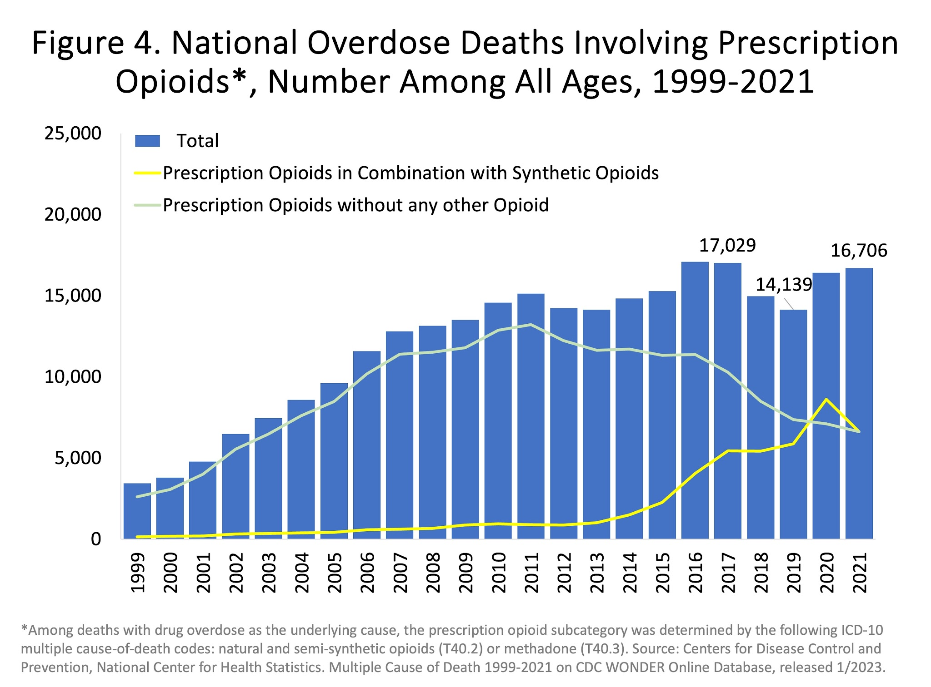
Source A: The image above is a bar graph and line chart presenting the number of overdose deaths from 1999 to 2021 due to prescription opioids. The bar chart clearly conveys an escalating number of deaths, beginning with less than 5,000 deaths in 1999 and reaching 16,706 deaths in 2021, proving a significant change. Additionally, the green and yellow lines specify whether prescription opioids were combined with other synthetic opioids or not, showing how the majority of the deaths were a result of a prescription opioid without any other opioids. (National Institute on Drug Abuse)

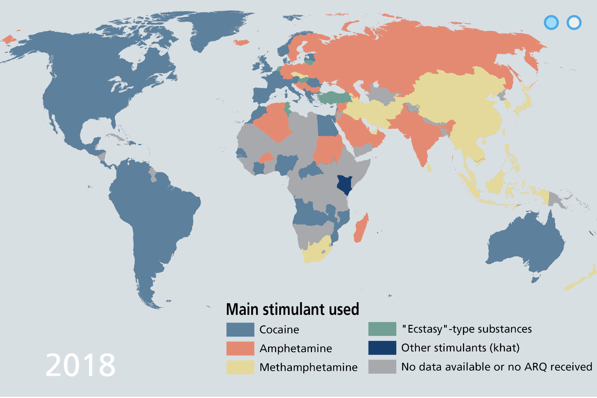
Source B: The image above portrays the most common stimulant (a class of drugs that increase the activity of the brain) used in each country throughout 2018. It is important to note that cocaine (represented by blue) is the most recurring color in the map. This is significant because cocaine is used within the medical field as a local anesthetic. (United Nations Office on Drugs and Crime)
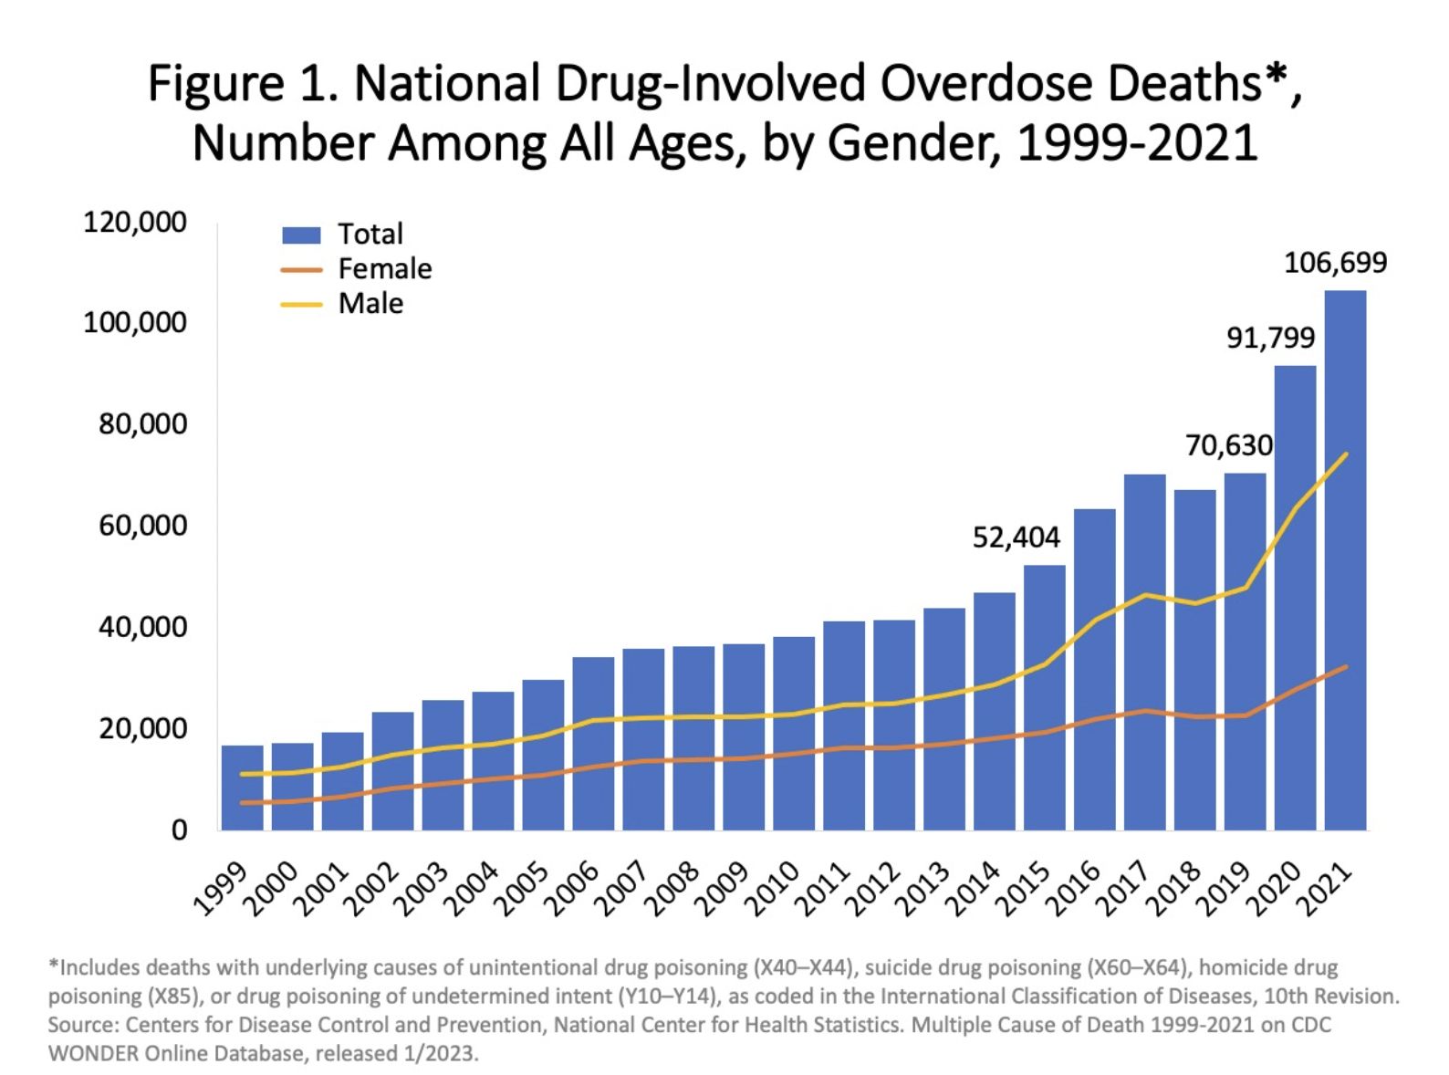
Source C: The image above is a bar graph and line chart that presents the number of drug-related overdose deaths from 1999 to 2021. The bar chart clearly conveys an escalating number of deaths, beginning with less than 20,000 deaths in 1999 and reaching 106,699 deaths in 2021, proving a significant change. Additionally, the red and yellow lines specify whether they’re female or male, showcasing how males are more likely to die due to drug-related overdose. (National Institute on Drug Abuse)

Bibliography
“Access to Controlled Drugs for Medical Purposes (GLOK67).” United Nations: Office on Drugs and Crime, 2021, www.unodc.org/unodc/es/drug-prevention-and-treatment/access-to-controlled-medicines/accessibility-medicines-availability-glok67.html. Accessed 7 Apr. 2024.

Afsan Bhadelia, et al. “Solving the Global Crisis in Access to Pain Relief: Lessons from Country Actions.” American Journal of Public Health, vol. 109, no. 1, American Public Health Association, Jan. 2019, pp. 58–60, https://doi.org/10.2105/ajph.2018.304769. Accessed 13 Apr. 2024.

Brandeis University. “The Ethics of Legalizing Medical Marijuana | Section Title | Ethical Inquiry | ENACT: The Educational Network for Active Civic Transformation.” Brandeis University, 2013, https://www.brandeis.edu/enact/archive/ethical-inquiry/2013/legalizing-marijuana.html. Accessed 7 April 2024.

Burke-Shyne, Naomi, et al. “How Drug Control Policy and Practice Undermine Access to Controlled Medicines.” Health and Human Rights, vol. 19, no. 1, 2017, pp. 237–52, www.ncbi.nlm.nih.gov/pmc/articles/PMC5473053/. Accessed 6 Apr. 2024.

Canadian Centre on Drug Abuse and Addiction. “Prescription Opioids (Canadian Drug Summary).” Www.ccsa.ca, Canadian Centre on Drug Abuse and Addiction, July 2020, www.ccsa.ca/sites/default/files/2020-07/CCSA-Canadian-Drug-Summary-Prescription-Opioids-2020-en.pdf. Accessed 13 Apr. 2024.

Centers for Disease Control and Prevention. “Opioid Overdose | Drug Overdose | CDC Injury Center.” Centers for Disease Control and Prevention, 2021, https://www.cdc.gov/drugoverdose/deaths/opioid-overdose.html. Accessed 7 April 2024.

“CONSULATE GENERAL of the REPUBLIC of INDONESIA JEDDAH, Kingdom of Saudi Arabia.” Kementerian Luar Negeri Republika Indonesia, 2018, www.kemlu.go.id/jeddah/en/news/25992/harsh-punishment-for-drug-dealers-in-saudi-arabia#:~:text=4%2FB%2F966%20dated%2010,deportation%2C%20imprisonment%20to%20death%20penalty. Accessed 13 Apr. 2024.

“Controlled Substances Agreement - Students.” Students, 2 Aug. 2018, students.wustl.edu/controlled-substances-agreement/. Accessed 6 Apr. 2024.

Cyr, Claude, et al. “Cannabis in Palliative Care: Current Challenges and Practical Recommendations.” Annals of Palliative Medicine, vol. 7, no. 4, AME Publishing Company, Oct. 2018, pp. 463–77, https://doi.org/10.21037/apm.2018.06.04. Accessed 13 Apr. 2024.

“Details.” Unodc.org, 2015, www.unodc.org/LSS/Country/DetailsLegalSystem?code=DLIL&country=CN. Accessed 7 Apr. 2024.

Drug Diversion: What Is a Prescriber’s Role in Preventing the Diversion of Prescription Drugs? 2016, www.hhs.gov/guidance/sites/default/files/hhs-guidance-documents/DrugDiversionFS022316.pdf

“Drug Overdose Death Rates | National Institute on Drug Abuse.” National Institute on Drug Abuse, 30 June 2023, nida.nih.gov/research-topics/trends-statistics/overdose-death-rates. Accessed 7 Apr. 2024.

ESMO. “Global Opioid Policy Initiative.” Esmo.org, 2014, www.esmo.org/policy/access-to-cancer-medicines-and-technologies/accessibility-and-availability-of-medicines-and-technologies/global-opioid-policy-initiative. Accessed 13 Apr. 2024.

Gateway Drugs Individual Counseling. “What Are Gateway Drugs? - Crest View Recovery.” Crest View Recovery Center, 24 March 2024, https://www.crestviewrecoverycenter.com/addiction-blog/gateway-drugs/. Accessed 8 April 2024.

Jenkins, Philip. “War on Drugs | History & Mass Incarceration.” Britannica, 5 March 2024, https://www.britannica.com/topic/war-on-drugs. Accessed 7 April 2024.

Joint Guidance Medical Council and Pharmaceutical Society of Ireland. “Safe Prescribing and Dispensing of Controlled Drugs.” Pharmaceutical Society of Ireland, https://www.thepsi.ie/Libraries/Practice_Guidance/PSI_and_Medical_Council_Joint_guidance.sflb.ashx. Accessed 18 May 2024.

johny.thomas. “Availability of Narcotic Drugs for Medical Use.” Incb.org, 2014, www.incb.org/incb/en/narcotic-drugs/Availability/availability.html. Accessed 13 Apr. 2024.

lamija.dzigal. “About.” Incb.org, 2024, www.incb.org/incb/en/about.html. Accessed 7 Apr. 2024.

Leyh, Brianne McGonigle, and Marie Elske Gispen. “Access to Medicines in Times of Conflict: Overlapping Compliance and Accountability Frameworks for Syria.” Health and Human Rights, vol. 20, no. 1, 2018, pp. 237–50, www.ncbi.nlm.nih.gov/pmc/articles/PMC6039728/. Accessed 13 Apr. 2024.

Lohman, Diederik. “‘Please, Do Not Make Us Suffer Any More….’” Human Rights Watch, 3 Mar. 2009, www.hrw.org/report/2009/03/03/please-do-not-make-us-suffer-any-more/access-pain-treatment-human-right#_ftn1. Accessed 13 Apr. 2024.

Manfredi, Christopher P. “Liberal Morality and the Myths of Drug Criminalization.” Policy Options, Apr. 2021, policyoptions.irpp.org/magazines/should-we-legalize-drugs/liberal-morality-and-the-myths-of-drug-criminalization/. Accessed 6 Apr. 2024.

Miller, Leah. “Drug Overdose Symptoms, Risks & Treatment.” American Addiction Centers, 2024, https://americanaddictioncenters.org/overdose. Accessed 18 May 2024.

Mohammad Hossein Mehrolhasani, et al. “Cross-Country Comparison of Treatment Policies Facing the Drug Abuse in Five Selected Countries.” PubMed, vol. 11, no. 2, National Institutes of Health, Apr. 2019, pp. 81–92, https://doi.org/10.22122/ahj.v11i2.233. Accessed 7 Apr. 2024.

Naina Bajekal. “Want to Win the War on Drugs? Portugal Might Have the Answer.” Time, Time, Aug. 2018, time.com/longform/portugal-drug-use-decriminalization/. Accessed 6 Apr. 2024.

National Cancer Institute. “Definition of opioid - NCI Dictionary of Cancer Terms - NCI.” National Cancer Institute, 2024, https://www.cancer.gov/publications/dictionaries/cancer-terms/def/opioid. Accessed 7 April 2024.

National Institute on Drug Abuse. “Drug Misuse and Addiction.” National Institute on Drug Abuse, 10 July 2020, https://nida.nih.gov/publications/drugs-brains-behavior-science-addiction/drug-misuse-addiction. Accessed 7 April 2024.

National Institute on Drug Abuse. “Opioids.” National Institute on Drug Abuse, March 2024, https://nida.nih.gov/research-topics/opioids. Accessed 7 April 2024.

“NCI Dictionary of Cancer Terms.” National Cancer Institute, Cancer.gov, 2024, www.cancer.gov/publications/dictionaries/cancer-terms/def/cannabis. Accessed 13 Apr. 2024.

Office, Accountability. “Preventing Drug Diversion: Disposal of Controlled Substances in Home Hospice Settings.” Gao.gov, 2020, www.gao.gov/products/gao-20-378#:~:text=Most%20patients%20get%20hospice%20care,anyone%20with%20access%20to%20them. Accessed 13 Apr. 2024.

Office. “Drug History.” U.S. Food and Drug Administration, 2023, www.fda.gov/about-fda/histories-fda-regulated-products/history-drug-regulation. Accessed 10 Apr. 2024.

“Philippines - Prohibited & Restricted Imports.” International Trade Administration | Trade.gov, 24 Jan. 2024, www.trade.gov/knowledge-product/philippines-prohibited-restricted-imports. Accessed 7 Apr. 2024.

‘Please, Do Not Make Us Suffer Any More….’ Human Rights Watch, 3 Mar. 2009, www.hrw.org/report/2009/03/03/please-do-not-make-us-suffer-any-more/access-pain-treatment-human-right#_ftn1. Accessed 13 Apr. 2024.

“Prescription Medicines Overview.” Therapeutic Goods Administration (TGA), 21 June 2022, www.tga.gov.au/resources/resource/guidance/prescription-medicines-overview. Accessed 13 Apr. 2024.

“Preventing Drug Diversion: Disposal of Controlled Substances in Home Hospice Settings.” Gao.gov, 2020, www.gao.gov/products/gao-20-378#:~:text=Most%20patients%20get%20hospice%20care,anyone%20with%20access%20to%20them. Accessed 13 Apr. 2024.

Procedures and Controls of Narcotics and Psychotropic Substances. www.sfda.gov.sa/sites/default/files/2021-09/Drug12112019e1.pdf.

Reuters. “Philippines’ Duterte Says Will Never Apologise for Drug War Deaths.” Reuters, 4 Jan. 2022, www.reuters.com/world/asia-pacific/philippines-duterte-says-will-never-apologise-drug-war-deaths-2022-01-04/. Accessed 7 Apr. 2024.

Sixty-Seventh World Health Assembly. Strengthening of Palliative Care as a Component of Comprehensive Care throughout the Life Course. World Health Assembly, 24 May 2015, apps.who.int/gb/ebwha/pdf_files/WHA67/A67_R19-en.pdf.

The Economist. “How Many People Have Been Killed in Rodrigo Duterte’s War on Drugs?” The Economist, The Economist, 22 Nov. 2021, www.economist.com/graphic-detail/2021/11/22/how-many-people-have-been-killed-in-rodrigo-dutertes-war-on-drugs. Accessed 7 Apr. 2024.

The, None. “Opioid Crisis: Addiction, Overprescription, and Insufficient Primary Prevention.” the Lancet Regional Health. Americas, vol. 23, Elsevier BV, July 2023, pp. 100557–57, https://doi.org/10.1016/j.lana.2023.100557. Accessed 7 Apr. 2024.

Timeline E PRINT. 2008, www.unodc.org/documents/wdr/WDR_2008/timeline_E_PRINT.pdf.

United Nations Office on Drugs and Crime. “EXECUTIVE SUMMARY.” United Nations Office on Drugs and Crime, 2023, https://www.unodc.org/res/WDR-2023/WDR23_Exsum_fin_SP.pdf. Accessed 18 May 2024.

US Department of Health. “Prescription Drug Abuse & Addiction Treatment Near Me.” American Addiction Centers, 3 January 2024, https://americanaddictioncenters.org/prescription-drugs. Accessed 8 April 2024.

VICE. “These Illegal Drugs Are Important Medicines | the War on Drugs.” YouTube, YouTube Video, 27 Feb. 2021, www.youtube.com/watch?v=odHk_oUvew8. Accessed 7 Apr. 2024.

“WHO Model Lists of Essential Medicines.” Who.int, 2023, www.who.int/groups/expert-committee-on-selection-and-use-of-essential-medicines/essential-medicines-lists. Accessed 6 Apr. 2024.

“WHO Revision of Pain Management Guidelines.” Who.int, 10 July 2023, www.who.int/who-revision-of-pain-management-guidelines. Accessed 13 Apr. 2024.

World Health Organization Executive Board. Strengthening of Palliative Care as a Component of Integrated Treatment throughout the Life Course . World Health Organization, 20 Dec. 2013, apps.who.int/gb/ebwha/pdf_files/EB134/B134_28-en.pdf. Accessed 13 Apr. 2024.

“What Are Palliative Care and Hospice Care?” National Institute on Aging, 2021, www.nia.nih.gov/health/hospice-and-palliative-care/what-are-palliative-care-and-hospice-care#:~:text=Palliative%20care%20is%20specialized%20medical,to%20cure%20their%20serious%20illness. Accessed 13 Apr. 2024.

Wood, Danielle. “Drug diversion.” Drug diversion | NPS, 2015, https://www.nps.org.au/assets/8e69d4a6876421a3-1aa701b7198d-Drug-diversion.pdf. Accessed 18 May 2024.

World Health Organization. “Opioid overdose.” World Health Organization (WHO), 29 August 2023, https://www.who.int/news-room/fact-sheets/detail/opioid-overdose. Accessed 18 May 2024.

Zhang, Phillip. “Practitioners And Prescriptive Authority - StatPearls.” NCBI, 2023, https://www.ncbi.nlm.nih.gov/books/NBK574557/. Accessed 18 May 2024.

ISP + ISP Chair Pairing
ISP + ISP Chair Pairing
Issue Bulletin 2
 | Chair 1 (Saksham) | Chair 2 (Sofia)
May 9th  11:59 pm | General Overview + Key Terms | Introduction + Major Parties
May 16th, at 11:59 pm | UN Involvement + Possible Solutions | Timeline + Evaluation of Previous Attempts to Resolve the Issue
May 23rd, at 11:59 pm | Appendix | Link to SDGs

