Forum: Human Rights Council (HRC)
Issue #1: Addressing the allocation of financial responsibility for healthcare provision in conflict zones
Student Officers: Esha Chugani
Position: Chair of the Human Rights Council

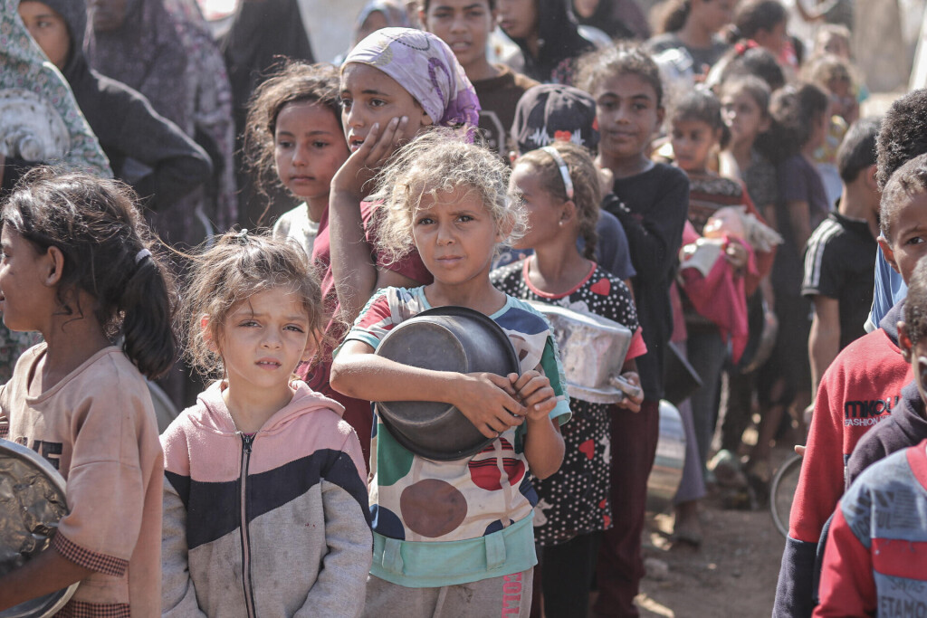
Bub, Gabriel. “Children in War Zones: Save the Children Calls for More Money for Humanitarian Aid.” Table.Briefings, 5 Nov. 2025, table.media/en/security/news-en/children-in-war-zones-save-the-children-calls-for-more-money-for-humanitarian-aid. Accessed 25 Apr. 2026.

Introduction
Today, more than ever, the question is asked: Is healthcare a human right? This question may seem straightforward, but answers vary across the globe. According to the International Society for Human Rights, healthcare is a fundamental right for all individuals, not a privilege. While many agree with this statement, an article published by the National Library of Medicine states that healthcare cannot be considered a human right. They claim it is quite impossible to state that healthcare is a human right for the reasons that it is difficult to define and unrealistic, especially in impoverished regions (Phillip Barlow, Southern General Hospital).

So if healthcare is not universally recognised as a human right, how can we ensure that impoverished and conflict regions have access to it? Between 5.7 and 8.4 million deaths are attributed to poor quality care each year (World Health Organization), demonstrating the importance of the allocation of financial responsibility for healthcare provision in conflict zones. The problem is that there are too many citizens in need of humanitarian aid and too many conflict zones, but insufficient funding for healthcare. Armed conflict in Palestine, Mexico, Sudan, and Syria has resulted in over 240,000 deaths in the past few months (ACLED Conflict Index).

Even if the warring countries have accessible healthcare systems, they are bombed by the opposing country or countries. Specifically, in Sudan, Ukraine, and Myanmar, hospitals were looted or occupied by opposing military forces. Furthermore, the majority of healthcare systems are severely damaged or nonfunctional. For example, in Sudan, 70% of health facilities in conflict areas ceased functioning by mid-2023, forcing millions to go without care. The healthcare facilities in Ukraine were struck by the Russians, damaging the few functioning hospitals they had left (Protect Aid Workers European Union). Overall, while healthcare is not the main reason for conflict, it plays a significant role in the lives of the citizens living in constant violence and fear.

Definition of Key Terms
Conflict zones: Conflict zones refer to war or political instability that disrupts essential services such as housing, transportation, communication, sanitation, water, and health care, which requires the response of people outside of the community affected. Over thirty wars are now being waged around the world. (National Library of Medicine)

Humanitarian Aid: Humanitarian aid is a form of assistance designed to save lives and alleviate suffering during and after crises, such as floods, famine, or conflicts. Aid is essential for addressing the immediate needs of affected populations and laying the groundwork for long-term recovery and development. More than 362 million people around the world are in critical need of humanitarian aid. When people are at their most vulnerable, humanitarian aid is often the difference between survival and suffering, or even life and death. (International Rescue Committee)

Financial Responsibility: Financial responsibility is about ethical money management for personal, societal, and environmental well-being. It is about building a secure foundation for the future. (Sustainability Directory)

Healthcare provision: Healthcare provision refers to the delivery and organization of medical services, resources, and care to individuals and communities. It encompasses a range of activities including preventive care, diagnosis, treatment, and rehabilitation. The structure and quality of healthcare provision can vary significantly across different regions, influenced by factors such as economic development, government policies, cultural values, and access to technology. (Fiveable)

Non-governmental organizations (NGOs): Nongovernmental organizations (NGOs) are typically mission-driven advocacy or service organizations in the nonprofit sector. There are large and small NGOs operating around the world and organized for just about every imaginable purpose. The term – coming from United Nations (UN) jargon to delineate between government bodies and private organizations – is relatively modern. (Harvard Law School)

Out-of-pocket expenditure (OOP): This indicator measures current health expenditure from out-of-pocket payments per person in USD. It indicates, on average, how much each person pays out-of-pocket in USD at the point of use. High out-of-pocket payments are associated with catastrophic and impoverishing household spending. Out-of-pocket payments are not pooled, and there is no sharing of risk among a wider group of people other than the household. This indicator describes the OOP expenditure in relation to the population size, facilitating international comparison. (World Health Organization)

Medical Neutrality: Medical neutrality refers to the principle of non-interference with medical services during conflicts and other humanitarian crises. TIt requires three things: (1) the protection of and non-interference with the operations of medical facilities, medical transport, and medical personnel; (2) the provision of the best medical care possible to all who need medical attention, combatants and non-combatants alike, regardless of their political affiliation or participation in conflicts and politics; and most generally, (3) the mandate that warring factions both protect and refrain from targeting civilians during conflicts. (Brill Publishers)

Sustainability: In 1987, the United Nations Brundtland Commission defined sustainability as “meeting the needs of the present without compromising the ability of future generations to meet their own needs.” Today, there are almost 140 developing countries in the world seeking ways of meeting their development needs, but with the increasing threat of climate change, concrete efforts must be made to ensure development today does not negatively affect future generations. The Sustainable Development Goals form the framework for improving the lives of populations around the world and mitigating the hazardous man-made effects of climate change.

Resource allocation: Resource allocation is the strategic distribution and management of resources—including human resources, physical resources, financial resources, and technological resources—across organizational initiatives, portfolios, and departments. (International Business Machines Corporation,)

General Overview
The Main Idea
The allocation of financial responsibility for healthcare provisions in conflict zones is an extremely multifaceted issue. Ranging from social issues, such as discrimination, all the way to political issues, such as funding healthcare systems. Addressing the issue at hand is not straightforward and requires efficiency, equity, and sustainability. Each country has its own process of allocating funds. For example, in the United States, governments allocate resources across regions, while hospitals and clinics focus on local needs, such as hiring staff or purchasing equipment (SAGE US).

Vulnerability of Conflict Zones
Over 240,000 people around the world were killed in conflict-related violence in the past 12 months (ACLED). Where conflicts flourish, the demand for healthcare intensifies. However, in conflict zones, healthcare systems are often severely compromised due to years of bombing and attacks on health infrastructure, particularly hospitals (Medical Humanitarian Action for Development, MEHAD). Syria, Yemen, Ukraine, and Palestine are currently facing various attacks on their medical facilities, leading to the migration of professional doctors and injured patients. Because conflict zones lack the infrastructure to support adequate healthcare facilities, any armed conflict affects them severely. Consequently, innocent civilians are unable to survive because the resources are inadequate and inaccessible.

Connection to Human Rights
The International Humanitarian Law (IHL) and Human Rights Law (HRL) are complementary frameworks that essentially establish what is considered a human right. In a report written by the International Review of the Red Cross, they state that in certain circumstances, the denial of medical treatment might also constitute cruel, inhuman, and degrading treatment, or even torture (IRRC). Using information from both IHL and HRL, the report goes beyond to show how the lack of funding for healthcare, and therefore inadequate healthcare, is a clear violation of human rights. Aside from being cruel towards citizens, it completely disregards the family situation of the injured civilian. This alone can lead to the fragmentation of a family, which can cause them to struggle economically and socially.

Global consequences
Where there is conflict, there is war, and with war comes severe and lasting consequences. Such consequences include extreme poverty and sanitation issues, resulting in the death of several citizens. The World Bank Group is currently working towards combating poverty through improving the funding of healthcare globally. However, because there are so many conflict zones around the world, this process would be extremely lengthy and expensive. According to the World Health Organization (WHO), over 4.6 billion civilians lack access to essential healthcare. Countries in conflict include Venezuela, Syria, Yemen, Russia, and Afghanistan.

Major Parties Involved and Their Views
The United States
The USA is the largest donor country when it comes to official development assistance (ODA), with a sum of USD 64.7 billion in 2023. (Norwegian Agency for Development Cooperation NORAD). Ukraine was the largest recipient country in 2023, receiving almost 12 billion USD in aid. Additionally, the US provided significant funding for Israel, both economically and concerning military systems (Council on Foreign Relations). Overall, the United States is a major state that holds great power within its country and globally.

China
China is the world’s second-largest healthcare market with an estimated value exceeding $1 trillion in 2024, and over $1.5 trillion by 2029, with 60 percent of health expenditures currently coming from the government (International Trade Administration). As a result of prioritizing sustainability, the “Healthy China 2030” initiative was started to provide further support for the expansion of healthcare services.

Russia
Russia has one of the highest consumer expenditures on healthcare (Statista). The 2025 Health Care Index ranks Russia’s system as the 57th best out of 89 countries, with a notably low score for the quality of its infrastructure (International Citizens Insurance).

Turkey
Turkey currently holds the world's largest refugee population. Around 2.3-3 million Syrian refugees reside here, due to the Syrian Civil War. Turkey implemented an "open door" policy, which allowed civilians to reside there and have access to their healthcare and protection.

Syria
Syria's funding of healthcare systems is heavily fragmented due to the current crisis. Millions of Syrians are unable to have access to decent healthcare.

Yemen
Yemen is heavily fragmented, and it is reflected on their healthcare provision. Their public health spending is extremely low; Yemen relies on international aid, private payments, and its public system. Less than 50% of their health facilities are functional, demonstrating the extreme need for improvement.

Ukraine
The Russia-Ukraine war has had a significant impact on Ukraine's need for public health systems. Their healthcare systems have specifically been attacked during wars, preventing Ukrainians from having access to adequate healthcare. Nonetheless, they are working consistently to improve access to public healthcare through the National Health Service of Ukraine.

World Bank Group
The mission of the World Bank Group is to end poverty and unite global citizens. It is made up of 189 countries, all working together towards the same mission. They provide global financial products, technical assistance and resources, and innovative solutions for complex development challenges (World Bank Group).

United Nations (UN)
In 2012, the United Nations established the Sustainable Development Goals (SDGs). 17 goals, each combating a significant worldwide struggle. Within these goals, healthcare and financial responsibility are extremely prevalent.

Timeline of Events, Relevant Resolutions, Treaties, and Events
Date Description of Event

1863 | In February 1863, what was to become the International Committee of the Red Cross met for the first time in Geneva, Switzerland. Henry Dunant, one of the five founding members, had previously published a book called A Memory of Solferino, which called for better care for wounded soldiers in wartime. (ICRC)
1864 | As a consequence of the foundation of the International Committee of the Red Cross in August 1864, at the initiative of the ICRC, the Swiss government organized a diplomatic conference attended by representatives of 15 European States and the United States of America to discuss the adoption of a convention to improve conditions for wounded soldiers on the battlefield.
1864 | The International Humanitarian Law (IHL) was adopted on 22 August 1864 and immediately signed by 12 present States at the Conference. The 1864 Convention thus became the first universal and lasting treaty of international humanitarian law. (ICRC)
1914 | World War I, also known as the Great War, officially began. As many as 8.5 million soldiers and some 13 million civilians died during World War I. The mass movement of soldiers and refugees helped spread one of the world’s deadliest influenza pandemics, also called the Spanish flu. (Britannica)
1939 | World War II began, increasing humanitarian issues around the world (Britain)
1944 | The United Nations (UN) was founded with 50 member states. Consequently, several changes occurred to human society. Issues ranging from gender based discrimination to healthcare provision were all being combatted.
1944 | The World Bank group was established. In July 1944 – one year before the end of World War II – delegates from 44 countries met for the United Nations Monetary and FInancial conference held at the Mount Washington Hotel in Bretton Woods, New Hampshire. The conference aimed to create the framework for post-war international economic cooperation and reconstruction. While the conference resulted in the formation of two institutions, the International Monetary Fund (IMF) and the International Bank for Reconstruction and Development (World Bank), the creation of the World Bank was not the primary focus. (World Bank Group)
1948 | The Universal Declaration of Human Rights (UDHR) was officially adopted. Drafted by representatives with different legal and cultural backgrounds from all regions of the world, the Declaration was proclaimed by the United Nations General Assembly in Paris on 10 December 1948 (General Assembly resolution 217 A) as a common standard of achievements for all peoples and all nations. It sets out, for the first time, fundamental human rights to be universally protected and it has been translated into over 500 languages. The UDHR is widely recognized as having inspired, and paved the way for, the adoption of more than seventy human rights treaties, applied today on a permanent basis at global and regional levels (all containing references to it in their preambles). (United Nations)
1980 | The Human Rights Council (HRC) was founded by Steve Endean to ensure global equality.
2011 - onward | The Syrian Civil War is one major global conflict caused by insufficient funding for healthcare. Since 2011, over 400,000 citizens have died during the war, not to mention those displaced and severely injured (Our World in Data).
2014 - onward | The Russia-Ukraine War had a lasting effect on Ukraine's healthcare systems. Attacks on Ukraine’s health care increased by 20% in 2025 (World Health Organization). This prevented their citizens from getting standard healthcare, resulting in over 1.2 million citizens either killed, lost, or missing (Center for Strategic and International Studies).

United Nations Involvement
Establishing the United Nations, 1944
The United Nations was established in 1944 among 50 member states. With this organization, their goal was to ensure global security and peace. One major aspect of the United Nations is its flexibility with funding. It would be extremely difficult for them to fund every conflict zone individually; therefore, they encourage and promote other ways of funding, such as non-governmental organizations. Their partnership with the World Bank Group and the International Monetary Fund (IMF) allows them to communicate with financial experts to ensure economic equality. Additionally, the United Nations has created several other committees, such as the United Nations High Commission for Refugees (UNHCR), that directly specialize in helping the refugees of conflict zones lacking healthcare.

The World Health Organization, 1948
Also known as WHO, the World Health Organization was established to connect nations, partners, and people to promote health, keep the world safe, and serve the vulnerable – so everyone, everywhere can attain the highest level of health (WHO). The goal of global health is most clearly seen in funding healthcare systems, especially in conflict zones. While the Human Rights Council (HRC) claims healthcare as a human right, establishing the World Health Organization (WHO) further enforces it and encourages funding.

The Universal Declaration of Human Rights, 1948
Officially established in 1948, the Universal Declaration of Human Rights is a document with 30 articles that establish human rights. This document was extremely important because it was the first time that humans were entitled to fundamental rights regardless of their freedom, nationality, race, religion, gender, or status. It was established soon after World War II and the Holocaust, demonstrating how crucial it was for ensuring global peace. The main reason why this document was so powerful was that it formally recognized healthcare as a human right. Previously, the United Nations had enforced and believed it, but by establishing the Universal Delaration if Human Rights, it became official.

Evaluation of Previous Attempts to Resolve the Issue
United Nations Security Council Resolution 2286
Resolution 2286 (2016) addresses the protection of medical and humanitarian personnel, facilities, and transport in armed conflict (UNSCR). The resolution aligns with the International Humanitarian Law by condemning attacks on medical facilities, personnel, and transport, and demands that all parties to armed conflicts comply fully with their obligations. The article has 14 clauses, which range from demanding protection of healthcare services during conflict to the United Nations personally monitoring each ongoing conflict. Overall, it was implemented to address not only the allocation of funds in conflict zones but also to combat the suffering of the citizens living in such critical conditions.

The WHO Health Emergencies Programme (WHE)
WHO’s Health Emergencies Programme works with all countries and partners to ensure the world is better prepared for all-hazards health emergencies that threaten global health security (WHO). Over the years, the program has funded conflicts in the Middle East, Africa, and Eastern Europe. In the Middle East, specifically Palestine and Israel, the program has been actively supporting the longer-term recovery and reconstruction of Gaza’s health system through the delivery of life-saving supplies, organizing external medical help, and monitoring and responding to disease outbreaks. Another example is in Africa, specifically Chad, the Central African Republic, Egypt, Ethiopia and South Sudan, where they worked intensively to coordinate the health response, reinforce disease surveillance, and distribute lifesaving medical supplies to people in need, despite the hampered access and insecurity (WHE). Finally, they have been working to support the Ukrainians suffering from the conflict of the Russia-Ukraine war. Besides delivering specialized medical supplies, coordinating the deployment of medical teams, and working with health authorities to minimise disruptions to the delivery of critical healthcare services within Ukraine, they have been providing citizens with essential medical supplies, such as Oxygen. WHO is coordinating nearly 200 health partners to deliver various health services across the country, reaching 8.5 million people in 2022 (WHO).

Possible Solutions
Localized Allocation for Healthcare Resources
Localisation refers to the collective process of shifting decision-making, funding, and responsibilities away from international actors and towards local actors, including affected communities, non-governmental organisations, and national governments (The Open Science Framework). In recent years, localisation has provided more timely, effective, and sustainable delivery of humanitarian assistance (Organisation for Economic Cooperation and Development, 2017). Since this process involves local citizens who are greatly affected by the lack of healthcare, especially in conflict zones, it allows them to be a part of the solution. Instead of international organizations working with the government, they would work with citizens who have suffered the consequences and whose lives are being influenced by the decisions being made.

Implement a Digital Monitoring System
In a study published in the British Medical Journal, titled "AI in conflict zones: the potential to revitalise healthcare in Syria and beyond," several benefits of implementing a digital monitoring system are outlined. First, it enables data-driven decisions to improve clinical care (BMJ Global Health), which can be used for future monitoring and diagnosis. Additionally, it encouraged the use of digital technology, such as video cameras, digital monitoring, and predominantly WhatsApp communication to support remote ward rounds, all of which were used in the Syrian American Medical Society (SAMS). Today, the use of artificial intelligence is growing exponentially, so it might as well be used to benefit the world, in this case by ensuring sufficient funding for healthcare, specifically in conflict zones.

Sustainable Development Goal (SDG)
SDG 3, Good Health and Well-Being
Sustainable Development Goal #3, Good Health and Well-Being, aims to “Ensure healthy lives and promote well-being for all at all ages” (United Nations SDGs). This includes children, mothers, senior citizens, and of course, citizens living in conflict zones. By establishing healthcare as a right rather than a privilege, the SDG goal directly aligns with the issue at hand. The acknowledgement automatically ensures adequate funding for healthcare globally, but especially in conflict zones.

Appendix
This section of the issue bulletin is dedicated to providing delegates with valuable sources to utilise during their research.

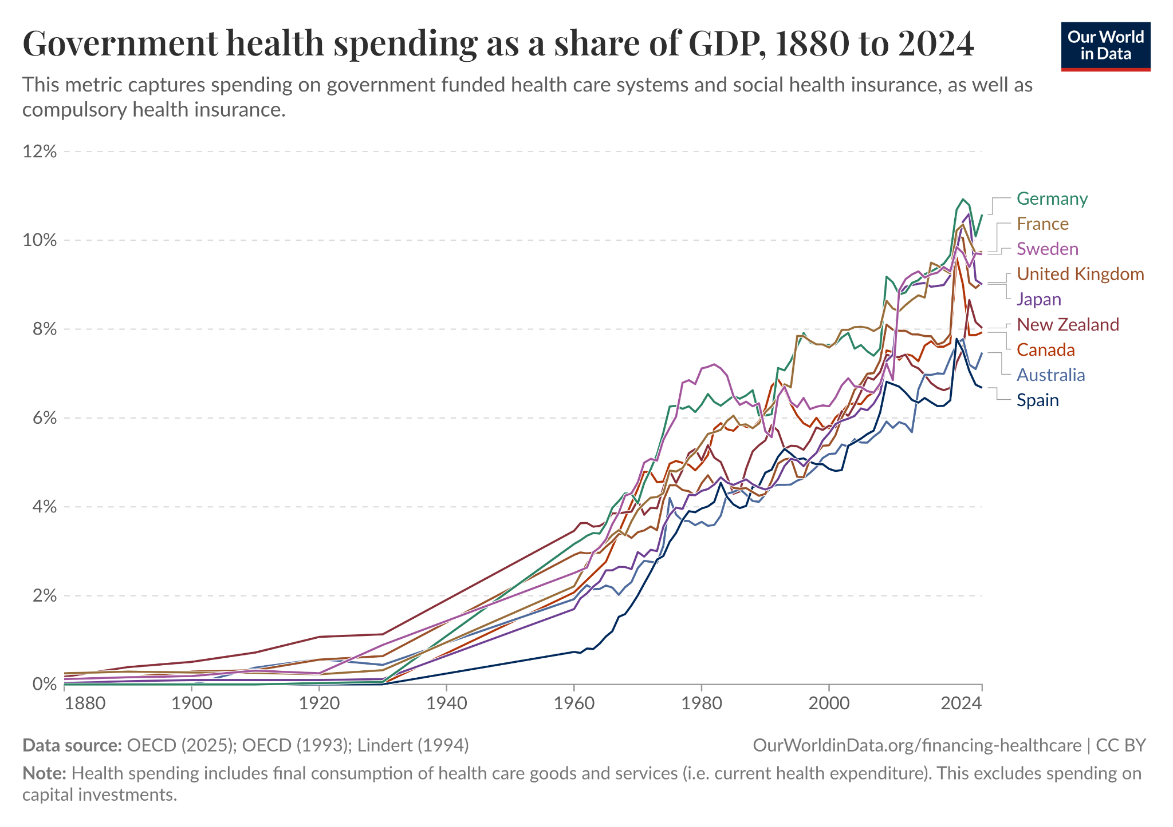
Source A: This image demonstrates the Government health spending share of Gross Domestic Product (GDP), from 1880 to 2024. The chart demonstrates a significant increase in spending, going from 0% to almost 12% in 40 years. This increase is directly correlated with the increase in global conflicts, which have raised the need for healthcare.

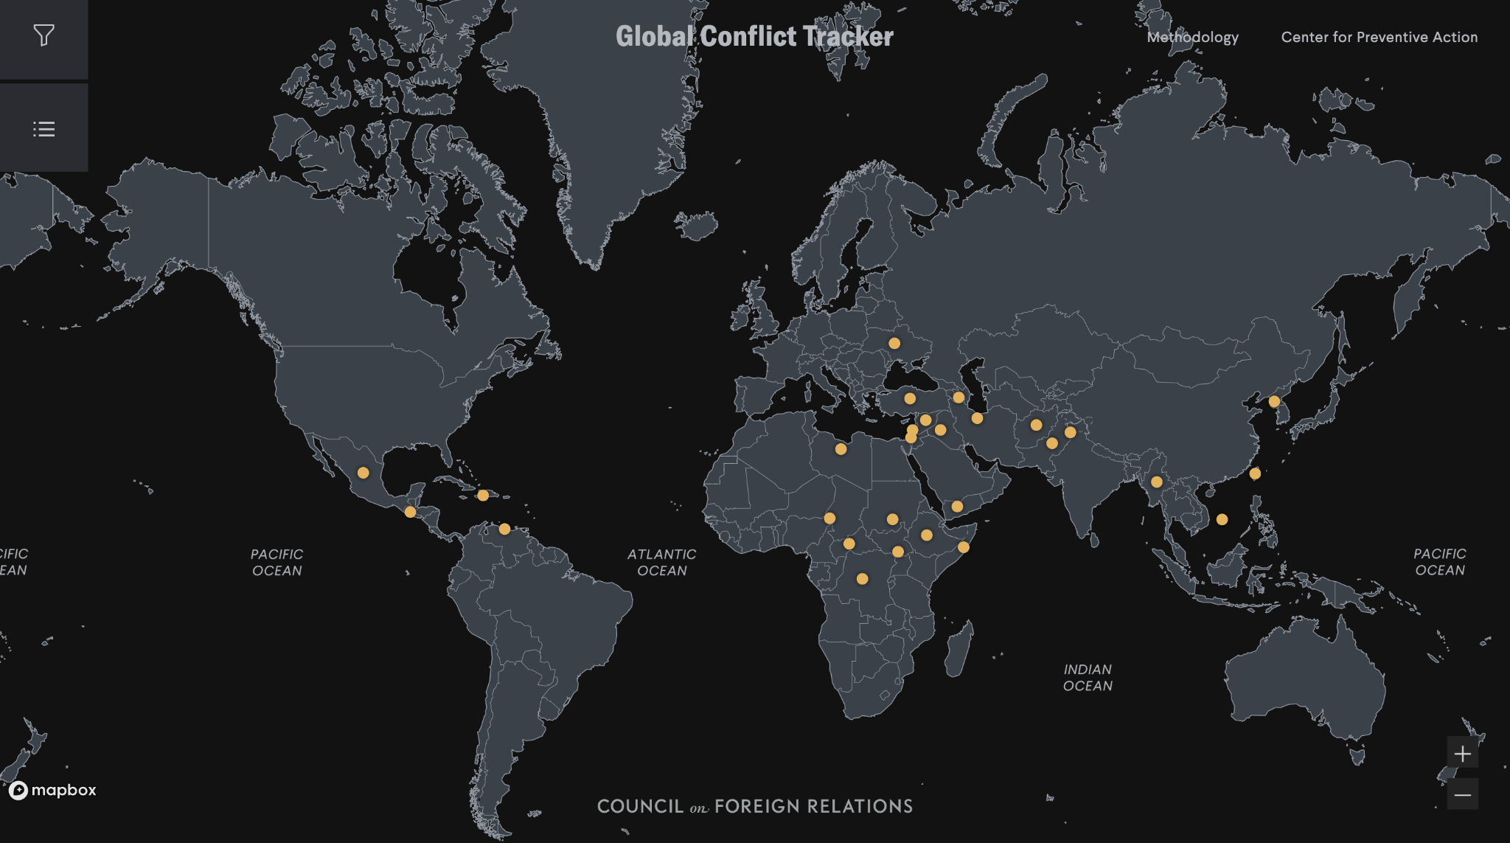
Source B: This image demonstrates the major conflict zones around the world. In Latin America, conflict zones include Mexico, Haiti, and Venezuela. There are several conflicts in Africa, including the Civil War in Sudan, the Conflict of Yemen and the Red Seas, and conflicts in Ethiopia, Libya, and more. The major conflicts are occurring in the Middle East, specifically in Iran, Pakistan, Afghanistan, and Syria.

Bibliography
"Access to Healthcare: A Right, Not a Privilege." International Service for Human Rights, https://ishr.org/access-to-healthcare-a-right-not-a-privilege/. Accessed 15 June 2026.

Ahmed, Anisa, et al. "Conflict and Health: The Impact of War on Health Systems." International Journal of Health Policy and Management, vol. 10, no. 2, 2021, https://pmc.ncbi.nlm.nih.gov/articles/PMC7851932/. Accessed 15 June 2026.

"Attacks on Ukraine's Health Care Increased by 20% in 2025." World Health Organization, 23 Feb. 2026, https://www.who.int/news/item/23-02-2026-attacks-on-ukraine-s-health-care-increased-by-20-in-2025. Accessed 15 June 2026.

"Conflict in Israel and the Occupied Palestinian Territory." World Health Organization, https://www.who.int/emergencies/situations/conflict-in-Israel-and-oPt. Accessed 15 June 2026.

"Financial Responsibility." Sustainability Directory, https://lifestyle.sustainability-directory.com/term/financial-responsibility/. Accessed 15 June 2026.

"Global Conflict Tracker." Council on Foreign Relations, https://www.cfr.org/global-conflict-tracker. Accessed 15 June 2026.

"Health Care in Conflict." Safeguarding Health in Conflict Coalition, https://protectaidworkers.org/health-care-in-conflict-by-shcc/. Accessed 15 June 2026.

"Health Care Is a Human Right." American Bar Association, https://www.americanbar.org/groups/crsj/resources/human-rights/archive/health-care-human-right/. Accessed 15 June 2026.

"Health Is a Fundamental Human Right." World Health Organization, https://www.who.int/news-room/commentaries/detail/health-is-a-fundamental-human-right. Accessed 15 June 2026.

"History of the ICRC." International Committee of the Red Cross, https://www.icrc.org/en/our-history. Accessed 15 June 2026.

"International Human Rights Law." Office of the United Nations High Commissioner for Human Rights, https://www.ohchr.org/en/instruments-and-mechanisms/international-human-rights-law. Accessed 15 June 2026.

"Quality Health Services." World Health Organization, https://www.who.int/news-room/fact-sheets/detail/quality-health-services. Accessed 15 June 2026.

"Resource Allocation." IBM, https://www.ibm.com/think/topics/resource-allocation. Accessed 15 June 2026.

"Sudan Emergency." World Health Organization, https://www.who.int/emergencies/situations/sudan-emergency. Accessed 15 June 2026.

"The ACLED Conflict Index." Armed Conflict Location & Event Data Project (ACLED), https://acleddata.com/series/acled-conflict-index. Accessed 15 June 2026.

"The Global Peace Index Map." Vision of Humanity, https://www.visionofhumanity.org/maps/. Accessed 15 June 2026.

"The Importance of Humanitarian Aid." International Rescue Committee, https://www.rescue.org/article/what-humanitarian-aid-and-why-it-important. Accessed 15 June 2026.

"United Nations Security Council Resolution 2286 (2016)." UNSCR, https://unscr.com/en/resolutions/doc/2286/. Accessed 15 June 2026.

"U.S. Aid to Israel in Four Charts." Council on Foreign Relations, https://www.cfr.org/articles/us-aid-israel-four-charts. Accessed 15 June 2026.

"World War I." Encyclopaedia Britannica, https://www.britannica.com/event/World-War-I. Accessed 15 June 2026.

Xu, Ke, et al. "Financing Healthcare." Our World in Data, https://ourworldindata.org/financing-healthcare. Accessed 15 June 2026.

Zwi, Anthony B., and Alastair B. Ager. "Complex Political Emergencies and Health." BMJ, vol. 321, no. 7255, 2000, https://pmc.ncbi.nlm.nih.gov/articles/PMC1126951/. Accessed 15 June 2026.

Leaning, Jennifer, and Debarati Guha-Sapir. "Natural Disasters, Armed Conflict, and Public Health." New England Journal of Medicine, vol. 369, no. 19, 2013, https://pmc.ncbi.nlm.nih.gov/articles/PMC4921424/. Accessed 15 June 2026.

"Health Financing and Protection of Health Care in Conflict." BMJ Global Health, vol. 9, no. 8, 2024, https://gh.bmj.com/content/bmjgh/9/8/e015755.full.pdf. Accessed 15 June 2026.

"Protecting Health Care in Armed Conflict." Open Science Framework, https://osf.io/rsztm/overview. Accessed 15 June 2026.

Bouvier, Antoine A. Humanitarian Law and the Protection of Health Care. Oxford UP, https://academic.oup.com/book/5907. Accessed 15 June 2026.

Müller, Amrei. "The Right to Health in Armed Conflict." The Right to Health in Armed Conflict, edited collection, Brill, https://brill.com/display/book/edcoll/9789004431140/BP000060.xml. Accessed 15 June 2026.

