Forum: Human Rights Council (HRC)
Issue #1: Addressing democratic backsliding and Its Impact on the protection of human rights.
Student Officers: Lia Caballero
Position: Chair of the Human Rights Council

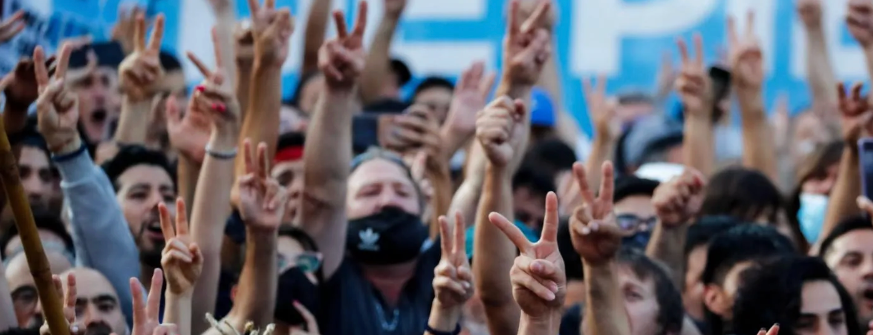
Understanding and Responding to Global Democratic Backsliding.” Carnegie Endowment for International Peace, 2022, carnegieendowment.org/research/2022/10/understanding-and-responding-to-global-democratic-backsliding.

Introduction
In an era where only about 29% of the world’s population lives in a democracy (Our World in Data), a silent threat looms: democratic backsliding—the gradual erosion of democratic structures, values, and safeguards (Bermeo). Traditionally, countries experience their transitions towards democracy at the end of the twentieth century, and particularly in the wake of the end of the Cold War, when dictatorships in places such as Latin America, Eastern Europe, and certain African nations were dismantled (Walker). In more contemporary times, there have been instances of democratic backsliding, which have become an increasing concern across both developed and developing regions.

It is debatable whether democratic backsliding occurs because elections take place, but they are often rigged, limited, and distorted. At the same time, elected officials claim that limitations on people’s rights and freedoms are necessary for the sake of ensuring their country’s security and prosperity, the conflict here involves sovereignty versus international responsibility, national security versus personal freedom. Democratic backsliding occurs without people realizing that, as governments can conduct themselves as legitimate democracies even though undermining the core principles of democracy, such as judicial independence or restricting media freedom.

The reason why this topic is important is that it is linked with democracy and human rights. The more democracy goes backwards, the more freedom becomes restricted. It can be about freedom of speech, freedom of the press, freedom of assembly, or freedom of trial. Solving or preventing backsliding is crucial for promoting accountability and protecting marginalized and oppressed groups, highlighting the need for stronger international cooperation and institutional safeguards to uphold democratic principles and human rights protections globally.

Definition of Key Terms
Democratic Backsliding: The gradual weakening of democratic institutions, processes, and norms, often leading to reduced political freedoms and weakened protection of human rights. This is the central issue being addressed (Meyerrose).

Populism: A political approach that claims to represent “the people” against perceived elites or institutions. In the context of democratic backsliding, populist rhetoric is often used to justify weakening democratic norms, undermining institutional checks, and concentrating power in the executive.

Majority Rule: A core democratic principle where decisions are made based on the preference of more than half of the population. While essential to democracy, it becomes problematic when used without safeguards, as it can enable the suppression of minority rights during periods of democratic decline.

Multi-Party System: A political system in which multiple parties compete for political power, allowing for diverse representation. Democratic backsliding often involves weakening opposition parties or restricting political competition, undermining this system (Hudson).

Minority Rights: The protections granted to groups that are smaller or politically marginalized within a society. These rights are especially vulnerable during democratic backsliding, when governments may prioritize majority interests at the expense of inclusivity and equality (Gorokhovskaia and Grothe).

Checks and Balances: Institutional mechanisms that allow different branches of government to limit and oversee each other’s powers, preventing any single branch from becoming too dominant. These mechanisms are often weakened or bypassed, enabling the concentration of authority and reducing accountability.

Rule of Law: The principle that all individuals and institutions are subject to and accountable under the law. It is crucial in preventing abuse of power, and its erosion is a key sign of democratic backsliding (“5.4: Democratic Backsliding”).

Judicial Independence: The ability of courts to operate without political interference. This is important because governments experiencing democratic backsliding often attempt to control the judiciary to avoid accountability (“U.S. Democratic Backsliding in Comparative Perspective”).

Separation of Powers: The division of government into branches (executive, legislative, judicial) to prevent the concentration of power. Democratic backsliding often involves one branch, usually the executive, gaining excessive control.

Civil Liberties: Basic individual freedoms of expression, assembly, and the press. They are often restricted during a democratic decline to limit opposition and public criticism.

Electoral Integrity: The extent to which elections are free, fair, and transparent. Manipulated or unfair elections are a major indicator of democratic backsliding.

General Overview
The Main Idea
Democratic backsliding is characterized by the gradual weakening of democratic institutions and the erosion of fundamental rights and freedoms (Sebők et al. 741). One of the most contentious issues related to democratic backsliding includes the varying opinions on governance and human rights that different countries have. Whereas some countries give priority to democracy and transparency over all else, others prioritize national sovereignty, safety, and economic stability before anything else. In light of such divergent approaches, countries may react differently to any criticism they receive and allow themselves more leeway in their dealings with foreign entities. Additionally, democratic backsliding is increasingly observed across both developing and developed nations, where leaders use existing institutions to consolidate power in subtle and incremental ways (Dean). Consequently, the ability of people to exercise their rights may vary according to the particular country one hails from, for freedom of speech, fair trial, and political engagement are examples of such rights (Sebők et al. 741)

Mechanisms of Democratic Backsliding
In many instances, democratic backsliding takes place gradually and legally as opposed to being abrupt or violent (“Home | V-Dem”). It can involve introducing policies that undermine the judiciary’s independence, opposition groups, and freedoms of expression, among other elements of democracy, but continue to maintain democratic institutions in form but not in substance through elections (Freedom House). This is where the process of voting takes place without integrity due to factors such as mismanagement or disinformation (International IDEA, “International IDEA”). The same applies when populism takes precedence, and leaders justify their actions by arguing they represent the interests of the people (“Yascha Mounk”).

Impact on Human Rights
There is a clear connection between the decline of democratic institutions and human rights protection (Freedom House). When these institutions become weaker, there is a tendency to curtail civil rights, including the right to speak freely, assemble, and practice journalism (Human Rights Watch). It is also common for minority communities to be discriminated against when there is a decline in democratic practices, as governments tend to protect the rights of their own people while ignoring those of minorities (Amnesty International). This is especially evident when the judiciary becomes less independent, making it easy to commit human rights abuses without facing any consequences (World Justice Project).

International Challenges and Responses
Democratic erosion poses a major problem for the international community (United Nations). Bodies like the United Nations try to tackle this problem by monitoring human rights violations and taking action when necessary (United Nations, “Ukraine: Behind the Numbers”). However, this is hampered by the concept of sovereignty, as some countries do not wish to be subject to any kind of intervention in their domestic policies (International IDEA, “International IDEA”). Yet, the trend of democracy’s erosion is growing globally and demands international cooperation (Freedom House). Measures taken to tackle this include using diplomacy, imposing sanctions, and promoting democratic norms (European Union).

Major Parties Involved and Their Views
United States
The United States plays a major role in promoting democracy and human rights advocacy. Yet, it faces several domestic problems, such as political polarization, voting limitations, and electoral trust issues. According to Freedom House (2025), the U.S. democracy rating has declined steadily from 89 to 83/100 in the last decade. Nevertheless, the country still actively encourages democratic accountability through diplomatic negotiations, sanctions, and international cooperation initiatives.

China
China offers a contrasting view, emphasizing state sovereignty and non-interference in internal affairs. The nation practices a one-party political system and restricts democratic activities and freedom of speech and association. As noted by Human Rights Watch (2025), numerous human rights violations occur despite these policies. China argues that stability and economic growth should precede any Western-style democratic transitions.

Russia
Russia has undergone significant democratic backsliding, with curbs on political opposition, media freedom, and civil society. Analysts emphasize the absence of competitive and fair elections. Freedom House (2026) rates Russia as “Not Free” due to extensive civil liberties restrictions. Russian officials frequently ignore external criticism and prioritize national sovereignty over global human rights interventions.

Hungary
In Europe, Hungary is an example of democratic backsliding within a democracy. It conducts elections but has been accused of violating judicial independence and media pluralism. The EU has instituted Article 7 procedures (launched in 2018, ongoing in 2025) against Hungary, highlighting the clash between national sovereignty and supranational democratic values.

India
The world’s largest democracy, India, wields considerable weight in this discussion because of its size. However, concerns have been raised about press freedom, minority protection, and constraints on civil society organizations. Freedom House 92025) classified India as “Partially Free,” indicating declining guarantees. India deals with these through a balance of democratic values and national security considerations.

Brazil
In Latin America, Brazil contends with political polarization, misinformation campaigns, and challenges to election legitimacy—issues that reveal backsliding risks in mature democracies. International IDEA (2025) analyzes how such dynamics erode public trust and institutions, steering the need for robust safeguards.

Turkey
Turkey has experienced significant democratic regression, particularly concerning freedom of the press and judicial independence. Freedom House (2026) ranks it “Not Free,” citing opposition repression and civil liberties restrictions. These are deemed necessary for national security by the government.

Venezuela
Venezuela exemplifies drastic backsliding, featuring institutional decay, disputed elections, and subsequent humanitarian disaster. Foreign bodies such as the OAS (2024) document extensive human rights violations, indicating the severe consequences of extended deterioration.

Germany
Germany promotes democracy and human rights on the international stage. It supports anti-backsliding measures via international organizations like the European Union, emphasizing the rule of law, judicial independence, and accountability systems.

United Nations (UN)
The United Nations, via the Human Rights Council, deals with backsliding through monitoring, reporting, and engagement. However, limitations exist due to state sovereignty. The International Institute for Democracy and Electoral Assistance (IDEA, 2025) reveals that over half of the world’s democracies exhibit regression, exacerbating the UN’s daunting challenges.

Timeline of Events, Relevant Resolutions, Treaties, and Events

Date Description of Event

1945 | Establishment of the United Nations to promote world peace, human rights, and democracy.
1948 | Adoption of the Universal Declaration of Human Rights, which sets an international standard on human rights and freedoms.
1970s–1990s | “Third Wave of Democratization” (coined by Samuel P. Huntington), where countries in Latin America, Eastern Europe, and Africa adopted democracies
1991 | Dissolution of the Soviet Union and the rapid democratization of Eastern European states.
2006 | The establishment of the United Nations Human Rights Council is charged with ensuring that there are no human rights violations in any country.
2010–Present | Trend toward democratic backsliding on the global stage, with growing encroachment on civil liberties and democratic institutions (Freedom House reports)
2014 | Annexation of the territory of Crimea by Russia is an issue because of potential implications for sovereignty, democracy, and human rights abuses.
2016 | Worries about issues concerning electoral integrity and misinformation in the global community, especially as seen in the context of the 2016 United States Presidential election.
2018 | European Union triggers Article 7 procedure against Hungary due to worries about judicial independence and democratic erosion
2020 | Global discussion about emergency powers in relation to the global pandemic, with accusations made by some of the excessive use of limitations in certain countries
2021 | The US Capitol Attack brings the problem of democratic instability to light.
2022 | Continued democratic decline is reported globally, with research from organizations like the Carnegie Endowment for International Peace emphasizing the need for international response.
2024–2026 | Reports by Freedom House and International IDEA indicate that over half the world’s democracies are facing some level of democratic backsliding.

United Nations Involvement
The United Nations has been actively involved in combating democratic erosion and securing human rights by implementing monitoring mechanisms, international resolutions, investigations, and collaborating with member countries. The United Nations Human Rights Council is one of the organizations that aims at fostering democratic governance, accountability, and respect for civil liberties globally (Nations).

Universal Declaration of Human Rights (1948)
The Universal Declaration of Human Rights was adopted by the United Nations General Assembly in 1948 after the Second World War. The declaration recognized fundamental human rights and freedoms that are enjoyed by everyone, which include freedom of speech, assembly, religion, and involvement in government affairs. These freedoms are key elements of a democracy and are often infringed upon when there are attempts to undermine democracy. Although the declaration is not legally enforceable, it has set the stage for contemporary human rights law (“Research Guides”).

International Covenant on Civil and Political Rights (ICCPR), 1966
The International Covenant on Civil and Political Rights is a convention that came into effect in 1976. It brings states that sign it to the protection of certain civil and political rights such as freedom of speech, the right to be tried fairly, the right to participate in elections, and freedom of the press. This international covenant is highly pertinent to the issue of democratic backsliding because many states, under the accusation of eroding democracy, violate these rights. The Human Rights Committee oversees member states and reviews their reports in regard to the implementation of the agreement (Nations, “Protect Human Rights | United Nations”).

Establishment of the United Nations Human Rights Council (2006)
This international organization, which replaced the UN Commission on Human Rights, was created in 2006 to address violations of human rights around the world and to promote democracy. Among other methods for overseeing the adherence to human rights, the UNHRC carried out the Universal Periodic Review (UPR). Under this process, the organization assesses all member states on their human rights records. The UN Human Rights Council often addresses issues related to media repression, judicial interference, opposition silencing, and the abuse of minorities’ rights in cases of democratic backsliding (Nations).

UN Resolution on Human Rights, Democracy, and the Rule of Law (2012)
In 2012, the UN Human Rights Council passed a resolution highlighting the relationship among democracy, human rights, and the rule of law. The resolution stressed that democratic governance would enhance human rights protection and urged states to sustain transparency in their institutions, ensure judicial independence, and maintain effective governance systems. This resolution also urges the international community to take action in response to declining democracy and assist countries grappling with weakened institutions (Human).

UN Monitoring and Investigations into Human Rights Violations
The United Nations is to investigate and monitor the cases of human rights abuse in connection with democratic backsliding in countries such as Venezuela, Myanmar, and Belarus. Using special rapporteurs and investigating commissions, the UN monitors human rights abuses linked to political oppression, manipulation of electoral processes, media censorship, and suppression of civil society organizations (Nations).

Evaluation of Previous Attempts to Resolve the Issue
Universal Declaration of Human Rights (1948)
One of the first global instruments aimed at ensuring democratic rights and freedoms across the world was the Universal Declaration of Human Rights (UDHR), adopted by the United Nations General Assembly in 1948. The declaration guaranteed basic human rights, including freedoms of expression, assembly, religion, and participation in governance. In other words, democratic freedoms and rights are integral parts of democracy, which are often challenged when democratic erosion occurs. The UDHR can be considered the basis for many future human rights instruments and standards of democracy worldwide.

On the other hand, it should be noted that the UDHR did not provide any legal enforcement mechanism for its provisions. Consequently, many authoritarian governments violating democratic norms have been able to ignore their commitments under the Declaration without facing serious consequences. In other words, even though the UDHR served as the basis for democratic and human rights standards around the globe, its non-binding nature has weakened its role in preventing democratic deterioration.

International Covenant on Civil and Political Rights (ICCPR)
The International Covenant on Civil and Political Rights (ICCPR), adopted in 1966 and ratified in 1967, sought to reinforce human rights protection through binding legal obligations. This covenant ensures the protection of rights such as the right to free expression, fair trial, participation in elections, and freedom of the press, which are essential for democracy. Further, the Human Rights Committee was formed to oversee compliance with the provisions of the covenant and conduct reviews of the information provided by member nations about the fulfillment of the covenant.

The ICCPR has contributed immensely to ensuring that there are international standards for holding countries accountable and enabling the UN to openly comment on any violation associated with democratic erosion. Nevertheless, the covenant is highly constrained by its dependence on the consent of the sovereign state, making it difficult to enforce. Most of the nations blamed for eroding democratic values tend to overlook the recommendations, deny access, and selectively comply with the obligations stipulated in the covenant. Therefore, although the ICCPR has enhanced human rights standards globally, democratic erosion persists in many member states.

United Nations Human Rights Council (2006)
The formation of the Human Rights Council of the United Nations (UNHRC) in 2006 was yet another notable international effort to curb the problem of democratic backsliding. It aimed to investigate cases of human rights violations, promote democracy, and enforce accountability through mechanisms such as the Universal Periodic Review (UPR), which includes an assessment of the human rights records of all UN member states, with special emphasis on issues like judicial independence, media repression, unfair elections, and political opposition.

It is worth mentioning that the UNHRC has achieved success in its effort to raise awareness of democratic regression worldwide and launch investigations of cases like those of Venezuela, Myanmar, and Belarus. These investigations have revealed human rights violations and pressured the countries involved through international intervention. Still, the organization faces criticism due to accusations of political prejudice and selectivity, as well as the issue of state sovereignty and the unwillingness of some nations to be interfered with domestically by external powers.

European Union Actions Against Democratic Backsliding
In addition to other regional organizations, the European Union has also taken some actions to counter democratic backsliding in member countries. In one of the most notable incidents, Article 7 proceedings were initiated against Hungary in 2018 owing to fears related to judicial independence, corruption, and media restrictions. Moreover, democratic erosion in Poland has been criticized by the European Union, which has tied funding procedures to adherence to democratic principles.

This action indicated the readiness of the European Union to safeguard democratic values in the region and put pressure on states accused of undermining democracy internationally. Nonetheless, there have been limitations to the efforts made due to the fact that Article 7 sanctions need unanimous approval among all members, and hence, their effective application has not been feasible. In addition, intervention by the EU in such matters tends to be seen by some governments as interfering in national affairs, creating tensions within the organization.

International Sanctions and Diplomatic Pressure
Another strategy that has been applied to deal with the issues of democratic erosion and human rights violations is the implementation of international sanctions and diplomatic pressure on countries such as Russia, Venezuela, Belarus, and Myanmar. International organizations and governments, particularly the US and the EU, have put various sanctions on the officials involved in democratic erosion and human rights violations by imposing travel bans, freezing assets, and imposing economic sanctions on their economies.

While international sanctions and diplomatic pressures have been effective in bringing the issue to the attention of the international community and isolating specific regimes diplomatically, such strategies have not helped in bringing significant democratic change and might negatively impact civilians more than government officials. Furthermore, sanctions have sometimes helped regimes to promote nationalistic sentiments among the citizens and increase repression against them.

Possible Solutions
Strengthening International Monitoring and Early Warning Mechanisms
One potential approach to addressing democratic backsliding is the enhancement of international monitoring systems that identify early signs of institutional decline. Agencies such as the UNHRC and OHCHR might make greater use of the Universal Periodic Review system but increase its frequency of application in regard to states that are at risk of democratic backsliding (United Nations Human Rights Council) . Moreover the implementation of a new, separate indicator for “Democracy Risk” through the UN would ensure that monitoring measures can more accurately track levels of judicial independence, freedom of the press, and fairness of elections (Hudson, “Explainer: Democratic Backsliding | International IDEA”).

Conditionality of International Aid and Trade Agreements
Another possible solution involves linking international financial assistance and trade benefits to measurable democratic and human rights standards. Multilateral agencies such as the International Monetary Fund (IMF), World Bank, and regional bodies such as the European Union should make more rigorous use of conditional policies whereby non-compliance with democratic norms will lead to serious penalties such as restrictions on access to finance and favorable trade deals (IMF; Human Rights in EU Trade Agreements, the Human Rights Clause and Its Application). This would mean that states that have undergone democratic reversals are subjected to conditional penalties when there is no adherence to these norms (Human Rights in EU Trade Agreements, the Human Rights Clause and Its Application).

Strengthening Protection of Civil Society and Independent Institutions
A further solution is the reinforcement of protections for civil society organizations, independent media, and judicial institutions through international legal instruments. The UN can set up an “International Civil Society Protection Mechanism” that will assist journalists, activists, and opposition members who suffer politically induced repression. Furthermore, sanctions can be imposed on individuals who violate the independence of the judiciary or the independence of the press instead of imposing economic sanctions on the countries (Human Rights in EU Trade Agreements, the Human Rights Clause and Its Application).

Expansion of International Election Observation and Verification Systems
International election missions may prove effective in curbing electoral manipulation, which is one of the major features of democratic erosion (Hudson, “Explainer: Democratic Backsliding | International IDEA”). This may involve giving institutions such as the OSCE, the Carter Center, and the United Nations an expanded mandate to observe elections not just at times of elections but on an ongoing basis. Some of the aspects that may be observed under this mandate include post-election dispute resolution mechanisms. Where elections turn out to be highly problematic, joint legitimacy evaluations may be conducted (Hudson, “Explainer: Democratic Backsliding | International IDEA”).

Sustainable Development Goal (SDG)
SDG 16, Peace, Justice, and Strong Institutions
The 16th Sustainable Development Goal: Peace, Justice, and Strong Institutions, is intended to create societies that are peaceful and inclusive, provide justice for all, and create capable, accountable, and inclusive institutions at all levels. According to the United Nations Sustainable Development Goals, SDG 16 is concerned with the safeguarding of civil liberties, the reduction of corruption, transparent government, and the rule of law. The connection between this goal and the topic of democratic erosion can be drawn here. Democratic backsliding threatens democratic institutions, hinders judicial independence, limits freedom of speech, and impairs electoral legitimacy, thereby contradicting the objectives of SDG 16. As states become more authoritarian and suppress individual freedoms, the state's protection of human rights becomes more vulnerable, particularly among minorities and marginalized communities. In addition, corruption and poor governance may result when institutions are weakened. This question is directly related to SDG 16 since it brings to light the significance of upholding democratic institutions, the rule of law, justice, and accountability in the world. Cooperation among nations is vital to prevent the erosion of democracy and to preserve the human rights of citizens. The United Nations aims to accomplish all the sustainable development goals by the year 2030, and one must address the backsliding of democracy for the achievement of SDG 16.

Appendix
This section of the issue bulletin is dedicated to providing delegates with valuable sources to utilize during their research.

https://carnegieendowment.org/research/2022/10/understanding-and-responding-to-global-democratic-backsliding?utm
Source A:
This source explains what democratic backsliding is all about and looks at how democratic institutions have been gradually undermined in various parts of the world. This would be relevant in comprehending how democracy has been eroded globally

https://freedomhouse.org/report/freedom-world?utm
Source B:
The database contains annual assessments of the state of political rights and civil liberties around the world. It can be useful in studying modern cases of democracy deterioration and limitation of freedom.

https://www.ohchr.org/en/ohchr_homepage
Source C:
This document from the UN provides details on the work of the Human Rights Council in ensuring that democracy flourishes in investigating any cases of human rights abuses that arise due to the decline of democracy.

https://www.un.org/en/about-us/universal-declaration-of-human-rights?utm
Source D:
This source explains some basic human rights and freedoms that exist on an international level, such as freedom of speech, association, and participation in the democratic process. This source may help explain how democracy is linked to human rights protection.

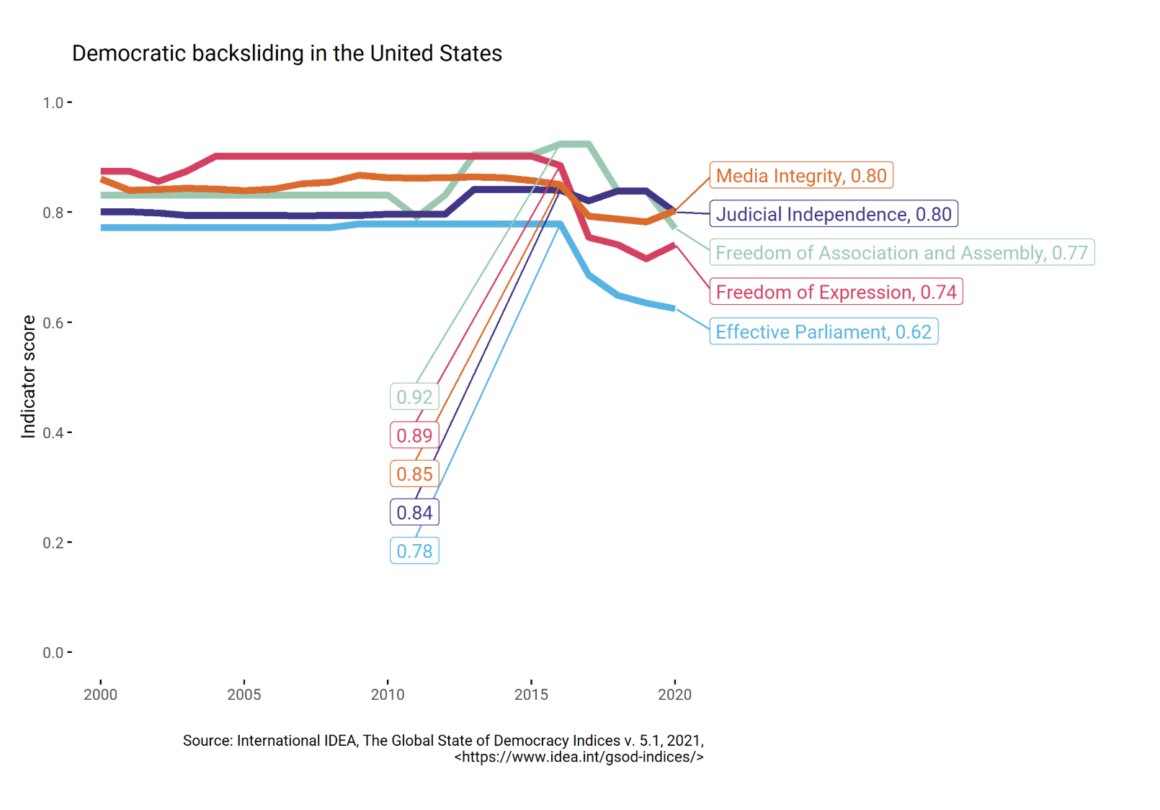
https://www.idea.int/blog/explainer-democratic-backsliding
Source E:
The graph above provides a visualization of the trends in the democratic retreat witnessed in the US from 2000 to 2020, revealing that democracy in the country has been deteriorating gradually over time, especially since 2016, owing to various factors such as weakening institutions and increased political polarization, among others.

Bibliography
“5.4: Democratic Backsliding.” Social Sci LibreTexts, 22 Feb. 2022, socialsci.libretexts.org/Bookshelves/Political_Science_and_Civics/Introduction_to_Comparative_Government_and_Politics_(Bozonelos_et_al.)/05:_Non-Democracies_and_Democratic_Backsliding/5.04:_Democratic_backsliding. Accessed 20 Apr. 2026.
America, Voice of. “Putin’s Human Rights Adviser: Freedom House Report ‘Politically Motivated.’” Voice of America, Voice of America (VOA News), 7 Feb. 2019, www.voanews.com/a/fact-check-russia-freedomhouse-not-free-politically-motivated/6742062.html. Accessed 25 Apr. 2026.
Amnesty International. “Amnesty International.” Amnesty.org, 2024, www.amnesty.org/en/.
Bermeo, Nancy. “On Democratic Backsliding.” Journal of Democracy, vol. 27, no. 1, Journal of Democracy, Jan. 2016, pp. 5–19, www.journalofdemocracy.org/articles/on-democratic-backsliding/.
Dean, James. “Democratic Decline a Global Phenomenon, Even in Wealthy Nations | Cornell Chronicle.” News.cornell.edu, 17 Jan. 2024, news.cornell.edu/stories/2024/01/democratic-decline-global-phenomenon-even-wealthy-nations.
European Union. “Your Gateway to the European Union.” European-Union.europa.eu, 2024, european-union.europa.eu/index_en.
Freedom House. “Freedom House.” Freedomhouse.org, 2025, freedomhouse.org/.
“Freedom in the World.” Freedom House, 26 Feb. 2025, freedomhouse.org/report/freedom-world?utm. Accessed 23 May 2026.
“Freedom’s Framework: The Case for Democracy - NATIONAL ENDOWMENT for DEMOCRACY.” NATIONAL ENDOWMENT for DEMOCRACY, 31 Mar. 2025, www.ned.org/freedoms-framework-the-case-for-democracy/.
Gorokhovskaia, Yana, and Cathryn Grothe. “The Uphill Battle to Safeguard Rights.” Freedom House, 2025, freedomhouse.org/report/freedom-world/2025/uphill-battle-to-safeguard-rights.
“Home | V-Dem.” Www.v-Dem.net, www.v-dem.net/.
Hudson, Alexander. “Explainer: Democratic Backsliding | International IDEA.” Www.idea.int, 17 Dec. 2021, www.idea.int/blog/explainer-democratic-backsliding.
---. “Explainer: Democratic Backsliding | International IDEA.” Www.idea.int, 17 Dec. 2021, www.idea.int/blog/explainer-democratic-backsliding.
Human Rights in EU Trade Agreements the Human Rights Clause and Its Application. www.europarl.europa.eu/RegData/etudes/BRIE/2019/637975/EPRS_BRI(2019)637975_EN.pdf.
HUMAN RIGHTS INDICATORS a Guide to Measurement and Implementation. www.ohchr.org/sites/default/files/Documents/Publications/Human_rights_indicators_en.pdf.
Human Rights Watch. “Human Rights Watch.” Human Rights Watch, 2025, www.hrw.org/.
Human, UN. “Human Rights, Democracy and the Rule of Law :: Resolution /: Adopted by the Human Rights Council.” United Nations Digital Library System, UN, 19 Apr. 2012, digitallibrary.un.org/record/725358?utm_source. Accessed 9 May 2026.
IMF. “IMF Conditionality.” IMF, Mar. 2023, www.imf.org/en/About/Factsheets/Sheets/2023/IMF-Conditionality.
International IDEA. “International IDEA.” Idea.int, IDEA, 2019, www.idea.int/.
---. “Launch of the Global State of Democracy Report 2025: ‘Democracy on the Move.’” YouTube, 11 Sept. 2025, www.youtube.com/watch?v=fom0bzAMETc. Accessed 25 Apr. 2026.
International IDEA at a Glance Supporting Democracy Worldwide. www.idea.int/sites/default/files/2025-05/International_IDEA_at_a_glance_2025_EN.pdf. Accessed 25 Apr. 2026.
Kurlantzick, Joshua. “As Democracy Falters Worldwide, Authoritarians Are Winning.” Cfr.org, Council on Foreign Relations, 19 Mar. 2026, www.cfr.org/articles/freedom-houses-annual-report-shows-the-dire-state-of-democracy-worldwide.
Meyerrose, Anna M. “Democratic Backsliding.” Eroding Democracy from the Outside In, Oxford University PressNew York, NY, Nov. 2025, pp. 20–34, https://doi.org/10.1093/9780197816479.003.0002.
Nations, United. “Democracy | United Nations.” United Nations, 2015, www.un.org/en/global-issues/democracy?utm_source.
---. “Protect Human Rights | United Nations.” United Nations, 2023, www.un.org/en/node/120156?utm_sourc. Accessed 9 May 2026.
---. “Universal Declaration of Human Rights | United Nations.” United Nations, 2023, www.un.org/en/about-us/universal-declaration-of-human-rights?utm.
Nations., United. “Research Guides: UN Human Rights Documentation: Overview.” Un.org, 2026, research.un.org/en/docs/humanrights?utm_sourc. Accessed 9 May 2026.
“Parliamentary Affairs | Oxford Academic.” OUP Academic, academic.oup.com/pa.
“QoG Data.” Qog.gu.se, 2024, datafinder.qog.gu.se/datasource/pei. Accessed 20 Apr. 2026.
“Research Guides.” Research.un.org, research.un.org/en.
“U.S. Democratic Backsliding in Comparative Perspective.” Carnegie Endowment for International Peace, 2025, carnegieendowment.org/research/2025/08/us-democratic-backsliding-in-comparative-perspective.
“Understanding and Responding to Global Democratic Backsliding.” Carnegie Endowment for International Peace, 2022, carnegieendowment.org/research/2022/10/understanding-and-responding-to-global-democratic-backsliding.
UNITED NATIONS. “OHCHR | about Democracy and Human Rights.” OHCHR, 2002, www.ohchr.org/en/about-democracy-and-human-rights.
United Nations. “Maintain International Peace and Security.” United Nations, 2025, www.un.org/en/our-work/maintain-international-peace-and-security.
---. “Ukraine: Behind the Numbers.” OHCHR, 2024, www.ohchr.org/en/ohchr_homepage.
United Nations Human Rights Council. “Universal Periodic Review.” OHCHR, 2025, www.ohchr.org/en/hr-bodies/upr/upr-home.
Wainwright, George. “Global Freedom Declined for Two Consecutive Decades: Freedom House.” Democracy without Borders, 24 Mar. 2026, www.democracywithoutborders.org/41714/global-freedom-declined-for-two-consecutive-decades-freedom-house/.
Walker, William. “End of Cold War | EBSCO.” EBSCO Information Services, Inc. | Www.ebsco.com, 2022, www.ebsco.com/research-starters/history/end-cold-war.
World Justice Project. “World Justice Project | Advancing the Rule of Law Worldwide.” World Justice Project, 2 Dec. 2019, worldjusticeproject.org/.
Wu, Alex. “China Scores 9 out of 100 in 2025 World Freedom Report.” The Epoch Times, 3 Mar. 2025, www.theepochtimes.com/china/china-scores-9-out-of-100-in-2025-world-freedom-report-5818910. Accessed 25 Apr. 2026.
“Yascha Mounk.” Yascha, www.yaschamounk.com/.

