Forum: Commission on Crime Prevention and Criminal Justice (CCPCJ)
Issue #2: Addressing the issue of unethical treatment of prisoners in correctional/detainment facilities.
Student Officer: Joaquin Arteaga
Position: Chair of the Commission on Crime Prevention and Criminal Justice

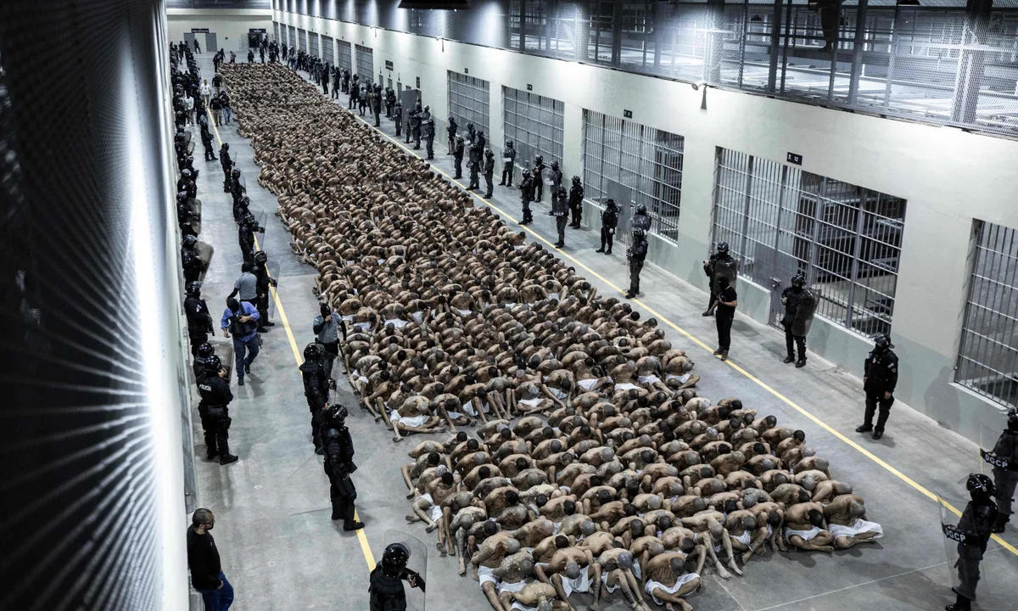
“A handout picture released by the El Salvador's presidency shows inmates belonging to the MS-13 and 18 gangs at a new prison in Tecoluca, El Salvador, in March.” March 2023, El Salvador's Presidency Press O/AFP/Getty Images. Accessed April 25, 2026. https://www.theguardian.com/world/2023/jul/27/el-salvador-nayib-bukele-gangs-mass-trials

Introduction
The issues that permeate through prison systems are not confined to specific regions or nations, but tend to span continents and have strong consequences for detainees. Overcrowding, for example, is observed in around 120 countries’ prison systems (with over 20 of these having systems holding prisoners at least double their capacity), and these often violate international standards, and can exacerbate existing issues such as limited realization of the needs of women and children (Penal Reform International). Therefore, when addressing the unethical treatment of prisoners within correctional/detainment facilities, it is important to bear in mind that these issues are multifaceted and have various potential causes. Prisoners might be subjected to physical violence, medical neglect, psychological torture, or sexual abuse in prisons by both wardens and other prisoners, with many cases often going unnoticed and with prisoners being dehumanized (Fuchsberg). The United Nations Office on Drugs and Crime (UNODC)’s Nelson Mandela Rules state that prisoners should be treated respectfully “due to their inherent dignity and value as human beings,” a principle that has had debatable levels of achievement in various prison systems worldwide.

According to the Global Detention Project, detention facilities primarily differ from prison systems in that they don’t have the aim of reintegrating detainees into society. These centers, as a result, often hold inmates for indefinite amounts of time, stripping away their rights to contact people outside of the prisons. As a result, these allow for prisoners to be vulnerable to violence and violate their freedom of speech and basic human rights, oftentimes placing a burden on migrants who are trafficked by dangerous networks or who seek asylum due to political turmoil or instability. The impact of incarceration on inmates in both detention centers and prisons, however, holds various shared characteristics. Loss of autonomy and connection to family members, especially children, and friends can both lead to a lost sense of purpose, which is harmful to prisoners’ mental health. A lost sense of purpose primarily stems from a disconnection with society, which can deprive inmates of their connections with others and can lead to unhealthy coping mechanisms such as substance abuse. While prison systems as a whole can lead to an erosion of mental health, those in cruel or degrading conditions can exacerbate and worsen the toll prisons have on mental health, often correlating with higher suicide rates and post-traumatic stress disorder (PTSD), leaving lasting effects that can last past the sentence itself (Quandt and Jones).

Definition of Key Terms
Recidivism: When a former prison convict returns to crime following a set period of time after their sentence, this is defined differently by each country, with some setting the limit at their trial date and some at their sentencing (National Institute of Justice).

Desistance: The opposite of recidivism, it is defined as a former convict ceasing criminal actions (National Institute of Justice).

Rehabilitation: The concept of using prisons to readapt prisoners to society, sometimes taking priority over the punishment process (National Institute of Justice).

Inmate: a person who has restricted freedom of movement, usually used in the context of a detention/correctional facility or a mental asylum (Cambridge Dictionary)

Correctional facility: a place where people who have been arrested, detained, or convicted by a court or criminal justice agency are held (Cornell Law School)

Jail: A type of correctional facility meant to hold inmates for short periods of time, including those awaiting trial or those with short sentences, usually less than a year (Prison Fellowship).

Prison: A type of correctional facility made for longer-term sentences given to inmates following convictions, usually run by the state (Prison Fellowship).

Prison warden: The highest position in a prison, often in charge of managing day-to-day activities and dealing with large incidents. Regional, also known as governor or superintendent (Saint Leo University).

General Overview
Common Flaws in Modern-Day Systems
Currently, many prison systems worldwide face a wide range of issues. In recent years, tactics such as solitary confinement have seen more frequent application despite their heavy negative toll on mental health, while other issues, such as overcrowding, are predominant. Many prisons fail to provide proper amounts of space to inmates, which can cause or exacerbate issues. Additionally, chronic diseases like HIV/AIDS are more common in prisons, which is further worsened by often weak medical systems alongside poor community support following incarceration (Penal Reform International). Forced labor is also commonly criticized within prison systems, with some labeling it as “modern slavery” as it often negatively affects prisoners while providing profit to the prison itself (Al-Jaber et al). However, while these issues are very frequent, they are more concentrated within impoverished and developing countries. These countries often lack resources to improve or make new prison facilities, further heightening issues such as overcrowding or poor sanitary conditions. While developing countries have lower incarceration rates, they tend to have higher overcrowding rates. Other issues can also include poor staff training and corrupt behavior from staff and wardens, all of which can add new issues while blocking development on existing ones (Wagner). According to the Prison Policy Initiative, prisons in some countries, such as the United States, are affected by racial tensions and often reflect judicial biases and institutional flaws.

Psychological Impact on Inmates
Prisoners are often reported to have a significantly higher rate of mental health issues, encompassing an estimated 44% of those in jail and 37% of those in prison (in the United States), which often leads inmates to a cycle of high recidivism and poverty, all of this ultimately negatively impacting their mental health. Solitary confinement, which is commonplace in systems and has become increasingly common, is linked to aggression, depression, and paranoia, among other mental issues, with 50% of suicides happening in solitary confinement in the United States, although these issues are global. Oftentimes, analysts will directly link prisoner health degradation to punishments like forced labor being prioritized over rehabilitation (Al-Jaber et al.). Organizations such as the National Alliance on Mental Illness often call for prisons to provide services to prisoners to help with mental health issues, such as therapy, as well as supportive treatment both during and after time in prison. These prioritize prisoners’ reintroduction to daily society over punishing them for criminal acts.

Physical Toll on Inmates
Prison systems impact physical health in various ways. While solitary confinement is more often linked to damaging mental health, it also harms physical health. A research report that interviewed prisoners in solitary confinement found that poor rations often lead to nutrient deficiency, with rations sometimes sufficing but lacking in quality and nutrient quantities. Additionally, prisoners were found to repeatedly have chronic pain, which was especially difficult to treat in solitary confinement. Poor conditions also lead to physical ailments such as rashes and flaky skin, while poor mobility leads to weaker body functions over time (Strong et al.). However, a major source of injuries and, at times, fatalities in prison stems from conflict between prisoners. Aside from a clear link to mental health damage, fights in prison, which supervisors often fail to properly address, prevent, or stop, can lead to serious damage for prisoners involved, which can be worsened by poor healthcare systems, making treatment difficult to obtain. Additionally, prisons often host environments that actively promote these behaviors. For example, heat has been correlated to higher aggressive levels of behavior, yet in many cases, prisons continue to operate without proper air conditioning, especially during the summer months. It is important to note that this can sometimes be tied to lower resource conditions; however, there are cases in which prison environments are neglected, which allows for violent, harmful behavior to grow and is often met with indifference by those with the power to prevent it (Dholakhia).

Political Crimes and Detainment/Detention Centers
Political crimes can also face torturous conditions due to unfair power dynamics. The Human Rights Watch has reported that prisoners arrested for crimes like attending anti-government protests face severe torture in countries like Chad. In these prisons, inmates are often heavily beaten and tortured, while violations of small protocols such as attendance checks could lead to prolonged torture, including treatment like solitary confinement (Mudge). Detainment centers, which often operate differently from correctional facilities, have a myriad of issues as well. This issue is found worldwide but often leads to unsafe conditions for migrants and asylum seekers, with indefinite stays and long trial procedures that can often violate human rights. While some countries have tried to reduce the usage of detention centers, the issue remains highly relevant worldwide, particularly in countries that are near conflicts or serve as key corridors for migrants, with detainment centers serving as a major point of contention, especially as the issue becomes more prevalent in modern political discourse. (Association of Visitors to Immigration Detainees).

Major Parties Involved and Their Views
United States
The United States has often been criticized for its prison systems. While most citizens and voters believe that prisons should allow inmates to have a second chance after getting out, most institutions fail to properly assist prisoners. These facilities then become bringers of social and physical isolation for inmates, and often lead to violence and fail to properly address motives for crime, from socioeconomic motives to mental health struggles. The United States’ legislative structure means that individual states define their own laws regarding the issue, meaning that some states have made more progress in prison reform than others (Subramanian et al.). Recent immigration policies have led to more prolific deployment of Immigration Enforcement Customs (ICE) agents throughout the country, who are meant to detain illegal immigrants within the country and send them to detainment facilities. ICE has been criticized for its violent approach, at times applying it to legal citizens, as well as for its unethical prison conditions. Fort Bliss detainment center in El Paso, Texas, for example, has been accused of having guards physically abuse detainees, and reports of sexual assault have been rampant, amongst prisoner deaths and disease outbreaks (Gassama). Overall, the United States faces significant, increasing criticisms regarding the treatment of its prisoners and detainees.

China
China has faced heavy criticisms of cruel treatment of its prisoners. Prisoner testimonies from citizens outside of the country have claimed that prisons lack proper sanitation facilities, further claiming that guards often beat prisoners and are coerced into confessing to crimes. Criticisms of Chinese justice systems often point to the nearly 100% incarceration rate. Prisons are described as not allowing prisoners to properly sanitize themselves and cruelly treating inmates by keeping the lights always on and deducting their “good behavior points” (which prisoners accumulated to try to reduce their sentences) after they reached higher levels, also citing constant punishments for minor mistakes such as not properly making their bed. Overall, prisoners have criticized Chinese prisons for psychological and physical torture as well as for regular false imprisonment (McDonnel). According to Amnesty International, China has also been criticized for holding political prisoners, particularly for torturing them and punishing any critics of the existing regime, as well as members of particular religions. Political prisoners often report similar maltreatment, citing solitary confinement and physical violence, among other human rights violations.

Finland
Finland is known as a pioneer of prison reform, being one of the first countries to endorse open prisons. While not all prisons, many prisons in Finland give a greater deal of autonomy to their inmates, allowing them to work within the prison and have greater interaction with the outside world, including owning cellphones and being able to go grocery shopping. Additionally, they typically employ non-hostile architecture, with the aim of reducing the desire to escape from prisoners. Finland’s prisons have regularly been praised for their ethical worldview and their success, citing low recidivism rates and establishing greater trust between prisoners and keepers. It is also important to note that Finland does not separate violent and nonviolent crime, meaning that sentences do not always have a major impact on whether a prisoner gets placed in an open prison or not (Moore).

Japan
According to the United Nations High Commission for Refugees (UNHCR) and refworld, Japanese prison systems are known for being isolated, often not allowing inmates to contact the outside world to a great extent. They are most famous for their silence; however, prisons are often criticized for devaluing prisoners and for treating them in dehumanizing ways. Prisoners are often intimidated, leading to misleadingly low riot numbers, which are sometimes interpreted as signs of a happy prison population. Overall, Japan’s prison system is criticized for treating prisoners unethically due to inherently structural issues over resource-based ones, still providing proper clothing, cells, and food to inmates, though often leading to psychological damage through low prisoner communication and general isolation.

El Salvador
In recent years, El Salvador’s president has placed a strong emphasis on cracking down on crime. In particular, this has led to mass arrests of suspected gang members. However, high arrest rates and poor resource provisions have led to various problems within cells. Some prisoners described conditions in which they would have to sleep standing up due to overcrowding. Additionally, other prisoners described regular beatings from wardens and officers, leading to unjust power dynamics. Mass arrests mean that the guilty status of prisoners is also questioned, leading to further concerns regarding the unethical treatment of prisoners within cells (Goebertus).

Timeline of Events, Relevant Resolutions, Treaties, and Events
Date Description of Event
1817 | The Auburn Prison opens in the United States. It’s considered the first industrial prison as it was the first prison to make prisoners do labor while in prison (Cole)
1829 | The Eastern State Penitentiary opens in the United States. It is often credited as having been the first “modern” prison, which used solitary confinement to try to inspire guilt in inmates (Eastern State)
1933 | The first open prison opens in New Hall Camp near Wakefield, England, seen as an early action against inhumane prisoner treatment (Howard League Penal Reforms)
1948 | The UN Declaration of Human Rights is signed, declaring that “No one shall be subjected to torture or to cruel, inhuman or degrading treatment or punishment.” (United Nations)
1955 | The First UN Congress on the Prevention of Crime and the Treatment of Offenders approved the Standard Minimum Rules for the Treatment of Prisoners, a document that outlines the rights of prisoners explicitly and condemns cruel treatment (United Nations)
1961 | Peter Benenson, sponsored by Amnesty International, publishes Persecution 61 (Benenson). This book was part of a wider program aiming to raise awareness on cruel prisoner treatment, one of the first to do so.
1984 | The UN Convention against Torture and Other Cruel, Inhuman or Degrading Treatment or Punishment passes in the General Assembly. This helped further prisoners’ rights, particularly condemning politically motivated cruel action (United Nations).
1990 | The General Assembly passes the Basic Principles for the Treatment of Prisoners (United Nations)
2011 | The UN General Assembly assembles an intergovernmental Expert Group that aims to look over the Standard Minimum Rules for the Treatment of Prisoners, involving different parts of civil society, UN bodies, and international and regional organisations (United Nations)
2015 | The Standard Minimum Rules for the Treatment of Prisoners are officially revised, now known as the Nelson Mandela Rules (United Nations). This is the newest international document focused on prisoners’ rights.

United Nations Involvement
The United Nations has held a significant role over the years concerning the issue of the unethical treatment of prisoners in correctional/detainment facilities.

Nelson Mandela Rules (2015)
The Nelson Mandela rules were signed in 2015, as a revised version of the Standard Minimum Rules for the Treatment of Prisoners, signed in 1955. These are the main and most recent international guidelines defining the rights of prisoners. Key parts include Rule 1, which defines prisoners as having “inherent dignity and value as human beings,” while emphasizing that prisons are not meant to “aggravate the suffering” (Rule 3) of prisoners and claiming that it is “not desirable to have prisoners in one cell or room” (Rule 11). Aside from defining fundamental rights for prisoners, it also outlines responsibilities prisons and states must take regarding prisons, including technological features such as digital identification or assigning responsibilities such as providing proper sanitation, nutrition, and clothing. In essence, the document provides a baseline for both first and second generation rights, providing a more focused view aside from broader documents such as the Declaration of Human Rights. The reforms particularly focused on emphasizing the roles and responsibilities that states have when it comes to treating prisoners and providing proper care and treatment (United Nations).

Convention against Torture and Other Cruel, Inhuman or Degrading Treatment or Punishment (1984)
The UN Convention against Torture and Other Cruel, Inhuman or Degrading Treatment or Punishment was signed to define torture and elaborate on rights established in the Declaration of Human Rights. Given that prison systems are the main areas where torture is seen, especially political torture, this document served to clearly dictate the rights of individuals. For example, Article 10 claims that the prohibition of torture must be implemented and educated for those handling any “individual subjected to any form of arrest, detention or imprisonment.” Article 11 claims that states must monitor systems regarding “persons subjected to any form of arrest, detention or imprisonment in any territory under its jurisdiction,” specifically pivoting it to preventing the use of torture (United Nations). This document, as a result, helps further define rights that prisoners have, although it primarily focuses on more extreme cases and on parts such as interrogation processes, not tackling other key issues that might be detrimental to prisoners but are not considered torture, such as overcrowding or general poor conditions for inmates.

Basic Principles for the Treatment of Prisoners (1990)
This document, part of the bigger Basic Principles document, similarly focused on establishing rights for prisoners. In particular, it focuses on the responsibilities that law enforcement has and emphasizes their role in treating prisoners ethically. This includes key areas such as Rule 16, which focuses on staff training and mentions governments’ responsibility to train staff that must emphasize rehabilitation, while also encouraging collaboration, both between different societal groups, as said in Rule 18, and international cooperation, as said in Rule 23. These help contextualize the rights of inmates as a global, pressing issue and embody ideas of collaboration. This document, being part of a larger resolution, helped highlight the role of law enforcement and governments in prison systems (United Nations).

Evaluation of Previous Attempts to Resolve the Issue
Nelson Mandela Rules (2015)
Being agreed upon by 193 countries, the Nelson Mandela rules are the most important UN document regarding prisoners’ rights and, by extension, one of the most important legal documents in general for the issue at hand. However, the extent to which it has been followed by countries is still limited. At least 120 countries face overcrowded prison situations, for example. However, the Nelson Mandela Rules still have a great impact on prison systems and are a major guideline for improvements. NGOs such as Penal Reform International have used the Mandela Rules as a base for helping advocacy for penal reform in countries such as Yemen and Morocco, leading to tangible change. While this document has been useful for prison reform, it is undeniable that there is still a lot of progress left, which itself requires overcoming major barriers such as resource inequalities and unjust systems (Rope).

UNODC Training Programs
The UNODC has had programs in place for years with the aim of educating prison staff and wards, particularly in developing countries in Africa and Asia, such as with the dealing of prisoners caught dealing in maritime crime. By doing so, the UNODC has directly acted on the issue and aimed to eliminate human rights violations. The courses tackle various themes. Some target newly hired workers in prisons, instructing them on identifying potential human rights violations and maintaining professionalism. Other courses tackle existing workers and aim to strengthen the ability to make ethical decisions for prisoners, often allowing participants to receive one-on-one feedback from instructors. Others teach individual skills like better reporting, which can better protect prisoners, and introduce concepts like parole systems, inviting reform without endangering communities (UNODC). Overall, the program has helped by doing direct action through education over force; however, its voluntary nature means that it has some flaws and requires compliance that is not always attainable.

European Prison Rules
The European Prison Rules are similar to the Mandela Rules; however, they are set by the Council of Europe, which features an extended version of the European Union and a total of 46 member states. These differ from the Mandela Rules both by being regional and by being significantly more specific. Whereas the Mandela Rules are designed to be more vague, the European Prison Rules are more heavily enforced and are more specific in regulations, detailing the rights of different prisoner categories and on how to carry out record keeping. These have been effective and have been used as a criterion for evaluating prison systems in Europe (European Council and Prisoner Reform International). While these systems are not perfect, the presence of these rules sets up for higher standards and higher scrutiny for regulations. This reflects the usefulness of regional regulations as a next step, built on international legislation.

Possible Solutions
Opening ‘Open Prisons’
The concept of open prisons itself can vary between countries, with some countries giving more freedom within prisons while other countries focus on letting prisoners out of the prison momentarily. Regardless of country differences, open prisons follow the general premise of allowing prisoners greater freedoms, particularly in order to help with rehabilitation (Larrauri). A study published in March of 2026 found that open prisons had a significantly lower risk of recidivism for inmates; however had inconclusive results regarding the effectiveness of temporary leaves, which is a feature in some open prisons; the study found that its usefulness in preventing future crime depends on the inmate’s individual situation. While the study itself had a few limitations, including not consulting prisoners who did not obtain any form of parole or open treatment and a limited scope of investigation (only looking into one German province), it reveals general positive trends, particularly in the process of designing prisons focusing on rehabilitation over punishment, which correlates with better treatment of inmates (Neumann et al.). Regardless, open criticisms face some criticisms. Some prisoners feel like regulations given to them while on temporary leave are overly intrusive and still inhibit their social lives. Additionally, some argue that open prisons still give inmates the same issues as closed prisons, such as disconnected social life, missing family, or a feeling of one’s life being wasted (Larrauri). Therefore, open prisons are a possible solution that, while having proven positive effects, are not necessarily perfect.

Adapting New Monitoring and Surveillance Methods
Many prisons are already monitored, with surveillance cameras and searches being commonplace, particularly in developed countries that are able to afford new technologies. In particular, the recent rise of artificial intelligence (AI) has led to prisons incorporating AI into their systems. For example, some prisons have implemented AI to track and detect health issues and prevent deaths, while also looking at inmates’ history to predict their predisposition to violence. This mirrors previous risk assessment tools, often criticized for being unable to properly predict conflict, although supporters argue that AI is able to better assess these situations and can work as a tool, aiding wardens and other prison staff. The involvement of AI is still at an early stage, but is raising concerns over privacy and blind trust (McCray). Parole systems often use electronic monitoring devices, which, aside from being expensive, have been criticized for enforcing abstract rules that often send inmates back into prisons, ultimately reducing their usefulness. Nonetheless, supporters argue that programs like these can reduce incarceration and improve prison conditions (Stroud and King). Some researchers even go as far as to argue that existing methods like CCTV cameras do little to deter violence in prisons (Lawrence). Overall, the adaptation of new monitoring and surveillance methods is an issue that not only brings controversy, but can depend on individual countries, with developing countries often being unable to access new technologies.

Sustainable Development Goal (SDG)
SDG 16: Peace, Justice, and Strong Institutions
The issue of cruel treatment towards prisoners is inexorably dependent on the institutions that govern detention and correctional facilities. NGOs like the Human Rights Watch have often linked corrupt governmental regimes and torture in prisons, primarily those arrested for political crimes, such as attending anti-government protests. Stronger institutions holding those accountable and allowing for transparency, then, would have a largely positive impact on how prisoners are treated, even in specialized institutions. Furthermore, corruption in prison systems themselves has an undeniably negative effect, oftentimes increasing the chance of abuse due to unfair power dynamics or unfair treatment. However, it is also worth noting that in some cases, flaws from prison systems are not entirely in states’ control; states with fewer resources are less able to provide proper facilities to inmates (Wagner). However, corruption at a national level can also often be a source of issues, meaning that, on a global scale, a search for ethical prisoner treatment means strengthening institutions and preventing corruption and unjust treatment, often embedded within them.

Appendix
This section of the issue bulletin is dedicated to providing delegates with valuable sources to utilize during their research.

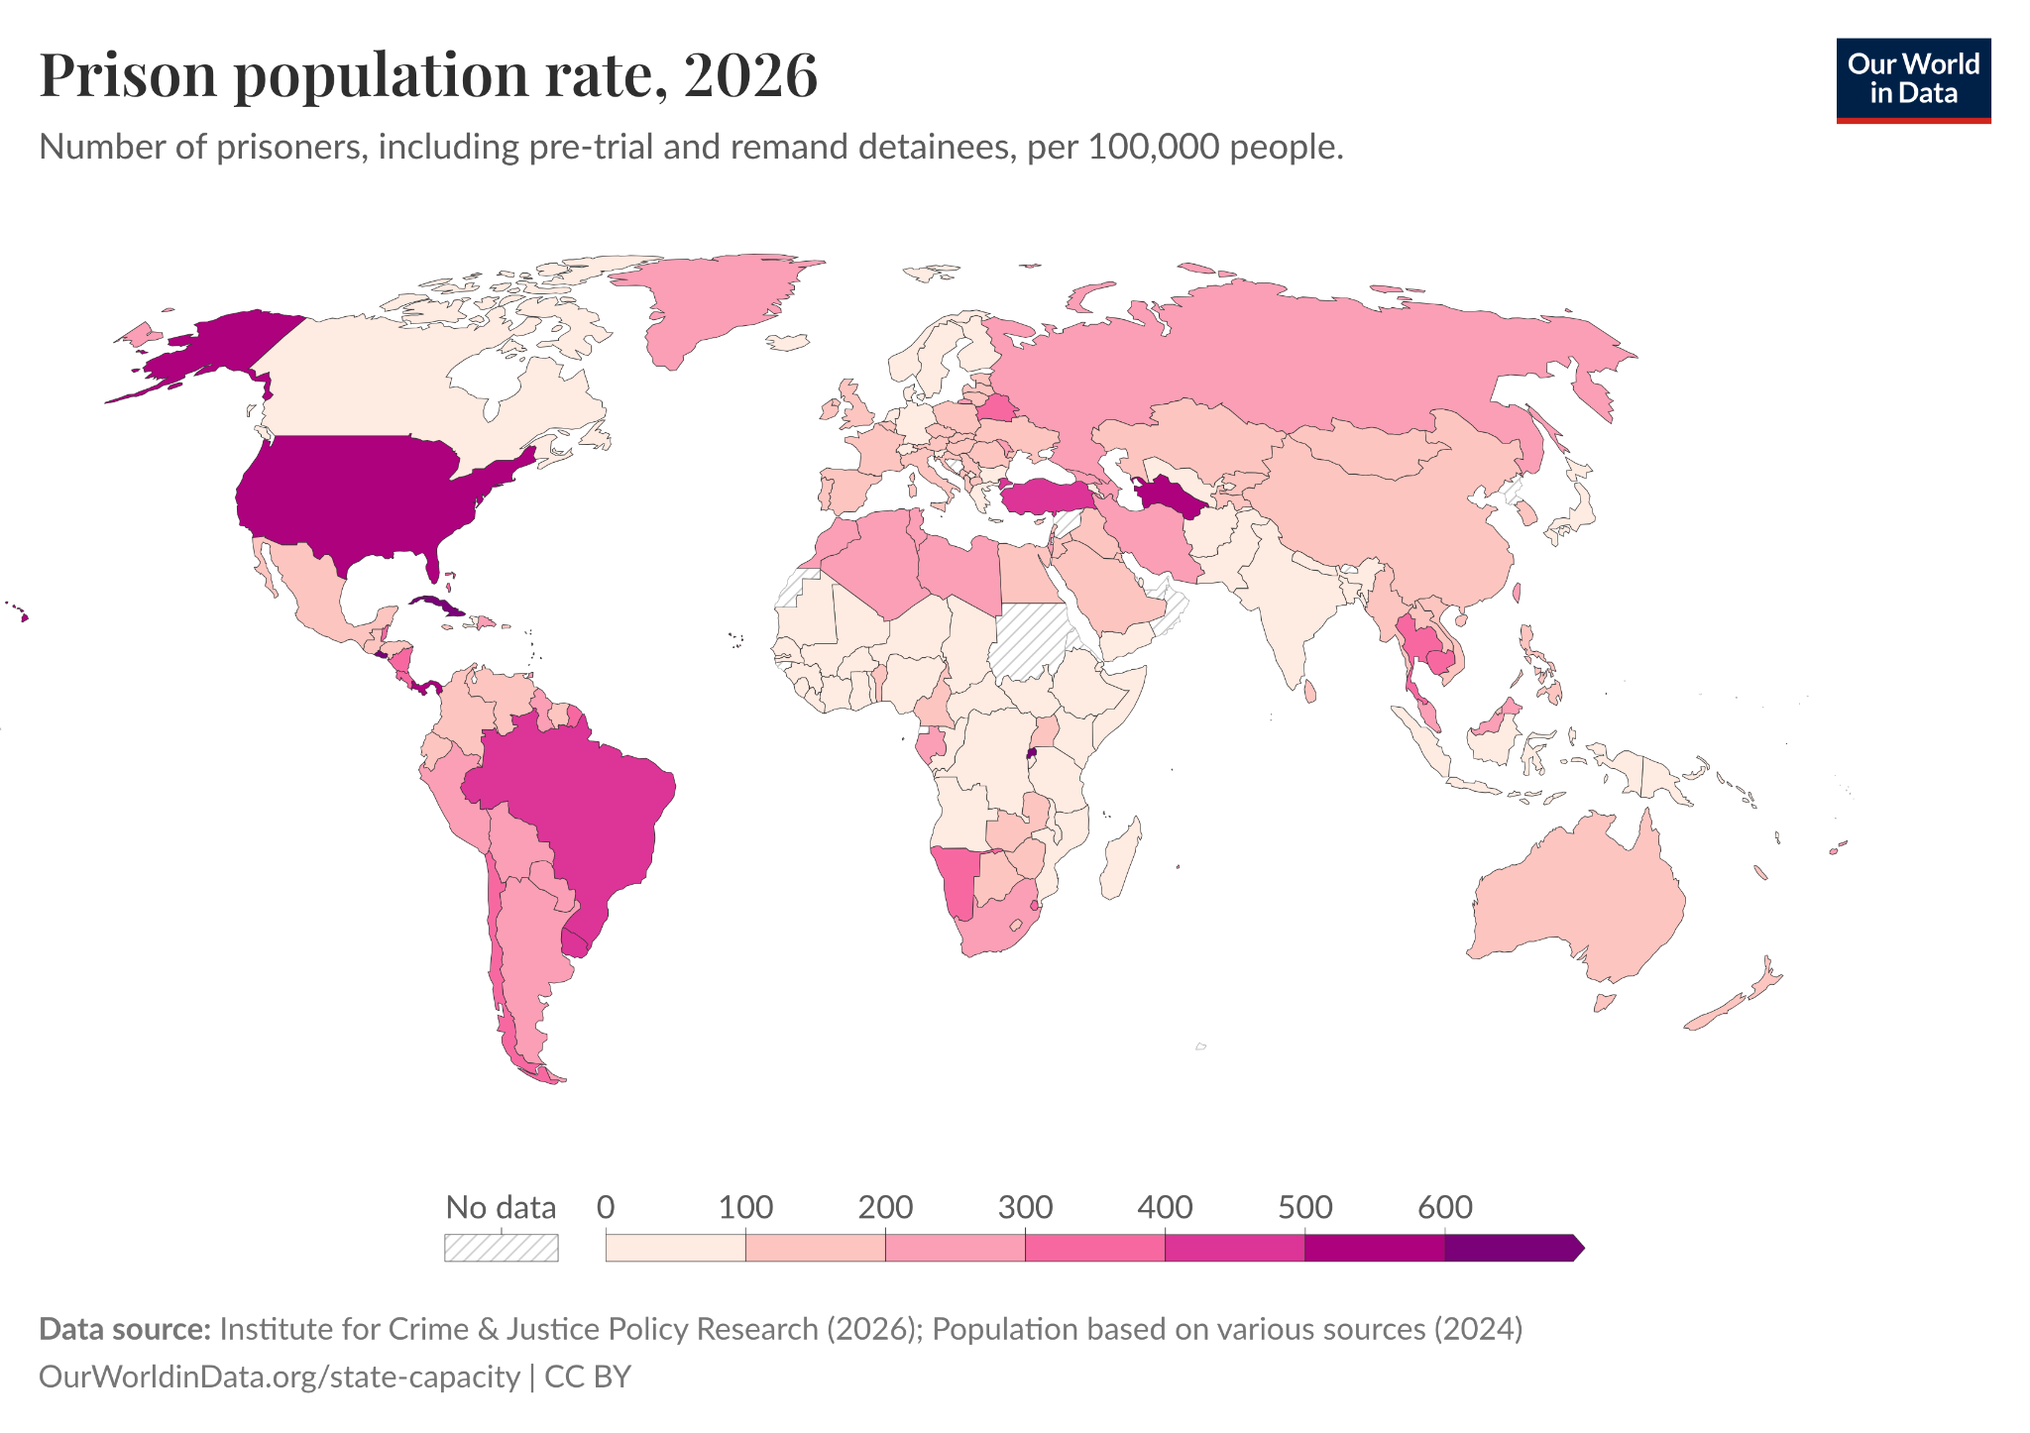
Source A: A map of prison population rate per capita, where countries with darker colors have more prisoners relative to the population. The incarceration rate can give insights into prison systems, particularly on how strict government measures are. Countries with higher prison population rates are more likely to face overcrowding in prisons. An interactive, year-by-year version of the map is available here: https://ourworldindata.org/grapher/prison-population-rate

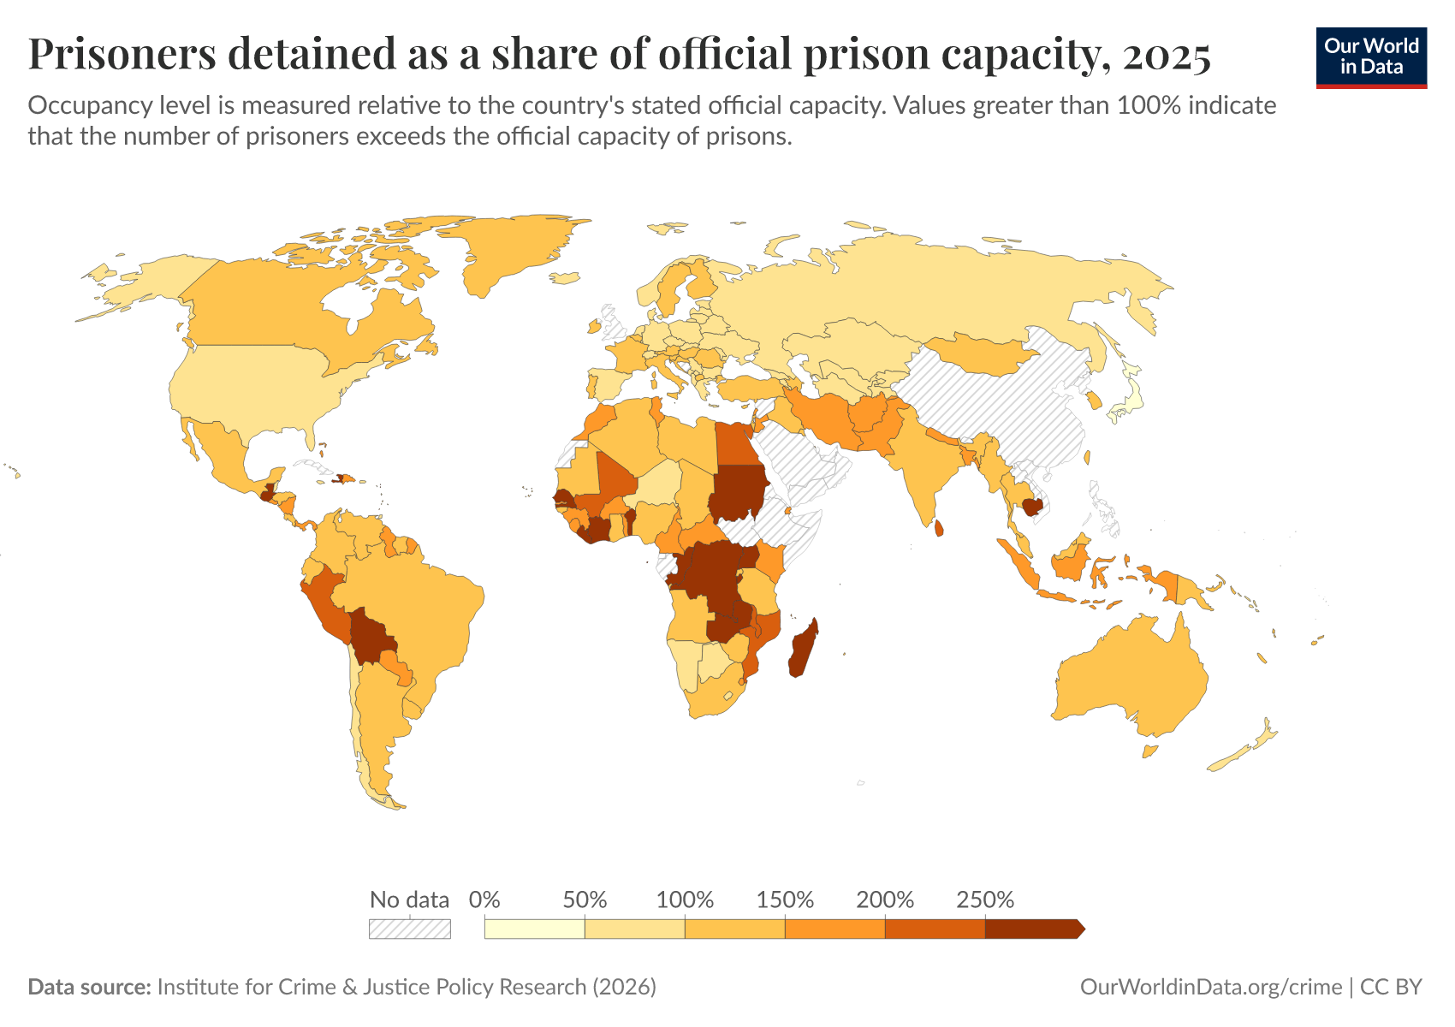
Source B: A map of prison occupancy rate, where countries with darker colors have higher levels of overcrowding. Overcrowding is one of the main sources of improper prisoner conditions. This map can give useful insight into where the issue is most predominant, both for countries and regions. An interactive version of the map is available here: https://ourworldindata.org/grapher/prison-capacity

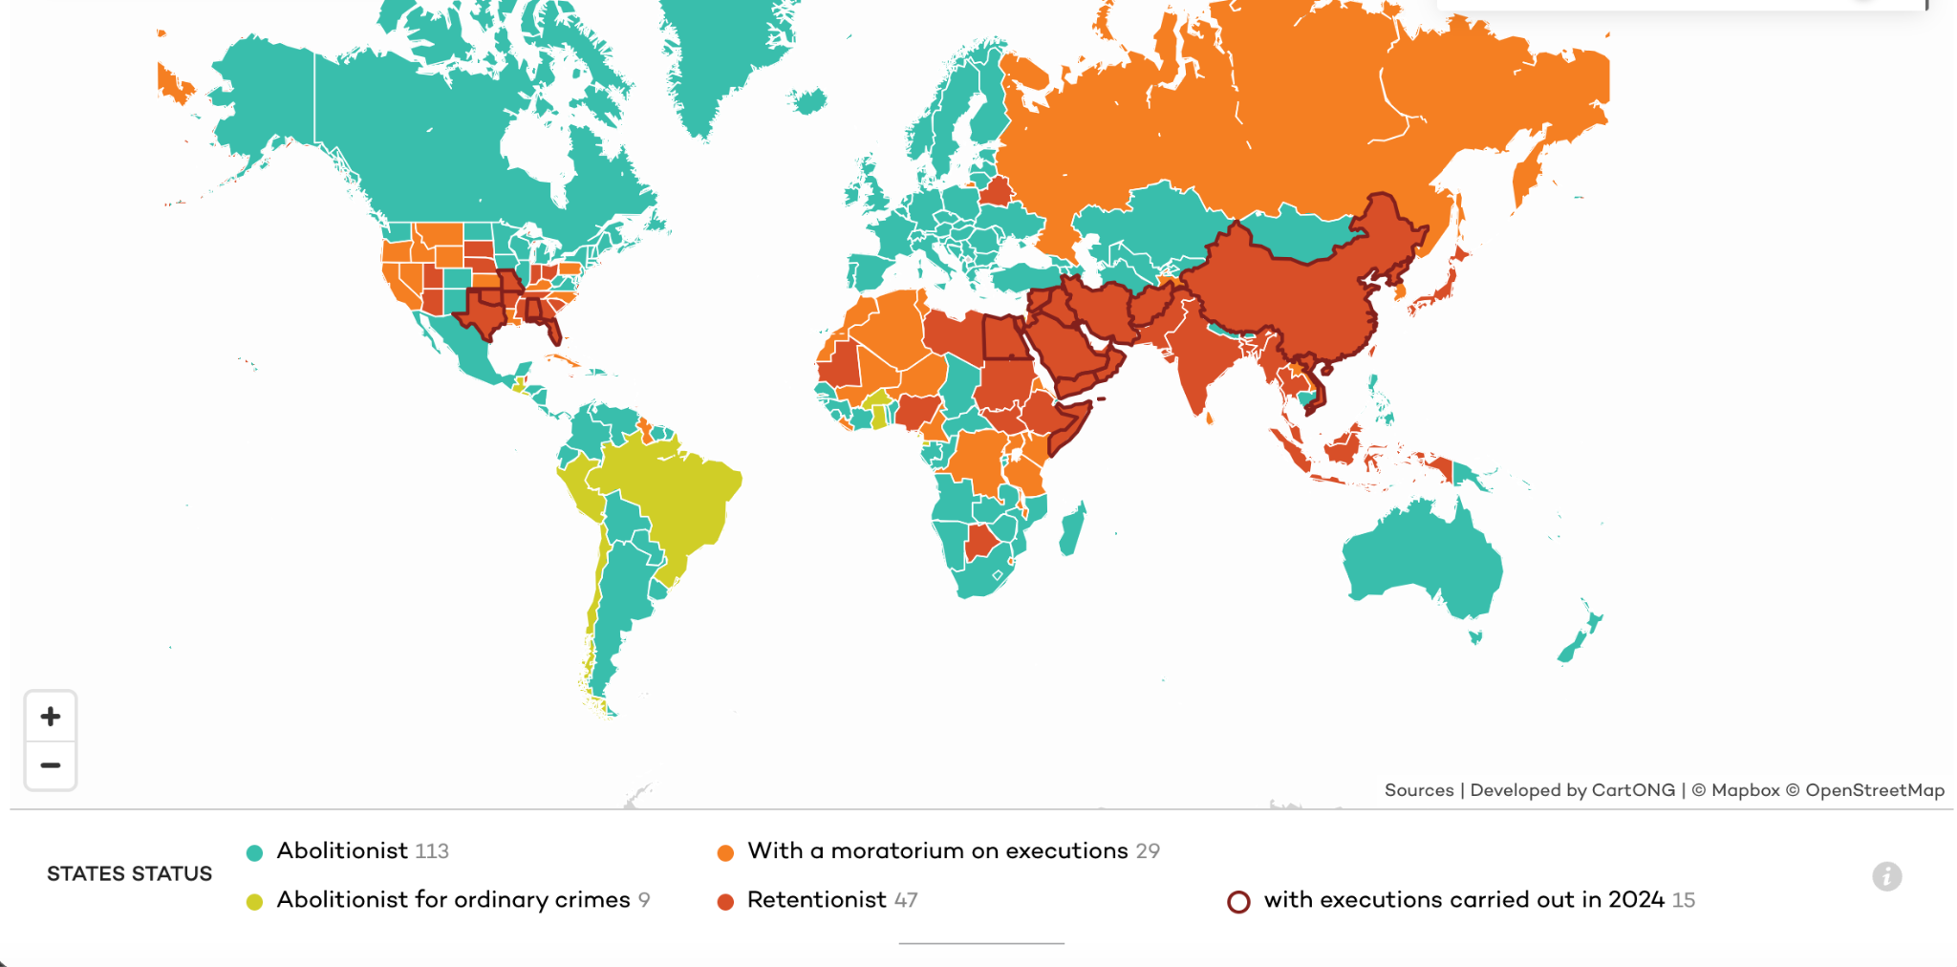
Source C: A map of the death penalty worldwide (or in subdivisions), where different colors denote different levels of death penalty acceptance. Inmates on death row often are subjected to psychological torture. Death row also goes against rehabilitation, which means that this map can reflect priorities in different states and regions. An interactive version of the map is available here: https://www.ecpm.org/en/worldmap/

Bibliography
Al-Jaber, Lour, et al. “The Corrupt System of Prison-Industrial Complexes, and How It Affects the Mental Health and Rehabilitation of Prisoners | OxJournal.” Oxjournal.org, 2024, www.oxjournal.org/the-corrupt-system-of-prison-industrial-complexes/.
Amnesty International. “Everything You Need to Know about Human Rights in China 2020.” Amnesty International, 2023, www.amnesty.org/en/location/asia-and-the-pacific/east-asia/china/report-china/.
AVID (Association of Visitors to Immigration Detainees) Compilation. “Detention around the Globe.” Aviddetention.org.uk, 2017, aviddetention.org.uk/article/detention-around-the-globe.
Benenson, Peter. “Persecution 61.” Amnesty.org, Amnesty International, 1 Jan. 1961, www.amnesty.org/en/documents/act10/001/1961/en/.
Cambridge Dictionary. “Inmate.” @CambridgeWords, 26 Oct. 2022, dictionary.cambridge.org/dictionary/english/inmate.
Cole, Krystal. “Auburn, N.Y.'S Oldest Prison, Started Many Standards for Early Incarceration.” Spectrumlocalnews.com, 7 Apr. 2025, spectrumlocalnews.com/nys/central-ny/news/2025/04/04/history-of-auburn-s-prison.
Cornell Law School. “Definition: Correctional Facility from 34 USC § 10651(L)(1) | LII / Legal Information Institute.” Www.law.cornell.edu, 2004, www.law.cornell.edu/definitions/uscode.php?width=840&height=800&iframe=true&def_id=34-USC-1339097894-1337661723&term_occur=999&term_src=title:34:subtitle:I:chapter:101:subchapter:XXXIII:section:10651.
Dholakia, Nazish. “Prisons and Jails Are Violent; They Don’t Have to Be.” Vera Institute of Justice, Vera, 7 July 2018, www.vera.org/news/prisons-and-jails-are-violent-they-dont-have-to-be.
Eastern State. “History of Eastern State Penitentiary | Eastern State.” Easternstate.org, 2025, easternstate.org/about/history-of-eastern-state-penitentiary.
European Council and Prisoner Reform International. “Short Guide to the European Prison Rules.” Penal Reform International, 2023, www.penalreform.org/resource/short-guide-to-the-european-prison-rules/..
This link leads to a download of a pdf that is the actual source.
Fuchsberg, Alan. “Signs of Mistreatment of Prisoners in Jail & What to Do.” Fuchsberg.com, 2025, www.fuchsberg.com/blog/mistreatment-of-prisoners-in-jail.
Global Detention Project. “About the Global Detention Project.” Global Detention Project | Mapping Immigration Detention around the World, 2020, www.globaldetentionproject.org/about.
Goebertus, Juanita. “Human Rights Watch Declaration on Prison Conditions in El Salvador for the J.G.G. V. Trump Case.” Human Rights Watch, 20 Mar. 2025, www.hrw.org/news/2025/03/20/human-rights-watch-declaration-prison-conditions-el-salvador-jgg-v-trump-case.
Haddy Gassama. “Immigrants Detained at Fort Bliss in Texas Report Abuse and Inhumane Conditions.” American Civil Liberties Union, 8 Dec. 2025, www.aclu.org/news/immigrants-rights/detained-immigrants-detail-physical-abuse-and-inhumane-conditions-at-largest-immigration-detention-center-in-the-u-s.
Larrauri, Elena. “Open Prisons: For a Less Harmful Prison.” Criminal Law, JOTWELL, 18 Jan. 2024, crim.jotwell.com/open-prisons-for-a-less-harmful-prison/.
Lawrence, Daniel S., et al. “The Impact of Correctional CCTV Cameras on Infractions and Investigations: A Synthetic Control Approach to Evaluating Surveillance System Upgrades in a Minnesota Prison.” Criminal Justice Policy Review, vol. 33, no. 8, May 2022, p. 088740342210932, https://doi.org/10.1177/08874034221093226.
McCray, Rebecca. “AI in Prison? Robot Guards? How the Criminal Justice System Is Adopting Tech.” The Marshall Project, 30 Aug. 2025, www.themarshallproject.org/2025/08/30/ai-california-prison-machine-surveillance.
McDonell, Stephen. “Australian Matthew Radalj Tells of Life in China Prison.” British Broadcasting Corporation (BBC), 17 May 2025, www.bbc.com/news/articles/c629664xp57o.
Moore, Natalie. “No Bars, No Chains, No Locks: How Finland Is Reimagining Incarceration.” Pulitzer Center, 16 Nov. 2021, pulitzercenter.org/stories/no-bars-no-chains-no-locks-how-finland-reimagining-incarceration.
Mudge, Lewis. “‘Worse than Hell’: Death and Torture at Chad’s Koro Toro Prison.” Human Rights Watch, 6 Aug. 2024, www.hrw.org/report/2024/08/06/worse-hell/death-and-torture-chads-koro-toro-prison.
NAMI (National Alliance on Mental Illness) Board of Directors. “Mental Health Treatment While Incarcerated.” National Alliance on Mental Illness (NAMI), 12 Sept. 2025, www.nami.org/advocacy-at-nami/policy-positions/improving-health/mental-health-treatment-while-incarcerated/.
National Institute of Justice. “Recidivism.” National Institute of Justice, 2023, nij.ojp.gov/topics/corrections/recidivism.
Neumann, Merten, et al. “A Study on the Impact of Open Doors: Investigating the Influence of Short Leave and Open Prison on Recidivism Rates.” Journal of Experimental Criminology, Mar. 2026, https://doi.org/10.1007/s11292-026-09741-9.
Penal Reform International. “Prison Conditions: Key Facts - Penal Reform International.” Penal Reform International, 2013, www.penalreform.org/issues/prison-conditions/key-facts/.
---. “Prison Conditions: The Issue.” Penal Reform International, 2021, www.penalreform.org/issues/prison-conditions/issue/.
Prison Fellowship. “FAQ: What Is the Difference between Jail and Prison? - Prison Fellowship.” Prison Fellowship, 2016, www.prisonfellowship.org/resources/training-resources/in-prison/faq-jail-prison/.
Prison Policy Initiative . “Racial and Ethnic Disparities.” Prisonpolicy.org, 2020, www.prisonpolicy.org/research/racial_and_ethnic_disparities/.
Quandt, Katie Rose, and Alexi Jones. “Research Roundup: Incarceration Can Cause Lasting Damage to Mental Health.” Prison Policy Initiative, 13 May 2021, www.prisonpolicy.org/blog/2021/05/13/mentalhealthimpacts/.
Refworld. “Prison Conditions in Japan.” Refworld + UNHCR, UNHCR, 1 Mar. 1995, www.refworld.org/reference/countryrep/hrw/1995/21898.
Rope, Olivia. “100 Years since the Birth of Nelson Mandela: The Legacy Left for Prisoners and Prison Staff Worldwide - Penal Reform International.” Penal Reform International, 15 Aug. 2018, www.penalreform.org/blog/100-years-since-the-birth-of-nelson-mandela/.
Saint Leo University. “Criminal Justice Career Spotlight: Working as a Prison Warden | Saint Leo University.” Www.saintleo.edu, 7 June 2021, www.saintleo.edu/about/stories/blog/criminal-justice-career-spotlight-working-as-a-prison-warden.
Strong, Justin D., et al. “The Body in Isolation: The Physical Health Impacts of Incarceration in Solitary Confinement.” PLOS ONE, edited by Andrea Knittel, vol. 15, no. 10, Oct. 2020, https://doi.org/10.1371/journal.pone.0238510.
Stroud, Hernandez D., and Taylor King. “How Electronic Monitoring Incentivizes Prolonged Punishment | Brennan Center for Justice.” Www.brennancenter.org, 26 July 2022, www.brennancenter.org/our-work/analysis-opinion/how-electronic-monitoring-incentivizes-prolonged-punishment.
Subramanian, Ram, et al. “Prison Reform in the United States.” Brennan Center for Justice, 17 Mar. 2026, www.brennancenter.org/our-work/research-reports/prison-reform-united-states.
United Nations. “Basic Principles for the Treatment of Prisoners :: Resolution /: Adopted by the General Assembly.” United Nations Digital Library System, UN General Assembly, 28 Mar. 1991, digitallibrary.un.org/record/105348?v=pdf.
---. “Convention against Torture and Other Cruel, Inhuman or Degrading Treatment or Punishment.” OHCHR, United Nations, 1984, www.ohchr.org/en/instruments-mechanisms/instruments/convention-against-torture-and-other-cruel-inhuman-or-degrading.
---. “Universal Declaration of Human Rights.” United Nations, 10 Dec. 1948, www.un.org/en/about-us/universal-declaration-of-human-rights.
United Nations Office on Drugs and Crime. A UNODC GLOBAL PRISON CHALLENGES PROGRAMME INITIATIVE in ASSOCIATION with the UNODC GLOBAL MARITIME CRIME PROGRAMME PRISON TRAINING COURSE CATALOGUE. www.unodc.org/documents/Maritime_crime/UNODC_GMCP_Prisons_Training_Catalogue.pdf.
---. “United Nations Standard Minimum Rules for the Treatment of Prisoners (Nelson Mandela Rules).” International Legal Materials, vol. 55, no. 6, Dec. 2016, pp. 1180–205, https://doi.org/10.1017/s0020782900030898.
Wagner, Ashley. “Prison Systems in Developing Nations: Basic Human Rights.” The Borgen Project, 30 Oct. 2018, borgenproject.org/prison-systems-in-developing-nations/.

