Tab 1
Forum: United Nations Office of Counter-Terrorism (UNOCT)
Issue #2: Measures to address terrorist exploitation of migrants and refugee flows
Student Officers: Jacopo Gaetani
Position: Chair of the United Nations Office of Counter-Terrorism

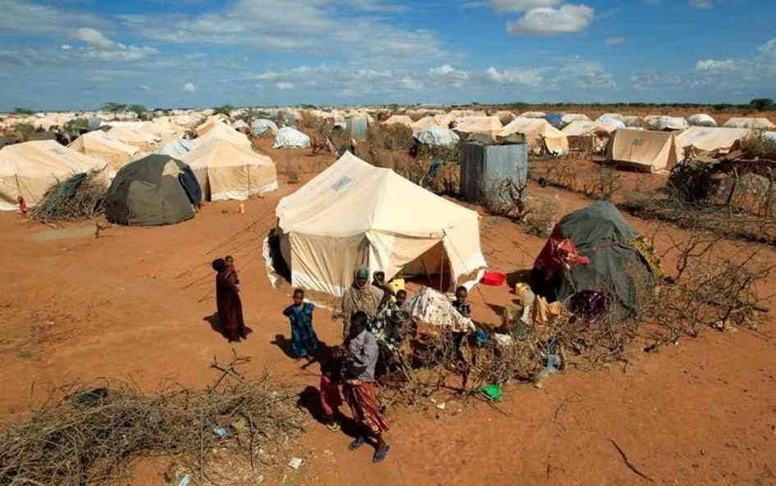Mukoya, Thomas, and Reuters. “Refugees Stand Outside Their Tent at the Ifo Extension Refugee Camp in Dadaab, near the Kenya-Somalia Border in Garissa County, Kenya,.” Human Rights Watch, Online Article, 19 Oct. 2011, www.hrw.org/news/2019/03/27/kenya-reverse-move-close-refugee-camp. Accessed 16 May 2026.
Introduction
The issue of terrorist exploitation of migrants and refugee flows has become a central issue in recent years. Especially in the 2000s, following the September 11, 2001, attacks on the World Trade Center in the USA. This attack changed how the world sees security between borders and placed a lot of mistrust in migrants around the world. In 2006, the UN Global Counter-Terrorism Strategy was adopted. This initiative formally acknowledged the link between terrorism and humanitarian crises, including migrant displacement (United Nations General Assembly, 2017). Consequently, in the beginning of 2011, the Syrian civil war and the rise of ISIS triggered the largest refugee crisis since World War 2 and displaced more than 65 million people by 2016 (UNHCR, 2016). Additionally, in November 2015, the Paris Attacks revealed that at least one ISIS-related terrorist entered Europe using a false Syrian passport through the refugee route via Greece (Europol, 2016).
The core problem is that terrorist organizations (ISIS, Al-Qaeda, and affiliates like Al-Shabaab and Boko Haram) have developed strategies to take advantage of mass movement of migrants and refugee flows to: Enter target countries undetected, using refugee camps as recruitment grounds where desperate migrants are vulnerable to radicalization, smuggling fighters, weapons, and financing terrorist attacks. The issue is that the majority of migrants are fleeing terrorism and conflicts in their countries, but in the migration processes, they are being punished or discriminated against as terrorists. (UNOCT, 2023)
This issue is controversial because of the fundamental tension between international refugee laws. The 1951 Refugee Convention enshrines the right of asylum and the principle of non-refoulement (prohibition of returning people to places where they face persecution or immediate danger)(UNHCR, 1951). This convention opposes some principles of national security that countries might have and might put more stress on and maybe restrict and reject some refugee flows. It could also facilitate racial or xenophobic profiling (Migration Policy Institute, 2016).
This issue is extremely important to address, as it has various victims. From a security perspective, terrorists are going to continue to exploit migrants and use these migration routes to sustain their illicit activities. From a humanitarian point of view, if these issues are addressed with multilateral, smart, and rights-compliant counter-terrorism frameworks for migration, it might mean that millions of actual refugees face increasingly hostile transitional processes (UN Security Council Resolution 2178, 2014). And from an international and diplomatic perspective, the politicization of migration as a security threat has and might fuel more xenophobic and racist extremism against immigration and migrants in general.

Definition of Key Terms
Refugee: A person who has been forced to flee their country of origin due to war, violence, or persecution and who cannot return safely. Under the 1951 Refugee Convention, refugees are granted specific international legal protections, including the right to seek asylum in other countries (UNHCR).

Migrant: A person who moves from their home country to another country, regardless of the reason or legal status of their movement. Unlike refugees, migrants are not necessarily fleeing persecution. (UNHCR, 1951)

Terrorist Exploitation: The exploitation of legal or illegal systems, networks, or vulnerable populations by terrorist organisations, to advance their goals including the use of migration and refugee flows to embed operatives, recruit members or move resources across borders (UN Security Council).

Foreign Terrorist Fighter: A person who travels or tries to travel to a country for the purpose of commiting, planning or preparing terrorist acts, or providing or receiving terrorist training outside of their home country. (UN Security Council Resolution 2178, 2014)

Radicalization: The process to make a person gradually adopt increasingly extreme political, social, or religious ideologies that may eventually lead to terrorist behavior. Displacement and being marginalized are recognized as conditions that can accelerate the process. (UNOCT, 2023)

Non-Refoulment: A core principle of international refugee law that prohibits countries from returning or expelling a refugee to their home country where their life or freedom would be threatened. (UNHCR, 1951)

Smuggling Network: A criminal network that facilitates the illegal movement of displaced people across international borders for money. These networks are frequently exploited by terrorist organizations to move operatives, weapons and financing alongside migrant flows (UNODC,2018).

Internally Displaced Person (IDP): A person who has been forced to flee their home but has not crossed an international border and remains within their own country, IDP camps have been identified as particularly vulnerable to terrorist recruitment. (UNHCR, 2022)

Countering Violent Extremism: A set of strategies aimed at preventing people from being radicalized into violent extremism. Including community engagement, education, and psychological support programs. These programs are considered essential to address the terrorist exploitation of migrants. (UNOCT, 2023)

Major Parties Involved and Their Views
United Nations Office of Counter-Terrorism: The UNOTC plays a direct role in supporting member states in developing legal frameworks, border security, and information-sharing mechanisms to prevent terrorist exploitation of migration routes (United Nations General Assembly Resolution 71/291, 2017). This office coordinates across various UN agencies including UNHCR, UNODC and Interpol. To ensure that counter-terrorism responses to migration issues are always assisted by specialists in the frontline of the problem. They also provide guidance on screening procedures that do not violate the principle of non-refoulement (UN Secretary-General's Plan of Action to Prevent Violent Extremism, 2016).

United Nations High Commissioner for Refugees (UNHCR): The UNHCR is the principal UN agency that protects refugees and stateless people worldwide and oversees the implementation of the 1951 Refugee Convention (UNHCR, 1951). This office has consistently argued that conflating refugees with terrorists undermines the protection regime that the international community built after WW2, and that the vast majority of refugees are victims of terrorism rather than perpetrators (UNHCR, 2016).

The European Union (EU): In the 2015 refugee crisis, where over one million migrants and refugees entered Europe mostly through Greece and Italy, the European Union created enormous political pressure on member states (Europol, 2016). The EU responded by implementing a series of measures including the European Agenda on Migration, strengthening of FRONTEX (EU border Agency), the establishment of hotspot registration centers and information sharing with outside partners, like Turkiye (European Commission, 2015).

The Islamic State of Iraq and Syria (ISIS): At the prime of its territorial control in Syria and Iraq between 2014 and 2017, ISIS embedded operatives in refugee flows traveling to Europe. They used the chaos of the mass displacement to recruit from IDP camps and in smuggling networks (particularly in the Aegean Sea and the Western Balkans) to move fighters and resources (International Centre for the Study of Radicalisation, 2015).
The African Union and Sahel States: This region is home to some of the world's fastest growing terrorist threats, including groups affiliated with ISIS, which have extensively exploited the displacement of millions of people across the LAke CHad Basin and the Sahel Corridor (Global Terrorism Database, 2022). These states lack the funding and infrastructure to register, screen and monitor refugee populations and their borders are largely ungloved and unprotected facilitating illicit migration and exploitation of these movements. The African Union has attempted to coordinate regional responses through frameworks but the constraints of limited resources and political instability has severely limited their effectiveness (African Union, 2019).

Kenya: Home to the Dadaab refugee complex, one of the largest housing accommodating half a million Somali refugees. Kenya has faced terrorist groups in this camp like Al-Shabaab that recruited, supplied and planned in it (Global Terrorism Database, 2022). This exploitation comes directly after some of the deadliest terrorist attacks in Kenyan history, such as the 2013 Westgate attack and the 2015 Garissa University Massacre, both of which were confirmed to come from Al-Shabaab operatives who moved in refugee camps (Human Rights Watch, 2015).

Turkiye: Turkiye has been one of the most affected countries in this issue. This country’s geographical position between active conflict zones in Syria and Iraq and the European continent made it the passing country in the 2015 refugee crisis and the movement of terrorist fighters traveling from ISIS controlled territory (International Centre for the Study of Radicalisation, 2015).

General Overview
The Main Idea
The most controversial aspect of this issue is the fundamental tension between two problems that have to be faced at the same time: protecting the human rights of millions of immigrants and displaced people that are fleeing conflict and persecution, and to prevent future attacks from terrorist organizations from exploiting these very same displaced people and their road to a better life. While many nations have developed sophisticated security and intelligence and the sharing of intelligence to detect terrorist attacks and infiltration within these refugee flows, many others ( mainly low-income border states) do not have the finding and the capacity to administer and introduce some sort of screening process to make sure these routes are not exploited (UNOTC, 2023). These huge humanitarian crises have put a lot of strain on host states, many of which already have internal conflict, making a precise investigation on every immigrant coming into a country extremely difficult. Terrorist organizations have recognized these weak spots and have exploited them in vast amounts. On the other side of the dice, displacement camps host hundreds of thousands of people in conditions of poverty, trauma, and legal uncertainty about their migration status. These desperate people are directly being recruited and trained to join the terrorid (Global Terrorisn Database, 2022)

The Legal and Political Landscape
The international legal framework that governs this issue is built on two different laws. The first law: the 1951 Refugee Convention and its 1967 Protocol, which establish the right to seek asylum and the principle of non-refoulment (UNHCR, 1951). And the second law: is the international counter-terrorism strategy of 2006 and some key Security Council resolutions, particularly on returning fighter and border screening, which obligated states to prevent the movement of terrorists across borders (UN Security Council, 2017). Following both of these frameworks has proven to be very difficult and very political, because the association between refugees and terrorism/terrorism attacks have fueled restrictive asylum policies across the globe that many argue are discriminatory and counterproductive (Migration Policy Institute, 2016).

The Scale of Displacement and Its Security Issues
The scale of global forced displacement makes this issue one of the most complex security and humanitarian challenges of the 21st century. By 2023, the number of displaced people in the world had surpassed 110 million (including: refugees, asylum seekers, and internally displaced persons) which has broken all records of displacement in modern human history (UNHCR, 2023). This never seen before scale creates a huge strain on host states, many of which are fragile and might already have internal-conflicts. Making security screening of every single person extremely difficult. Terrorist organizations have recognized this strain and have deliberately exploited it: ISIS alone has embedded operatives within refugee flows crossing the Aegean Sea into
Europe between 2014 ans 2016, using forged Syrian passports. In addition to direct infiltration, displacement camps hosting hundreds of thousands of people in horrible-conditions of poverty, trauma and legal uncertainty have been identified as environments particularly vulnerable to terrorist recruitment. Groups like Al-Shabaab and AQIM have exploited these desperate populations.

Timeline of Events, Relevant Resolutions and Treaties

Date | Description of Event
1951 | The Refugee Convention is adopted. This establishes the legal definition of a refugee and the principal of non-refoulement.(UNHCR)
1967 | The Protocol Relating to the Status of Refugees is adopted. This expands the 1951 convention to cover refugees worldwide regardless of when or where they were displaced. (UNHCR)
2001 | The UN Security Council adopts Resolution 1373 following the September 11 attacks in the United States. This requires all member states to criminalize terrorist financing, strengthen borders, and improve information sharing to prevent terrorist movement between international borders. (UN Security Council)
2006 | The UN Global Counter-Terrorism Strategy is adopted. This is the first comprehensive UN framework addressing terrorism and acknowledges the link between displacement and marginalization and the rise of terrorism. ( UN General Assembly)
2013 | Al-Shabaab operatives, who used refugee and border communities, carried out the Westgate shopping mall attack in Nairobi, Kenya (with at least 67 deaths). (Global Terrorism Database)
2014 | The UN Security Council adopts Resolution 2178. This resolution addresses the threat of foreign terrorist fighters and obligating member states to prevent the travel of individuals crossing borders for malicious purposes. (UN Security Council)
2015 | The Syrian civil war drives over a million migrants and refugees into Europe. This created the largest refugee influx in modern history. In November, the Paris attacks killed 130 people, with proof of at least one perpetrator using a false Syrian passport through the refugee route via Greece. (Europol)
2016 | The EU-Turkiye Statement is signed. Significantly reducing irregular crossings from Turkiye into Greece in exchange for EU financial support for refugee management. (European Commision)
2016 | The UN General Assembly adopts the New York Declaration for Refugees and Migrants. This assembly reaffirms the international community’s commitment to refugee protection while taking into account security concerns. ( United Nations General Assembly)
2017 | The UN General Assembly establishes the United Nations Office of Counter-Terrorism (UNOTC) through Resolution 71/291. This is the creation of a specific body to lead the implementation of the UN Global Counter-Terrorism Strategy and coordinate with member states on border security and migration related counter-terrorim measures.
2019 | The UN Security Council adopts Resolution 2462. Urging member states to stephen measures preventing terrorist financing through migration and smuggling networks. (UN Security Council)
2021 | The fall of Kabul to the Taliban triggers a massive displacement crisis in Afghanistan, with over 600 000 people newly displaced within weeks. (UNHCR)
2023 | The number of forcibly displaced people in the world surpasses 110 million for the first time in recorded history. (UNHCR)

United Nations Involvement
The United Nations has held a significant role over the years concerning the issue of the exploitation of migrants and refugee flows by terrorists.

UN Security Council Resolution 1373, 2001
UN Security Council Resolution 1373, was adopted unanimously in October 2001 in the aftermath of the September 11 attacks, representing the foundational UN legal instrument requiring that member states have to take action to prevent terrorist movement across international borders. The resolution obligates all member states to deny safe haven to those who are related to terrorist acts and to criminalize the active and passive recruitment of individuals for terrorist purposes, and to strengthen the border controls and travel document security to prevent the exploitation of migration pathways. This resolution also established the Counter-Terrorism Committee (CTC), which monitors member states’ implementation of the obligations and provides help to states struggling to develop these tools. (UN Security Council)

UN Global Counter-Terrorism Strategy, 2006
The UN Global Counter-Terrorism Strategy was adopted by the General Assembly in September 2006. This is the first comprehensive and universally agreed framework for international counter-terrorism cooperation. This strategy has 4 pillars: Addressing conditions that lead to the spread of terrorism, preventing and combating terrorism, building states’ capacity to fight terrorism and ensuring respect for human rights in counter-terrorism measures. The Strategy mandates UNOTC to assist member states in implementing all four pillars at the same time, meaning that responses to terrorist identification have to be compliant with international humanitarian and human rights law. (United Nations General Assembly)

UN Security Council Resolution 2178, 2014
UN Security Council Resolution 2178 was adopted in September 2014 at the height of ISIS’s expansion across Syria and Iraq. This resolution specifically addresses the threat posed by foreign terrorist fighters and obligates all member states to criminalize this travel, prevent the financing of these movements and develop border security measures capable of detecting and intercepting terrorists attempting to cross borders. The resolution also calls for member states to strengthen cooperation with international organizations.

The New York Declaration of Refugees and Migrants, 2016
This Declaration was adopted by the UN General Assembly in September 2016. This declaration represents the international community’s acknowledgement of the unprecedented scale of the global migration crisis and the need for a better international response. It specifically recognizes the problem of security at this global scale, it calls for an enhanced international cooperation on border management and sharing of information. (United Nations General Assembly, 2016)

The UN Secretary-General's Plan of Action to prevent violent Extremism, 2016
The Plan of Action to Prevent Violent Extremism, presented to the General Assembly by the UN Secretary-General Ban Ki-Moon was hosted in January 2016. This document has shifted the focus of the international community from direct response at borders to the root causes of this issue. The Plan specifically identifies the conditions of displacement, marginalization and lack of economic opportunity, which are directly linked to refugee and migrant being vulnerable and leads to recruitment to terrorist organisations.

Evaluation of Previous Attempts to Resolve the Issue
European Union’s European Agenda on Migration, 2015
The European Union launched this Agenda in May 2015 in response to the escalation of the Mediterranean migration crisis. The Agenda introduced a series of measures: Creation of hotspot registration centers, where migrants and refugees are systematically registered, fingerprinted, and screened before being allocated to a EU country. Another solution introduced was the strengthening of FRONTEX, borders in general and coast guards agencies. It expanded FRONTEX’s budget and made international cooperation between countries faster and easier.

The EU-Turkiye Statement, 2016
The Statement, signed in March 2016, is a bilateral agreement where Turkiye agreed to accept the return of all irregular migrants crossing through the country to get to Greece. This return would be made in exchange for EU financial assistance, EU visa for Turkish people being removed and accelerated EU integration talks. This agreement achieved a significant reduction in irregular crossings, from 57,000 arrivals in Greece to less than 2,000 arrivals by June 2016. And in addition it really disrupted the smuggling networks that terrorist organizations had been exploiting to put operatives into Europe (European Commission, 2016).

The United States’ Refugee Admissions Vetting System
Following the September 11 attacks, the United States developed the world’s most comprehensive refugee vetting program, involving multiple layers of security screening with biometrics, in-person interviews and background checks against terrorism databases. Additionally, for more precise checks, review processes and visa obtention can take up to 24 months to complete. The system was also upgraded after the 2015 Paris attacks, when the U.S Congress passed a legislation adding additional screening requirements to people coming for zones of conflict. Since 9/11, no refugee that has been admitted by the government has carried out a fatal terrorist attack in the country. (Migration Policy Institute, 2016)

Tukiye’s Biometric Registration and Border Security Reforms
Following the immense international pressure from EU countries and its own experience with terrorist attacks linked to the transit of operatives in their country, Turkiye took significant border security measures and refugee registration reforms between 2015 and 2018. These include the integration of biometric registration for all Syrian refugees residing temporarily in Turkiye, the additional border security forces, reinforcement of the physical border along its Syrian border and the establishment of the Directorate General of Migration Management to make more efficient and effective the management of the enormous refugee population in Turkey. (European Commission, 2016)

The G5 Sahel Joint Force
The G5 Sahel Joint Force, founded in 2017 by Burkina Faso, Chad, Mali, Mauritania and Niger. This force represents the most impacting security initiatives in the Sahel area, aimed at combatting the intersection of terrorism and displacement. It was also specifically designed to combat terrorist groups that are exploiting displacement flows and unprotected border regions, such as ISIS and Al-Qaeda. The G5 Sahel Joint Force had been supported financially by the EU and operated by France’s Operation Barkhane. (African Union, 2019)

Sustainable Development Goal (SDG)
SDG 10, Reduced Inequalities
Sustainable Development Goal 10, Reduced Inequalities is connected to this issue on a deep level. Inequality is one the major reasons why people and groups are forced to migrate and become vulnerable to terrorist radicalisation. The majority of the planet’s refugees are hosted by developing countries that don't have the resources to provide adequate protection, integration services and screening. This setting creates a deep inequality in the global burden of managing displacement that directly enables terrorist exploitation (UNHCR, 2023). Refugees and migrants face extreme inequalities in access to healthcare, education, legal status, job opportunities and security, which all lead to easier recruitment by terrorist organizations. Target 10.7 of this SDG specifically calls for safe, orderly, and regular migration and the programing of planned and appropriately managed migration policies, which is what this committee is seeking to achieve. Addressing the inequality that makes refugees vulnerable to these exploitations from terrorist groups is the key to resolving this issue.

Possible Solutions
Standardizing International Protocols
One of the biggest gaps in the current response to terrorist exploitation of refugee flows is the many inconsistencies between countries in screening and vetting procedures. While some countries such as the USA and members of the EU have developed an intricate biometric screening system and terrorism databases, the majority of refugee hosting states do not have these resources or the trained personnel and miss the access to international terrorist databases. (UNOCT, 2023). With a standardized international screening protocol, every member state could be able to identify verified terrorists passing through their borders.

Enhancing Legal Pathways for Refugees
The biggest reason for displacement and the use of refugee flows, is because the legal flows, such as airports or secured borders are usually off-limits for the people that most need it. An expansion of legal and safe pathways for refugees to reach protection could minimize the amount of refugees passing through illegal pathways that then go on to be recruited to terrorist organisations and put their lives in danger. (UNODC, 2018)

Appendix
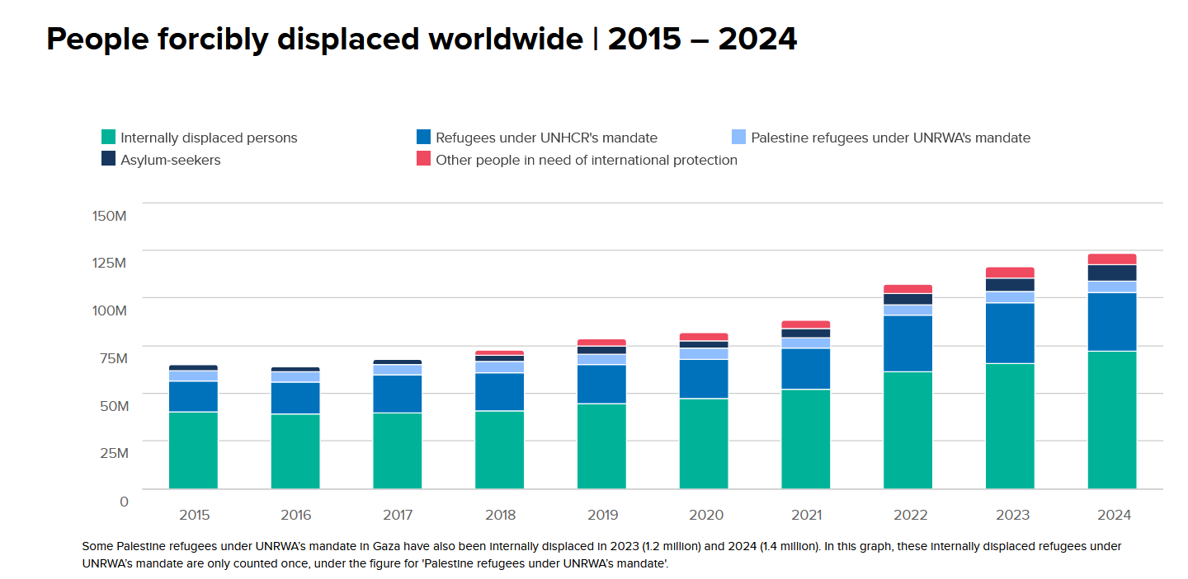
Source A: The image above is a bar graphic about UNHCR’s Global Trends Report. This graphic presents the total number of displaced people in the world from 2015 to 2024. This report clearly highlights an uninterrupted increase in displacement all over the world, rising from around 62 million in 2015 to almost 125 million in 2024. Almost 2% of the entire population on earth is displaced. Additionally the different colors announce the different classifications of displaced people.
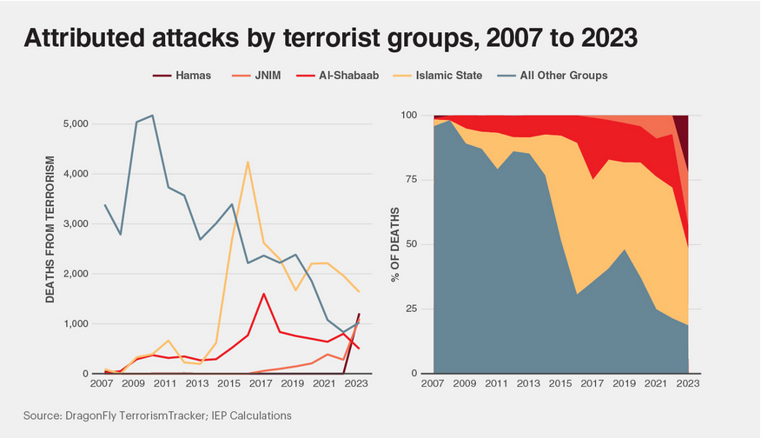
Source B: The line chart above illustrates the attributed attacks by terrorist groups from 2007 to 2023. This chart shows how different terrorist organisations have killed thousands of people over the years. This information shows why terrorist groups and recruiting for these operations have to cease to exist.

Bibliography
Amnesty International. “Amnesty International.” Amnesty.org, Amnesty International, 9 July 2014, www.amnesty.org/en/documents/EUR05/001/2014/en/. Accessed 11 May 2026.
Elkind, Sergey. “Unclaimed Violence: ISIS, Bondi Beach, and Digital Mobilisation - GNET.” GNET, 22 May 2026, gnet-research.org/2026/05/22/unclaimed-violence-isis-bondi-beach-and-digital-mobilisation/. Accessed 27 May 2026.
European Council. “EU-Turkey Statement, 18 March 2016.” Europa.eu, European Council, 18 Mar. 2016, www.consilium.europa.eu/en/press/press-releases/2016/03/18/eu-turkey-statement/. Accessed 12 May 2026.
FRONTEX. “Frontex | European Union Agency.” Www.frontex.europa.eu, FRONTEX, 2024, www.frontex.europa.eu/. Accessed 3 May 2026.
“G5 SAHEL.” Www.g5sahel.org, www.g5sahel.org/.
General Assembly. “Document Viewer.” Un.org, United Nations, 2025, docs.un.org/en/a/res/71/291. Accessed 19 Apr. 2017.
Global Terrorism Database. “Global Terrorism Database.” University of Maryland, 2010, www.start.umd.edu/gtd/. Accessed 17 Apr. 2026.
International Center for the Study of Radicalisation. “Home.” ICSR, 20 May 2025, icsr.info/. Accessed 29 Apr. 2026.
International Organization for Migration. “Global Compact for Migration.” International Organization for Migration, United Nations, 25 Jan. 2019, www.iom.int/global-compact-migration. Accessed 20 Apr. 2026.
Interpol. “Terrorism.” Interpol.int, INTERPOL, 2017, www.interpol.int/en/Crimes/Terrorism. Accessed 24 Apr. 2026.
IOM. “International Organization for Migration.” International Organization for Migration, United Nations, 2018, www.iom.int/. Accessed 22 Apr. 2026.
Kälin, Walter. “Refugees and Internally Displaced Persons in Serbia.” Brookings, Brookings, 30 June 2009, www.brookings.edu/topic/refugees/. Accessed 28 Apr. 2026.
martin.margesin. “UNODC Smuggling of Migrants.” Unodc.org, United Nations, 2011, www.unodc.org/unodc/en/human-trafficking/smuggling-of-migrants.html. Accessed 9 May 2026.
Migration Policy Institute. “Topics.” Migrationpolicy.org, Migration Policy Institute, 2022, www.migrationpolicy.org/topics/migrants-refugees-and-security. Accessed 31 Apr. 2026.
Mukoya, Thomas, and Reuters. “Refugees Stand Outside Their Tent at the Ifo Extension Refugee Camp in Dadaab, near the Kenya-Somalia Border in Garissa County, Kenya,.” Human Rights Watch, Online Article, 19 Oct. 2011, www.hrw.org/news/2019/03/27/kenya-reverse-move-close-refugee-camp. Accessed 16 May 2026.
Office of Counter-Terrorism. “Global Programme on Preventing and Countering Violent Extremism (PCVE) | Office of Counter-Terrorism.” Office of Counter-Terrorism, United Nations, 6 Dec. 2021, www.un.org/counterterrorism/en/preventing-violent-extremism. Accessed 22 Apr. 2026.
---. “UN Office of Counter-Terrorism | Office of Counter-Terrorism.” Un.org, United Nations, 2024, www.un.org/counterterrorism/en. Accessed 24 Apr. 2026.
---. “United Nations Global Counter-Terrorism Strategy | Office of Counter-Terrorism.” Office of Counter-Terrorism, United Nations, 26 Sept. 2006, www.un.org/counterterrorism/en/un-global-counter-terrorism-strategy. Accessed 19 Apr. 2026.
Pandit, Puja. “The Deadliest Terror Groups in 2024.” Vision of Humanity, Vision of Humanity, 29 Feb. 2024, www.visionofhumanity.org/deadliest-terror-groups-in-2024/. Accessed 23 May 2026.
RAND. “Terrorism.” Rand.org, RAND, 2024, www.rand.org/topics/terrorism.html. Accessed 29 Apr. 2026.
Refugees, United Nations High Commissioner for. “Afghanistan.” UNHCR, www.unhcr.org/afghanistan.html. Accessed 31 Apr. 2026.
Security Council. “Document Viewer.” Un.org, United Nations, 28 Sept. 2001, docs.un.org/en/S/RES/1373(2001). Accessed 20 Apr. 2026.
---. “Document Viewer.” Un.org, United Nations, 24 Sept. 2014, docs.un.org/en/S/RES/2178(2014). Accessed 21 Apr. 2026.
---. “Document Viewer.” Un.org, United Nations, 21 Dec. 2017, docs.un.org/en/S/RES/2396(2017). Accessed 21 Apr. 2026.
---. “Reports | Security Council.” Main.un.org, main.un.org/securitycouncil/en/sanctions/1267/monitoring-team/reports. Accessed 3 May 2026.
The UN Refugee Agency. “Lebanon | UNHCR.” UNHCR, 14 Nov. 2025, www.unhcr.org/where-we-work/countries/lebanon?dataset=POP&yearsMode=range&selectedYears=%5B2012%2C2026%5D&level=OPR&category=PTY&fundingSource=ALS&compareBy=%5B%22category%22%5D&levelCompare=%5B%5B%22OLBN_ABC%22%5D%5D&viewType=chart&chartType=bar&contextualDataset=BUD&tableDataView=absolute. Accessed 12 May 2026.
---. “New York Declaration for Refugees and Migrants.” UNHCR, United Nations, 19 Sept. 2016, www.unhcr.org/what-we-do/protect-human-rights/asylum-and-migration/new-york-declaration-refugees-and-migrants. Accessed 21 Apr. 2026.
UNHCR. “Figures at a Glance.” UNHCR, United Nations, 2022, www.unhcr.org/figures-at-a-glance.html. Accessed 11 May 2026.
---. “Syria Emergency.” UNHCR, United Nations, Aug. 2023, www.unhcr.org/emergencies/syria-emergency. Accessed 26 Apr. 2026.
---. “The 1951 Refugee Convention.” UNHCR, 2011, www.unhcr.org/1951-refugee-convention.html. Accessed 21 Apr. 2026.
United Nations. “Goal 10 | Reduce Inequality within and among Countries.” United Nations, 2025, sdgs.un.org/goals/goal10. Accessed 13 May 2026.
---. “Goal 16 | Department of Economic and Social Affairs.” Sdgs.un.org, United Nations, 2025, sdgs.un.org/goals/goal16. Accessed 13 May 2026.
---. “Goal 17 | Department of Economic and Social Affairs.” Sdgs.un.org, United Nations, 2015, sdgs.un.org/goals/goal17. Accessed 12 May 2026.
---. “Security Council | Counter-Terrorism Committee.” Www.un.org, United Nations, 19 May 2026, www.un.org/securitycouncil/ctc/. Accessed 22 May 2026.
---. “UNHCR - the UN Refugee Agency.” Unhcr.org, United Nations, 2023, www.unhcr.org/. Accessed 3 May 2026.
United Nations High Commissioner for Refugees. “Global Trends.” UNHCR, 6 Apr. 2024, www.unhcr.org/global-trends. Accessed 1 May 2026.
UNODC. “Migrant Smuggling.” United Nations : Office on Drugs and Crime, United Nations, www.unodc.org/unodc/en/human-trafficking/migrant-smuggling/migrant-smuggling.html. Accessed 21 May 2026.

