Forum: United Nations Educational, Scientific, and Cultural Organization
Issue #2: Balancing tourism growth with cultural heritage protection
Student Officers: Emma Reyes
Position: Chair of the United Nations Educational, Scientific, and Cultural Organization

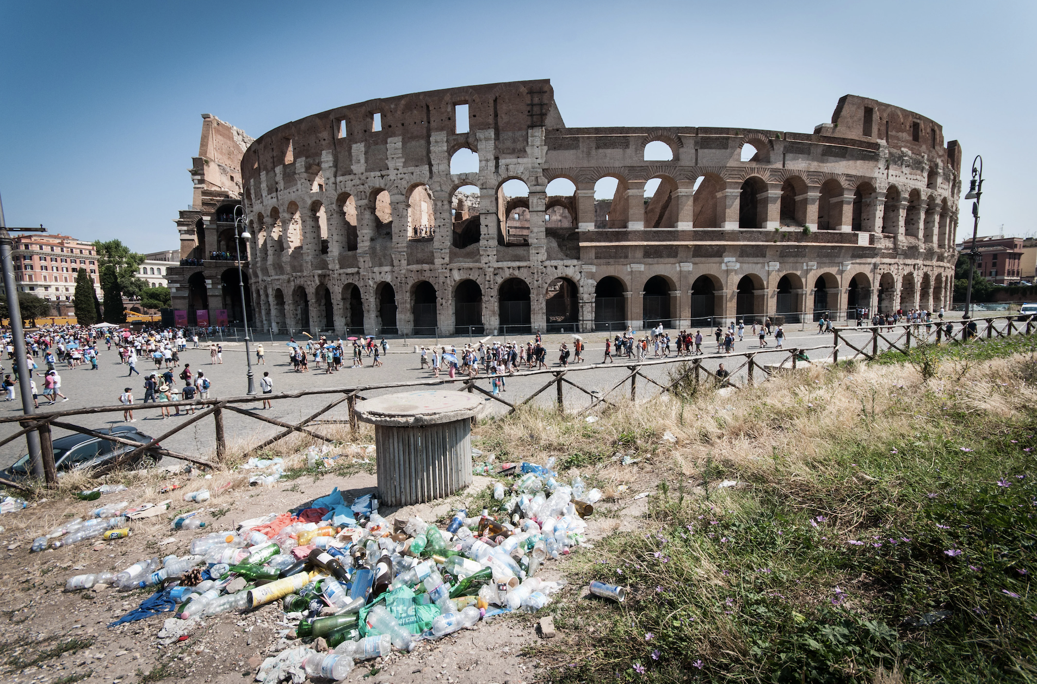
Zampano, Giada. Why Is Rome Drowning in Trash? thepointsguy.com/news/why-is-rome-drowning-in-trash/.

Introduction
Tourism is one of the fastest-growing industries globally, employing over 103 million people worldwide (“Tourism Employment Statistics | 2026 Sourced Report”), and contributing to approximately 10% of global GDP (Pfalz). For an abundance of countries, especially those with rich cultural traditions and historical landmarks, tourism provides a necessary source of revenue that supports education, infrastructure, development, and local economies. The United Nations Educational, Scientific and Cultural Organization (UNESCO) has stated that tourism makes up approximately 40% of international travel, which highlights the importance of heritage sites and how they are central to attracting tourists (UNESCO). Nonetheless, rapid growth in tourism can cause commercialization of heritage sites, overcrowding, environmental decline, and more. Popular tourism sites such as Venice, Machu Picchu, and Angkor Wat are all examples of tourism sites that have faced challenges and damages, where rising tourism rates threaten the preservation of cultural heritage and identity, and the physical integrity of monuments.

Concomitantly, cultural heritage protection is necessary for keeping traditions, historical landmarks, and community identities safe. UNESCO’s World Heritage Convention highlights that heritage sites are irreplaceable, yet many are at risk due to uncontrolled tourism (UNESCO, “The World Heritage Convention”). For example, the World Monuments Fund has listed several sites as endangered because of pressures directly caused by tourism, like erosion and pollution (“World Monuments Fund”). Protecting heritage requires nations to enforce conservation policies and invest in sustainable tourism practices, which can lead to issues between economic incentives and preservation. Even though tourism acts as a financial benefit, inadequate protection risks irreversible damage to cultural heritage. Therefore, the debate centers on balancing these competing interests, ensuring that tourism continues to prosper without eliminating or undermining the cultural and historical assets of nations.

Definition of Key Terms
Sustainable tourism: Tourism that meets the needs of present visitors and host regions, while also protecting and enhancing opportunities for the future of the nation. It emphasizes minimizing environmental and cultural damage while maximizing economic and social benefits (“Sustainable Development”).

Cultural Heritage: The legacy of physical artifacts; like monuments, buildings, and landscapes, and culture, such as traditions, languages, and practices. These are inherited from past generations and are preserved for future generations (Centre).

Overtourism: The situation where excessive tourist numbers negatively impact local communities, cultural heritage sites, and the environment. It can often lead to overcrowding, degradation of monuments, and loss of local and cultural identity (Brajcich).

Carrying Capacity: The maximum amount of visitors a site or destination can sustain without causing alterations to its environment, value, or community life (“Understanding the Multifaceted Concept of Carrying Capacity in Tourism • the Tourism Institute”).

Authenticity: The quality of cultural heritage being genuine and true to its origins. In tourism, authenticity refers to preserving the original meaning and integrity of traditions, practices, and monuments rather than commercialized versions (Stainton).

Cultural Commodifications: The process of turning cultural traditions, practices, or heritage into marketable products for tourism. While it can create a source of income, it risks exploiting cultural identity (“Understanding Commodification in Tourism • BA Notes”).

Cultural Identity: The sense of belonging to a particular culture or group, shaped by shared traditions, language, values, costumes, and heritage. In the context of tourism, it refers to how communities maintain and express their unique cultural characteristics while interacting with foreigners (Oxford Review).

Community-Based Tourism (CBT): A tourism model where local communities can actively benefit from tourism. It ensures that cultural heritage protections align with the locals interests and their traditions (Sustainability Directory).

Heritage Impact Assessment (HIA): A formal evaluation of how proposed tourism projects or developments may affect cultural heritage sites. It helps policymakers balance economic growth with preservation (Ashrafi et al.).

World Heritage Site: A landmark or area recognized by UNESCO for its universal value to humanity. These sites are legally protected under international treaties, but tourism pressure can challenge their preservation (Centre, “What Is World Heritage? - Frequently Asked Questions (FAQ)”).

General Overview
The Main Idea
The central issue lies within the tension between tourism as a driver of economic growth and the imperative to safeguard cultural heritage. Tourism generated approximately $11.6 trillion dollars in 2025 (World Travel and Tourism Council), which provided employment and infrastructure development. Nonetheless, unchecked growth can often lead to overtourism, which threatens tangible heritage such as monuments, historic cities, archaeological sites, and intangible heritage, which includes traditions, languages, rituals, and more. Nations differ in their approaches to this issue, as some prioritize maximizing visitor numbers to raise their GDP, and others impose strict regulations in order to protect heritage, even at the expense of revenue. The debate is shaped by factors such as the economic dependence of countries with low GDPs on tourism, the vulnerability of heritage sites to overcrowding and environmental damage, and the cultural identity of local communities. Ultimately, the accessibility of cultural heritage sites to tourists is directly influenced by national policy choices.

Regulatory Challenges and Overtourism
International tourist arrivals reached approximately 1.4 billion in 2024, representing 99% of pre-pandemic tourism levels (“International Tourism Recovers Pre-Pandemic Levels in 2024”). This nearly full recovery highlights the urgency of developing comprehensive regulatory frameworks in order to manage tourism flows and mitigate overtourism. Prominent heritage destinations such as Venice, Machu Picchu, and Angkor Wat have all adopted measures, including visitor caps, ticketing systems, and more, to help mitigate their overtourism issue. However, enforcement remains inconsistent, and many states lack the capacity or financial resources to conduct systematic heritage impact assessments. The central challenge lies in reconciling economic dependence on tourism revenues with the goal of preserving cultural identity.

Role of Local Communities and Policymakers
Local communities play an extremely important and pivotal role in heritage protection. Community-based tourism models allow residents to manage some tourism activities, which can help ensure that cultural practices are preserved and economic benefits are distributed equitably. Meanwhile, policymakers must design frameworks that integrate heritage protection into national development strategies. This should include enforcing capacity limits, investing in restoration projects, and collaborating with UNESCO to create resolutions in order to safeguard World Heritage Sites. The effectiveness of these measures will depend on the political will and international cooperation that the resolutions face, as heritage protection will require transnational support.

Cultural and Social Consequences
Tourism can strengthen cultural identity through the promotion of traditions and fostering global awareness. However, when heritage is changed or authenticity is diluted for tourists, communities risk losing their cultural distinctiveness. Overtourism can also strain local populations, leading to protests against the rising costs of living, overcrowding, loss of community space, and more. UNESCO has warned that uncontrolled tourism can cause irreversible damage to sites of outstanding cultural and universal value (Centre, “UNESCO World Heritage Centre - World Heritage”). The consequences extend beyond monuments, as heritage and traditions could be altered or abandoned under tourist pressure. Therefore, the debate is not only focused on the economic perspective of tourism, but also on the culture, which can lead to the debate of how societies define and protect their identity in a globalized world.

Major Parties Involved and Their Views
United States: Tourism contributes over 2 trillion annually to the U.S economy (“Travel & Tourism: Economic Impact U.S. 2008-2028”), with sites like the Statue of Liberty and Yellowstone National Park constantly under visitor pressure (National Park Service). The U.S emphasizes sustainable tourism through the National Park Service and UNESCO, but heritage protection can be decentralized. Overall, the U.S stance prioritizes economic growth, but also promotes conservation policies as tensions rise between commercialization and preservation (UNESCO, “UNESCO World Heritage Centre”).

France: France is the world’s most visited country, welcoming around 100 million visitors annually (World Population Review). Sites such as the Eiffel Tower, Mont-Saint-Michel, and Versailles are facing overtourism challenges. The French government heavily insists on restoration and conservation, and enforces strict heritage laws in collaboration with UNESCO. Frances’s position strongly supports international cooperation to safeguard cultural heritage while maintaining tourism as a pillar of its economy.

Italy: Venice, Rome, Florence, and a plethora of other areas in Italy face severe overtourism pressures. Venice has introduced entry fees and restrictions to manage visitor numbers (Comerford). Italy advocates for carrying capacity policies and stricter UNESCO oversight, believing that uncontrolled tourism risks eroding cultural identity and damaging heritage sites.

Spain: Tourism accounts for nearly 12% of Spain's GDP (“INEbase / Services /Hotel Industry and Tourism /Spanish Tourism Satellite Account / Latest Data”). Overtourism has caused local protests, which have led to stricter regulations on short-term rentals and heritage site access. Spain highlights community-based tourism and sustainable visitor management, framing heritage protection as essential for maintaining the possibility of long-term tourism.

Greece: Tourism contributes to about 12.7% of Greece’s GDP (“Tourism’s Contribution to the Greek Economy: 2024 in Review”), with sites like the Acropolis under constant pressure. Greece has invested in restoration projects funded by tourism revenue and supports UNESCO-led initiatives. Greece highlights that heritage protection is not only cultural but also economic, as the sustainability of tourism depends on preserving its ancient monuments, which need to be funded.

Cambodia: Angkor Wat, Cambodia’s most visited site, has and continues to face severe overtourism and structural damage. The government has partnered with UNESCO to manage visitor flows and restore damaged structures. Cambodia’s position emphasizes that heritage protection must be prioritized over short-term economic gains.

Bhutan: Bhutan’s tourism policy charges daily fees in order to limit visitor numbers (Marais). This policy is designed to deliberately restrict mass tourism inflows, thereby mitigating risks of cultural damage and environmental degradation. By highlighting the importance of cultural identity and ecological integrity over short-term economic profit, Bhutan is a leading example of sustainable tourism.

Timeline of Events, Relevant Resolutions, Treaties, and Events

Date Description of Event

1945 | UNESCO was established as a specialized agency of the United Nations in order to create international cooperation in education, science, culture, and heritage protection (Mingst).
1972 | The Convention Concerning the Protection of the World Cultural and Natural Heritage (World Heritage Convention) was adopted in Paris. It has become a cornerstone treaty for safeguarding cultural and natural sites of outstanding universal value (UNESCO, “Convention Concerning the Protection of the World Cultural and Natural Heritage”).
1999 | UNESCO launched the International Cultural Tourism Charter, highlighting the need to balance tourism development with the conservation of cultural heritage sites (“INTERNATIONAL CULTURAL TOURISM CHARTER Managing Tourism at Places of Heritage Significance (1999)”).
2001 | UNESCO creates the Universal Declaration on Cultural Diversity, which highlights the importance of protecting cultural identity while encouraging sustainable tourism practices (Universal Declaration on Cultural Diversity Adopted by the General Conference of the United Nations Educational, Scientific and Cultural Organization at Its Thirty-First Session on 2)
2010 | The UN General Assembly adopts the resolution A/RES/65/173 on sustainable tourism, which focuses on the link between tourism growth and environmental and cultural heritage protection (“Official Document System - UN”).
2012 | Resolution A/RES/67/223 was passed, which promotes sustainable tourism as a driver of poverty eradication and cultural preservation, which encourages member states to integrate heritage protection into national tourism strategies (“Official Document System - UN”).
2014 | Resolution A/RES/69/233 highlights ecotourism and sustainable tourism development, which urged states to integrate heritage protection into tourism policies (“Official Document System - UN”).
2016 | Resolution A/RES/71/240 reinforces tourism's role in achieving the Sustainable Development Goals, specifically Goal 11 on protecting cultural and natural heritage (“Official Document System - UN”).
2017 | Resolution A/RES/72/214 highlights sustainable tourism’s role in eradicating poverty and preserving cultural heritage (“Official Document System - UN”).
2021 | Resolution A/RES/76/201 stresses resilience in tourism development, urging states to integrate heritage protection into post-pandemic recovery strategies (“Official Document System - UN”).
2025 | Resolution A/RES/80/134 highlights sustainable tourism in Central America, highlighting regional efforts to balance tourism growth with heritage protection (“Official Document System - UN”).

United Nations Involvement
The United Nations has played a significant role over the years in addressing the challenge of balancing tourism growth with the protection of cultural heritage. The UN has created conventions, declarations, and resolutions through UNESCO and the General Assembly that frame tourism as both an economic driver and a responsibility to safeguard humanity’s shared heritage.

World Heritage Convention, 1972
The Convention Concerning the Protection of the World Cultural and Natural Heritage was adopted in Paris in 1972. It remains a foundation treaty for safeguarding sites of outstanding universal value. The convention established the World Heritage List (UNESCO, “UNESCO World Heritage Centre - World Heritage List”), which includes a plethora of sites. Nations commit to protecting these sites from threats such as uncontrolled tourism, urbanization, and environmental degradation. Although the convention has been successful in raising global awareness, many sites still face issues and challenges from mass tourism.

UNESCO International Cultural Tourism Charter, 1999
In 1999, UNESCO launched the International Cultural Tourism Charter, which highlights the need to balance tourism development with conservation. The charter showed that tourism can generate economic benefits, but must be managed to avoid damaging cultural identity and heritage sites. It also continues to urge governments to adopt sustainable tourism policies that involve local communities in their decisions.

UN General Assembly Resolutions on Sustainable Tourism (2010-2025)
Beginning in 2010, the UN General Assembly adopted a series of resolutions linking tourism growth to sustainable development and heritage protection. Resolutions A/RES/65/173, A/RES/67/223, A/RES/69/233, and more, all recognized tourism’s role in promoting cultural exchange but stressed the need to safeguard heritage, as well as reinforcing tourism's goal in achieving the Sustainable Development Goals (SDGs), specifically Goal 11.

UNESCO Sustainable Tourism Program
UNESCO has also developed the Sustainable Tourism Program, which provides guidelines for managing tourism at World Heritage Sites (“One Planet | UN Tourism”). The program encourages site managers to assess visitor impact, create management plans, and promote responsible tourism. It highlights that tourism should not only be a source of revenue, but also strengthen cultural identity and community.

Evaluation of Previous Attempts to Resolve the Issue
UNESCO World Heritage and Sustainable Tourism Programme
The UNESCO World Heritage and Sustainable Tourism Programme, which was launched in 2011, sought to integrate tourism planning and heritage management (UNESCO, “World Heritage and Sustainable Tourism Programme”). Its stated aim was to strengthen the capacity of World Heritage stakeholders to manage tourism sustainably (Paris and Headquarters). The programme promoted destination-level strategies, stakeholder dialogue, and heritage impact assessments. It was somewhat successful, as it included community-based projects funded by Germany’s BMZ, which enhanced resilience and visit management in Latin America and Africa. Nonetheless, UNESCO’s own evaluation reports highlight persistent challenges. Many states lack the institutional capacity or financial resources to enforce systematic visitor management. Consequently, overtourism in states such as Venice and Machu Picchu has continued the programme's efforts.

Muscat Declaration on Tourism and Culture (2017)
Adopted at the World Conference on Tourism and Culture in Oman, the Muscat Declaration reaffirmed the importance of strengthening synergies between tourism and culture, while also explicitly linking cultural tourism to the 2030 Agenda for Sustainable Goal Development (“Muscat Declaration on Tourism and Culture: Fostering Sustainable Development). The Declaration emphasized empowering local communities and promoting innovative tourism models. Its impact has been largely symbolic, since without binding obligations or accountability mechanisms, overtourism pressures at world heritage sites continue to escalate. The declarations, aspirational language advanced the debate but failed to produce measurable outcomes.

Regional and National Initiatives
Regional projects have attempted to operationalize sustainable tourism principles, for example, UNESCO’s 2021-2024 initiative in Latin America and the Caribbean, funded by Saudi Arabia’s Ministry of Culture, aimed to strengthen resilience and safeguard intangible heritage through tourism (“Latin America and the Caribbean: Strengthening Capacities for Resilient Communities through Sustainable Tourism and Heritage Safeguarding - UNESCO Intangible Cultural Heritage”). Workshops in Mexico and the Dominican Republic promoted visitor management and integration of cultural practices into urban planning. While these initiatives demonstrated localized success, they remain dependent on external funding and lack long-term sustainability. National measures have also been introduced; Venice implemented entry fees in 2022 to limit overcrowding, and Peru established visitor caps at Machu Picchu. These policies illustrate practical attempts to balance tourism growth with heritage protection, but enforcement challenges and public resistance have hindered their effectiveness.

Possible Solutions
Aligning Tourism Regulations Among Countries
Continuously, each nation has adopted diverse rules regarding tourism management at heritage sites, which has resulted in uneven levels of protection and inconsistent visitor experiences. Therefore, implementing UNESCO and the United Nations World Tourism Organization’s (UNWTO) guidance would ensure that all countries adopt minimum standards for heritage impact assessments, visitor caps, and funding for restoration. The 1972 World Heritage Convention made a framework for safeguarding sites of “outstanding universal value" (UNESCO, “Convention Concerning the Protection of the World Cultural and Natural Heritage”). Expanding this framework concept for safeguarding tourism regulation would provide a reliable and carefully structured approach to balancing tourism growth with heritage protection.

Enhancing Visitor Management Systems
Heritage sites often suffer from overcrowding due to insufficient regulation of visitor flows. In order to decrease the risk of overtourism, the addition of timed ticketing, daily visitor limits, and differentiated pricing would be enforced. Many cases of heritage degradation emerge from uncontrolled visitor numbers. Therefore, to mitigate damage, visitor management systems should be strengthened and adapted to local contexts. These systems' main goal should be to optimize the visitor experience, while also protecting cultural authenticity, which ensures that tourism contributes positively without eroding heritage value.

Strengthening Community-Based Tourism
Local communities hold an extremely important role when it comes to preserving cultural identity and authenticity. Since tourism directly impacts residents' lives and traditions, it is essential that communities are empowered to manage tourism activities. Many cases of heritage commodification emerge when local voices are excluded from decision-making. Therefore, community-based tourism should be enforced in order to decrease the risk of cultural erosion. Residents should also be well informed of tourism's advantages and consequences, and should be considered and involved in planning, ensuring that economic benefits and cultural practices are preserved.

Improving Monitoring and Accountability
The regulation of tourism is extremely critical for the sustainability of its heritage sites. It is essential that international organizations and national governments are aware and well prepared in order to handle this topic. Many cases of ineffective heritage protection stem from weak enforcement and a lack of accountability. Therefore, in order to decrease heritage loss, monitoring systems should be enforced. UNESCO audits, why are reporting mechanisms, and penalties of non-compliance could ensure that commitments to resolutions are upheld. The goal should be to enhance accountability and optimize heritage protection while also keeping in mind the consequences of overtourism, as well as the importance of cultural preservation.

Sustainable Development Goal (SDG)
SDG 11, Sustainable Cities and Communities
Sustainable Development Goal #11, Sustainable Cities and Communities, aims to make cities and human settlements inclusive, safe, resilient, and sustainable (United Nations). A central component of this goal is the protection of cultural and natural heritage, which is directly linked to and threatened by overtourism and poorly regulated tourism growth. Last year, international tourism arrivals reached 1.52 billion (“UN Tourism World Tourism Barometer | Global Tourism Statistics”). This surge has intensified pressures on heritage sites, and so visitor caps and ticket systems have been introduced to mitigate damage.

The SDG Report 2023 highlights that one in three urban residents worldwide live in slums or informal settlements, underscoring the vulnerability of communities when tourism development is prioritized over cultural identity and local well-being. Furthermore, UNESCO has warned that uncontrolled tourism can lead to the irreversible loss of sites of outstanding universal value. SDG 11 directly addresses the challenges by calling for integrated policies that balance economic growth with heritage protection, community resilience, and sustainable urban planning.

The tissue of balancing tourism growth with cultural heritage protection is therefore embedded within the broader mission of SDG 11. By ensuring that heritage sites are preserved and communities are considered, the goal aims to guarantee that tourism contributes to sustainable development and does not undermine cultural authenticity.

Appendix
This section of the issue bulletin is dedicated to providing delegates with sources to use during their research.
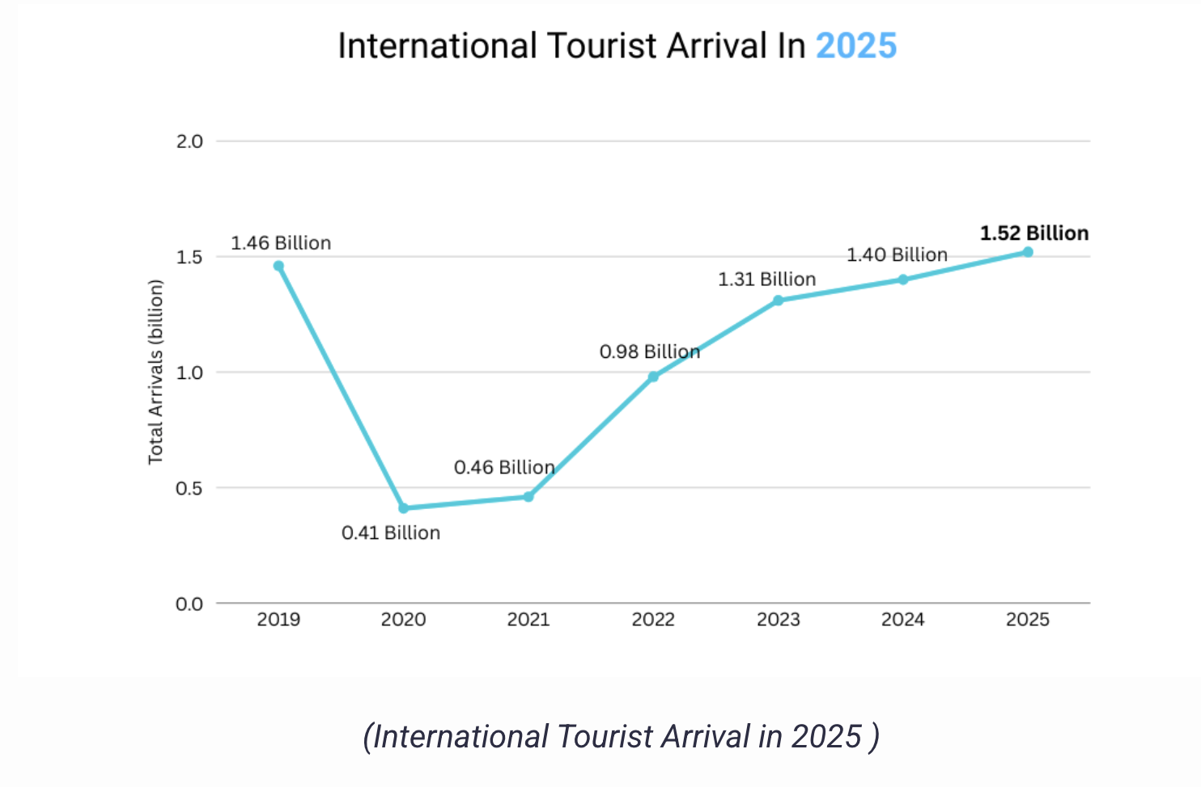
Source A: This source shows international tourist arrivals from 2019 onward, which highlights the decline in 2020 due to Covid-19 and the recovery to 1.4 billion arrivals in 2024, which is 99% of prepandemic levels. It demonstrates the scale of tourism growth and renewed pressures on heritage sites (Yam Chhetri).

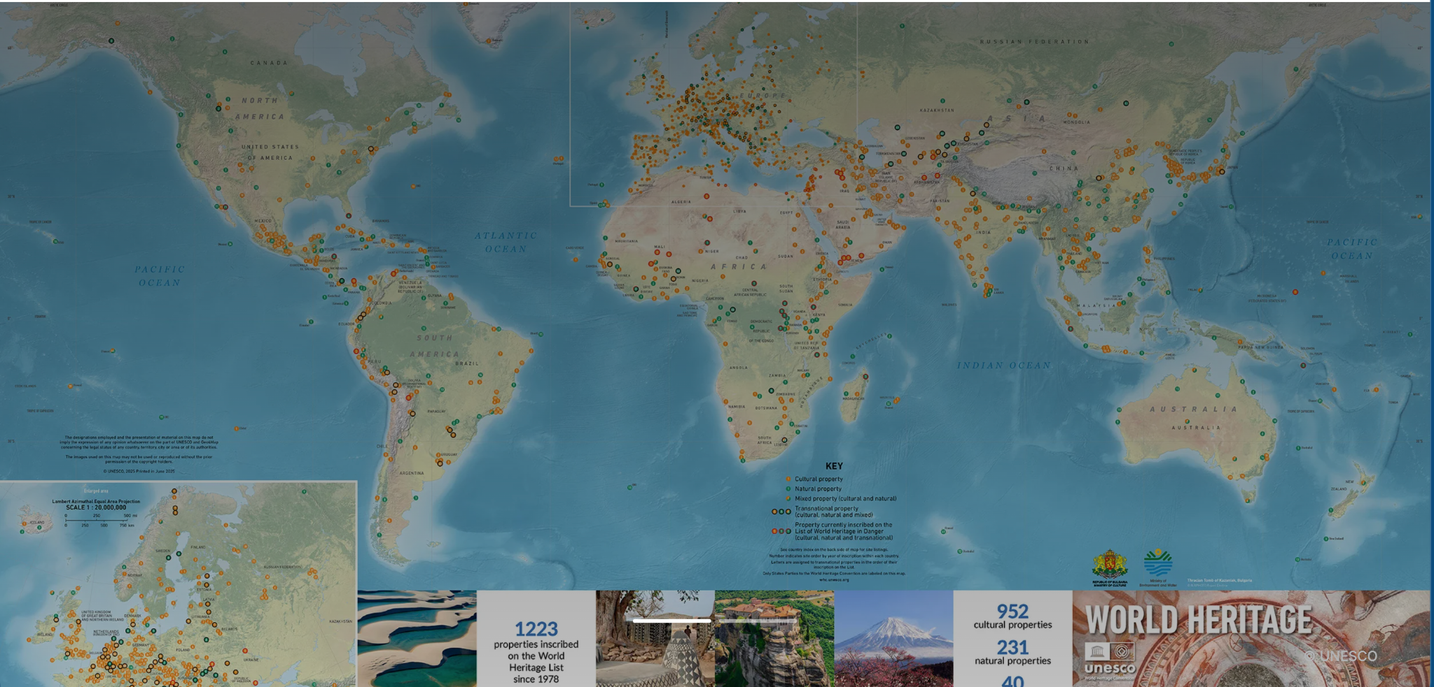
Source B: This UNESCO map marks the cultural and natural world heritage sites worldwide. It can be used in order to illustrate how overtourism pressures are concentrated in regions with high tourist inflows, such as areas in Europe and Southeast Asia (World).

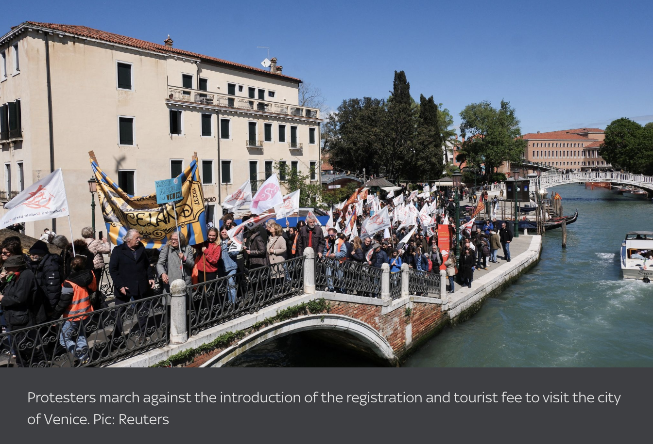
Source C: The image above shows protesters in Venice opposing overtourism measures, such as cruise ship access and tourist fees. This is significant because it shows the social consequences of overtourism. Such as, local communities resisting policies that affect their daily lives, and demanding stronger protections for their heritage (“Anger as Overcrowded Venice Begins Charging Visitors to Enter City from Today”).

Bibliography
“Anger as Overcrowded Venice Begins Charging Visitors to Enter City from Today.” Sky News, news.sky.com/story/anger-as-venice-begins-charging-visitors-to-enter-city-from-today-13122541.
Ashrafi, Baharak, et al. “A Conceptual Framework for Heritage Impact Assessment: A Review and Perspective.” Sustainability, vol. 14, no. 1, 21 Dec. 2021, p. 27, https://doi.org/10.3390/su14010027.
Brajcich, Kaitlyn. “What Is Overtourism and Why Is It a Problem?” Sustainable Travel International, 15 Aug. 2024, sustainabletravel.org/what-is-overtourism/.
Centre, UNESCO World Heritage. “Cultural Heritage - Glossary.” UNESCO World Heritage Centre, whc.unesco.org/en/glossary/224/.
---. “UNESCO World Heritage Centre - World Heritage.” UNESCO World Heritage Centre, whc.unesco.org/en/review/.
---. “What Is World Heritage? - Frequently Asked Questions (FAQ).” UNESCO World Heritage Centre, 2024, whc.unesco.org/en/faq/19/.
Comerford, Ruth. “Venice Extends €5 Tourist Entry Fee to 2025.” BBC, 24 Oct. 2024, www.bbc.com/news/articles/c86qlz6l4qno.
“INEbase / Services /Hotel Industry and Tourism /Spanish Tourism Satellite Account / Latest Data.” INE, ine.es/dyngs/INEbase/en/operacion.htm?c=estadistica_C&cid=1254736169169&menu=ultiDatos&idp=1254735576863.
“INTERNATIONAL CULTURAL TOURISM CHARTER Managing Tourism at Places of Heritage Significance (1999).” Docslib, 2018, docslib.org/doc/4840412/international-cultural-tourism-charter-managing-tourism-at-places-of-heritage-significance-1999. Accessed 17 May 2026.
“International Tourism Recovers Pre-Pandemic Levels in 2024.” Untourism.int, 2024, www.untourism.int/news/international-tourism-recovers-pre-pandemic-levels-in-2024.
“Latin America and the Caribbean: Strengthening Capacities for Resilient Communities through Sustainable Tourism and Heritage Safeguarding - UNESCO Intangible Cultural Heritage.” Unesco, 2025, ich.unesco.org/en/projects/latin-america-and-the-caribbean-strengthening-capacities-for-resilient-communities-though-sustainable-tourism-and-heritage-safeguarding-00506.
Marais, Emma. “Why Bhutan Limits Tourist Numbers — the Real Impact of Bhutan’s SDF Tourism Fee.” Follow Alice, 3 Dec. 2025, followalice.com/adventure-trips/discover-bhutan/posts/why-bhutan-limits-tourist-numbers.
Mingst, Karen. “UNESCO | Definition, History, Members, & Facts.” Encyclopædia Britannica, 21 Sept. 2018, www.britannica.com/topic/UNESCO.
“Muscat Declaration on Tourism and Culture: Fostering Sustainable Development | Déclaration de Mascate Sur Le Tourisme et La Culture : Promouvoir Le Développement Durable | Declaración de Mascate Sobre Turismo Y Cultura: “Fomentar El Desarrollo Sostenible.”” UNWTO Declarations | Déclarations de l’OMT | Declaraciones de La OMT, vol. 26, no. 5, 12 Dec. 2017, pp. 1–12, https://doi.org/10.18111/unwtodeclarations.2017.26.05. Accessed 10 Apr. 2021.
National Park service. “NPS.gov Homepage (U.S. National Park Service).” Nps.gov, 2017, www.nps.gov/index.htm.
“Official Document System - UN.” Un.org, 2026, documents.un.org/symbol-explorer?s=A%2FRES%2F65%2F173&i=A/RES/65/173_4492411. Accessed 17 May 2026.
“Official Document System - UN.” Un.org, 2026, documents.un.org/symbol-explorer?s=A%2FRES%2F67%2F223&i=A/RES/67/223_9466505. Accessed 17 May 2026.
“One Planet | UN Tourism.” Untourism.int, 2023, www.untourism.int/sustainable-development/one-planet.
Oxford Review. “Cultural Identity - Definition and Explanation.” The Oxford Review - or Briefings, 23 Oct. 2024, oxford-review.com/the-oxford-review-dei-diversity-equity-and-inclusion-dictionary/cultural-identity-definition-and-explanation/.
Paris, Unesco, and Headquarters. World Heritage 18 GA Distribution Limited EIGHTEENTH SESSION of the GENERAL ASSEMBLY of STATES PARTIES to the CONVENTION CONCERNING the PROTECTION of the WORLD CULTURAL and NATURAL HERITAGE. 2011.
Pfalz, Lacey. “Travel & Tourism Industry to Generate 11 Percent of Global GDP by 2035.” TravelPulse, TravelPulse US, 9 Apr. 2025, www.travelpulse.com/news/features/travel-tourism-industry-to-generate-11-percent-of-global-gdp-by-2035.
Stainton, Hayley. “Authenticity in Tourism- a Simple Explanation.” Tourism Teacher, 10 July 2019, tourismteacher.com/authenticity-in-tourism/.
Sustainability Directory. “How Does Community-Based Tourism Differ from Conventional Tourism Development? → Learn.” Learn → Sustainability Directory, 27 Apr. 2026, learn.sustainability-directory.com/learn/how-does-community-based-tourism-differ-from-conventional-tourism-development/. Accessed 2 May 2026.
“Sustainable Development.” Untourism.int, 2025, www.untourism.int/sustainable-development.
“Tourism Employment Statistics | 2026 Sourced Report.” Worldmetrics.org, 2026, worldmetrics.org/tourism-employment-statistics/. Accessed 25 Apr. 2026.
“Tourism’s Contribution to the Greek Economy: 2024 in Review.” Europa.eu, 2024, transition-pathways.europa.eu/tourism/knowledge-documents/tourisms-contribution-greek-economy-2024-review.
“Travel & Tourism: Economic Impact U.S. 2008-2028.” Statista, www.statista.com/statistics/292518/contribution-of-travel-and-tourism-to-gdp-in-us-time-series/.
“UN Tourism World Tourism Barometer | Global Tourism Statistics.” Untourism.int, 2025, www.untourism.int/un-tourism-world-tourism-barometer-data.
“Understanding Commodification in Tourism • BA Notes.” BA (Bachelor of Arts) Hub, 20 Nov. 2023, banotes.org/tourism-anthropology/commodification-in-tourism-explained/.
“Understanding the Multifaceted Concept of Carrying Capacity in Tourism • the Tourism Institute.” Study Tourism, 25 Nov. 2023, thetourism.institute/tourism-impacts/carrying-capacity-tourism-concept/.
UNESCO. “Convention Concerning the Protection of the World Cultural and Natural Heritage.” Unesco.org, 1972, whc.unesco.org/en/conventiontext/.
---. “Cutting Edge | Bringing Cultural Tourism Back in the Game | UNESCO.” Www.unesco.org, 2023, www.unesco.org/en/articles/cutting-edge-bringing-cultural-tourism-back-game.
---. “The World Heritage Convention.” UNESCO, 1972, whc.unesco.org/en/convention/.
---. “UNESCO World Heritage Centre.” Unesco.org, 2019, whc.unesco.org/.
---. “UNESCO World Heritage Centre - World Heritage List.” Unesco.org, UNESCO, 2023, whc.unesco.org/en/list/.
---. “World Heritage and Sustainable Tourism Programme.” Unesco.org, 2019, whc.unesco.org/en/tourism/.
United Nations. “Goal 11 | Make Cities and Human Settlements Inclusive, Safe, Resilient and Sustainable.” United Nations, United Nations, 2015, sdgs.un.org/goals/goal11.
Universal Declaration on Cultural Diversity Adopted by the General Conference of the United Nations Educational, Scientific and Cultural Organization at Its Thirty-First Session on 2. 2001.
“World Monuments Fund.” Wmf.org, 2022, www.wmf.org/world-monuments-watch.
World Population Review. “Most Visited Countries 2020.” Worldpopulationreview.com, 2023, worldpopulationreview.com/country-rankings/most-visited-countries.
World Travel and Tourism Council. “Travel & Tourism Economic Impact Research (EIR).” Wttc.org, 2024, wttc.org/Research/Economic-Impact.
World, UNESCO. “Order the World Heritage Map - UNESCO World Heritage Centre.” Unesco.org, 2018, whc.unesco.org/en/map/?-interactive%. Accessed 31 May 2026.
Yam Chhetri. “Global Tourism Statistics 2026:Trends and Forecasts - WP Travel.” WP Travel, 14 Jan. 2025, wptravel.io/global-tourism-industry-statistics/?utm_source=copilot.com. Accessed 31 May 2026.
Zampano, Giada. Why Is Rome Drowning in Trash? thepointsguy.com/news/why-is-rome-drowning-in-trash/.

