Forum: Organization of American States (OAS)
Issue #1: Addressing migration enforcement and the protection of migrant rights in the Americas
Student Officers: Chloe White
Position: Chair of the Organization of American States

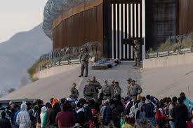
"Thousands of migrants wait at U.S.-Mexico border to see if asylum restrictions end." PBS NewsHour, 21 Dec. 2022, www.pbs.org/newshour/politics/thousands-of-migrants-wait-at-u-s-mexico-border-to-see-if-asylum-restrictions-end. Accessed 13 Apr. 2026.

Introduction
The issue regarding addressing migration enforcement and the protection of migrant rights in the Americas is serious and urgent. The dynamics and scale of migration throughout the Americas have changed since the COVID-19 pandemic. Millions of migrants are arriving every year at different American borders, especially the U.S. This surge has also been propelled due to Venezuela's immigration crisis - Rampant violence, inflation, gang warfare, soaring crime rates, and shortages of food, medicine, and essential services are forcing millions to flee, causing one of the biggest displacement crises in the world. (UNHCR) It’s spilling into places such as the Darien Gap, where over 500,000 immigrants crossed in 2023, exposing vulnerable populations to deadly risks like human trafficking, sexual violence, and harsh jungle terrain.
This massive wave is overwhelming borders, stirring up politics, and creating humanitarian issues. Countries like the U.S. dealt with over 2.4 million encounters at the border in 2023 (CBP), and migrants are facing huge dangers like trafficking and violence. But we can't ignore their rights under things like the Global Compact for Migration. This committee should push for smart ways to enforce rules fairly while keeping people safe, balancing security with humanity across the region.

Definition of Key Terms
Migrant: Someone moving away from their habitual place of residence, whether within a country or across borders, for various reasons. (IOM)

Migration enforcement: The government-led process of upholding immigration laws through the detection, detention, and removal of non-citizens who violate these laws, such as those entering without authorization or overstaying visas. (IOM)

Asylum Seekers: Individuals who have left their home country and are seeking international protection, but whose claim for refugee status has not yet been officially decided. (UNHCR)

Undocumented migrants: Individuals residing in a country without legal authorization, often having entered without inspection or overstaying visas

Border encounters: Border encounters, reported by U.S. Customs and Border Protection (CBP), represent the total number of times officials stop individuals at the border, encompassing both apprehensions (arrests) and expulsions.

Title 42: a pandemic-era public health policy implemented in March 2020 by the Trump administration that allowed U.S. border agents to immediately expel migrants, including asylum seekers, to Mexico or their home countries without traditional immigration hearings. (BBC)

Unaccompanied minors: Children under 18 separated from both parents and relatives, not cared for by an adult responsible for them.

International Covenant on Civil and Political Rights (ICCPR): The International Covenant on Civil and Political Rights (ICCPR) is a major UN human rights treaty adopted in 1966 and entered into force in 1976. It binds ratifying states to protect core civil and political freedoms for everyone under their jurisdiction, without discrimination based on race, sex, origin, or other status.

Arbitrary expulsion: Deportation of non-nationals without individual assessment or due process, like mass removals based on nationality alone. ICCPR Article 13 prohibits it, requiring states to give notice, reasons, and a chance to appeal.

Migrant Smuggling vs. Trafficking: Smuggling is consensual, profit-driven illegal border transport that ends at the destination (UN Smuggling Protocol). Trafficking uses force or deception for ongoing exploitation, like labor or sex work (Palermo Protocol).

Integration Policies: Government programs helping migrants access jobs, education, healthcare, and language classes, while promoting community adaptation to cut social tensions.

“Remain in Mexico”: Trump's immigration policy that requires migrants seeking asylum to remain in Mexico until their US immigration court date.

Temporary Protection Statute: Colombia’s policy, which facilitates the transition of migrants from an emergency migratory regime to a regularization status, granting access to formal employment, education, healthcare, and financial services for almost two million Venezuelan migrants and refugees. (GFMD)

Major Parties Involved and Their Views
United States
The United States serves as the primary destination for the vast majority of migrants arriving in the Americas, recording over 2.5 million border encounters in 2025 alone, predominantly from Venezuela, Central America, and other regions. Following President Trump's reelection in November 2024 and inauguration in January 2025, the administration has intensified enforcement measures, including expanded border wall construction, mass deportation operations targeting undocumented individuals, reinstatements of Title 42-style public health expulsions, and the "Remain in Mexico" policy requiring asylum seekers to await hearings outside U.S. territory. These actions emphasize national security, resource protection, and sovereignty amid strained Customs and Border Protection (CBP) capacities and political pressures from border states. However, such policies have drawn widespread criticism from organizations like the ACLU and UNHCR for alleged violations of international obligations, including non-refoulement under the ICCPR, asylum processing requirements, and protections against family separations and inhumane detention conditions.

Mexico
Mexico functions as a critical transit nation, managing massive inflows from the Darién Gap and southward routes while facing intense pressure from the United States to restrict northward migration. Mexican authorities, through the National Migration Institute (INM) and National Guard deployments, detain over 100,000 migrants annually and enforce the Migrant Protection Protocols ("Remain in Mexico"). The country hosts more than 1 million Venezuelans under temporary protected status, providing limited humanitarian relief amid economic challenges. Yet, pervasive cartel involvement in smuggling—resulting in widespread violence, extortion, kidnappings, and mass graves—combined with institutional corruption, has led to frequent reports of arbitrary expulsions, inadequate screening, and rights abuses, despite Mexico's commitments under the Los Angeles Declaration on Migration and Protection.

Colombia
Colombia bears the heaviest refugee burden in the region, sheltering approximately 2.8 million Venezuelans as of 2026, the largest such population globally. Through the 2021 Statute of Temporary Protection, the government grants work authorization, access to healthcare, education, and financial services, particularly in border areas. As co-chair of the 2022 Los Angeles Declaration, Colombia advocates for equal burden-sharing and multilateral cooperation within the Organization of American States (OAS) and UN frameworks.

Venezuela
Venezuela stands as the primary origin of the ongoing migration crisis driving millions northward. Under the Maduro regime, the country faced an acute economic collapse, hyperinflation exceeding 1 million percent in past years, widespread shortages of food and medicine, rampant gang violence, and political repression, displacing over 7.7 million people since 2014, the largest external displacement in Latin American history. Venezuela contributes minimally to regional solutions, instead fueling outflows that strain its neighbors like Colombia (2.8M refugees) and the U.S. border.

Guatemala
Guatemala operates as both a major origin and transit country within the Northern Triangle, where entrenched gang violence from groups like MS-13 and Barrio 18, and extreme poverty, unemployment exceeding 60% among youth, and institutional corruption propel significant outflows toward the United States. Reinforced by U.S. funding for anti-smuggling task forces and interdiction efforts, Guatemalan authorities prioritize enforcement, resulting in mass expulsions of families and unaccompanied minors without adequate individual assessments, raising concerns over (refugee law that prohibits states from returning refugees or asylum-seekers to any country where their life or freedom would be threatened due to race, religion, nationality, political opinion, or membership in a particular social group) violations. Participation in the Los Angeles Declaration signals commitments to address root causes through poverty alleviation and protection screening, though implementation gaps favor security measures over comprehensive rights safeguards.

General Overview
The Main Idea
Migration in the Americas has become one of the most urgent regional challenges, especially after the COVID-19 pandemic. Economic collapse, political instability, violence, and climate-related issues have pushed millions of people, particularly from Venezuela, Central America, and the Caribbean, to leave their home countries in search of safety and opportunity. As a result, migration routes such as the U.S.-Mexico border and the Darién Gap have seen record numbers of crossings.

This surge has created pressure on governments to strengthen migration enforcement, but it has also raised serious concerns about the protection of migrant rights. Many countries have increased border security, detention, and deportation measures, sometimes at the cost of due process and humane treatment. Policies like Title 42 and “Remain in Mexico” have limited access to asylum, while migrants continue to face dangers such as trafficking, violence, and exploitation during their journeys.

At the same time, international frameworks like the Global Compact for Migration and the ICCPR emphasize that migrants (regardless of status) are entitled to basic human rights, including protection from arbitrary expulsion and the right to seek asylum. This creates a key challenge for the OAS: how to balance national sovereignty and border enforcement with humanitarian responsibilities.

Causes of Migration
The drivers of migration in the Americas are deeply interconnected to structural issues. Economic instability remains a major factor, especially in countries like Venezuela, where hyperinflation, unemployment, and shortages of basic goods have made daily life unsustainable. Political instability and authoritarian governance have also forced many to flee due to a lack of civil freedoms.

In addition, widespread violence from organized crime groups, such as gangs in the Northern Triangle countries of Guatemala, Honduras, and El Salvador, has created unsafe living conditions. Climate change is another growing factor, as extreme weather events, droughts, and food insecurity displace vulnerable populations.

Migration Routes and Risks
Migration routes across the Americas are often dangerous and unregulated. One of the most notable pathways is the Darién Gap, a jungle between Colombia and Panama, where hundreds of thousands of migrants travel despite extreme risks. Migrants face threats including human trafficking, sexual violence, exploitation by smugglers, and life-threatening environmental conditions.

As migrants move northward, many rely on smuggling networks to cross borders, which increases their vulnerability to abuse. Transit countries like Mexico have become obstructions where migrants may face detention, extortion, or uncertainty while waiting to continue their journey or apply for asylum.

Enforcement Policies and State Responses
In response to rising migration, many countries have strengthened enforcement measures to control their borders. The United States, for example, has implemented policies such as Title 42 and the “Remain in Mexico” program to limit entry and manage asylum claims. Similarly, Mexico and other transit countries have increased detentions and deportations, often under pressure from destination countries.

While these policies are intended to maintain national security and manage resources, they have been widely criticized for restricting access to asylum and potentially violating international human rights standards. In some cases, enforcement practices have led to overcrowded detention centers, family separations, and expedited expulsions without proper legal review.

Timeline of Events, Relevant Resolutions, Treaties, and Events

Date Description of Event

2014–Present | Venezuela’s economic and political crisis began, leading to over 7.7 million people fleeing the country, creating the largest displacement crisis in Latin American history (UNHCR).
2020 | The United States implements Title 42, allowing the rapid expulsion of migrants without asylum hearings due to COVID-19 concerns (BBC).
2021 | Colombia introduces the Temporary Protection Statute, granting legal status and access to services for millions of Venezuelan migrants (Government of Colombia / UNHCR).
2022 | The Los Angeles Declaration on Migration and Protection is adopted, promoting regional cooperation and shared responsibility among countries in the Americas (U.S. Department of State).
2023 | Over 500,000 migrants cross the Darién Gap, highlighting the dangers of irregular migration routes and the scale of movement in the region (UNHCR / IOM).
2023 | The United States records over 2.4 million border encounters, reflecting a major increase in migration flows (U.S. Customs and Border Protection (CBP)).
2024-2025 | The U.S. expands enforcement policies, including stricter border controls, increased deportations, and renewed use of policies similar to Title 42 and “Remain in Mexico” (CBP / DHS reports).
2025-2026 | Migration remains at record highs, with over 2.5 million U.S. border encounters, while regional countries continue struggling to balance enforcement with humanitarian protections (CBP / DHS estimates).

United Nations Involvement
UN treaty committees: joint guidance for protecting migrants (2018)
The United Nations has actively addressed migrant rights in the Americas through UN committees issuing urgent calls for protection. In 2018, the Committee on the Protection of the Rights of All Migrant Workers and Members of their families (CMW) and the Committee on the Rights of the Child came together to urge states of origin, transit, and destination to safeguard migrants fleeing violence and poverty from countries such as Honduras, El Salvador, and Guatemala. They emphasized obligations under the International Convention on Migrant Workers, stressing certain principles like non-refoulement, bans on arbitrary expulsion, and non-detention for migration offenses, while highlighting vulnerabilities of women and children. These committees also promoted more of their joint general comments (Nos. 3/4 and 22/23) as a guideline for handling child migrants and women. (OHCHR)

UNHCR: regional cooperation and the Los Angeles Declaration (2022–2024)
UNHCR has supported multiple regional frameworks, such as the 2022 Los Angeles Declaration on Migration Protection, to enhance multinational cooperation across the Americas. Endorsed by 22 countries at the Summit of the Americas, the Declaration promotes solidarity, legal pathways, humane management, and human rights respect. UNHCR highlighted progress such as regularization that benefitted millions, humanitarian aid, the strengthening of asylum systems, and socioeconomic inclusion, whilst also calling for more coordinated efforts at meetings such as the 2024 Guatemala gathering. The agency is committed to expanding resettlement, protection policies, and host communities alongside IOM. (ungeneva)

IOM: humanitarian assistance and migration-management support
The United Nations International Organization for Migration (IOM) has implemented assistance programs amid migration surges in Central America and Mexico. IOM provides hygiene items, food, health care, protection services, shelter, and voluntary returns, while running awareness campaigns on irregular migration risks and countering misinformation as well. These efforts help to support a regional strategy under the GCM (Global Compact on Migration) advocating for collaboration to assist in upholding humanitarian duties and rights during more complex flows. IOM also helps provide tools like the Los Angeles Declaration website for resources on migration management. (UN/IOM)

Evaluation of Past Attempts
Addressing migration enforcement and the protection of migrant rights in the Americas requires balancing state sovereignty with human dignity. In recent years, many governments have relied on stricter border control, deportation, and detention policies to manage migration flows. However, these approaches have often treated migration as only a security issue, while ignoring the deeper causes that push people to move, such as violence, poverty, political instability, and climate-related displacement.

Previous solution attempts have included temporary protection programs, legalization measures, and regional cooperation agreements. These efforts have helped some migrants gain legal status or avoid immediate removal, but they have not solved the broader problem. Many of these policies are limited, inconsistent, or dependent on changing political priorities, which makes them hard to rely on as long-term solutions. As a result, migrants in the Americas still face exploitation, unsafe journeys, family separation, and limited access to justice.

Sustainable Development Goal (SDG)
SDG Number 10: Reduce inequality within and among countries
This issue is closely linked to the Sustainable Development Goals, especially SDG 10, which focuses on reducing inequalities and promoting safe, orderly, and regular migration. It also connects to SDG 8, since migrant workers are often vulnerable to low wages, unsafe labor conditions, and abuse. In addition, SDG 16 is relevant because fair migration systems depend on strong institutions, due process, and the protection of human rights.

For this reason, any lasting solution must go beyond enforcement alone and include cooperation between countries, stronger legal protections, and policies that address the root causes of migration. States in the Americas should work together to create migration systems that are both effective and humane. A successful response must recognize that protecting migrants is not separate from development and security, but essential to both.

Appendix

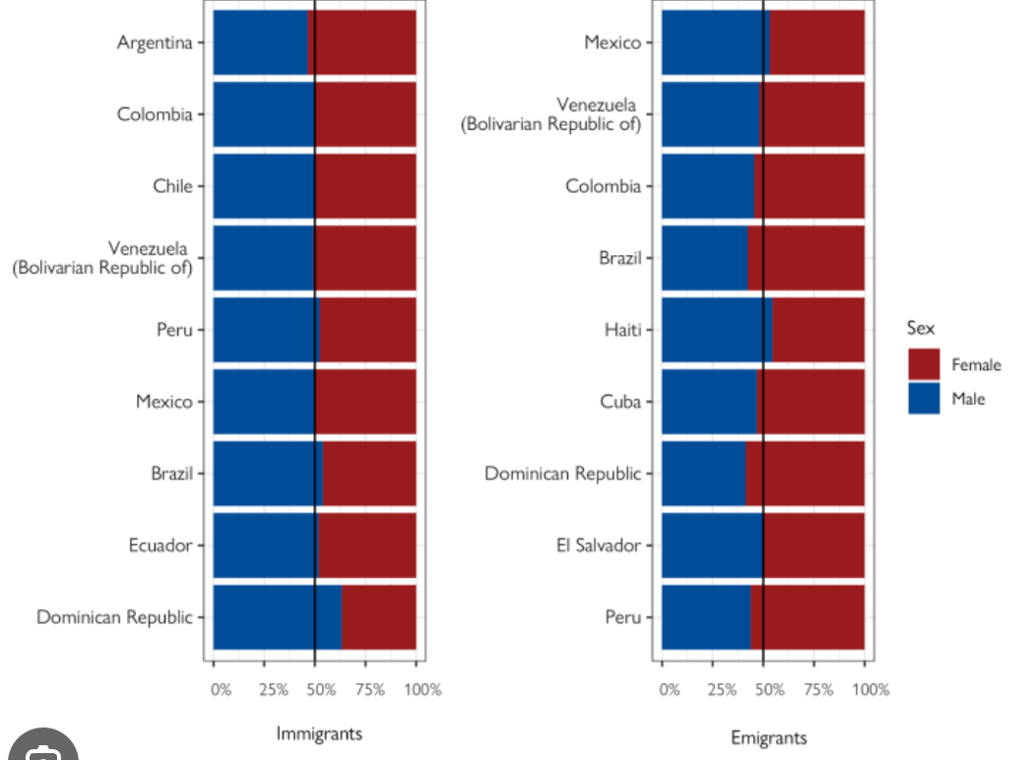
Source A: The image above is a horizontal bar graph presenting sex distribution of immigrants and emigrants by country. This graph shows the different risks that different demographics may face such as; women being more vulnerable to gender-based violence, exploitation, trafficking, or barriers to healthcare, and men may face higher rates of detention, dangerous border crossings, or labor exploitation. This is significant because knowing certain demographics help understand which protections may be most needed.

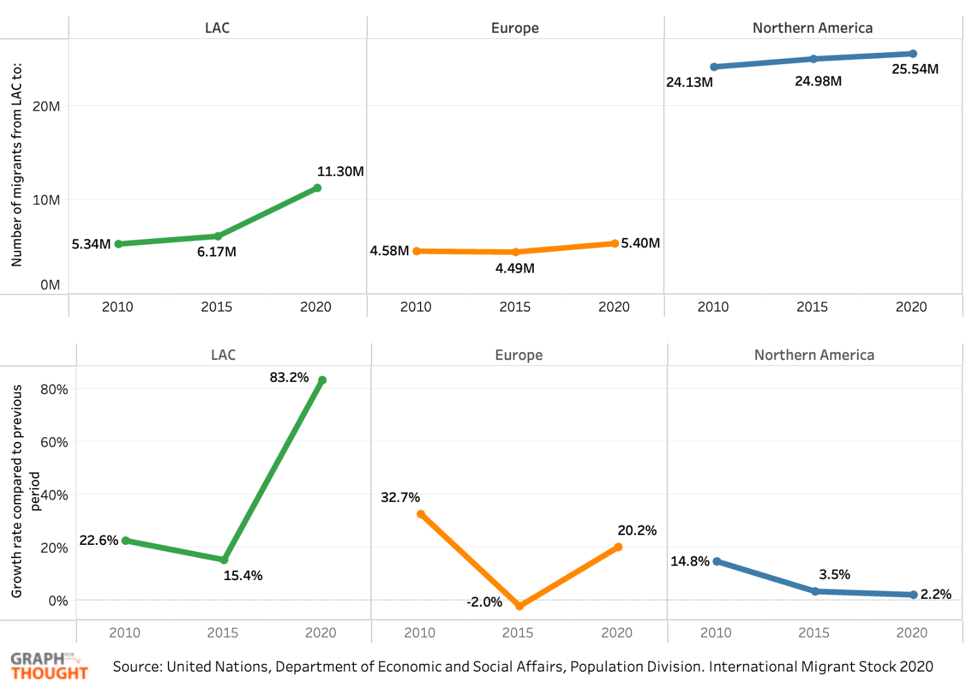
Source B: The image above are multiple line graphs which show the number of migrants living in LAC (Latin America and the Caribbean), other Northern American countries and Europe. It shows a significant increase in migration throughout the last tens years and provides the growth rates of migration by regional area.
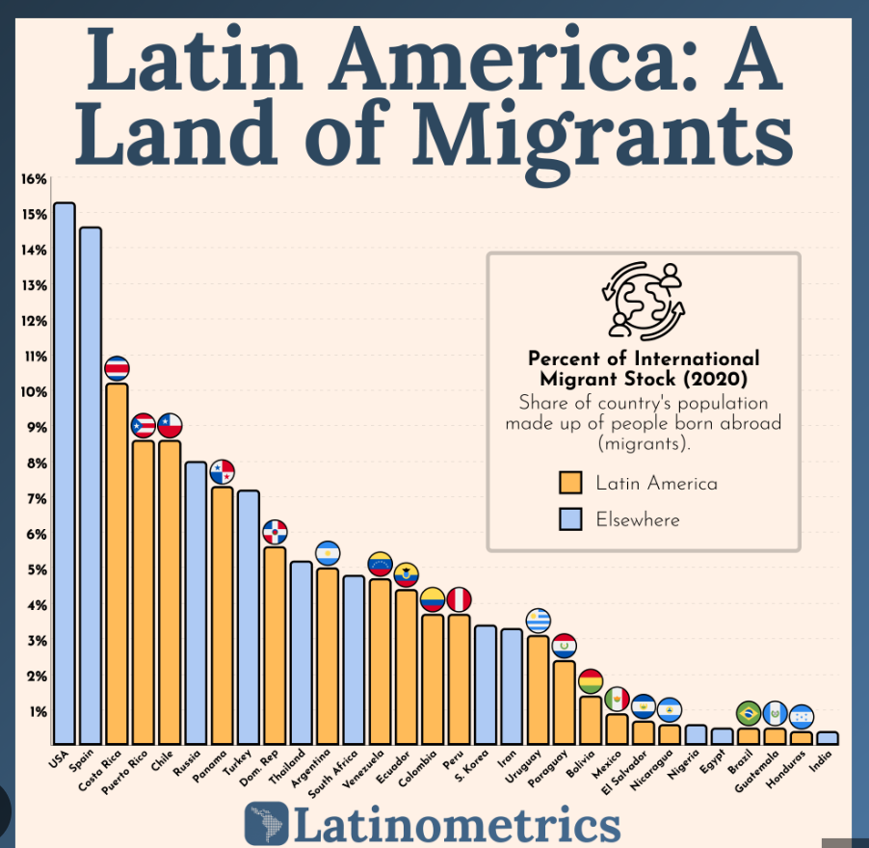

Source C: The image above is a bar graph that shows the percentage of international migrant stock per country in 2020. It shows how many American states are not only sources for migrants but also destinations for them as well. Furthermore, it also shows the difference between how many migrants vs. citizens or people born in that specific country.

Bibliography
brownins. “Venezuelan Migration: Past, Present, and Future - Georgetown Journal of International Affairs.” Georgetown Journal of International Affairs, 2 Feb. 2026,

gjia.georgetown.edu/society-culture/venezuelan-migration-past-present-and-future/. Accessed 20 Apr. 2026.Dejusticia. “Human Mobility under Threat: How Is Latin America Responding?” Dejusticia, Sept. 2025,

www.dejusticia.org/en/human-mobility-under-threat-how-is-latin-america-responding/.
Accessed 10 May 2026.Freeman, Will, et al. “Why Six Countries Account for Most Migrants at the U.S.-Mexico Border.” Cfr.org, Council on Foreign Relations, 25 June 2024, www.cfr.org/articles/why-six-countries-account-most-migrants-us-mexico-border.

Accessed 13 Apr. 2026.INTER-AMERICAN PRINCIPLES on the HUMAN RIGHTS of ALL MIGRANTS, REFUGEES, STATELESS PERSONS and VICTIMS of HUMAN TRAFFICKING Declaration for Refugees and Migrants; the Global Compact on Refugees; the Global Compact for Safe, Orderly and Regular Migration; the 2030 Agenda for Sustainable Development; and Other Relevant International Instruments.“Inter-American Principles on the Human Rights of All Migrants, Refugees, Stateless Persons and Victims of Trafficking in Persons.” United Nations Network on Migration, 2025, migrationnetwork.un.org/policy-repository/inter-american-principles-human-rights-all-migrants-refugees-stateless-persons.

Accessed 10 May 2026.International Organization for Migration. “Global Compact for Migration.” International Organization for Migration, 25 Jan. 2019, www.iom.int/global-compact-migration.Lyon, Beth. “The Unsigned United Nations Migrant Worker Rights Convention: An Overlooked Opportunity to Change the Brown Collar Migration Paradigm.” Villanova University Charles Widger School of Law Digital Repository, 2026, digitalcommons.law.villanova.edu/wps/art145/.

Accessed 4 May 2026.---. “The Unsigned United Nations Migrant Worker Rights Convention: An Overlooked Opportunity to Change the Brown Collar Migration Paradigm.” Villanova University Charles Widger School of Law Digital Repository, 2026, digitalcommons.law.villanova.edu/wps/art145/.“Migrant Rights.” Migration Data Portal, 5 May 2022,

www.migrationdataportal.org/themes/migrant-rights#:~:text=Indeed%2C%20human%20rights%20are%20not,international%20customary%20law%20and%20absolute. Accessed 20 Apr. 2026.Nations, United. “Migrants | United Nations.” United Nations, 2020, www.un.org/en/fight-racism/vulnerable-groups/migrants#:~:text=The%20International%20Convention%20on%20the,migrant%20workers%20and%20their%20families.
Accessed 4 May 2026.---. “Protection of Migrants’ Rights and State Sovereignty | United Nations.” United Nations, 2026, www.un.org/en/chronicle/article/protection-migrants-rights-and-state-sovereignty.
Accessed 4 May 2026.---. “Protection of Migrants’ Rights and State Sovereignty | United Nations.” United Nations, 2026, www.un.org/en/chronicle/article/protection-migrants-rights-and-state-sovereignty.

Accessed 4 May 2026.“Nationwide Encounters.” U.S. Customs and Border Protection, 2026, www.cbp.gov/newsroom/stats/nationwide-encounters. Accessed 26 Apr. 2026.Saulo Padilha. “The Effectiveness of the Inter-American System of Human Rights Protection - Sur - International Journal on Human Rights.” Sur - International Journal on Human Rights, 17 Sept. 2017, sur.conectas.org/en/effectiveness-inter-american-system-human-rights-protection/.

Accessed 10 May 2026.Thompson, Laura. “Protection of Migrants’ Rights and State Sovereignty.” United Nations, Sept. 2013, www.un.org/en/chronicle/article/protection-migrants-rights-and-state-sovereignty.United Nations. “International Convention on the Protection of the Rights of All Migrant Workers and Members of Their Families.” OHCHR, 18 Dec. 1990, www.ohchr.org/en/instruments-mechanisms/instruments/international-convention-protection-rights-all-migrant-workers.---. “Migrants.” United Nations, 2021,
www.un.org/en/fight-racism/vulnerable-groups/migrants.---. “OHCHR | about Migration and Human Rights.” OHCHR, 2024, www.ohchr.org/en/migration/about-migration-and-human-rights.

