Forum: Economic and Social Council (ECOSOC)
Issue #2: Addressing the impact of global inflation on developing countries
Student Officers: Ana Sofia Galindo and Candelaria Plavan
Position: Chair of the Economic and Social Council

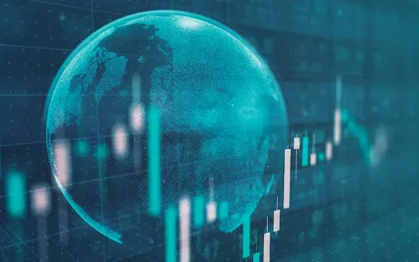
“Is the Recent Inflationary Spike a Global Phenomenon? ” Liberty Street Economics, 16 May 2024, https://libertystreeteconomics.newyorkfed.org/2024/05/is-the-recent-inflationary-spike-a-global-phenomenon/. Accessed 9 May 2026.

Introduction
Global inflation has become one of the most urgent economic challenges facing developing countries. Inflation refers to the general increase in prices over time, which reduces the purchasing power of households, governments, and businesses. The World Bank measures inflation using the consumer price index, which tracks the annual percentage change in the cost of a basket of goods and services commonly purchased by consumers (World Bank, 'Inflation, Consumer Prices'). While inflation affects all countries, developing economies are often more vulnerable because many depend heavily on imported food, fuel, medicine, and industrial goods. When global prices rise, these countries face higher import costs, weaker currencies, increased debt burdens, and greater pressure on public spending.
The effects of global inflation are especially severe for low-income households, as a larger share of their income is spent on basic needs such as food, housing, transportation, and energy. The World Economic Situation and Prospects 2026 explains that although global inflation is expected to ease, high prices continue to reduce real incomes and increase inequality, especially for vulnerable populations (UNCTAD, World Economic Situation and Prospects 2026). The report also emphasises that many developing economies continue to face limited fiscal space, heavy debt burdens, and restricted access to affordable financing, making it harder for governments to protect citizens from rising costs.
The International Monetary Fund’s World Economic Outlook: April 2026 further highlights that emerging market and developing economies continue to face risks from global economic uncertainty, inflationary pressure, and slower growth (IMF, World Economic Outlook: April 2026). The World Bank also explains that inflation in emerging and developing economies is shaped by both global and domestic factors, including exchange rate movements, inflation expectations, and international price shocks. As a result, delegates must consider how countries can balance inflation control, social protection, debt sustainability, food and energy security, and long-term development goals.

Definition of Key Terms
Inflation: According to the Federal Reserve Board, inflation is “a general increase in the overall price level of the goods and services in the economy” (Peterson Foundation). Inflation is also known as the increase of products over time. Inflation cannot be measured by an increase in the cost of one product or service, or even several products or services.

Consumer Price Index (CPI): Is referred to as a measure of the average change over time in prices in a market basket of consumer services and goods by urban consumers. Many places around the world are connected to indexes, mainly the U.S. (“CPI Home”)

Developing Countries: Are described as countries that have a lower average in various sections, such as economy or human rights. Additionally, to having smaller economies, typical developing countries have a more corrupt and less functional government. Generally, in developing countries, there is weaker human rights protection and lower life expectancies (Britannica).

Core inflation: Core inflation helps to show how prices are rising in economies. Moreover, they are constantly tracking prices, leaving out food and energy, since the prices of those items can be unpredictable in most economies. These trackers are helpful as they show how prices can change and affect an individual's spending power over a long period of time (Kenton).

Purchasing power: Is referred to as the amount of products or services that a single unit of money can acquire; this can connect to the real-world value of currency throughout companies and marketplaces. However, it can be a major weakness over time due to inflation. This is because prices are effectively decreasing the number of goods or services. Every aspect of the economy impacts consumer demand, investment trends, and overall national prosperity (Hayes).

Supply shock: Is defined as a sudden change in the availability of a product or service, leading to price fluctuations. Supply shocks can also be short-term, like blocked shipping routes, or even long-term due to events like wars or trade embargoes. Supply shocks occur when an unexpected event disrupts the availability of a good commodity, which can significantly cause price shifts (stonex.com).

Disinflation: Disinflation is defined as a slowing down or reduction in the rate of inflation. It represents a decrease in the speed at which prices increase rather than a drop in the prices themselves. The worst economic crises are strongly associated with deflation, like the Great Depression (“Inflation vs. Deflation | Britannica Money”)

Monetary policy: Is defined as a combination of many strategies and actions that the Federal Reserve employs to achieve the economic goals set for it by Congress. Monetary policy strategies can also include revising interest rates and changing bank reserve requirements. Lastly, it is commonly classified/known as either expansionary or contractionary.

Cost of living price: The cost of living is the total amount of money that can be a requirement to maintain specific standards to live a comfortable and safe way. These expenses are essential. They include food, healthcare, housing, and more.

General Overview
The Main Idea:
The most controversial aspects of global inflation on developing countries are the stark disparities, as different nations can experience and also respond to rising prices of different sections. In addition, inflation constantly affects the cost of living, which weakens conditions for workers and other people/families. The general cost of higher inflation can be reduced by the purchasing power of money falling into exchange rates, which creates heavy reliance on food and energy imports (economics). Five main countries in the region around the Middle East have seen a high food inflation going beyond 60% just now in 2026, with Lebanon and Syria facing a major increase at a 138% increase, mainly in essential foods such as bread, rice, and vegetables, demonstrating how people struggle every day with rising prices (UN World Food Programme)

Regulatory Challenges and Global Inflation Drivers:
Since March of 2022, 71 million people in developing countries have experienced soaring inflation rates and have seen an increase in the number of lower-income families and people. This means that it led to poverty mainly as food and energy were key inflation areas, which led millions of people into poverty globally (UNDP). It has most significantly and commonly affected developing countries, including supply-side disruptions since COVID-19, the war in Ukraine, and extreme weather events that have reduced global trade operations.

Role of Governments and International Organisations:
Central banks play a crucial role in controlling inflation impacts. Central banks are institutions that oversee a nation's monetary system. They also help to supply money and set interest rates, which all help to regulate inflation. As they manage insulation to establish financial markets, their influence is also felt in every part of the world, making them important all over the world (Holborn Assets). Furthermore, it is clearly seen that governments must identify vulnerable populations, which include low-income households facing food insecurity, unemployment, and many other critical issues (MENA).

Major Parties Involved and Their Views
United States
The United States is a major party involved because its economy, interest rates, and monetary policy strongly influence the global financial system. When the United States raises interest rates to control inflation, borrowing costs can rise internationally, making it harder for developing countries to repay debt or access affordable loans. This can create additional pressure on countries that already face high debt burdens and limited government budgets. The IMF explains that global inflation, financial conditions, and policy decisions in major economies continue to affect growth and stability in emerging markets and developing economies (IMF, World Economic Outlook: April 2026).

China
China is an important party because it is one of the world’s largest exporters and trading partners for many developing countries. Changes in Chinese production, demand, and trade affect the prices of goods, raw materials, and supply chains around the world. Many developing countries rely on Chinese imports for machinery, electronics, construction materials, and manufacturing goods, so prices in China can influence inflation in those countries. Since inflation in developing economies can be affected by global price shocks and international trade conditions, China plays a major role in this issue (World Bank Inflation in Emerging and Developing Economies).

India
India is a major developing economy and an important voice for the Global South. Because India has a large population and a growing economy, inflation can strongly affect food security, wages, energy access, and poverty reduction. India is also significant because it represents many of the challenges faced by developing countries, balancing economic growth, inflation control, and protection for vulnerable communities. The World Bank notes that inflation in emerging and developing economies can be influenced by domestic conditions, exchange rates, and global price shocks, all of which are relevant to large developing economies like India (World Bank, Inflation in Emerging and Developing Economies).

Brazil
Brazil is an important party because it is one of the largest economies in Latin America, and a major exporter of agricultural goods, energy products, and raw materials. Inflation in Brazil can affect food prices, poverty, and regional economic stability. At the same time, Brazil's role in global food and commodity markets means that changes in its production or export prices can affect other countries, especially those that depend on imported food. The World Bank's inflation data shows how consumer price inflation is a key measure for understanding price instability across countries and regions (World Bank, "Inflation, Consumer Prices").

Egypt
Egypt is a major party because it is a developing country that depends heavily on imported food, especially wheat, and has faced pressure from rising food and energy prices; inflation can create serious challenges for Egyptian households because many people spend a large portion of their income on basic goods. Egypt also shows how inflation can connect to food security, currency pressure, and debt concerns. The UN explains that high prices can reduce real incomes and worsen inequality, especially in developing economies with limited fiscal space (UNCTAD, World Economic Situation and Prospects 2026).

Nigeria
Nigeria is important because it is one of Africa’s largest economies and has faced inflation linked to food prices, fuel costs, currency depreciation, and supply challenges. Inflation in Nigeria can affect millions of people by making food, transportation, and basic goods less affordable. As a major oil-producing country, Nigeria also shows how inflation can affect countries differently depending on whether they export or import energy. The UN DESA briefing emphasises that global economic instability and inflationary pressures can create serious challenges for developing economies (UN DESA, monthly briefing No. 189).

Timeline of Events, Relevant Resolutions, Treaties, and Events
Date Description of Event

1966 | The International Covenant on Economic, Social, and Cultural Rights, also known as ICESCR, was adopted. This treaty protects rights such as the right to work, education, healthcare, social security, and an adequate standard of living. It is important to global inflation because inflation can weaken the rights when citizens lose purchasing power, and governments in developing countries cannot afford enough support programs. ( ‘’Timeline of major international human rights treaties’’ ).
1986 | The UN adopted the principles relating to remote sensing of the earth from outerspace thorough general assembly resolution 41/65. Although this is not directly about inflation. It matters because satellite data can help countries monitor agriculture, natural disasters, drought, and food supply. These factors are important because food shortages and climate shocks can increase food prices, especially in developing countries that depend heavily on imports or agriculture ( ‘’Space Law Treaties and Principles’’ ).
1993 | The World Conference on Human Rights took place in Vienna, Austria, and led to the Vienna Declaration and Programme of Action. This event reinforced that human rights, development, and international cooperation are connected. For the issue of inflation, this matters because economic crises can increase inequality and reduce access to basic needs, meaning inflation should not only be seen as an economic problem but also as a human development issue (Tehran to Vienna Timeline; OHCHR).
1996 | The UN adopted the Declaration of International Cooperation in the exploration and use of Outer Space for the benefit and interest of all states, especially taking into account the needs of developing countries. This is relevant because it supports the idea that technology and international cooperation should help poorer nations. For inflation, technology such as satellite monitoring can help developing countries prepare for climate disasters, protect food systems, and reduce sudden price increases (‘’Space Law Treaties and Principles’’).
2000 | The Millennium Development Goals were introduced by the United Nations to reduce poverty, hunger, disease, and inequality. These goals are connected to global inflation because inflation can reverse progress in reducing poverty. When food, fuel, and basic goods become more expensive, low-income families in developing countries are affected the most, making development goals harder to achieve (‘’Understanding the UN’’).
2015 | The UN adopted the 2030 Agenda for sustainable development though general assembly resolution 70/1. This created the 17 Sustainable Development Goals, including goals on poverty, hunger, economic growth, and inequality. Global inflation threatens these goals because rising prices can increase poverty, worsen hunger, lower wages, and make it harder for developing countries to invest in education, healthcare, and infrastructure (UN General Assembly Resolution 70/1).
2022 | The UN General Assembly adopted resolution 77/156 on external debt sustainability and development. This resolution is important because developing countries are often more vulnerable when inflation rises globally. Higher inflation can lead to higher interest rates, which makes debt repayment more expensive and leaves government with less money to spend on food security, healthcare, education, and social protection programs ( UN General Assembly Resolution 77/156).
2024 | The pact for the future was adopted as part of the un’s efforts to strengthen international cooperation and improve global governance. This is connected to inflation because developing countries often face inflation due to global causes such as supply chain disruptions, debt, climate change, conflict, and energy price shock. The event shows that the UN continues to focus on multilateral solutions for modern global problems (‘’ Understanding the UN’’).
2024-2027 | The UN began moving toward a legally binding treaty on the protection of persosn in the event of disasters, with negotiaions expected to continue through 2027. This is relevant because disasters can destroy crops, damage infrastructure, interrupt trade, and increase food and energy prices. Developing countries are often more exposed to these shocks, so disaster protection is connectedto preventing inflation from becoming worse during emergencies (IFRC Disaster Law’’).

United Nations Involvement
The United Nations has held a significant role over the years concerning the issue of inflation in developing countries.

UNDP SDG Stimulus Plan - 2023
In 2023, the UN issued and enforced the 'United Nations Secretary-General’s SDG Stimulus to Deliver Agenda 2030.' It calls upon global financial systems. First is addressing the growth of debts over time in 2030. Increase risks of debt crises by replacing short-term, even high-interest, loans with long-term borrowing at lower interest rates. Public development banks (PDBs), which include multilateral development banks (MDBs), show increases in affordable long-term financial development. In addition, the SDG Stimulus Plan also reinforced the increase in availability of emergency and financial issues for low-income and developing countries. This plan calls for $500 billion per year to have greater, more sustainable development and affordable long-term financing for developing countries (UN report SDG).

UN DESA World economics situation & prospects (WESP) report
UN DESA’s annual report states that inflation trends globally and projects are around 25% of developing countries facing inflation exceeding 10% in 2024, and also with high consumer prices mainly in developing economies, majorly increased by around 21.1% since 2021, meaning prices have increased specifically pre-pandemic. Meanwhile, there is global economic performance, which increased expectations in 2023; the reports call attention to how short-term risks can possibly be seen and cause damage. Overall, the DESA report encourages and recommends governments and countries to expand support while calling for debt issues and climate financing to help developing countries around the world (UN report SDG).

UNCTAD Trade & Development Report - 2024
UNCTAD calls for a "rethink" of development strategies amid global economic slowdown and rising social discontent. The report highlights that inflation has eroded household incomes by 8% since 2022, which shows the need for coordinated actions to stabilize prices. The report also labels that despite opportunities for developing countries due to growth in South trade and demand for minerals, which created issues in the global economy (UNCTAD).

Evaluation of Previous Attempts to Resolve the Issue
General international frameworks and economic coordination
International organizations have tried to address global inflation in developing countries through policy coordination, debt relief, and development financing. UN DESA’s World Economic Situation and Prospects 2026 explains that these efforts have aimed to control inflation while supporting economic growth. However, they have not been fully successful because global cooperation remains fragmented, and many developing countries have limited fiscal space to protect citizens from rising food, fuel, and transport prices (UN DESA, World Economic Situation and Prospects 2026).

UNCTAD and financing-for-development initiatives have also attempted to support developing countries through concessional finance and debt reform platforms. These efforts are important because high debt and borrowing costs make it harder for governments to fund subsidies, healthcare, education, and food security. However, implementation has been uneven, meaning many least developed countries remain vulnerable to inflation shocks (UNCTAD, World Economic Situation and Prospects 2026).

Targeted efforts by global organizations
The IMF has supported inflation control through tighter monetary policy, higher interest rates, and fiscal consolidation. While these policies can help reduce inflation, they can also harm poorer populations if they lead to cuts in social spending or make borrowing more expensive. This shows that IMF-backed solutions may stabilize economies but can also increase poverty and inequality if they are not paired with social protection (IMF, World Economic Outlook April 2026).
The World Bank has evaluated tools such as exchange rate stabilization, subsidies, price controls, and wage indexation programs. These can sometimes provide short-term relief, but they may also create problems, such as expensive government spending or market shortages. Therefore, inflation policies in developing countries need to be carefully designed so they do not place the greatest burden on the poorest groups (World Bank, Inflation in Emerging and Developing Economies).

ECOSOC and limitations of previous solutions
ECOSOC has promoted cooperation between the UN, IMF, World Bank, WTO, and UNCTAD to improve macroeconomic policy and financing for development. However, many ECOSOC recommendations are non-binding, meaning countries are encouraged but not forced to act. As a result, ECOSOC has helped create dialogue, but it has not always produced strong protection systems for developing countries facing inflation (ECOSOC Special High-level Meeting).

Overall, previous attempts have only been partially effective. International organisations have helped with policy advice, financial support, and debt discussions, but many solutions focus more on economic stability than on protecting vulnerable people from rising prices. Future solutions should combine inflation control with social protection, food and energy support, debt relief, and reliable development financing.

Possible Solutions
Establishing a global unified inflation framework
Around the world, countries have implemented fiscal and diverse monetary frameworks and policies to minimize inflation; however, they have led to harsh disparities and issues mainly in developing nations, which are experiencing and have experienced rising prices in daily needs. According to the UN global headline, inflation has declined from 5.6% in 2023 to 4% in 2024 (Nations). Although this data demonstrates some change, countries, specifically developing countries, are still facing rising prices. Therefore, ECOSOC should establish and implement a framework to ensure coordinated political actions across all countries, which would significantly help those low-income countries. The framework will help standardize approaches to inflation, requiring UN DESAS to publish monthly work on economic situations and prospects reports on developing nations.

Enhancing targeted social protection through digital cash transfers
Governments and massive international organizations play a crucial role in protecting developing countries during crises such as inflation. Organizations and central banks help conduct monetary policy by adjusting the supply of money, normally by targeting the sale or purchase of securities (“Monetary Policy and Central Banking”). UNDP research shows that targeted digital cash transfers work much more effectively than universal subsidies for the cost of living standards and crises. Meaning to decrease the amount of poverty within nations caused by inflation, governments and more should create and address the idea of mobile-based digital cash transfer systems, which will be able to ensure aid reaches intended recipients.

Strengthening debt restructuring and concessional financing mechanisms
One major concern in developing countries is the amount of unsustainable debts; when inflation increases, this can be a huge danger for families and individuals, for social protection and economic development. Meaning ECOCSOC, working with organizations and the World Bank, should establish mandatory sovereign restructuring for countries facing massive inflation. This would ensure access to better and more affordable means while also helping to decrease debt issues. Expanding on this mechanism would help the debt relief framework internationally, which would result in a standardized and reliable way.

Sustainable Development Goal (SDG)
SDG 1, No Poverty
Sustainable Development Goal #1 aims to end poverty. In 2025, 808 million people, meaning 1 in 10 people worldwide, were living in extreme poverty, affecting many areas of an individual's life (UN). According to the UNDP, soaring inflation has been seen as a massive increase for less privileged countries and individuals; it has significantly increased by 71 million in the three months since March 2022. The administrator, Achim Steiner, states that "this cost-of-living crisis is tipping millions of people into poverty and even starvation at breathtaking speed, and with that, the threat of increased social unrest grows by the day.” This suggests the urgent need to emphasize solutions for this issue as it increases over time (UNDP). High inflation affects lower-income families and individuals as they have different sectors to spend on; these include food, healthcare, and more. Thereby, it creates poverty. This issue aims to strengthen economic security. Overall, it is the United Nations' mission to help ensure all sustainable goals by 2030; however, inflation and poverty rates increase by the day.

Appendix
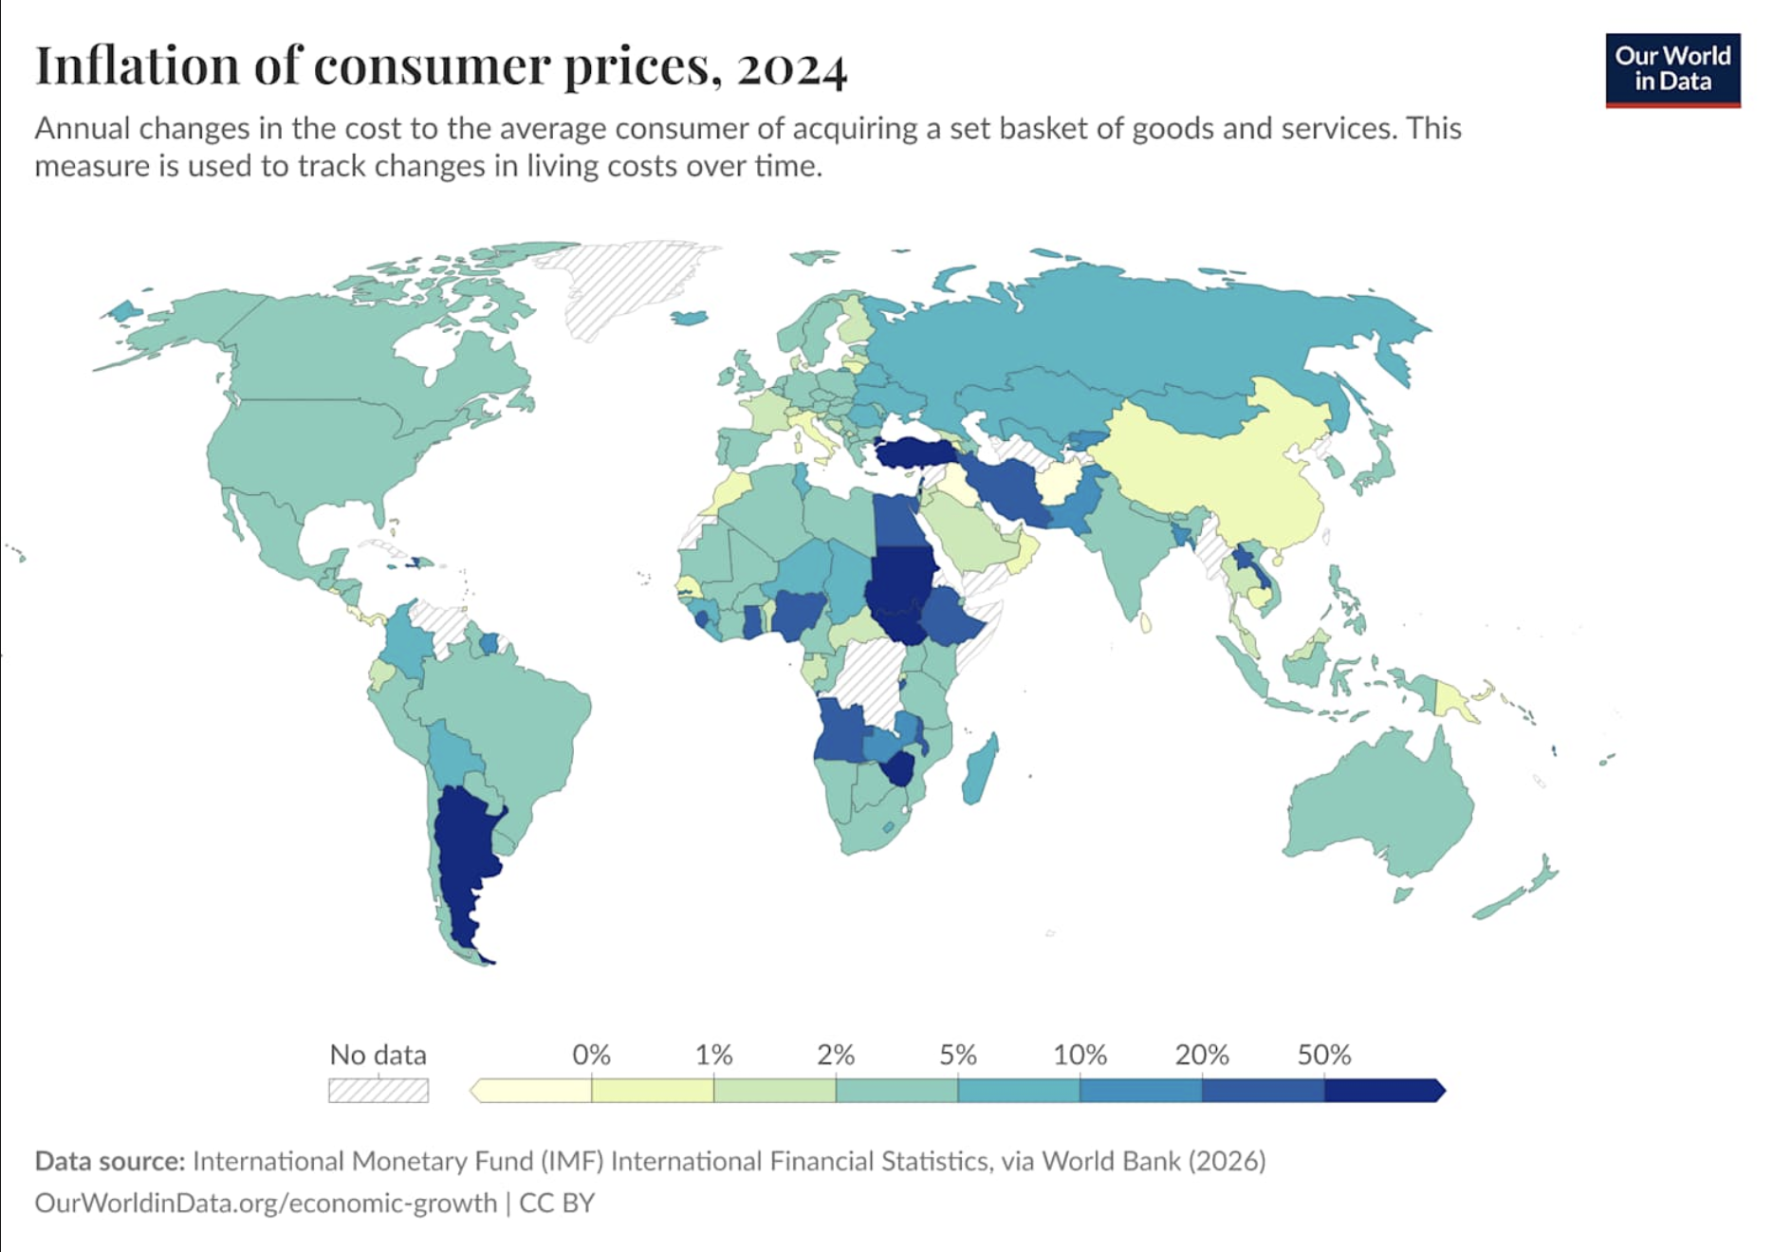
Source A:
This source and world map it shows the annual inflation rates across countries in 2024 and highlight how inflation has increased in many parts of the world in recent years. This source is important because it demonstrates that inflation is not only a local issue but rather a global challenge that affects developing countries more severely due to their dependence on imported goods, fuel, and food. In many of these countries, rising prices reduce purchasing power and make it harder for governments and households to afford basic necessities. This map helps delegates understand the broad scale of the issue and why international cooperation is necessary to address it (“Inflation, Consumer Prices (annual %)”; World Bank)

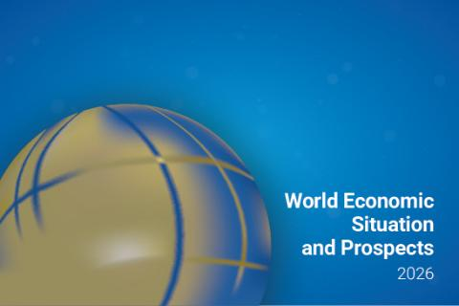
Source B:
In this source and the accompanying data from the UN DESA World Economic Situation and Prospects Mid-2026 report it shows that inflation in developing economies remains a serious challenge even as some global conditions improve. According to the report, inflation in developing economies was expected to rise from 4.2% to 5.2%, largely because of higher energy, transport, and import costs. This source shows that inflation continues to weaken household incomes and increase the cost of living, especially for lower-income populations. It also highlights that developing countries often have less fiscal space, meaning they have fewer resources to respond with subsidies or public support. This makes the graph especially useful because it demonstrates how inflation directly affects development and poverty reduction efforts (UN DESA, World Economic Situation and Prospects Mid-2026).

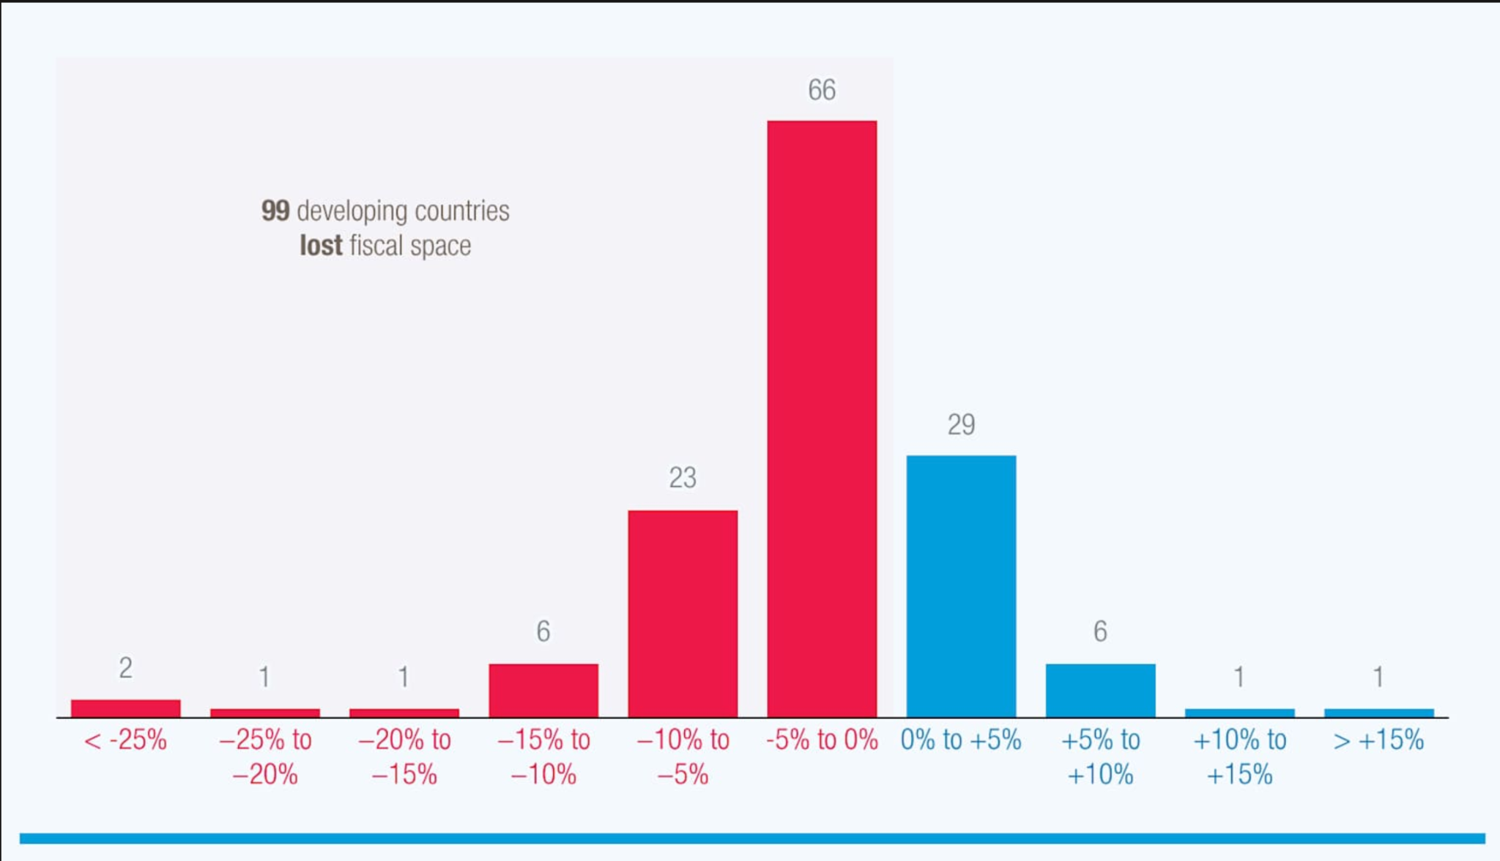
Source C:
This source and data chart from UNCTAD show how debt pressure and high borrowing costs make inflation even more harmful for developing countries. Many governments in the Global South already face debt burdens, and when inflation rises together with interest rates, countries have fewer resources to spend on healthcare, education, food security, and social protection. The chart demonstrates that rising debt costs are squeezing development prospects across developing countries, with many experiencing higher external debt service costs. This source is relevant because it demonstrates that inflation is not only about rising prices, but also about the broader economic pressure it creates on governments. In addition, it helps show why debt relief, concessional finance, and stronger international support are often suggested as solutions for developing countries facing inflation shocks (UNCTAD, World Economic Situation and Prospects 2026; World Bank, Inflation in Emerging and Developing Economies).

Bibliography

Works Cited
“CPI Home.” Bureau of Labor Statistics, 15 Feb. 2023, www.bls.gov/cpi/. Accessed 9 May 2026.
“Developing Country | Definition, Characteristics, Economy, & Origin | Britannica Money.” Encyclopedia Britannica, 2026, www.britannica.com/money/developing-country. Accessed 9 May 2026.
dpicampaigns. “Goal 1: End Poverty in All Its Forms Everywhere - United Nations Sustainable Development.” United Nations Sustainable Development, 10 Sept. 2025, www.un.org/sustainabledevelopment/poverty/. Accessed 18 May 2026.
elena. “UN Calls for USD 500 Billion per Year for Sustainable Development.” SDG Knowledge Hub, 2 Mar. 2023, sdg.iisd.org/news/un-calls-for-usd-500-billion-per-year-for-sustainable-development/. Accessed 15 May 2026.
---. “UN Report Projects 2024 Growth to Slow, Inflation to Decline.” SDG Knowledge Hub, 11 Jan. 2024, sdg.iisd.org/news/un-report-projects-2024-growth-to-slow-inflation-to-decline/. Accessed 15 May 2026.
“Global Cost-of-Living Crisis Catalyzed by War in Ukraine Sending Tens of Millions into Poverty, Warns UN Development Programme.” UNDP, 2022, www.undp.org/european-union/press-releases/global-cost-living-crisis-catalyzed-war-ukraine-sending-tens-millions-poverty-warns-un-development-programme. Accessed 10 May 2026.
“Global Cost-of-Living Crisis Catalyzed by War in Ukraine Sending Tens of Millions into Poverty, Warns UN Development Programme.” UNDP, 2022, www.undp.org/press-releases/global-cost-living-crisis-catalyzed-war-ukraine-sending-tens-millions-poverty-warns-un-development-programme. Accessed 18 May 2026.
Hayes, Adam. “Purchasing Power Explained: How Inflation Impacts Value.” Investopedia, 2026, www.investopedia.com/terms/p/purchasingpower.asp. Accessed 9 May 2026.
Holborn Assets. “Understanding the Role of Central Banks in the Global Economy.” Holbornassets.com, Holborn Assets, 24 Dec. 2024, holbornassets.com/blog/understanding-the-role-of-central-banks-in-the-global-economy/. Accessed 10 May 2026.
https://www.facebook.com/economicshelp.org. “The Impact of Inflation in Developing Economies - Economics Help.” Economics Help, 23 Feb. 2022, www.economicshelp.org/blog/167817/economics/the-impact-of-inflation-in-developing-economies/. Accessed 10 May 2026.
“Inflation vs. Deflation | Britannica Money.” Encyclopedia Britannica, Apr. 2026, www.britannica.com/money/inflation-vs-deflation. Accessed 9 May 2026.
“Is the Recent Inflationary Spike a Global Phenomenon?” Liberty Street Economics, 16 May 2024, libertystreeteconomics.newyorkfed.org/2024/05/is-the-recent-inflationary-spike-a-global-phenomenon/. Accessed 9 May 2026.
Kenton, Will. “What Is Core Inflation?” Investopedia, 2026, www.investopedia.com/terms/c/coreinflation.asp. Accessed 9 May 2026.
“MENA: 4 Policies Countries Can Adopt to Combat Inflation.” World Bank Blogs, 2022, blogs.worldbank.org/en/arabvoices/mena-4-policies-countries-can-adopt-combat-inflation. Accessed 10 May 2026.
“Monetary Policy and Central Banking.” IMF, 13 Jan. 2023, www.imf.org/en/about/factsheets/sheets/2023/monetary-policy-and-central-banking. Accessed 15 May 2026.
Nations, United. “Navigating through an Inflationary World | United Nations.” United Nations, 2025, www.un.org/en/desa/navigating-through-inflationary-world. Accessed 15 May 2026.
Peterson Foundation. “What Is Inflation and Why Does It Matter?” Peterson Foundation, 30 Apr. 2026, www.pgpf.org/article/what-is-inflation-and-why-does-it-matter/. Accessed 4 May 2026.
stonex.com. “What Is Supply Shock?” Stonex.com, stonex.com, 2026, www.stonex.com/en/business/financial-glossary/supply-shock/.
“UN World Food Programme (WFP).” Wfp.org, 23 Mar. 2023, www.wfp.org/news/food-inflation-and-currency-collapse-threaten-food-security-middle-east-and-north-africa. Accessed 10 May 2026.
“UNCTAD Calls for a ‘Rethink’ of Development Strategies amid Global Economic Slowdown and Rising Social Discontent.” UN Trade and Development (UNCTAD), 29 Oct. 2024, unctad.org/news/unctad-calls-rethink-development-strategies-amid-global-economic-slowdown-and-rising-social. Accessed 15 May 2026.
“UNCTAD Calls for a ‘Rethink’ of Development Strategies amid Global Economic Slowdown and Rising Social Discontent.” UN Trade and Development (UNCTAD), 29 Oct. 2024, unctad.org/press-material/unctad-calls-rethink-development-strategies-amid-global-economic-slowdown-and-rising. Accessed 15 May 2026.
anamaria. “ECOSOC, IFIs Discuss Financing for Sustainable Development.” SDG Knowledge Hub, 17 Apr. 2014, sdg.iisd.org/news/ecosoc-ifis-discuss-financing-for-sustainable-development/. Accessed 3 June 2026.
“Coming Soon: World Economic Outlook, April 2026.” IMF, 14 Apr. 2026, www.imf.org/en/publications/weo/issues/2026/04/14/world-economic-outlook-april-2026.
displacement. “Geneva Technical Briefing: Advancing the Treaty on the Protection of Persons in the Event of Disasters - Platform on Disaster Displacement.” Platform on Disaster Displacement, 20 Apr. 2026, disasterdisplacement.org/news-events/advancing-the-treaty-on-the-pped/. Accessed 3 June 2026.
“From Teheran to Vienna: A Timeline.” OHCHR, 2025, www.ohchr.org/en/about-us/history/vienna-declaration/teheran-vienna-timeline.
General, UN. “Declaration on International Cooperation in the Exploration and Use of Outer Space for the Benefit and in the Interest of All States, Taking into Particular Account the Needs of Developing Countries :: Resolution /: Adopted by the General Assembly.” United Nations Digital Library System, UN, 4 Feb. 1997, digitallibrary.un.org/record/231739. Accessed 3 June 2026.
---. “The Pact for the Future :: Resolution /: Adopted by the General Assembly.” United Nations Digital Library System, UN, 22 Sept. 2024, digitallibrary.un.org/record/4061879?ln=en. Accessed 3 June 2026.
“IDEAL - Disaster Law Treaty.” Mysite, 2024, www.disasterlaw.net/disaster-law-treaty. Accessed 3 June 2026.
“Inflation in Emerging and Developing Economies.” World Bank, www.worldbank.org/en/research/publication/inflation-in-emerging-and-developing-economies.
“Inflation of Consumer Prices.” Our World in Data, ourworldindata.org/grapher/inflation-of-consumer-prices.
Jackson, Peter. “A Prehistory of the Millennium Development Goals: Four Decades of Struggle for Development in the United Nations.” United Nations, 1 Dec. 2007, www.un.org/en/chronicle/article/prehistory-millennium-development-goals-four-decades-struggle-development-united-nations.
migration. “RES 41/65.” Unoosa.org, 2024, www.unoosa.org/oosa/oosadoc/data/resolutions/1986/general_assembly_41st_session/res_4165.html.
MONTHLY BRIEFING Navigating through an Inflationary World KEY MESSAGES. www.un.org/development/desa/dpad/wp-content/uploads/sites/45/MB189.pdf. Accessed 3 June 2026.
“Special High-Level Meeting of ECOSOC with UNCTAD, the World Bank, the IMF and the WTO.” UN Trade and Development (UNCTAD), 2024, unctad.org/meeting/special-high-level-meeting-ecosoc-unctad-world-bank-imf-and-wto. Accessed 3 June 2026.
“The Rising Cost of Debt Is Squeezing Development Prospects in Many Countries.” UN Trade and Development (UNCTAD), 19 Mar. 2026, unctad.org/news/rising-cost-debt-squeezing-development-prospects-many-countries.
United Nations. “International Covenant on Economic, Social and Cultural Rights.” OHCHR, United Nations, 16 Dec. 1966, www.ohchr.org/en/instruments-mechanisms/instruments/international-covenant-economic-social-and-cultural-rights.
World Bank. “Inflation, Consumer Prices (Annual %).” Worldbank.org, 2024, data.worldbank.org/indicator/FP.CPI.TOTL.ZG.
“World Economic Situation and Prospects 2026.” UN DESA Voice, 2026, desapublications.un.org/un-desa-voice/events/january-2026/world-economic-situation-and-prospects-2026. Accessed 3 June 2026.
“World Economic Situation and Prospects 2026 |.” UN Trade and Development (UNCTAD), 8 Jan. 2026, unctad.org/publication/world-economic-situation-and-prospects-2026.
“World Economic Situation and Prospects as of Mid-2026.” DESA Publications, 19 May 2026, desapublications.un.org/publications/world-economic-situation-and-prospects-mid-2026.

