UNCSTD Issue #2 PANAMUN XXXIV
Forum: United Nations Commission on Science and Technology for Development (UNCSTD)
Issue #2: “Addressing the impact of autonomous weapons on modern warfare."
Student Officers: Antonella Rumman
Position: Chair of the United Nations Commission on Science and Technology for Development

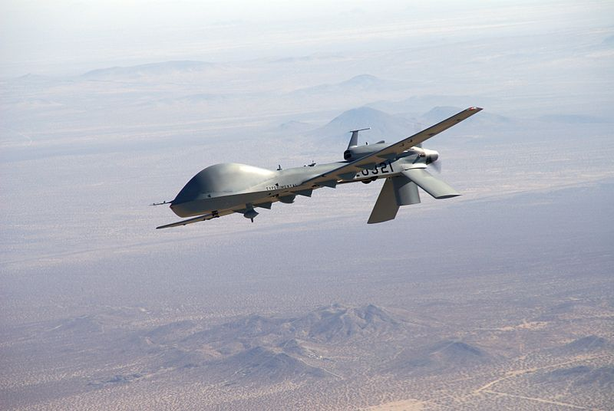
Autonomous Weapons Mini-Series: Distance, Weapons Technology and Humanity in Armed Conflict, https://blogs.icrc.org/law-and-policy/2017/10/06/distance-weapons-technology-and-humanity-in-armed-conflict/.

Introduction
The development of autonomous weapons systems (AWS), which are often powered by artificial intelligence, has altered the structures of modern-day warfare on a larger scale. It is within these programs’ capabilities to identify and engage targets without the need for input from humans, which raises immense ethical, legal, and security concerns. Although military efficiency/effectiveness is a huge upside to this issue, there is also the factor of blaming the technology and not taking accountability for the actions of the machines.

With countries upgrading to AI-powered military technologies, a consensus must be reached in the global community to create regulations and resolutions for the issue at hand, seeing as their absence may cause international calamities. There are still many questions that remain untouched, such as the possibility of an arms race, following both domestic and multinational laws, and the concerns for weaponry without human input. Due to this, it’s vital that nations explore different frameworks for all aspects of the topic, making sure that they align with the missions of global peace and security.

Possible long-term effects of sovereign weaponry on international collaboration and peace raise even more concerns than before. Due to the steadfast rise and development of these technologies, there could be a surge in geopolitical conflicts in the race for supremacy. In order to tackle arising issues such as unintentional escalation in armed conflicts, global stability, and eroding state confidence, the international committee should prioritize cooperative discourse and formulation of ethical, legal and secure policies.

Definition of Key Terms
Autonomous Weapons Systems (AWS): Weaponry that is capable of engaging targets without the need for human intervention. These systems use sensors, algorithms, and software to identify and strike targets independently.

Artificial Intelligence (AI): Algorithm-based technologies that simulate human intelligence; in this context, it is used for military purposes.

Lethal Autonomous Weapons Systems (LAWS): Military systems that, when activated, are able to search for, identify, and engage targets without human intervention: a subcategory of AWS.

Meaningful Human Control: The principle that humans, not algorithms, must retain authority and accountability over AI systems, particularly in lethal autonomous weapons.

International Humanitarian Laws (IHL): A set of rules that limits the effects of armed conflict by protecting individuals who are not partaking in the fighting, for instance, civilians, medics, or aid workers.

Accountability Gap: The established uncertainty of who is to blame in the instance of a breach in IHL, especially in the legal and ethical perspectives.

Arms Race: An informal “competition” between nations’ militaries in order to gain strategic and/or technological supremacy over other nations in the field of Artificial Intelligence in warfare and/or warfare technologies.

Disarmament Framework: Worldwide treaties, policies, and agreements that are focused on the limitations, regulations, and prohibitions of certain categories of weapon systems in order to foster peace and security, often regarding autonomous weapons systems.

General Overview
The Main Idea
One of the main concerns that faces today’s international security and technology governance is autonomous weapons systems (AWS). The use of artificial intelligence for military purposes has surged beyond logistic assistance and surveillance to include sovereign target selection and engagement programs. By improving the speed, the accuracy, and the ability to combat remotely, this development has created a turning point in contemporary warfare. Although it has also sparked serious questions about ethics, legality, and maintaining human control over the use of force.

Legal and Ethical Challenges
Using self-operating weapons in war creates a big and confusing issue with what is right (or ethics), and what's allowed by law. Currently, humans making choices in battle are meant to follow the usual rules of humanitarian law, or, in other words, tell the difference between soldiers and civilians, and have justified reasons to do what they do. However, these ideas become harder to deal with when AWS is used, particularly if there are ordinary people nearby or if the fight is happening and changing rapidly. If something illegal causes injury at the hands of an automated system, who is to blame? In these cases, there could be a shift of accountability, which causes a gap in frameworks that needs to be closed by the countries debating the issue in the UNCSTD.

Geopolitical Tensions and the Risk of an Arms Race
Yet another factor that should not be overlooked is the impact that this challenge has on international relations and strategic stability around the world. The concerns about a technological arms race, where states prioritize strategic gain over regulation and collaboration, have become even stronger owing to the fast creation of military robots by leading global powers. Given that autonomous machines can facilitate swift and cost-effective military interventions, this ‘competition’ carries a risk of escalating geopolitical tension and lowering the threshold of military engagement. The urgent need for the formulation of common regulations prior to the emergence of new technologies was emphasized in the recent talk held at the United Nations Headquarters (UNHQ) in Geneva.

International Cooperation and Regulatory Frameworks
Finally, it is vital to improve the coordination and communication in the area of international policies. There is no internationally binding convention that deals explicitly with AWS, although most countries support the concept of human effective control and regulate their use. This causes an issue of legality and pits at stake the principles of collective security. It is essential to enhance cooperation among technological innovation, arms control, and the defense of peace and security through the UNCSTD and the whole UN system.

Major Parties Involved and Their Views
United States
The United States of America has repeatedly supported the advancement of AI in military applications, showcasing its potential for improvements in the safety of its personnel, efficiency in operations, and even precision in the engagement of targets. However, they’ve openly rejected requests for legal worldwide bans, and often remark that current times call for modern technologies. Even so, they still promote human surveillance and domestic responsibility.

Russian Federation
Similarly, Russia has stated they believe that pre-existing policies for armed conflicts are enough and should be kept reinforced. They heavily oppose the development of new, legally binding global norms for AWS. They emphasize domestic independence, and have recently been under fire for hindering the development of more thorough international accords on the matter.

People’s Republic of China
In the case of China, its position appears more nuanced. While it is less in favor of placing restrictions on research and development, it has expressed willingness to impose limitations on the employment of fully autonomous lethal weapons, which do not require any human intervention. This demonstrates the two roles of China as both a major military AI innovator and an international regulatory debate participant.

European Union (EU) and Supportive States
Many countries from Europe, for instance, Germany, Austria, or Belgium, are strong supporters of international, binding frameworks. In the past, they’ve been some of the most outspoken countries regarding the promotion of global policies for the use of these AWS. Generally, said nations of the EU have stated their unwavering support for compliance with international humanitarian laws, taking accountability, and human interventions in these systems.

United Nations and International Organizations
The main platform for international discussion regarding AWS is usually in global forums such as the United Nations, specifically in committees such as the Convention on Certain Conventional Weapons (CCW), Disarmament and International Security Committee (DISEC), and our own committee, the United Nations Commission on Science and Technology for Development (UNCSTD). Many UN bodies, including the ones mentioned before, and the Secretary General, have advocated for the immediate drafting of regulations, highlighting that machines should not have unrestricted access to make possibly catastrophic choices.

Timeline of Events, Relevant Resolutions, Treaties, and Events

Date | Description of Event
2013 | The issue of LAWS was formally entered into international discussion by Christo Heyns, who raised concerns about the legality and ethics of robots in warfare.
2014 | Formal negotiations begin with the United Nations Office for Disarmament Affairs' first experts meeting on LAWS, held in Geneva in the CCW.
2015 | Second Informal Meeting of Experts.
2016 | Nations vote to create a Group of Governmental Experts (GGE) to research possible regulations regarding AWS in the CCW’s Fifth Review Conference.
2019 | The GGE drafts 11 guiding principles for regulations regarding LAWS.
2021 | At the next CCW conference, member states are unable to come to a consensus, therefore delaying the drafting of possible frameworks.
2023 | The UN General Assembly (GA) adopts Resolution A/RES/78/241 on LAWS.
2024 | The GA adopts several resolutions, including one of the most notable, the Pact for the Future, urging the creation of an international forum for specific discussion regarding AWS.
2025 | The GGE met several times, but no prominent changes were made.
2026 | The GGE is set to meet more times this year.

United Nations Involvement
Convention on Certain Conventional Weapons (CCW) Discussions on LAWS
The CCW provided the UN’s first opportunity to address issues related to AWS; however, negotiations concerning LAWS began in 2014. Up until now, the CCW has served as the primary platform for governments to engage in multilateral discourse about security, ethical, and legal concerns associated with these new technologies. The GGE mechanism was established to explore and research different policy frameworks that could potentially be adopted to regulate the development of autonomous weapons and assess the extent to which existing humanitarian law would prove sufficient to do so.

UN General Assembly Resolution on Lethal Autonomous Weapons Systems (2023)
The GA adopted Resolution A/RES/78/241 in 2023, which marked a peak in the raising of awareness of the lack of proper regulations for AWS globally. This resolution portrayed the emerging threat awaiting us all in the future and stated that immediate action needs to be taken to prevent it. Finally, this resolution also called upon the nations of the world to further discuss potential international legal frameworks for these new technologies.

UN General Assembly Resolution and the “Pact for the Future” (2024)
With subsequent discussion in the GA, including the adoption of “Pact for the Future” , the role of the UN as a whole was strengthened in 2024. In said initiative, the need for authentic human control over decision-making and innovation was stated. Nevertheless, it also called upon countries to push for the achievement of binding international legal frameworks for LAWS, symbolizing a shift from general concerns to more specific deliberations regarding policy expectations.

Evaluation of Previous Attempts to Resolve the Issue
Progress via Discussion but Absence of Conclusive Results
Previous efforts by the UN, especially within the framework of the CCW, have proven to be effective in creating continuous dialogue among nations regarding AWS. The ability of states to come up with a consensus on common issues like the applicability of international humanitarian laws and the importance of human accountability in weapon usage was made possible through the establishment of the GGE. However, despite much discussion, these processes have become mainly consultative and not determinative in nature because there is no concrete agreement that is legally binding for all states concerned.

UN General Assembly Resolutions' Strengths and Limitations
Decisions taken by the GA on LAWS (more specifically in 2023 and 2024) have greatly contributed to political incentive and global recognition. They have made stronger the need for meaningful human control and further legal regulation, as well as engagement beyond CCW member countries. Regardless, the non-binding nature of such decisions makes their implementation highly impossible. For that reason, they have not been able to produce any regulations or restrictions regarding the development and deployment of autonomous weapons.

Ongoing Challenges and Fragmentation of International Consensus
The inability to come up with a global approach to regulations for AWS is one of the main factors that cause the failure of previous attempts. Member countries are usually divided into three categories: supporters of stricter regulations, supporters of their complete abolishment, and opposers of further policy developments. The steadfast emergence of these new innovations is what makes discussions even harder for countries, especially when putting together an international framework that works for all, if not the majority of countries concerned.

Possible Solutions
Establishment of a Legally Binding International Treaty
One of the most supported solutions to regulate or ban certain weapons is to draft a legally binding, international framework that does so. This said framework would be able to be enforced according to international humanitarian laws, and can clearly mention and define what is considered acceptable and unacceptable use of AWS, and the conditions that must be met regarding human interventions. It may also provide reports and verifications in order to ensure the compliance of the state to the agreement.

Strengthening Human Control and International Oversight Mechanisms
Enforcing the idea of meaningful human control is vital to mitigate possible effects of AWS, and it is recommended that this enforcement happens through domestic and global monitoring. While the UN is able to set up panels of experts such as the CCW’s GGE, countries are also encouraged to create domestic (national) policies and laws regarding sovereign weapons as well. Additionally, mandatory disclosure of AWS is an instance of transparency that can help prevent geopolitical tensions and foster confidence between nations, allowing for a balance between security inquiries and humanitarian laws. This initiative would help promote regulation without stopping the development of technology, which is also important for the future of our world.

Sustainable Development Goal(s)
SDG 9: Industry, Innovation and Infrastructure
Creating infrastructure for resilience, promoting sustainable and equitable industrialization, and new innovations are key goals under the ninth Sustainable Development Goal. These goals are directly associated with the issue of AWS; although such developments may improve efficiency and lead to technological innovations, they also serve as an example to highlight the importance of having a responsible framework for research and development to prevent their misuse.

SDG 16: Peace, Justice and Strong Institutions
The goal of the sixteenth Sustainable Development Goal is to cultivate inclusive communities that promote peace and justice for everyone, and to guarantee accountable, yet efficient institutions. Nevertheless, the surge of AWS imposes new issues of accountability in war, because if any violations of international humanitarian laws occur, then who is to blame? The countries using them, the machines themselves, or their manufacturers? It is important to consider the compliance with these international laws, and the accountability that needs to be taken in order to prevent any escalations in battle. In order to halt these new technological innovations from inflicting risk factors on worldwide peace and security, there is a crucial need for cooperation between countries.

Appendix
This section of the issue bulletin is dedicated to providing delegates with valuable sources to utilize during their research.

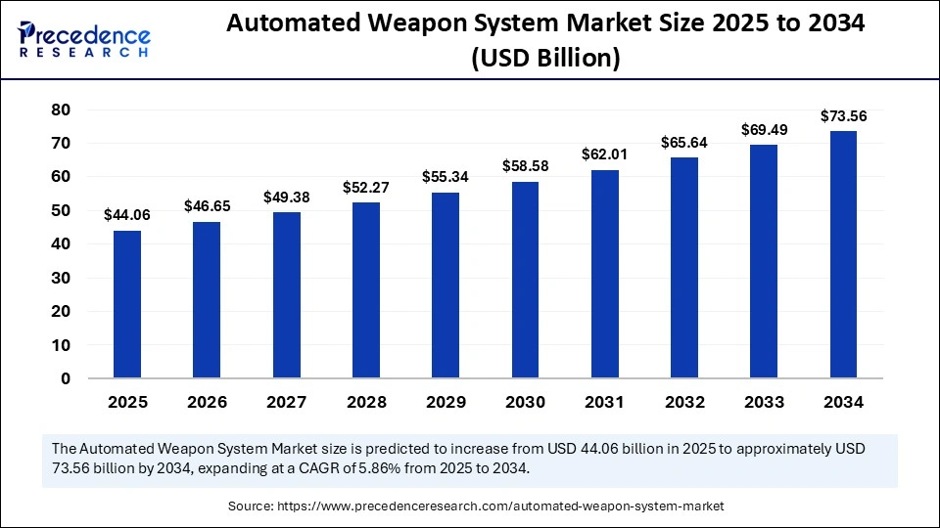Source A: This is a bar graph that shows the predicted growth of the automated weapon systems market size based on its current rates from 2025 to 2026. As you can see, the amount of USD spent on autonomous weapons in 2025 alone began with $44.06 billion, and is only expected to increase as time goes on. Based on the rapidly growing global economy, rising prices, and development of society regarding AI, it is predicted that there will be a total of $73.56 billion USD spent in 2034.

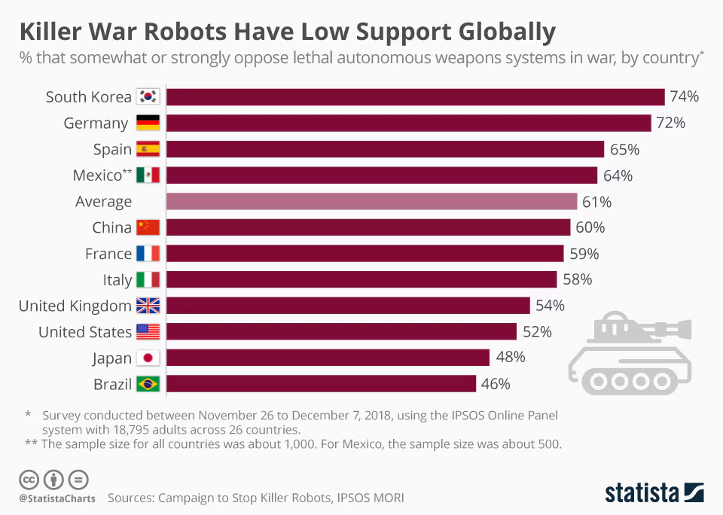
Source B: This source is highly recommended because it portrays an overall view of major players’ percentage support for autonomous weapons, in warfare, specifically. Although not all major parties were specifically noted in the above section, countries that are involved with the North Atlantic Treaty Organization (NATO) and the European Union (EU) are still significant contributors to the issue at hand. Delegates may use this source to guide themselves on what different opinions in the committee may look like.

https://meetings.unoda.org/ccw/convention-on-certain-conventional-weapons-group-of-governmental-experts-on-lethal-autonomous-weapons-systems-2025
Source C: The Chairs would highly recommend delegates to use this source, because not only does it give a small overview of the GGE’s stance on LAWS, but it also provides a list of all the documents that were drafted in their meetings. These documents include working papers, provisional agendas, Chair’s summaries, lists of participants, background papers, and even the Chair’s additional thoughts and suggestions on the topic. This source is incredibly useful and detailed for delegates who wish to go into further research about the topic and other countries’ stances.

https://lieber.westpoint.edu/legal-accountability-ai-driven-autonomous-weapons/
Source D: The Lieber website on lethal autonomous weapons systems is also a very thorough resource for delegates to use. It provides insights into the different aspects of the issue regarding legal accountability. A sister source of this was used in this Issue Bulletin, but we find this page also very interesting, should delegates want to go deeper into the branch of accountability.

https://globalsecurityreview.com/lethal-autonomous-weapon-systems-a-new-battlefield-reality/
Source E: This webpage is also useful for those delegates who want to learn more about LAWS, specifically in 2026. Published on the 31st of March, 2026, this resource has the most recent news and overviews on the issue. In addition, the source also includes links that define certain terms, and also links to other webpages of theirs if delegates want to know more about certain subtopics.

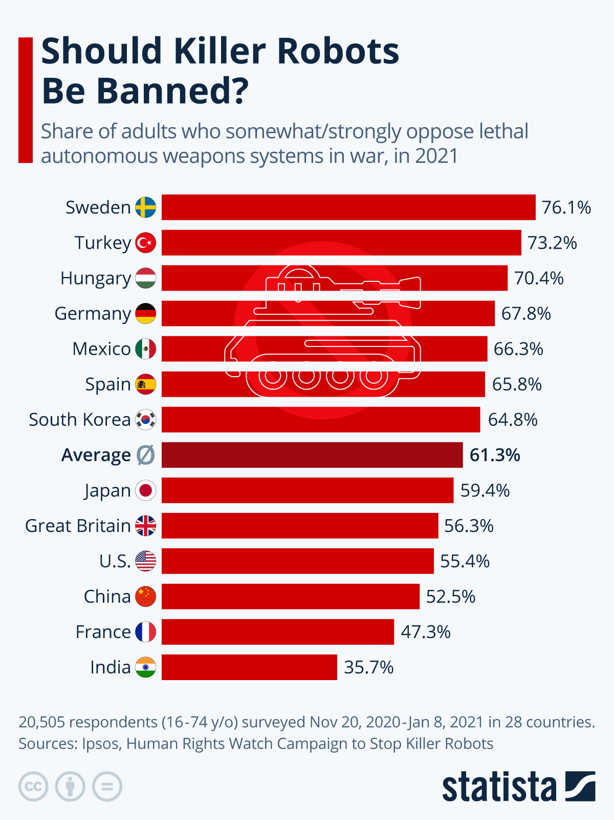
Source F: This image, owned and created by Statista © is a visual representation of the opinions of some of the major players’ populations on the eradication of “killer robots”, or also formally known as LAWS. Besides this, it also includes the average percentage of adults who oppose LAWS globally, not just the countries you see above. This source could also serve as a base for delegates to map out possible allies or solutions.

Bibliography

Arms Control Association. “Geopolitics and Regulation of Autonomous Weapons Systems.” Arms Control Today, 2025, https://www.armscontrol.org/act/2025-01/features/geopolitics-and-regulation-autonomous-weapons-systems.

Human Rights Watch. “A Hazard to Human Rights: Autonomous Weapons Systems and Digital Decision-Making.” HRW, 28 Apr. 2025, https://www.hrw.org/report/2025/04/28/a-hazard-to-human-rights/autonomous-weapons-systems-and-digital-decision-making.

International Committee of the Red Cross. “Autonomous Weapon Systems and International Humanitarian Law: Selected Issues.” ICRC, https://www.icrc.org/en/article/autonomous-weapon-systems-and-international-humanitarian-law-selected-issues.

International Committee of the Red Cross. “Distance Weapons: Technology and Humanity in Armed Conflict.” ICRC Blogs, 6 Oct. 2017, https://blogs.icrc.org/law-and-policy/2017/10/06/distance-weapons-technology-and-humanity-in-armed-conflict/.

Lieber Institute West Point. “Human Oversight and Lethal Autonomous Weapons.” Lieber Institute, https://lieber.westpoint.edu/no-new-rules-needed-russias-minimalist-vision-human-oversight-for-laws/.

Lieber Institute West Point. “Human Oversight and Chinese Approaches to LAWS.” Lieber Institute, https://lieber.westpoint.edu/human-oversight-chinese-characteristics-lethal-autonomous-weapons-ccw-gge/.

Precedence Research. “Automated Weapon System Market.” Precedence Research, https://www.precedenceresearch.com/automated-weapon-system-market.
Reuters. “Progress on Rules for Lethal Autonomous Weapons Urgently Needed, Says Geneva Chair.” 3 Mar. 2026, https://www.reuters.com/world/progress-rules-lethal-autonomous-weapons-urgently-needed-says-chair-geneva-talks-2026-03-03/.

United Nations Office for Disarmament Affairs. “Timeline of LAWS Discussions in the CCW.” UNODA, https://disarmament.unoda.org/timeline-of-laws-in-the-ccw/.
United Nations Human Rights Council. “Report on Autonomous Weapons Systems.” UNHRC, 2013.

United Nations General Assembly. “Resolution A/RES/78/241: Lethal Autonomous Weapons Systems.” 2023.

United Nations General Assembly. “Pact for the Future.” 2024.

World Economic Forum. “Regulate Non-State Use of Arms.” WEF, May 2022, https://www.weforum.org/stories/2022/05/regulate-non-state-use-arms/.

