Forum: The Disarmament and International Security Committee (DISEC)
Issue #1: Addressing the nuclear proliferation and missile development in the Middle East
Student Officers: Sofia Magaña and Eva Valencia
Position: Chairs of the Disarmament and International Security Committee

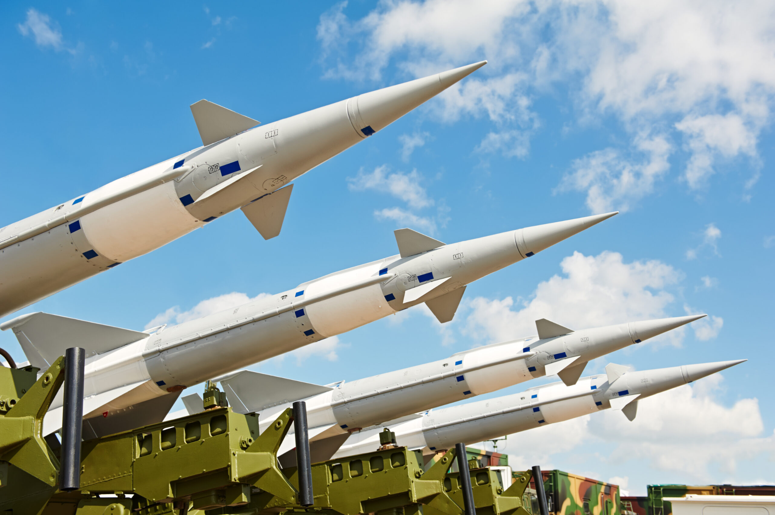
“Nuclear Proliferation in the Middle East Beyond Iran Stimson Center.” Stimson Center, 14 Mar. 2023, https://www.stimson.org/event/nuclear-proliferation-in-the-middle-east-beyond-iran/. Accessed 4 May 2026.

Introduction
Nuclear proliferation and the development of missiles are among the most acute problems that have been challenging the peace and prosperity of the Middle Eastern region and international security as a whole for the past few decades. Despite the long-term and seemingly hopeless nature of this problem, the Middle East continues facing threats associated with the nuclear programs developed and pursued by certain states located in the region. This issue stems from a series of long-standing geopolitical confrontations among Middle Eastern countries, accompanied by security dilemmas and mutual mistrust. In multiple cases, states with existing conditions of external threat tend to develop more advanced defense capabilities. As a result, nuclear technology and missile programs become the priority tasks of their military and foreign policies due to their potential to enhance sovereignty.

Even though multiple states operating in the Middle East region claim that their nuclear programs are solely aimed at peaceful development, there are reasonable grounds for suspicion regarding the true purpose of these programs. In particular, the main reason is that it is extremely difficult to draw the line between a purely civilian use of nuclear technology and its application for military purposes. This aspect considerably complicates things. proliferation efforts, as there appears to be a challenge that consists of proving whether or not certain states violate the international standards regulating their activity in terms of nuclear technology. The core document that defines these rules is called the Treaty on the Non-Proliferation of Nuclear Weapons (NPT). Its objectives include limiting proliferation, encouraging disarmament, and promoting nuclear technology for peaceful purposes (KJIS, 2025).

Parallel to the mentioned issues, there are other complications associated with the fast progress made by certain states in creating missile programs. Ballistic and cruise missiles are considered instruments of deterrence, as they can help states in projecting their power in cases of confrontation with other countries or hostile parties. However, the progress achieved by these programs becomes a source of concern for the Middle Eastern countries because of possible arms races and escalations of conventional wars into full-scale confrontations in which nuclear weapons would play their role

Definition of Key Terms
Nuclear Proliferation: The spread of nuclear weapons, nuclear technology, or weapons-related knowledge to countries that do not already possess them. It is considered a major global security concern because more nuclear-armed states increase the risk of war and instability.

Ballistic Missile: A missile that is launched into the atmosphere and follows a curved trajectory toward its target. Ballistic missiles are important because they can carry conventional or nuclear warheads over long distances.

Missile Development: The process of researching, designing, testing, and producing missile technology. In the Middle East, missile development is closely linked to military power and deterrence strategies.

Weapons of Mass Destruction (WMDs): Weapons capable of causing large-scale death and destruction, including nuclear, chemical, and biological weapons. International organizations work to prevent the spread of these weapons.

Nuclear Weapon: An explosive weapon that releases enormous energy through nuclear reactions such as fission or fusion. Nuclear weapons are far more destructive than conventional explosives.

Nuclear Program: A country’s activities related to nuclear technology, including energy production, scientific research, and uranium enrichment. Nuclear programs may be peaceful or suspected of military purposes.

Deterrence: A military strategy in which countries maintain powerful weapons to discourage attacks from other states. Nuclear deterrence is based on the threat of severe retaliation.

Arms Race: A competition between states to build stronger military forces and weapons. In the Middle East, rivalries can encourage countries to expand nuclear and missile capabilities.

Sanctions: Economic or political penalties imposed on a country to pressure it into changing its behavior. Sanctions are often used against states accused of violating nuclear agreements.

Joint Comprehensive Plan of Action (JCPOA): The 2015 nuclear agreement between Iran and several world powers. It limited Iran’s nuclear activities in exchange for sanctions relief and increased international inspections.

International Atomic Energy Agency (IAEA): A United Nations agency responsible for monitoring nuclear programs and promoting the peaceful use of nuclear technology. It conducts inspections to verify compliance with nuclear agreements.

Treaty on the Non-Proliferation of Nuclear Weapons (NPT): An international treaty designed to prevent the spread of nuclear weapons, promote peaceful nuclear energy, and encourage nuclear disarmament. Most countries in the world are members.

General Overview
When the world witnessed the devastation caused by the first atomic bombs, it served as a warning of the detrimental power that nuclear weapons possess. However, are the years of stigma and anxiety beginning to erode? Due to the decades of regional conflict, insecurity, and geopolitical rivalry, it has marked the precedent for nuclear proliferation and missile development in the Middle East. Concerns intensified after wars such as the Arab-Israeli conflicts, the Iran-Iraq War, and the Gulf Wars, which are all catalysts of modern Middle Eastern conflict. These demonstrate the strategic value of missile systems and weapons of mass destruction. Over time, the international community has increasingly focused on preventing the spread of nuclear weapons and limiting destabilizing missile programs in the region.

One of the central aspects of the issue is Iran’s nuclear program. Iran insists that its nuclear activities are intended for peaceful purposes such as energy production and scientific research. However, many countries, particularly the United States, Israel, and several Gulf states, fear that Iran could develop nuclear weapons capability. These concerns led to the creation of the 2015 Joint Comprehensive Plan of Action (JCPOA), an agreement between Iran and world powers that limited Iran’s nuclear activities in exchange for sanctions relief. The agreement significantly reduced Iran’s uranium enrichment levels and increased international inspections. However, after the United States withdrew from the deal in 2018, tensions escalated, and Iran gradually reduced compliance with several restrictions.

Another major dimension of the problem is ballistic missile development. Ballistic missiles are important because they can potentially carry nuclear warheads over long distances. Iran possesses one of the largest missile arsenals in the Middle East, including short-range and medium-range ballistic missiles capable of reaching neighboring countries and parts of Europe. Critics argue that previous agreements focused too heavily on nuclear enrichment while failing to adequately restrict missile programs. As a result, missile development has become a growing source of regional insecurity.

Regional rivalries also intensify the proliferation problem. The ongoing competition between Iran and countries such as Saudi Arabia and Israel has created fears of a regional arms race. Israel is widely believed to possess nuclear weapons, although it has never officially confirmed this. Meanwhile, some Arab states have expressed concerns that if Iran develops nuclear weapons capability, they may seek similar capabilities for deterrence purposes. This possibility threatens the global non-proliferation system established under the Treaty on the Non-Proliferation of Nuclear Weapons (NPT).

The issue also has broader global implications. Experts warn that weakening arms-control agreements and growing missile capabilities could trigger a new nuclear arms race not only in the Middle East but internationally. Increased militarization raises the risk of conflict escalation, accidental confrontations, and threats to civilian populations. As a result, many analysts argue that long-term solutions require stronger diplomacy, renewed arms-control agreements, regional cooperation, and confidence-building measures between rival states.

Major Parties Involved and Their Views
United States
The United States has always played a prominent role in the context of global anti-proliferation efforts and international security in the Middle East. Being one of the five recognized nuclear weapons states (NPT), America is an active proponent of preventing nuclear proliferation and missile programs that pose a threat to the region or the whole world. Thus, American foreign policy in the Middle East revolves around preventing countries like Iran from acquiring nuclear weapons while maintaining strategic relationships with states like Israel and Saudi Arabia.

The United States employs various strategies, from diplomatic talks to international inspections and economic sanctions or military deterrence, to prevent the proliferation of nuclear weapons in the Middle East. In this context, one of the significant steps made by the US and several other countries was the signing of the Joint Comprehensive Plan of Action (JCPOA) in 2015. The plan involved the restriction on Iran's nuclear development activities and sanctions relief. However, in 2018, President Donald Trump withdrew from the agreement, which resulted in increased tensions between Iran and its opponents (U.S. Department of State, 2018). Furthermore, Washington insists on preventing missile development activities in the Middle East, claiming that this contributes to regional instability and escalates conflicts in the area.

Iran
Currently, Iran continues to be the subject of many discussions and controversies related to nuclear proliferation in the Middle East. Officially, the Iranian authorities insist that their nuclear program is exclusively peaceful and that their nuclear development activities aim at providing energy, conducting research, and performing medical functions. According to Iran, as one of the signatories to the NPT, the country is entitled to use civilian nuclear energy under international laws (Congress Government, 2025).

However, Iran's opponents in the region and beyond are convinced that the country seeks to acquire nuclear weapons capabilities. After reports of enrichment of uranium exceeding limits set by the JCPOA had emerged, the issue became a concern again. Additionally, the development of long-range ballistic missiles in Iran poses a considerable risk to regional security. From the Iranian perspective, missile development is necessary for defending themselves from foreign aggression because of the numerous economic sanctions, military interventions, and hostilities in the region.

Israel
Israel is an exceptional case in the Middle Eastern nuclear environment. While the presence of nuclear arms is not officially announced by the country, it is widely known that Israel possesses quite an arsenal of nuclear weapons. The nation is not a participant in the NPT regime and practices nuclear ambiguity, meaning the absence of public confirmation or denial of the possession of nuclear arms.

Israeli authorities consider the nuclear and missile development activities carried out by Iran an existential threat. For this reason, Israel is an adamant supporter of applying stricter measures against Iran, such as imposing sanctions, isolating the country diplomatically, and even using military force if necessary (New York Times, 2025). In Israelis' leaders' perspectives, preventing hostile powers from obtaining weapons of mass destruction is vital for regional stability and existence. Moreover, Israel strives to build and maintain missile defense systems like Iron Dome and Arrow (BBC, 2021).

Saudi Arabia
As one of the most powerful Middle Eastern states, Saudi Arabia is extremely concerned about nuclear proliferation and missile development in the region. The Kingdom opposes the influence of Iran in the Middle East and views Iran's nuclear activities as a potential threat to the whole region. Moreover, Saudi Arabian officials claim that Iran's acquisition of nuclear weapons might provoke an arms race. While officially advocating for nonproliferation policies, Saudi Arabia has hinted at developing its own nuclear arsenal if Iran achieves success in creating weapons of mass destruction (Instituto Affari Internazionali, 2023). Currently, Saudi Arabia implements civilian nuclear programs in order to diversify energy sources. Furthermore, in recent years, the nation has started investing more money in missile defense programs because of the increasing number of attacks from the Yemeni conflict zone and Iranian-supported militants (Global Conflict Tracker, 2025).

United Nations Security Council (UNSC)
Being an international body in charge of international peace and security, the United Nations Security Council has taken an active part in preventing the spread of nuclear arms and ballistic missiles in the Middle East through sanctions, resolutions, and diplomacy. Consequently, the Security Council adopted multiple resolutions on Iran, urging it to comply with international regulations. It also approved sanctions imposed on Iran to prevent the enrichment of uranium and other nuclear activities in the country. In addition to this, the council supports the implementation of non-proliferation policies as outlined by the NPT (Security Council Report, 2026). Nevertheless, sometimes disagreement among permanent members of the council, including representatives of Western nations, Russia, and China, hampers joint efforts in preventing proliferation.

International Atomic Energy Agency (IAEA)
An important international organization engaged in the prevention of nuclear proliferation is the International Atomic Energy Agency (IAEA). Established in 1957, the agency promotes the peaceful application of nuclear energy while ensuring civilian nuclear programs do not have military purposes (IAEA, 2016). In terms of the Middle East, the IAEA regularly inspects nuclear sites in Iran and evaluates the results of such inspections before reporting them to the United Nations Security Council. Furthermore, the agency emphasizes that transparency, diplomacy, and inspections are key tools for preventing nuclear proliferation. Nonetheless, the efficiency of this approach can be undermined by political disagreement among members of the organization and access issues.

Timeline of Events, Relevant Resolutions, Treaties, and Events
Date Description of Event
1945 | The UN organization was established after the end of World War II to advance international peace, security, and cooperation. One of the long-term aims of the organization was to prevent the proliferation of nuclear weapons via diplomatic, legal, and security actions (United Nations)
1957 | The IAEA organization was created as an independent international body associated with the UN. Its primary mission is to enhance nuclear cooperation by ensuring the safe development of nuclear energy without making it a source of military technology (IAEA).
1968 | The Treaty on the Non-Proliferation of Nuclear Weapons was signed, becoming the core document of international law dedicated to arms control and disarmament (United Nations Office for Disarmament Affairs).
1970 | The Treaty on the Non-Proliferation of Nuclear Weapons entered into force. The treaty became one of the foundations of the international nuclear non-proliferation regime, facilitating the global efforts to reduce the risks of nuclear conflict and decrease nuclear weapon programs worldwide (UNODA).
1981 | Operation Opera was implemented by Israel when the country bombed the Iraqi nuclear facility Osirak located near Baghdad. Israel believed the reactor was a source of a threat to the nuclear potential of Iraq, which is why they struck first (Britannica)
1991 | After the end of the Gulf War, the UN Security Council passed Resolution 687, ordering Iraq to dismantle all its weapons of mass destruction and undergo international inspections (UNSC Resolution 687).
1995 | At the conference reviewing the Treaty on the Non-Proliferation of Nuclear Weapons, the member states passed resoution 45/56 regarding the establishment of a Middle East region free of weapons of mass destruction (UNODA).
2002 | New information about the secret Iranian facilities in Natanz and Arak attracted the attention of the international community to the nuclear activities of the country (IAEA).
2006 | The UN Security Council introduced resolution 1696, requiring Iran to stop uranium enrichment immediately and comply with the rules established by the Nuclear Non-Proliferation Treaty (UNSC).
2015 | Iran agreed with the P5+1 members on restricting its nuclear programs in exchange for sanctions relief (U.S. Department of State, IAEA).
2018 | The United Nations withdrew from the Joint Comprehensive Plan of Action and imposed new sanctions on Iran. This event raised concerns regarding the future of the agreement and escalated the already existing tension between Iran and the other states (U.S. Department of State)
2020 | As a result of signing the Abraham Accords, Israel normalized its relationships with several Arab states, including the United Arab Emirates and Bahrain. This event became one of the landmark breakthroughs in the field of Middle Eastern diplomacy.
UN Involvement
Promotion of the Nuclear Non-Proliferation Treaty (NPT)
The United Nations has been heavily involved in promoting the Treaty on the Non-Proliferation of Nuclear Weapons (NPT) in the Middle East. The NPT is an international agreement designed to prevent the spread of nuclear weapons, encourage peaceful uses of nuclear energy, and promote disarmament. Through the UN, member states discuss ways to strengthen the treaty and encourage Middle Eastern nations to comply with its rules. The UN views the NPT as one of the main tools for reducing the risk of nuclear conflict in the region.

Monitoring Iran’s Nuclear Program
The UN has played a significant role in monitoring Iran’s nuclear activities through cooperation with the International Atomic Energy Agency (IAEA). The IAEA conducts inspections of Iranian nuclear facilities and reports its findings to the UN Security Council. When concerns arose that Iran could develop nuclear weapons, the UN imposed sanctions and passed resolutions demanding greater transparency and limits on uranium enrichment. These actions were meant to slow nuclear proliferation and encourage diplomatic negotiations.

Efforts to Create a Nuclear-Weapon-Free Zone
The United Nations has consistently supported the creation of a Nuclear-Weapon-Free Zone (NWFZ) in the Middle East. This proposal aims to ban nuclear weapons across the region to reduce tensions and prevent an arms race. The UN General Assembly regularly discusses the issue and encourages regional cooperation between Middle Eastern countries. Although political conflicts and distrust have slowed progress, the UN continues to organize conferences and diplomatic discussions on the topic.

Addressing Ballistic Missile Development
The UN is also involved in addressing ballistic missile development in the Middle East because missiles can potentially carry nuclear warheads. Through Security Council resolutions and international diplomacy, the UN has attempted to limit missile testing and the transfer of missile technology in the region. Concerns over missile programs in countries such as Iran have led the UN to call for restraint and stronger arms control measures. These efforts are intended to reduce regional instability and lower the risk of military escalation.

Evaluation of Previous Attempts to Resolve the Issue
Treaty on the Non-Proliferation of Nuclear Weapons (NPT)
One of the key international actions aimed at solving the problem of nuclear proliferation was the Treaty on the Non-Proliferation of Nuclear Weapons (NPT). This treaty was signed in 1968 and came into effect in 1970. This action is intended to prohibit the spread of nuclear weapons, promote peaceful use of nuclear energy, and assist in the process of nuclear disarmament throughout the world (United Nations Office of Disarmament Affairs [UNODA] 2023). The NPT created the basis for distinguishing nuclear-weapon and non-nuclear-weapon states and promoting international cooperation based on adherence to IAEA safeguards. Despite the limitations of this treaty, which were primarily associated with some Middle Eastern countries that did not join the treaty, the NPT could be considered the best action to solve the issue discussed.

Additionally, it should be noted that according to the UN Office of Disarmament Affairs, the NPT is still the cornerstone of the international nonproliferation regime and has made a substantial contribution to decreasing the number of nuclear weapons in the world (UNODA, 2024). Despite its success, some countries in the Middle East, including Iran, continue to experience certain issues associated with their nuclear programs. Moreover, many experts emphasize that NPT is an effective mechanism for controlling nuclear programs; however, it does not eliminate doubts regarding nuclear proliferation.

International Atomic Energy Agency (IAEA) Safeguards and Inspections
Another international institution that played a critical role in preventing nuclear proliferation was the International Atomic Energy Agency (IAEA), which conducted inspections, implemented safeguard agreements, and created special monitoring mechanisms to control countries' use of nuclear technology. Since the organization was founded in 1957, the IAEA has been working to promote the safe use of nuclear energy for peaceful purposes (IAEA, 2022). By using different verification tools, the organization has attempted to increase transparency concerning national programs of nuclear weapon development. However, this process has met with numerous challenges associated with the voluntary nature of inspections.

Furthermore, it is known that Iran has experienced many issues with the IAEA since the early 2000s, when the presence of unreported nuclear facilities in Natanz and Arak was discovered. After conducting numerous inspections of these sites, the agency published many reports about compliance with the obligations concerning nuclear programs (IAEA, 2022). Meanwhile, IAEA inspections often encountered considerable difficulties, as the agency's authority relied solely on the willingness of states to cooperate with inspectors.

Possible Solutions
Middle East Nuclear Weapons Reduction Treaty
A possible solution to nuclear proliferation in the Middle East would be the creation of a regional Nuclear Weapons Reduction Treaty. Under this agreement, Middle Eastern nations would gradually reduce their nuclear stockpiles, limit uranium enrichment levels, and commit to not expanding missile systems capable of carrying nuclear warheads. The treaty could include phased disarmament goals, regular diplomatic meetings, and international oversight from the United Nations and the International Atomic Energy Agency (IAEA). Similar agreements, such as the Strategic Arms Reduction Treaties (START) between the United States and Russia, show that gradual arms reduction agreements can lower tensions and reduce the risk of conflict.

Expanding Diplomatic Negotiations and Arms Control Agreements
One possible solution to nuclear proliferation and missile development in the Middle East is expanding diplomatic negotiations and regional arms control agreements. Instead of relying on stricter inspections, the United Nations could encourage countries to participate in long-term dialogue focused on limiting missile programs, reducing uranium enrichment, and increasing regional cooperation. Agreements similar to the Iran nuclear deal (JCPOA) demonstrate how diplomacy can temporarily reduce nuclear tensions through negotiated compromises rather than force. By promoting communication, economic incentives, and peaceful conflict resolution, the UN could help lower mistrust and decrease the likelihood of a regional arms race.

Sustainable Development Goal (SDG)
SDG 16, Peace, Justice, and Strong Institutions
Sustainable Development Goal #16, peace, justice, and strong institutions, emphasizes the need for establishing peace, preventing violence, and increasing international cooperation. As stated by the United Nations Sustainable Development Goals Report, the existing armed conflicts, instability, and threats are continuously challenging international peace and sustainable development. This problem is related to SDG 16 since nuclear proliferation affects the state of international security, peace, and cooperation. Hence, there is a certain level of uncertainty associated with the nuclear weapons programs, missile technologies, and regional competition. Consequently, to mitigate these negative outcomes, some international organizations, such as the Nuclear-Weapon-Free Nations and the IAEA, have taken steps to increase global security and minimize military tensions by introducing nonproliferation agreements. For instance, the treaty on the non-proliferation of nuclear weapons (NPT) and the Joint Comprehensive Plan of Action (JCPOA) aim to promote international negotiations regarding a Middle East nuclear-weapon-free zone, showing that there are efforts to provide stability in the region.

In conclusion, SDG 16 has a strong relationship with the issue of nuclear proliferation since preventing said problem helps build peaceful relations and secure international institutions. Using diplomacy and cooperation, the United Nations tries to achieve peaceful societies by 2030.

Appendix
This section of the issue bulletin is dedicated to providing delegates with valuable sources to utilize during their research.

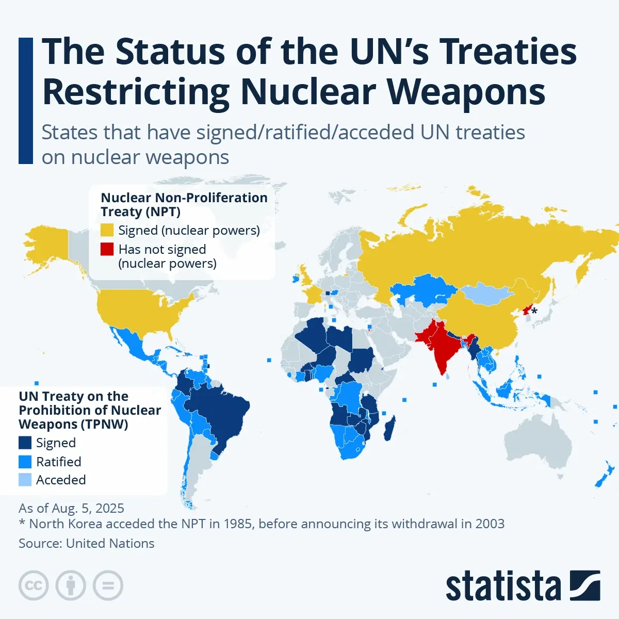
Source A: The picture above depicts the current state of major United Nations treaties dealing with nuclear weapons, specifically the treaty on the Non-Proliferation of Nuclear Weapons (NPT) and the Treaty on the Prohibition of Nuclear Weapons (TPNW). The map identifies which countries have signed, ratified, acceded to, or refused these treaties. Delegates must identify those states that are not parties to the NPT, as these are states posing challenges to the regime of non-proliferation of nuclear weapons. This source is relevant because it provides the level of international involvement in nuclear disarmament and the areas of unresolved tension with respect to nuclear weapons (United Nations).

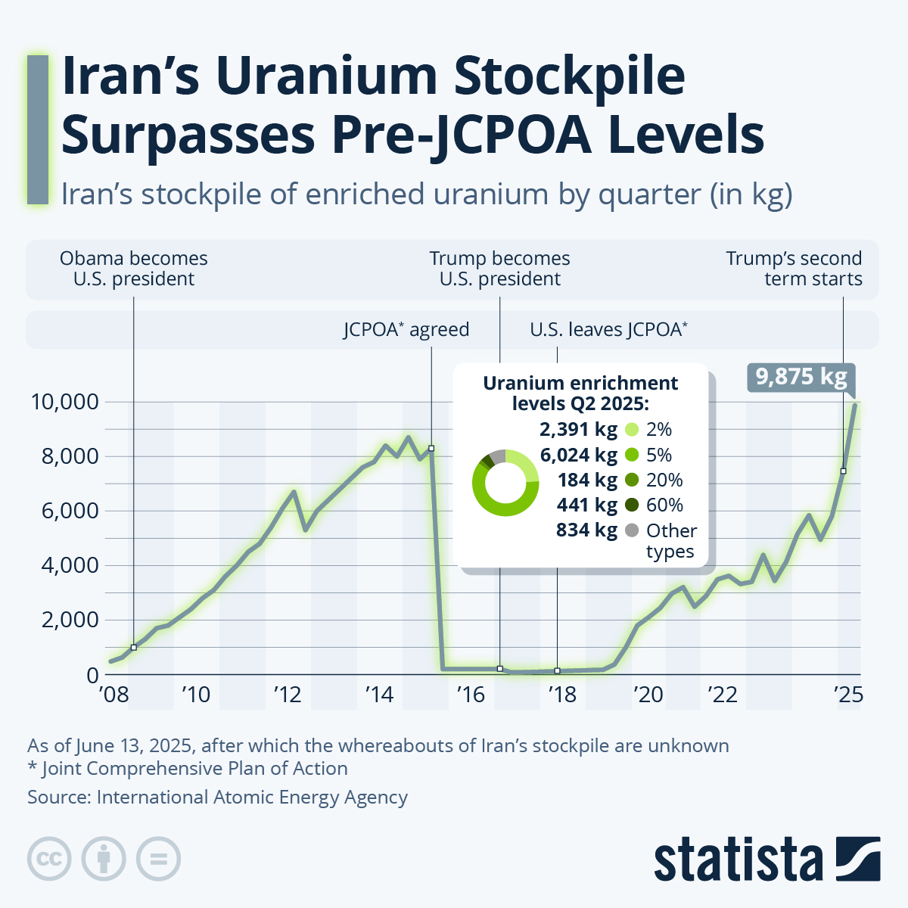

Source B: The picture above reflects the growth of the stockpile of enriched uranium in Iran for the period from 2008 to 2025. Moreover, it indicates major events such as the signing of the Joint Comprehensive Plan of Action (JCPOA) and the United States withdrawal from the agreement. The graph shows a dramatic decrease in the stockpiles of uranium after the JCPOA, in addition to a significant increase in subsequent years. Delegates are expected to consider how diplomatic agreements and sanctions affected the development of Iran's nuclear program. This source provides valuable insight into the most prominent nuclear proliferation challenges facing the international community. (International Atomic Energy Agency)

Bibliography
“A Draft Treaty for a WMD Free Zone in the Middle East: Time to Envisage the Practical | United Nations Office for Disarmament Affairs.” Unoda.org, 4 May 2026, disarmament.unoda.org/en/updates/draft-treaty-wmd-free-zone-middle-east-time-envisage-practical. Accessed 12 May 2026.
“Arms Control in the Middle East | SIPRI.” Www.sipri.org, www.sipri.org/research/armament-and-disarmament/weapons-mass-destruction/arms-control-middle-east.
“Ballistic Missile Capabilities in the Middle East.” Carnegie Endowment for International Peace, 26 Apr. 2002, carnegieendowment.org/research/2002/04/ballistic-missile-capabilities-in-the-middle-east. Accessed 6 May 2026.
BBC. “How Israel’s Iron Dome Missile Shield Works.” BBC News, 17 May 2021, www.bbc.com/news/world-middle-east-20385306.
Center for Preventive Action. “Conflict in Yemen and the Red Sea.” Global Conflict Tracker, Council on Foreign Relations, 26 Mar. 2025, www.cfr.org/global-conflict-tracker/conflict/war-yemen.
Cochran, Thomas B, and Robert S Norris. “Nuclear Weapon | History, Facts, Types, Countries, Blast Radius, & Effects.” Encyclopedia Britannica, 26 July 1999, www.britannica.com/technology/nuclear-weapon/Other-countries#ref988781.
“Document Viewer.” Un.org, 2025, docs.un.org/en/S/RES/688(1991).
Farago, Niv. “Nuclear Proliferation and Systemic Stability in the Middle East: The Challenge of Iran.” The Korean Journal of International Studies, vol. 23, no. 3, 30 Dec. 2025, pp. 395–419, kjis.org/journal/view.html?uid=328&vmd=Full, https://doi.org/10.14731/kjis.2025.12.23.3.395.
Herrera, Manuel. “Saudi Arabia’s Nuclear Ambitions: Frozen Once Again?” IAI - Istituto Affari Internazionali, 29 Nov. 2023, www.iai.it/en/publications/c05/saudi-arabias-nuclear-ambitions-frozen-once-again. Accessed 7 May 2026.
“IAEA Draws Safeguards Conclusions for 188 States — Safeguards Implementation Report 2022.” Www.iaea.org, 14 June 2023, www.iaea.org/newscenter/news/iaea-draws-safeguards-conclusions-for-188-states-safeguards-implementation-report-2022.
International Atomic Energy Agency. “History | IAEA.” Iaea.org, International Atomic Energy Agency, 8 June 2016, www.iaea.org/about/overview/history.
---. “Iran to Sign Additional Protocol and Suspend Uranium Enrichment and Reprocessing.” Iaea.org, 9 Nov. 2003, www.iaea.org/newscenter/pressreleases/iran-sign-additional-protocol-and-suspend-uranium-enrichment-and-reprocessing. Accessed 12 May 2026.
---. “Non-Proliferation Treaty.” International Atomic Energy Agency, 8 June 2016, www.iaea.org/topics/non-proliferation-treaty.
Jakes, Lara. “What to Know about Israel’s Secretive Nuclear Weapons Program.” The New York Times, 17 June 2025, www.nytimes.com/2025/06/17/world/middleeast/israel-nuclear-weapons.html.
Kerr, Paul. “Iran and Nuclear Weapons Production.” Congress.gov, 2025, www.congress.gov/crs-product/IF12106.
“MERIA: U.S. Responses to Proliferation of WMD in the Middle East.” Ciaotest.cc.columbia.edu, ciaotest.cc.columbia.edu/olj/meria/meria98_steinberg.html.
Middle. “Middle East Crisis: Closed Consultations*.” Security Council Report, 2026, www.securitycouncilreport.org/whatsinblue/2026/05/middle-east-briefing-under-the-threats-to-international-peace-and-security-agenda-item.php.
“Middle East Missile Mania: It’s Not Just Iran.” The Nuclear Threat Initiative, 26 Mar. 2025, www.nti.org/analysis/articles/middle-east-missile-mania-its-not-just-iran/.
Nations, United. “Site Search | United Nations.” United Nations, 2026, www.un.org/en/site-search?query=nuclear+proliferation+timeline. Accessed 12 May 2026.
“Nuclear-Weapon-Free Zones | United Nations Office for Disarmament Affairs.” Unoda.org, 2025, disarmament.unoda.org/en/our-work/weapons-mass-destruction/nuclear-weapons/nuclear-weapon-free-zones.
U.S. Department of State. “Joint Comprehensive Plan of Action.” State.gov, 2017, 2009-2017.state.gov/e/eb/tfs/spi/iran/jcpoa/.
---. “The Abraham Accords.” United States Department of State, 2020, www.state.gov/the-abraham-accords.

